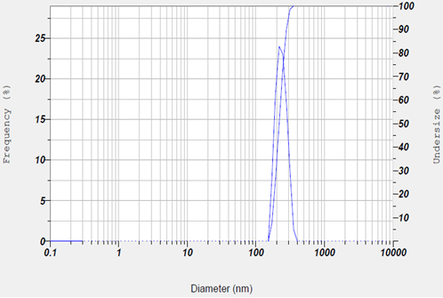
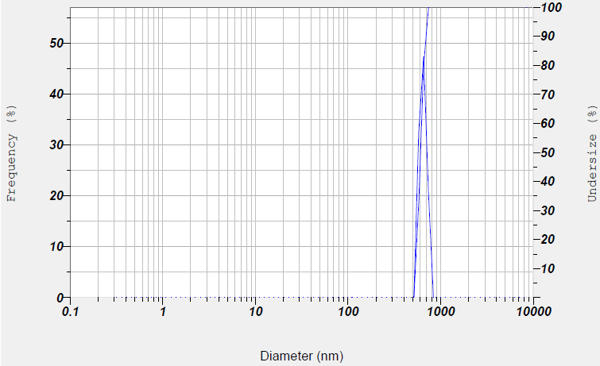
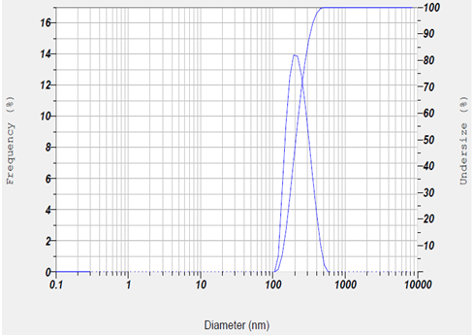
b

a

c

DLS analysis of green synthesized MgO-NP (a: MgO NPs with proportion of 30 D.W /70 ETH, b: MgO NPs with proportion of 50 D.W /50 ETH, c: MgO NPs with proportion of 70 D.W /30 ETH)

Zeta potential

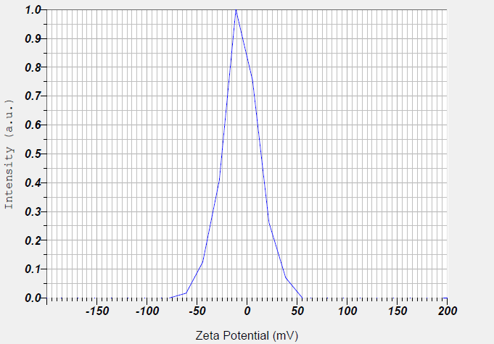
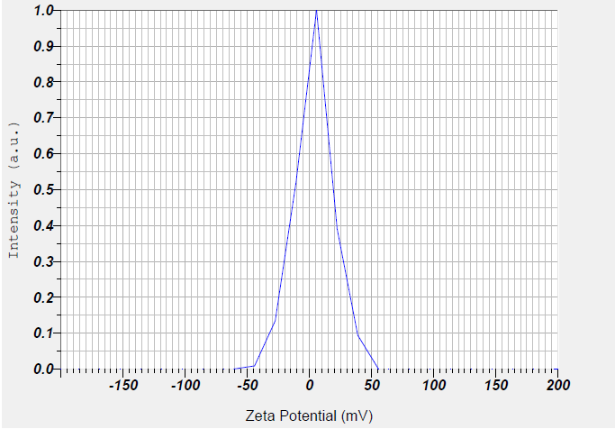
a

b

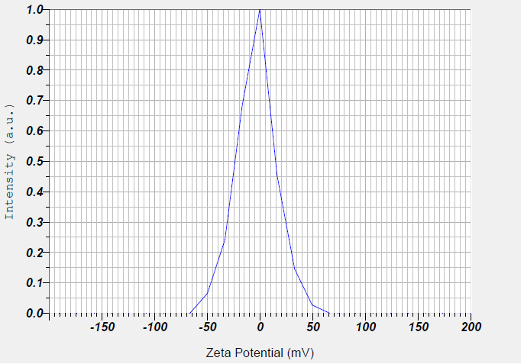
c

Zeta potential of green synthesized MgO-NPs (a: MgO NPs with proportion of 30 D.W /70 ETH, b: MgO NPs with proportion of 50 D.W /50 ETH, c: MgO NPs with proportion of 70 D.W /30 ETH).

