Efficacy and safety of probiotic supplements on cognitive function: A systematic review and meta-analysis of randomized clinical trials

SUPPLEMENTARY MATERIAL

Supplemental Table 1. Prisma 2020 Checklist

Section and Topic | Item # | Checklist item | Location where item is reported (N° page)
TITLE
Title | 1 | Identify the report as a systematic review. | 1
ABSTRACT
Abstract | 2 | See the PRISMA 2020 for Abstracts checklist. | 2
INTRODUCTION
Rationale | 3 | Describe the rationale for the review in the context of existing knowledge. | 4
Objectives | 4 | Provide an explicit statement of the objective(s) or question(s) the review addresses. | 4
METHODS
Eligibility criteria | 5 | Specify the inclusion and exclusion criteria for the review and how studies were grouped for the syntheses. | 5-6
Information sources | 6 | Specify all databases, registers, websites, organisations, reference lists and other sources searched or consulted to identify studies. Specify the date when each source was last searched or consulted. | 5
Search strategy | 7 | Present the full search strategies for all databases, registers and websites, including any filters and limits used. | 5
Selection process | 8 | Specify the methods used to decide whether a study met the inclusion criteria of the review, including how many reviewers screened each record and each report retrieved, whether they worked independently, and if applicable, details of automation tools used in the process. | 6-7
Data collection process | 9 | Specify the methods used to collect data from reports, including how many reviewers collected data from each report, whether they worked independently, any processes for obtaining or confirming data from study investigators, and if applicable, details of automation tools used in the process. | 6-7
Data items | 10a | List and define all outcomes for which data were sought. Specify whether all results that were compatible with each outcome domain in each study were sought (e.g. for all measures, time points, analyses), and if not, the methods used to decide which results to collect. | 7
Data items | 10b | List and define all other variables for which data were sought (e.g. participant and intervention characteristics, funding sources). Describe any assumptions made about any missing or unclear information. | 7
Study risk of bias assessment | 11 | Specify the methods used to assess risk of bias in the included studies, including details of the tool(s) used, how many reviewers assessed each study and whether they worked independently, and if applicable, details of automation tools used in the process. | 7
Effect measures | 12 | Specify for each outcome the effect measure(s) (e.g. risk ratio, mean difference) used in the synthesis or presentation of results. | 7
Synthesis methods | 13a | Describe the processes used to decide which studies were eligible for each synthesis (e.g. tabulating the study intervention characteristics and comparing against the planned groups for each synthesis (item #5)). | 7
Synthesis methods | 13b | Describe any methods required to prepare the data for presentation or synthesis, such as handling of missing summary statistics, or data conversions. | 7
Synthesis methods | 13c | Describe any methods used to tabulate or visually display results of individual studies and syntheses. | 7
Synthesis methods | 13d | Describe any methods used to synthesize results and provide a rationale for the choice(s). If meta-analysis was performed, describe the model(s), method(s) to identify the presence and extent of statistical heterogeneity, and software package(s) used. | 7
Synthesis methods | 13e | Describe any methods used to explore possible causes of heterogeneity among study results (e.g. subgroup analysis, meta-regression). | 8
Synthesis methods | 13f | Describe any sensitivity analyses conducted to assess robustness of the synthesized results. | 7
Reporting bias assessment | 14 | Describe any methods used to assess risk of bias due to missing results in a synthesis (arising from reporting biases). | 7
Certainty assessment | 15 | Describe any methods used to assess certainty (or confidence) in the body of evidence for an outcome. | 7-8
RESULTS
Study selection | 16a | Describe the results of the search and selection process, from the number of records identified in the search to the number of studies included in the review, ideally using a flow diagram. | 9
Study selection | 16b | Cite studies that might appear to meet the inclusion criteria, but which were excluded, and explain why they were excluded. | 9
Study characteristics | 17 | Cite each included study and present its characteristics. | 9
Risk of bias in studies | 18 | Present assessments of risk of bias for each included study. | 9-10
Results of individual studies | 19 | For all outcomes, present, for each study: (a) summary statistics for each group (where appropriate) and (b) an effect estimate and its precision (e.g. confidence/credible interval), ideally using structured tables or plots. | 10, Table 1 and Table 2
Results of syntheses | 20a | For each synthesis, briefly summarise the characteristics and risk of bias among contributing studies. | 11
Results of syntheses | 20b | Present results of all statistical syntheses conducted. If meta-analysis was done, present for each the summary estimate and its precision (e.g. confidence/credible interval) and measures of statistical heterogeneity. If comparing groups, describe the direction of the effect. | 11-12
Results of syntheses | 20c | Present results of all investigations of possible causes of heterogeneity among study results. | 12
Results of syntheses | 20d | Present results of all sensitivity analyses conducted to assess the robustness of the synthesized results. | 11-12
Reporting biases | 21 | Present assessments of risk of bias due to missing results (arising from reporting biases) for each synthesis assessed. | 12
Certainty of evidence | 22 | Present assessments of certainty (or confidence) in the body of evidence for each outcome assessed. | 11
DISCUSSION
Discussion | 23a | Provide a general interpretation of the results in the context of other evidence. | 14
Discussion | 23b | Discuss any limitations of the evidence included in the review. | 16-17
Discussion | 23c | Discuss any limitations of the review processes used. | 16-17
Discussion | 23d | Discuss implications of the results for practice, policy, and future research. | 15-16
OTHER INFORMATION
Registration and protocol | 24a | Provide registration information for the review, including register name and registration number, or state that the review was not registered. | 5
Registration and protocol | 24b | Indicate where the review protocol can be accessed, or state that a protocol was not prepared. | 5
Registration and protocol | 24c | Describe and explain any amendments to information provided at registration or in the protocol. | 5
Support | 25 | Describe sources of financial or non-financial support for the review, and the role of the funders or sponsors in the review. | 1
Competing interests | 26 | Declare any competing interests of review authors. | 1
Availability of data, code and other materials | 27 | Report which of the following are publicly available and where they can be found: template data collection forms; data extracted from included studies; data used for all analyses; analytic code; any other materials used in the review. | Supplemental Tables
From: Page MJ, McKenzie JE, Bossuyt PM, Boutron I, Hoffmann TC, Mulrow CD, et al. The PRISMA 2020 statement: an updated guideline for reporting systematic reviews. BMJ 2021;372:n71. doi: 10.1136/bmj.n71. This work is licensed under CC BY 4.0. To view a copy of this license, visit https://creativecommons.org/licenses/by/4.0/

Supplemental Table 2. Search strategy on each databases
Database | Search strategy  Search date: July 30, 2024 |  | Results
Pubmed | #1 | #1: "Probiotics"[Mesh] OR Probiotic*[tiab] OR "lactobacillus"[tiab] OR "bifidobacter"[tiab] OR "Lactococcus"[tiab] OR "Saccharomyce"[tiab] OR "pediococcus"[tiab] OR "streptococcus"[tiab] OR "Lactic Acid Bacteria"[tiab] OR "Bifidobacterium"[tiab] | 233
Pubmed | #2 | "Cognition"[Mesh] OR "Cogniti*"[tiab] OR "Cognitive Function"[tiab] OR Awareness[tiab] OR "Cognitive Dissonance"[tiab] OR "Cognitive Reflection"[tiab] OR "Cognitive Reserve"[tiab] OR Comprehension[tiab] OR Consciousness[tiab] OR Imagination[tiab] OR Dream*[tiab] OR Fantas*[tiab] OR Intuition[tiab] OR Metacognition[tiab] OR memor*[tiab] OR "Processing Speed"[tiab] | 233
Pubmed | #3 | "Randomized Controlled Trials as Topic"[Mesh] OR "Clinical Trial*"[tiab] OR "Randomized Clinical Trial*"[tiab] OR "Randomized Controlled Trial" [Publication Type] | 233
Pubmed | #4 | #1 AND #2 AND #3 | 233
WoS | #1 | TS=(Probiotic* OR "lactobacillus" OR "bifidobacter" OR "Lactococcus" OR "Saccharomyce" OR "pediococcus" OR "streptococcus" OR "Lactic Acid Bacteria" OR "Bifidobacterium") OR TI=(Probiotic* OR "lactobacillus" OR "bifidobacter" OR "Lactococcus" OR "Saccharomyce" OR "pediococcus" OR "streptococcus" OR "Lactic Acid Bacteria" OR "Bifidobacterium") OR AB=(Probiotic* OR "lactobacillus" OR "bifidobacter" OR "Lactococcus" OR "Saccharomyce" OR "pediococcus" OR "streptococcus" OR "Lactic Acid Bacteria" OR "Bifidobacterium") OR AK=(Probiotic* OR "lactobacillus" OR "bifidobacter" OR "Lactococcus" OR "Saccharomyce" OR "pediococcus" OR "streptococcus" OR "Lactic Acid Bacteria" OR "Bifidobacterium") OR KP=(Probiotic* OR "lactobacillus" OR "bifidobacter" OR "Lactococcus" OR "Saccharomyce" OR "pediococcus" OR "streptococcus" OR "Lactic Acid Bacteria" OR "Bifidobacterium") | 255
WoS | #2 | TI=("Cogniti*" OR "Cognitive Function" OR Awareness OR "Cognitive Dissonance" OR "Cognitive Reflection" OR "Cognitive Reserve" OR Comprehension OR Consciousness OR Imagination OR Dream* OR Fantas* OR Intuition OR Metacognition OR memor* OR "Processing Speed") OR AK=("Cogniti*" OR "Cognitive Function" OR Awareness OR "Cognitive Dissonance" OR "Cognitive Reflection" OR "Cognitive Reserve" OR Comprehension OR Consciousness OR Imagination OR Dream* OR Fantas* OR Intuition OR Metacognition OR memor* OR "Processing Speed") OR KP=("Cogniti*" OR "Cognitive Function" OR Awareness OR "Cognitive Dissonance" OR "Cognitive Reflection" OR "Cognitive Reserve" OR Comprehension OR Consciousness OR Imagination OR Dream* OR Fantas* OR Intuition OR Metacognition OR memor* OR "Processing Speed") OR TS=("Cogniti*" OR "Cognitive Function" OR Awareness OR "Cognitive Dissonance" OR "Cognitive Reflection" OR "Cognitive Reserve" OR Comprehension OR Consciousness OR Imagination OR Dream* OR Fantas* OR Intuition OR Metacognition OR memor* OR "Processing Speed") OR AB=("Cogniti*" OR "Cognitive Function" OR Awareness OR "Cognitive Dissonance" OR "Cognitive Reflection" OR "Cognitive Reserve" OR Comprehension OR Consciousness OR Imagination OR Dream* OR Fantas* OR Intuition OR Metacognition OR memor* OR "Processing Speed") | 255
WoS | #3 | TI=("Clinical Trial*" OR "Randomized Controlled Trial" OR "Randomized Clinical Trial") OR AB=("Clinical Trial*" OR "Randomized Controlled Trial" OR "Randomized Clinical Trial") OR AK=("Clinical Trial*" OR "Randomized Controlled Trial" OR "Randomized Clinical Trial") OR KP=("Clinical Trial*" OR "Randomized Controlled Trial" OR "Randomized Clinical Trial") OR TS=("Clinical Trial*" OR "Randomized Controlled Trial" OR "Randomized Clinical Trial") | 255
WoS | #4 | #1 AND #2 AND #3 | 255
Scopus | #1 | TITLE-ABS-KEY(Probiotic* OR "lactobacillus" OR "bifidobacter" OR "Lactococcus" OR "Saccharomyce" OR "pediococcus" OR "streptococcus" OR "Lactic Acid Bacteria" OR "Bifidobacterium") | 955
Scopus | #2 | TITLE-ABS-KEY("Cogniti*" OR "Cognitive Function" OR Awareness OR "Cognitive Dissonance" OR "Cognitive Reflection" OR "Cognitive Reserve" OR Comprehension OR Consciousness OR Imagination OR Dream* OR Fantas* OR Intuition OR Metacognition OR memor* OR "Processing Speed") | 955
Scopus | #3 | TITLE-ABS-KEY("Clinical Trial*" OR "Randomized Controlled Trial" OR "Randomized Clinical Trial") | 955
Scopus | #4 | #1 AND #2 AND #3 | 955
Embase | #1 | ('probiotic agent'/exp OR 'probiotic':ti,ab,kw OR 'probiotic agent':ti,ab,kw OR 'probiotics':ti,ab,kw OR 'probiotic supplementation'/exp) | 739
Embase | #2 | ('cognition'/exp OR 'cognition':ti,ab,kw OR 'cognitive accessibility':ti,ab,kw OR 'cognitive balance':ti,ab,kw OR 'cognitive dissonance':ti,ab,kw OR 'cognitive function':ti,ab,kw OR 'cognitive structure':ti,ab,kw OR 'cognitive symptoms':ti,ab,kw OR 'cognitive task':ti,ab,kw OR 'cognitive thinking':ti,ab,kw OR 'neurobehavioural manifestations':ti,ab,kw OR 'volition':ti,ab,kw) | 739
Embase | #3 | ('randomized controlled trial'/exp OR 'controlled trial, randomized':ti,ab,kw OR 'randomised controlled study':ti,ab,kw OR 'randomised controlled trial':ti,ab,kw OR 'randomized controlled study':ti,ab,kw OR 'randomized controlled trial':ti,ab,kw OR 'trial, randomized controlled':ti,ab,kw OR 'clinical trial'/exp OR 'clinical drug trial':ti,ab,kw OR 'clinical trial':ti,ab,kw OR 'major clinical trial':ti,ab,kw OR 'trial, clinical':ti,ab,kw OR 'controlled clinical trial'/exp OR 'clinical trial, controlled':ti,ab,kw OR 'controlled clinical comparison':ti,ab,kw OR 'controlled clinical drug trial':ti,ab,kw OR 'controlled clinical experiment':ti,ab,kw OR 'controlled clinical study':ti,ab,kw OR 'controlled clinical test':ti,ab,kw OR 'controlled clinical trial':ti,ab,kw OR 'clinical trial (topic)'/exp OR 'clinical trial (topic)':ti,ab,kw OR 'clinical trials':ti,ab,kw OR 'clinical trials as topic':ti,ab,kw) | 739
Embase | #4 | #1 AND #2 AND #3 | 739

Supplemental Table 3. Summary of Findings Table for the effects of probiotics supplementation versus placebo on cognitive function

Population | Patients with and without cognitive impairment
Intervention | Probiotic supplements
Control | Placebo
Outcomes  ( follow -up) | Number of patients (number of studies) | Intervention: Probiotics supplementation | Control group: Placebo | Relative effect (95% CI) | Absolute difference (95% CI) | Certainty | Interpretation
MMSE at 8 weeks | 146  (2 RCTs) | Mean: 27.67 | Mean: 27.71 | - | MD: -0.02  (-0.69 to 0.65) | ⨁◯◯◯  Very low ^{a, b,c} | The evidence is very uncertain regarding the effect of probiotics on cognitive function at 8 weeks of follow-up.
MMSE at 12 weeks | 160  (3 RCTs) | Mean: 20.51 | Mean: 16.16 | - | MD: 4.23 (2.77 to 5.68) | ⨁⨁◯◯  Low ^{c} | Compared with placebo, probiotic supplementation may improve cognitive function as measured by the MMSE at 12 weeks of follow-up.
MoCA at 12 weeks | 148  (3 RCTs) | Mean: 23.48 | Mean: 22.53 | - | MD: 1.21 (0.06 to 2.36) | ⨁⨁◯◯  Low ^{c} | Compared with placebo, probiotic supplementation may improve cognitive function as measured by the test MoCA at 12 weeks follow-up.
Cognition CFT 12 weeks | 120  (2 RCTs) | Mean: 8.27 | Mean: -4.33 | - | MD: 3.94 (3.20 to -4.69) | ⨁⨁◯◯  Low ^{d} | Compared with placebo, probiotic supplementation may improve cognitive function as measured by the CFT at 12 weeks of follow-up.
Monostrain | 120  (2 RCTs) | Mean: 8.27 | Mean: -4.33 |  | MD: 4.67 (1.13 to -8.22) | ⨁⨁◯◯  Low ^{d, e} | Compared with placebo, probiotics formulated with monostrain could improve cognitive function.
Multistrain | 120  (2 RCTs) | Mean: 8.27 | Mean: -4.33 |  | MD: 1.76 (-0.96 to 4.49) | ⨁◯◯◯  Very low ^{a, c, e} | The evidence is very uncertain regarding the effect of multi-strain probiotic formulations on cognitive function.
Alzheimer's disease | 120  (2 RCTs) | Mean: 8.27 | Mean: -4.33 |  | MD: 4.67 (1.13 to -8.22) | ⨁⨁◯◯  Moderate ^{d , e} | Compared with placebo, probiotic supplementation may improve cognitive function in subjects with Alzheimer's .
Cognitive impairment | 163  (3 RCTs) | Mean: 8.27 | Mean: -4.33 |  | MD: 2.38 (-1.46 to 6.22) | ⨁◯◯◯  Very low a, c, e | The evidence is very uncertain regarding the effect of probiotics on cognitive function in subjects with cognitive impairment.
Healthy adults | 38  (1 RCTs) | Mean: 25.80 | Mean: -25.80 |  | MD: 0.00 (-1.96 to 1.96) | ⨁⨁⨁⨁  High | Compared with placebo, probiotics did not improve cognitive function in healthy older adults.
Any adverse event | 325  (4 RCTS) | 40/163 | 43/162 | RR: 0.91  (0.65 to 1.27) | RD: 24 fewer per 1,000  (93 fewer to 72 more) | ⨁◯◯◯  Very low ^{b, c ,f} | The evidence on the effect of probiotics on adverse events is very uncertain.
RCT: randomized controlled trial, RR: risk ratio, CI: confidence interval, RD: risk difference, MD: mean difference
Explanations of certainty of evidence:
- Certainty was reduced by one level due to inconsistency, as the I² lies between 40% and 80%.
- Strong suspicion of publication bias (possible conflicts of interest)
- Certainty was downgraded by two levels due to risk of bias, as ≤50% of the meta-analysis weight came from studies with low risk of bias.
- Certainty was downgraded one level due to risk of bias, as more than one domain was at important risk of bias
- Certainty was reduced by one level due to imprecision, as the 95% CI of the absolute effect exceeds 1 DMI.
- Certainty was downgraded by one level due to imprecision because the 95% CI of the relative effect exceeds 0.75 or 1.25.

Supplemental Table 4. List of studies that were assessed in full-text and excluded.

Author and year | Title of the study | Exclusion reason
EXCLUDED REPORTS DURING THE FIRST SEARCH PHASE: DATABASE AND REGISTERS
Akhgarjand C. (2024) | The effects of probiotic supplements on oxidative stress and inflammation in subjects with mild and moderate Alzheimer's disease: a randomized, double-blind, placebo-controlled study | Wrong outcome
Aljumaah M. (2022) | The gut microbiome, mild cognitive impairment, and probiotics: A randomized clinical trial in middle-aged and older adults | Wrong outcome
Ascone L. (2022) | Effect of Continuous Ingestion of Bifidobacteria and Dietary Fiber on Improvement in Cognitive Function: A Randomized, Double-Blind, Placebo-Controlled Trial | Wrong publication type
Bartos A. (2022) | Effect of human probiotics on memory, psychological and biological measures in elderly: A study protocol of bi-center, double-blind, randomized, placebo-controlled clinical trial (CleverAge Biota) | Wrong study design
Bernier F. (2021) | Association of Plasma Hemoglobin A1c with Improvement of Cognitive Functions by Probiotic Bifidobacterium breve Supplementation in Healthy Adults with Mild Cognitive Impairment | Wrong outcome
Hu L. (2023) | Perioperative probiotics attenuates postoperative cognitive dysfunction in elderly patients undergoing hip or knee arthroplasty: A randomized, double-blind, and placebo-controlled trial | Wrong population
Nagasaki Y. (2019) | Effect of a dietary supplement containing heat-killed bifidobacterium longum N61 on neurocognitive functions in healthy old adults with perceived memory impairment: A randomized, double-blind, placebo-controlled trial | No full text
Ruiz-Gonzalez C. (2022) | Effects of probiotics on cognitive and emotional functions in healthy older adults: Protocol for a double-blind randomized placebo-controlled crossover trial | Wrong study design
Sanborn V. (2022) | Examining the cognitive benefits of probiotic supplementation in physically active older adults: A randomized clinical trial | No full text
Sanborn V. (2018) | A randomized clinical trial examining the impact of LGG probiotic supplementation on psychological status in middle-aged and older adults | Wrong study design
Slykerman R. (2018) | Effect of early probiotic supplementation on childhood cognition, behaviour and mood a randomised, placebo-controlled trial | Wrong population
Sun Y. (2024) | Efficacy of probiotics on the cognitive function, sleep efficiency, and antioxidative biomarkers in patients with Alzheimer's disease dementia: a 12-week randomized, double-blind, parallel-group clinical trial | Wrong study design
Wang P. (2021) | Perioperative probiotic treatment decreased the incidence of postoperative cognitive impairment in elderly patients following non-cardiac surgery: A randomised double-blind and placebo-controlled trial | Wrong population
Wattanathorn J. (2023) | A Randomized, Double-Blind, Placebo-Controlled Study of an Anthocyanin-Rich Functional Ingredient on Cognitive Function and Eye Dryness in Late Adulthood Volunteers: Roles of Epigenetic and Gut Microbiome Modulations | Wrong intervention
Akbari E. (2016) | Effect of Probiotic Supplementation on Cognitive Function and Metabolic Status in Alzheimer's Disease: A Randomized, Double-Blind and Controlled Trial | Publication withdrawn

Supplemental Table 5. Comparison with previous systematic reviews and meta-analyses

Study | Years included | No. of RCTs | Population | Probiotics tested | Evaluation of adverse events | Quality tools | Result | I² (%) | Key Findings | Studies included in the meta-analysis
 | SYSTEMATIC REVIEWS AND META-ANALYSIS
Tahmasbi et al. (2022). | Until 2020 | 10 | Advanced age | Single and multi-strain | No | Risk of Cochrane bias  No GRADE | General cognitive function | No | SMD = -0.04, (-1.07, 0.98) | - Different cognitive function assessment instruments (MoCA, REBANS, Test Your Memory).  - Study with co-supplementation (selenium)  - Studio withdrawn (Akbari)
Liu et al. (2023) | No mention of | 10 | Patients 50 to 100 years of age with cognitive impairment, Alzheimer's disease (AD) and people without cognitive impairment | Single and multi-strain | No | Risk of Cochrane bias  No GRADE | General cognitive function | 92 | SMD =0.64, (0.15 - 1.12) | - Different follow-up times,  - Different instruments for cognitive function assessment (ADAS-cog, MoCA, REBANS, Cognition score NIH Toolbox  - Retired studios (Akbari)  - Study with co-supplementation (selenium)
 |  |  |  |  |  |  | Cognitive impairment/Alzheimer's disease | 95. | SMD =1.34, (0.51 - 2.16)
 |  |  |  |  |  |  | No cognitive impairment | 92 | SMD =0.04, (0.51 -0.42)
 |  |  |  |  |  |  | Unique probiotics | 81 | SMD = 0.40 (0.06 - 0.75)
 |  |  |  |  |  |  | Multiple probiotics | 97 | SMD =1.13, (0.43 -2.68)
 |  |  |  |  |  |  | Duration ≥ 12 wk | 94 | SMD = 0.90 (0.23 - 1.57
 |  |  |  |  |  |  | Duration < 12 wk | 93 | SMD = 0.17 (0.90 - 1.24)
 |  |  |  |  |  |  | Dose > 1 × 10⁹ CFU/g) | 93 | SMD =0.93 (0.36 - 1.49
Kou et al. (2023) | 1984 - 2023 | 10 | Older adults with cognitive impairment, mild cognitive impairment (MCI) and dementia, Alzheimer's disease | Single and multi-strain | No | Risk of Cochrane bias  No GRADE | Memory | 0 | MD = 0.14 (0.05 - 0.22
 |  |  |  |  |  |  | General cognitive function | 86 | SMD = 0.73, (0.25 - 1.21) | - Different follow-up times,  - Different cognitive function assessment instruments (MMSE, CTF, ADAS-cog, Petersen/Winbla, REBANS).  - Studio withdrawn (Akbari)  - Intervention groups with co-supplementation (selenium)
 |  |  |  |  |  |  | Alzheimer's | 48 | MD = 2.29 (1.66 - 2.93)
 |  |  |  |  |  |  | MCI | 95 | MD = 1.81 (2.08 - 5.7)
 |  |  |  |  |  |  | MMSE Scale | 87 | MD = 1.61, (0.45 - 2.77)
 |  |  |  |  |  |  | Probiotics ,mixed | 65 | MD = 2.41, (1.25- 3.57
 |  |  |  |  |  |  | Unique probiotics) | 78 | SMD = 0.39, (-0.07 -0.86)
Present study (2025) | Until 2024 | 34 | Adults ≥18 years (healthy and with MCI, Alzheimer's). | Single and multi-strain | Yes | Cochrane RoB 2.0,  GRADE  Table SOF | MMSE 8 weeks | 0 | MD = -0.02 (-0.69 -0.65)
 |  |  |  |  |  |  | MMSE 12 weeks | 0 | MD = 4.23 (2.77 -5.68)
 |  |  |  |  |  |  | MoCA 12 weeks | 35 | MD = 1.21 (0.06 - 2.36)
 |  |  |  |  |  |  | CFT 12 weeks |  | MD = 3.94 (3.20 -4.69)
 |  |  |  |  |  |  | Monostrain | 0 | MD = 4.67 (1.13 -8.22)
 |  |  |  |  |  |  | Multistrain | 76.5 | MD = 1.76 (-0.96 - 4.49)
 |  |  |  |  |  |  | Alzheimer's disease | 0 | MD = 4.67 (1.13 - 8.22)
 |  |  |  |  |  |  | MCI | 68 | MD = 2.38 (-1.46 -6.22)
 |  |  |  |  |  |  | Healthy |  | MD = -0.00(-1.96 - 1.96)
 | SYSTEMATIC REVIEWS
Baldi et al. (2021) | Until 2020 | 23 | Mixed populations  healthy and sick people of all ages | Single and multi-strain | Did not evaluate safety | No GRADE
Widyadharma et al. (2024) | 2015-2020 | 5 | Alzheimer's disease and older adults with cognitive impairment | Mixed formulations | Not reported | No GRADE
Rianda et al. (2019). | 1990 a 2018 | 7 | Children and adolescents (<18 years) | Mixed formulations | Not reported | No GRADE
Eastwood et al. (2021) | 2007 - 2019 | 30 | All ages Mixed populations | Single and multi-strain | No events reported | No GRADE

Supplementary figures 1

- Sensitivity for MMSE 8 weeks
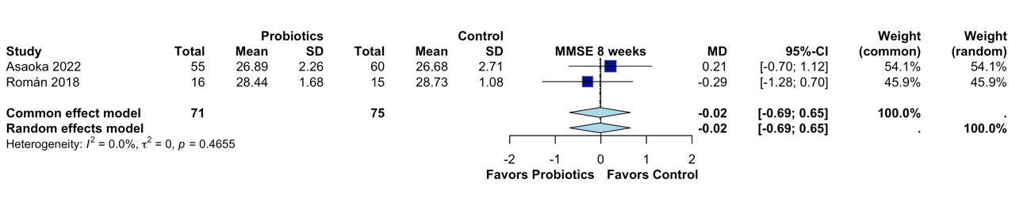

- Sensitivity for MMSE 12 weeks
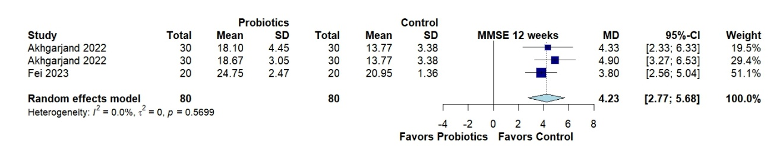

- Sensitivity for MoCA

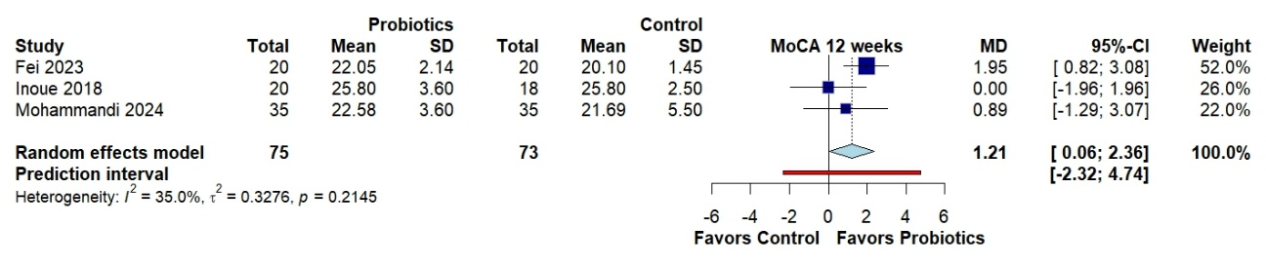
- Sensitivity for CFT

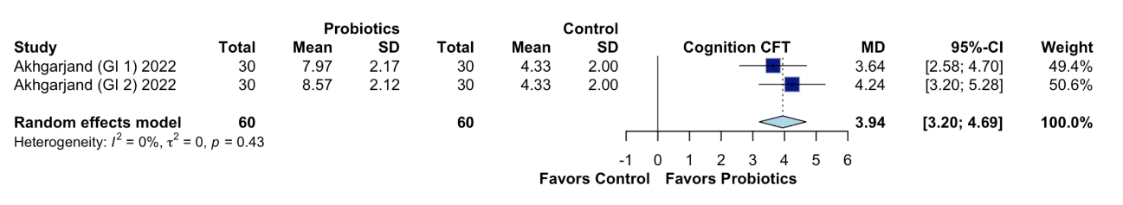

- Any adverse events

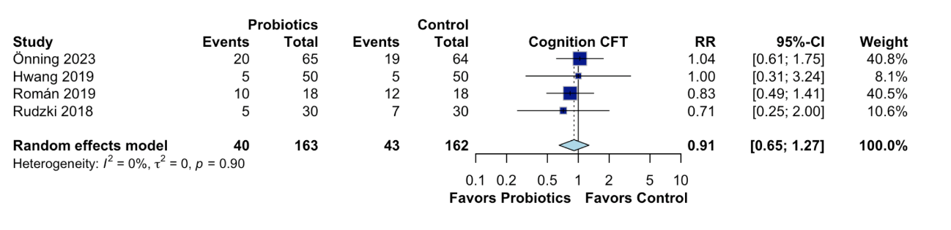

- Sensitivity for subgroup type strain

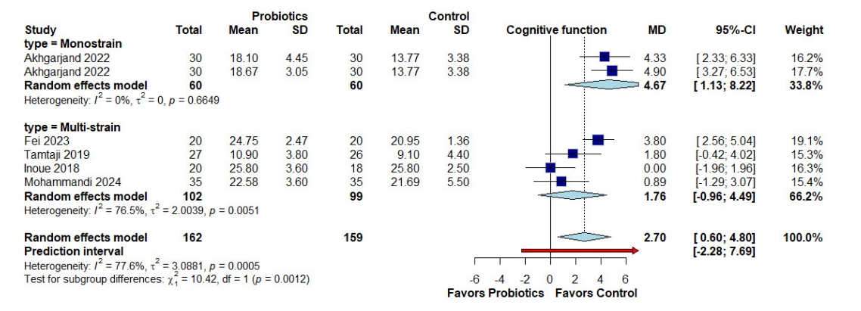

- Sensitivity for subgroup type strain
