Supplementary Online Content

eFigure1 SPIRIT figure
eTable 1 Location of non-acupoints in sham acupuncture group
eTable 2 Information on Patients Lost to Follow-up
eTable 3 Patients’ expectations for acupuncture treatment at baseline
eTable 4 per-protocol analysis of the mean change in HAMD-17 score from baseline
eTable 5 Acupuncture receptivity of the verum acupuncture group
eTable 6 Adverse events
eTable 7 Blinding assessment

This supplementary material has been provided by the authors to give readers additional information about their work.

eFigure1 SPIRIT figure
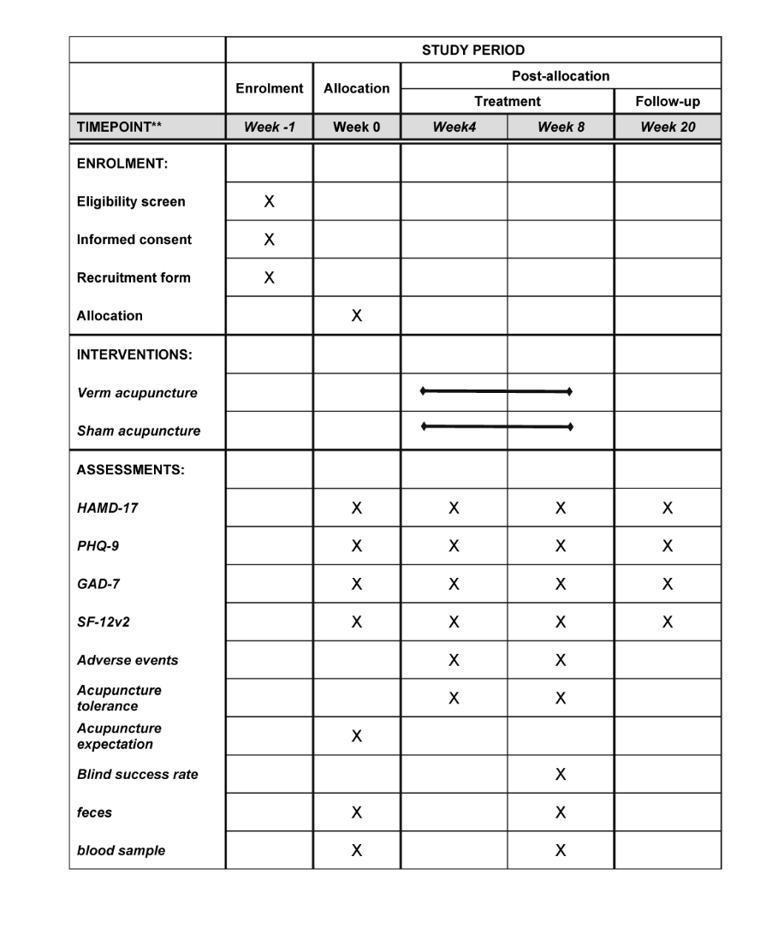

eTable 1 Location of non-acupoints in sham acupuncture group
Non-acupoints | Location
NA1 | In the outside of the forearm, 1cm outside the midpoint of the line between Yanglao(SI6) and Waiguan(TE5)
NA2 | In the outside of the forearm, 1cm outside the midpoint of the line between Shousanli(LI10) and Quchi(LI11) .
NA3 | In the abdomen, 1cm outside the midpoint of the line between Daheng (SP15) and Fushe(SP13)
NA4 | In the outside of the calf, 1cm below the midpoint of the line between Zusanli (ST36) and Yanglingquan(GB34)
NA5 | In the back of the foot, the midpoint of the line between Qiuxu(GB40) and Jiexi(ST41)

eTable 2 Information on Patients Lost to Follow-up
 | Trail phase |  | Total | P value ª
Group | 8-week Treatment | 12-week Follow-up | Total | P value ª
VA | 1 (3.13%) | 1 (3.13%) | 2 (6.25%) | 1.00
SA | 2 (6.25%) | 1 (3.13%) | 3 (9.38%) | 1.00
Abbreviations: VA= verum acupuncture SA=sham acupuncture
ª Fisher's exact test

eTable 3 Patients’ expectations for acupuncture treatment at baseline
Do you believe that acupuncture can improve your symptoms? | VA | SA | P value ª
Yes | 22(68.75%) | 24(75%) | 0.78
No | 0(0%) | 0(0%) | 0.78
Unclear | 10(31.25%) | 8(25%) | 0.78
Abbreviations: VA= verum acupuncture SA=sham acupuncture
ª Fisher's exact test

eTable 4 Per-protocol analysis of the mean change in HAMD-17 score from baseline
Outcome | Mean change in HAMD-17 score from baseline (95% CI) ª |  | Difference  Lsmean (95%CI) | P value ^{b}
Outcome | VA | SA | Difference  Lsmean (95%CI) | P value ^{b}
Week 4 | -5.31 ( -6.21 to -4.42 ) | -2.56 ( -3.38 to -1.75 ) | -3.11 ( -4.27 to -1.95 ) | <0.001
Week 8 | -7.23 ( -8.23 to -6.22 ) | -3.59 ( -4.78 to -2.82 ) | -3.8 ( -4.99 to -2.61 ) | <0.001
Week 20 | -7.12 ( -7.73 to -6.01 ) | -2.31 ( -3.66 to -1.23 ) | -4.88 ( -6.08 to -3.67 ) | <0.001
Abbreviations: VA = Verum Acupuncture; SA = Sham Acupuncture; HAMD-17 = Hamilton Depression Rating Scale-17; LSmean = Least Squares Mean
ª Scores range, 0-52; higher scores indicate worse depression.
^{b} Calculated using Bonferroni correction.

eTable 5 Acupuncture receptivity of the verum acupuncture group
Can you accept acupuncture? | after the first treatment (N=32) | after the last treatment (N=31) | P value ª
No | 0 (0%) | 0 (0%) | 0.672
Accept | 2 (6.25%) | 3 (9.68%) | 0.672
Easy accept | 30 (93.75%) | 28 (90.32%) | 0.672
ª Fisher's exact test

eTable 6 Adverse events
adverse events | VA | SA | P value ª
Subcutaneous bruising | 3(9.37%) | 1(3.13%) | 1.00
post-acupuncture residual pain | 2(6.25%) | 1(3.13%) | 1.00
Abbreviations: VA = Verum Acupuncture; SA = Sham Acupuncture
ª Fisher's exact test

eTable 7 Blinding assessment
Group | Guess |  | P valueª
Group | VA | SA | P valueª
VA | 16(50.00%) | 16(50.00%) | 0.802
SA | 15(46.88%) | 17(53.12%) | 0.802
Abbreviations: VA = Verum Acupuncture; SA = Sham Acupuncture
ª Chi-square test

