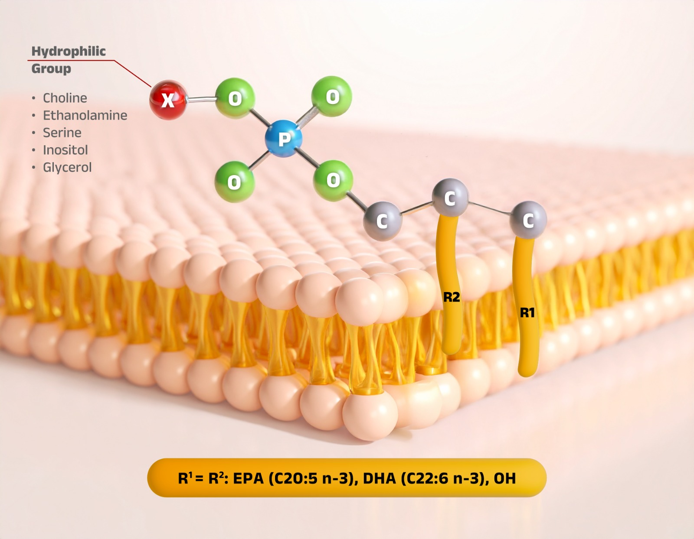

Appendix product information
Ruby-O® Balance (phospholipid-bound Omega-3 formulation) has been developed as an advanced omega-3 formulation that combines EPA and DHA (non-polar lipids) with a matrix of phospholipids (polar lipids) covalently bound to omega-3 fatty acids (EPA+DHA). This matrix is primarily composed of phosphatidylcholine (PC), lysophosphatidylcholine (LPC), phosphatidylinositol (PI), phosphatidylethanolamine (PE), and other structural phospholipids that are naturally present in cell membranes.
This molecular architecture is designed to enhance the efficiency of omega-3 absorption and metabolic utilization by promoting their direct incorporation into cellular membranes, reducing susceptibility to oxidation, and facilitating a more efficient and sustained tissue distribution.

