Supplementary Tables

Table S1. Literature search strategy
1.Pubmed
Search number | Query | Records
#1 | "Acupuncture Therapy"[Mesh] | 29452
#2 | (((((((((((((((((((((Acupuncture Therapy[Title/Abstract]) OR (Acupuncture[Title/Abstract])) OR (Acupuncture Treatment[Title/Abstract])) OR (Acupuncture Treatments[Title/Abstract])) OR (Pharmacopuncture[Title/Abstract])) OR (Acupotomy[Title/Abstract])) OR (Acupotomies[Title/Abstract])) OR (Shonishin[Title/Abstract])) OR (Electroacupuncture[Title/Abstract])) OR (Electric acupuncture[Title/Abstract])) OR (Electrical acupoint stimulation[Title/Abstract])) OR (Electrical acupuncture[Title/Abstract])) OR (Electro-acupuncture[Title/Abstract])) OR (Electrode acupuncture[Title/Abstract])) OR (Electronic acupuncture[Title/Abstract])) OR (Ear acupunctures[Title/Abstract])) OR (Auricular acupuncture[Title/Abstract])) OR (Ear acupuncture[Title/Abstract])) OR (Auricular acupunctures[Title/Abstract])) OR (Acupressure[Title/Abstract])) OR (Acupuncture points[Title/Abstract])) OR (Moxibustion[Title/Abstract]) | 34180
#3 | ("Acupuncture Therapy"[Mesh]) OR ((((((((((((((((((((((Acupuncture Therapy[Title/Abstract]) OR (Acupuncture[Title/Abstract])) OR (Acupuncture Treatment[Title/Abstract])) OR (Acupuncture Treatments[Title/Abstract])) OR (Pharmacopuncture[Title/Abstract])) OR (Acupotomy[Title/Abstract])) OR (Acupotomies[Title/Abstract])) OR (Shonishin[Title/Abstract])) OR (Electroacupuncture[Title/Abstract])) OR (Electric acupuncture[Title/Abstract])) OR (Electrical acupoint stimulation[Title/Abstract])) OR (Electrical acupuncture[Title/Abstract])) OR (Electro-acupuncture[Title/Abstract])) OR (Electrode acupuncture[Title/Abstract])) OR (Electronic acupuncture[Title/Abstract])) OR (Ear acupunctures[Title/Abstract])) OR (Auricular acupuncture[Title/Abstract])) OR (Ear acupuncture[Title/Abstract])) OR (Auricular acupunctures[Title/Abstract])) OR (Acupressure[Title/Abstract])) OR (Acupuncture points[Title/Abstract])) OR (Moxibustion[Title/Abstract])) | 39561
#4 | "Polycystic Ovary Syndrome"[Mesh] | 18193
#5 | (((((((((((polycystic ovarian syndrome[Title/Abstract]) OR (Stein-Leventhal Syndrome[Title/Abstract])) OR (Stein Leventhal Syndrome[Title/Abstract])) OR (Sclerocystic Ovarian Degeneration[Title/Abstract])) OR (Sclerocystic Ovary Syndrome[Title/Abstract])) OR (Polycystic Ovary Syndrome[Title/Abstract])) OR (Sclerocystic Ovaries[Title/Abstract])) OR (Sclerocystic Ovary[Title/Abstract])) OR (Insulin resistance syndrome[Title/Abstract])) OR (Metabolic Syndrome[Title/Abstract])) OR (PCOS[Title/Abstract])) OR (PCOD[Title/Abstract]) | 87719
#6 | ("Polycystic Ovary Syndrome"[Mesh]) OR ((((((((((((polycystic ovarian syndrome[Title/Abstract]) OR (Stein-Leventhal Syndrome[Title/Abstract])) OR (Stein Leventhal Syndrome[Title/Abstract])) OR (Sclerocystic Ovarian Degeneration[Title/Abstract])) OR (Sclerocystic Ovary Syndrome[Title/Abstract])) OR (Polycystic Ovary Syndrome[Title/Abstract])) OR (Sclerocystic Ovaries[Title/Abstract])) OR (Sclerocystic Ovary[Title/Abstract])) OR (Insulin resistance syndrome[Title/Abstract])) OR (Metabolic Syndrome[Title/Abstract])) OR (PCOS[Title/Abstract])) OR (PCOD[Title/Abstract])) | 90210
#7 | (("Acupuncture Therapy"[Mesh]) OR ((((((((((((((((((((((Acupuncture Therapy[Title/Abstract]) OR (Acupuncture[Title/Abstract])) OR (Acupuncture Treatment[Title/Abstract])) OR (Acupuncture Treatments[Title/Abstract])) OR (Pharmacopuncture[Title/Abstract])) OR (Acupotomy[Title/Abstract])) OR (Acupotomies[Title/Abstract])) OR (Shonishin[Title/Abstract])) OR (Electroacupuncture[Title/Abstract])) OR (Electric acupuncture[Title/Abstract])) OR (Electrical acupoint stimulation[Title/Abstract])) OR (Electrical acupuncture[Title/Abstract])) OR (Electro-acupuncture[Title/Abstract])) OR (Electrode acupuncture[Title/Abstract])) OR (Electronic acupuncture[Title/Abstract])) OR (Ear acupunctures[Title/Abstract])) OR (Auricular acupuncture[Title/Abstract])) OR (Ear acupuncture[Title/Abstract])) OR (Auricular acupunctures[Title/Abstract])) OR (Acupressure[Title/Abstract])) OR (Acupuncture points[Title/Abstract])) OR (Moxibustion[Title/Abstract]))) AND (("Polycystic Ovary Syndrome"[Mesh]) OR ((((((((((((polycystic ovarian syndrome[Title/Abstract]) OR (Stein-Leventhal Syndrome[Title/Abstract])) OR (Stein Leventhal Syndrome[Title/Abstract])) OR (Sclerocystic Ovarian Degeneration[Title/Abstract])) OR (Sclerocystic Ovary Syndrome[Title/Abstract])) OR (Polycystic Ovary Syndrome[Title/Abstract])) OR (Sclerocystic Ovaries[Title/Abstract])) OR (Sclerocystic Ovary[Title/Abstract])) OR (Insulin resistance syndrome[Title/Abstract])) OR (Metabolic Syndrome[Title/Abstract])) OR (PCOS[Title/Abstract])) OR (PCOD[Title/Abstract]))) | 299

2.Cochrane
Search number | Query
#1 | MeSH descriptor: [Acupuncture Therapy] explode all trees
#2 | (Acupuncture Therapy):ti,ab,kw OR (Acupuncture):ti,ab,kw OR (Acupuncture Treatment):ti,ab,kw OR (Acupuncture Treatments):ti,ab,kw OR (Pharmacopuncture):ti,ab,kw
#3 | (Acupotomy):ti,ab,kw OR (Acupotomies):ti,ab,kw OR (Shonishin):ti,ab,kw OR (Electroacupuncture):ti,ab,kw OR (Electric acupuncture):ti,ab,kw
#4 | (Electrical acupoint stimulation):ti,ab,kw OR (Electrical acupuncture):ti,ab,kw OR (Electro-acupuncture):ti,ab,kw OR (Electrode acupuncture):ti,ab,kw OR (Electronic acupuncture):ti,ab,kw
#5 | (Ear acupunctures):ti,ab,kw OR (Auricular acupuncture):ti,ab,kw OR (Ear acupuncture):ti,ab,kw OR (Auricular acupunctures):ti,ab,kw OR (Acupressure):ti,ab,kw
#6 | (Acupuncture points):ti,ab,kw OR (Moxibustion):ti,ab,kw
#7 | #1 or #2 or #3 or #4 or #5 or #6
#8 | MeSH descriptor: [Polycystic Ovary Syndrome] explode all trees
#9 | (polycystic ovarian syndrome):ti,ab,kw OR (Stein-Leventhal Syndrome):ti,ab,kw OR (Stein Leventhal Syndrome):ti,ab,kw OR (Sclerocystic Ovarian Degeneration):ti,ab,kw OR (Sclerocystic Ovary Syndrome):ti,ab,kw
#10 | (Polycystic Ovary Syndrome):ti,ab,kw OR (Sclerocystic Ovaries):ti,ab,kw OR (Sclerocystic Ovary):ti,ab,kw OR (Insulin resistance syndrome):ti,ab,kw OR (Metabolic Syndrome):ti,ab,kw
#11 | (PCOS):ti,ab,kw OR (PCOD):ti,ab,kw
#12 | #8 or #9 or #10 or #11
#13 | #7 and #12

3.Embase
Search number | Query | Records
#1 | 'acupuncture'/exp | 57970
#2 | 'acupuncture therapy':ab,ti OR acupuncture:ab,ti OR 'acupuncture treatment':ab,ti OR 'acupuncture treatments':ab,ti OR pharmacopuncture:ab,ti OR acupotomy:ab,ti OR acupotomies:ab,ti OR shonishin:ab,ti OR electroacupuncture:ab,ti OR 'electric acupuncture':ab,ti OR 'electrical acupoint stimulation':ab,ti OR 'electrical acupuncture':ab,ti OR 'electro acupuncture':ab,ti OR 'electrode acupuncture':ab,ti OR 'electronic acupuncture':ab,ti OR 'ear acupunctures':ab,ti OR 'auricular acupuncture':ab,ti OR 'ear acupuncture':ab,ti OR 'auricular acupunctures':ab,ti OR acupressure:ab,ti OR 'acupuncture points':ab,ti OR moxibustion:ab,ti | 46466
#3 | #1 OR #2 | 62661
#4 | 'polycystic ovarian syndrome':ab,ti OR 'stein-leventhal syndrome':ab,ti OR 'stein leventhal syndrome':ab,ti OR 'sclerocystic ovarian degeneration':ab,ti OR 'sclerocystic ovary syndrome':ab,ti OR 'polycystic ovary syndrome':ab,ti OR 'sclerocystic ovaries':ab,ti OR 'sclerocystic ovary':ab,ti OR 'insulin resistance syndrome':ab,ti OR 'metabolic syndrome':ab,ti OR pcos:ab,ti OR pcod:ab,ti | 128625
#5 | #3 AND #4 | 398

4.Web of science
Search number | Query | Records
#1 | Acupuncture Therapy (Topic) OR Acupuncture (Topic) OR Acupuncture Treatment (Topic) OR Acupuncture Treatments (Topic) OR Pharmacopuncture (Topic) OR Acupotomy (Topic) OR Acupotomies (Topic) OR Shonishin (Topic) OR Electroacupuncture (Topic) OR Electric acupuncture (Topic) OR Electrical acupoint stimulation (Topic) OR Electrical acupuncture (Topic) OR Electro-acupuncture (Topic) OR Electrode acupuncture (Topic) OR Electronic acupuncture (Topic) OR Ear acupunctures (Topic) OR Auricular acupuncture (Topic) OR Ear acupuncture (Topic) OR Auricular acupunctures (Topic) OR Acupressure (Topic) OR Acupuncture points (Topic) OR Moxibustion (Topic) | 30661
#2 | polycystic ovarian syndrome (Topic) OR Stein-Leventhal Syndrome (Topic) OR Stein Leventhal Syndrome (Topic) OR Sclerocystic Ovarian Degeneration (Topic) OR Sclerocystic Ovary Syndrome (Topic) OR Polycystic Ovary Syndrome (Topic) OR Sclerocystic Ovaries (Topic) OR Sclerocystic Ovary (Topic) OR Insulin resistance syndrome (Topic) OR Metabolic Syndrome (Topic) OR PCOS (Topic) OR PCOD (Topic) | 171443
#3 | #1 AND #2 | 301

Table S2 The results of node-splitting
Outcomes | Comparison | Direct Mean Difference  (95% Cl) | Indirect Mean Difference  (95% Cl) | Network Mean Difference  (95% Cl) | P.value CI
Testosterone | Cmedicine vs ACE | -0.04(-1.19,1.10) | 0.80(-1.16,2.75) | 0.17(-0.81,1.15) | 0.46
 | medicine vs ACE | 1.40(-0.34,3.15) | 0.56(-0.88,2.01) | 0.89(-0.21,2.00) | 0.45
 | Cmedicine vs acupuncture | 0.07(-0.73,0.88) | -0.77(-2.88,1.36) | -0.03(-0.77,0.71) | 0.45
 | medicine vs acupuncture | 0.65 (0.28,1.03) | 1.50(-0.02,3.01) | 0.69(0.34,1.06) | 0.27
 | placebo vs acupuncture | 0.58(-0.55,1.72) | 0.67(-0.68,2.02) | 0.73(-0.08,1.57) | 0.92
 | medicine vs Eacupuncture | 0.12(-0.88,1.14) | -0.07(-1.43,1.28) | 0.04(-0.73,0.84) | 0.81
 | placebo vs Eacupuncture | 0.04(-0.76,0.86) | 0.24(-1.23,1.72) | 0.09(-0.60,0.79) | 0.81
 | placebo vs medicine | 0.28(-1.25,1.82) | 0.22(-0.77,1.19) | 0.04(-0.77,0.85) | 0.94
FG scores | medicine vs acupuncture | 0.08(-0.69,0.89) | -1.63(-3.65,0.50) | -0.06(-0.92,0.77) | 0.10
 | placebo vs acupuncture | 0.23(-0.61,1.23) | 2.07(0.05,4.13) | 0.51(-0.35,1.50) | 0.09
 | placebo vs medicine | 0.82(-0.72,2.57) | 0.31(-1.80,2.42) | 0.57(-0.38,1.67) | 0.64
BMI | Cmedicine vs ACE | 0.65(-0.68,1.98) | 1.03(-1.58,3.70) | 0.73(-0.424,1.89) | 0.79
 | Eacupuncture vs ACE | 0.69(-1.09,2.51) | 0.44(-2.38,3.21) | 0.64(-0.811,2.09) | 0.87
 | medicine vs ACE | 2.44(-0.23,5.10) | 1.36(-0.521,3.26) | 1.74(0.249,3.25) | 0.50
 | Cmedicine vs acupuncture | 0.05(-1.70,1.82) | -0.33(-2.71,2.03) | -0.08(-1.48,1.30) | 0.79
 | medicine vs acupuncture | 0.93(0.19,1.70) | 1.13(-1.61,3.86) | 0.92(0.232,1.62) | 0.88
 | placebo vs acupuncture | 0.07(-1.19,1.34) | 0.45(-1.70,2.67) | 0.38(-0.703,1.50) | 0.75
 | medicine vs Eacupuncture | 0.97(-1.64,3.62) | 1.11(-0.436,2.71) | 1.09(-0.192,2.41) | 0.92
 | placebo vs Eacupuncture | 0.55(-0.39,1.54) | 0.60(-1.83,3.01) | 0.56(-0.29,1.44) | 0.96
 | placebo vs medicine | 0.76(-1.42,2.96) | -0.92(-2.31,0.45) | -0.53(-1.72,0.65) | 0.18
WHR | Cmedicine vs ACE | 0.02(-0.04,0.10) | 0.06(-0.03,0.17) | 0.04(-0.014,0.10) | 0.5
 | Eacupuncture vs ACE | 0.03(-0.05,0.11) | 0.01(-0.13,0.16) | 0.02(-0.03,0.09) | 0.83
 | medicine vs ACE | 0.11(0.02,0.19) | 0.05(-0.07,0.17) | 0.09(0.02,0.14) | 0.41
 | Cmedicine vs acupuncture | 0.01(-0.06, 0.08) | 0.01(-0.06, 0.08) | -0.00(-0.05,0.05) | 0.51
 | medicine vs acupuncture | 0.03(-0.01,0.07) | 0.08(-0.01,0.17) | 0.04(0.01,0.07) | 0.33
 | placebo vs acupuncture | 0.01(-0.06,0.08) | -0.01(-0.10,0.07) | 0.00(-0.05,0.05) | 0.63
 | medicine vs Eacupuncture | 0.07 (-0.01,0.16) | 0.04(-0.06,0.13) | 0.06(0.00,0.11) | 0.48
 | placebo vs Eacupuncture | 0.01(-0.02,0.04) | 0.03(-0.06,0.15) | 0.01(-0.01,0.04) | 0.63
Triglycerides | medicine vs acupuncture | 0.16(-0.15,0.46) | -0.08(-1.02,0.814) | 0.13(-0.14,0.40) | 0.56
 | placebo vs acupuncture | 0.10(-0.48,0.69) | 0.35(-0.402,1.14) | 0.19(-0.23,0.64) | 0.56
 | medicine vs Eacupuncture | -0.20 (-0.83,0.43) | 0.04(-0.671,0.796) | -0.08(-0.54,0.36) | 0.56
 | placebo vs Eacupuncture | -0.00 (-0.29,0.31) | -0.25(-1.17,0.683) | -0.03(-0.29,0.25) | 0.57
HDL | medicine vs acupuncture | 0.16(-0.15,0.46) | -0.08(-1.02,0.826) | 0.13(-0.14,0.40) | 0.56
 | placebo vs acupuncture | 0.11(-0.48,0.69) | 0.35(-0.408,1.13) | 0.19(-0.23,0.64) | 0.57
 | medicine vs Eacupuncture | -0.20 (-0.84,0.43) | 0.04(-0.673,0.783) | -0.08(-0.54,0.36) | 0.56
 | placebo vs Eacupuncture | -0.00 (-0.29,0.31) | -0.25(-1.16,0.683) | -0.03(-0.29,0.25) | 0.56
LDL | medicine vs acupuncture | -0.00(-0.82.0.76) | 0.06(-1.62,1.61) | 0.01(-0.59,0.57) | 0.91
 | placebo vs acupuncture | -0.03(-1.0,1.00) | -0.10(-1.54,1.39) | -0.05(-0.72,0.62) | 0.91
 | medicine vs Eacupuncture | 0.18(-0.92,1.31) | 0.11(-1.25,1.56) | 0.15(-0.54,0.87) | 0.91
 | placebo vs Eacupuncture | 0.08(-0.38,0.67) | 0.15(-1.53,1.89) | 0.07(-0.28,0.54) | 0.91
FBG | Cmedicine vs ACE | 0.01(-0.53,0.56) | -0.18(-1.33,0.964) | -0.02(-0.50,0.44) | 0.74
 | Eacupuncture vs ACE | 0.04(-0.56,0.66) | -0.00(-1.31,1.23) | -0.00(-0.50,0.48) | 0.93
 | medicine vs ACE | -0.10(-0.97,0.77) | 0.42(-0.36,1.30) | 0.16(-0.35,0.74) | 0.34
 | Cmedicine vs acupuncture | -0.15(-1.08,0.79) | 0.04(-0.83,0.930) | -0.04 (-0.65,0.55) | 0.75
 | medicine vs acupuncture | 0.22(-0.11,0.62) | -0.33(-1.32,0.611) | 0.14(-0.15,0.48) | 0.23
 | placebo vs acupuncture | 0.07(-0.41,0.57) | 0.53(-0.36,1.51) | 0.17(-0.18,0.56) | 0.34
 | medicine vs Eacupuncture | -0.09(-0.98,0.78) | 0.36(-0.23,1.07) | 0.16(-0.27,0.67) | 0.35
 | placebo vs Eacupuncture | 0.27(-0.11,0.73) | -0.09(-0.95,0.74) | 0.19(-0.13,0.58) | 0.38
 | placebo vs medicine | 0.09(-0.79,0.99) | -0.01(-0.63,0.58) | 0.02(-0.40,0.43) | 0.81
HOMA-IR | Cmedicine vs ACE | 0.27(-1.43,1.98) | -1.29(-3.06,0.51) | -0.50(-1.72,0.80) | 0.19
 | Eacupuncture vs ACE | -0.76(-1.79,0.21) | 0.35(-2.14,2.73) | -0.74(-1.70,0.16) | 0.38
 | medicine vs ACE | -2.20(-3.11，-1.29) | 0.29(-0.57,1.25) | -0.90(-1.91,0.12) | 0.0009
 | Cmedicine vs acupuncture | 0.13(-1.23,1.51) | 1.72(-0.33,3.76) | 0.59(-0.54,1.79) | 0.19
 | medicine vs acupuncture | 0.20(-0.34,0.748) | -0.03(-1.84,1.75) | 0.19(-0.30,0.67) | 0.78
 | placebo vs acupuncture | 0.62(-0.45,1.71) | 0.32(-1.23,1.86) | 0.48(-0.32,1.26) | 0.73
 | medicine vs Eacupuncture | 0.03(-0.70,0.81) | -0.24(-0.96,0.53) | -0.16(-0.95,0.69) | 0.59
 | placebo vs Eacupuncture | 0.09(-0.77,1.03) | 0.23(-1.19,1.76) | 0.12(-0.59,0.90) | 0.86
 | placebo vs medicine | -0.15(-1.66,1.35) | 0.55(-0.55,1.63) | 0.29 (-0.50,1.08) | 0.41
LH | Cmedicine vs ACE | 0.48(-3.33,4.29) | 0.02(-2.94,3.10) | 0.19(-2.09,2.54) | 0.84
 | Eacupuncture vs ACE | 0.02(-2.55,2.60) | 2.73(-1.36,6.85) | 0.73(-1.37,2.89) | 0.26
 | medicine vs ACE | 2.47(-0.37,5.45) | 1.53(-1.65,4.75) | 2.00(-0.03,4.12) | 0.65
 | Cmedicine vs acupuncture | -0.76(-2.52,0.98) | -0.10(-4.72,4.47) | -0.57(-2.14,0.99) | 0.78
 | medicine vs acupuncture | 1.27(0.36,2.22) | 1.16(-2.40,4.69) | 1.23(0.37,2.11) | 0.95
 | placebo vs acupuncture | -0.38(-3.46,2.60) | -0.82(-3.95,2.35) | -0.60(-2.76,1.52) | 0.83
 | medicine vs Cmedicine | -0.34(-5.38,4.72) | 2.08(0.233,4.02) | 1.80(0.09,3.53) | 0.37
 | medicine vs Eacupuncture | 0.74(-2.06,3.51) | 1.85(-1.14,4.93) | 1.25(-0.68,3.25) | 0.58
 | placebo vs Eacupuncture | -0.66(-2.56,1.26) | -0.21(-4.22,3.64) | -0.57(-2.27,1.10) | 0.83
LH/FSH | Cmedicine vs ACE | 0.20(-0.50,0.89) | 0.11(-0.48,0.73) | 0.14(-0.29,0.60) | 0.84
 | Eacupuncture vs ACE | -0.01(-0.48,0.45) | 0.46(-0.27,1.22) | 0.11(-0.26,0.50) | 0.26
 | medicine vs ACE | 0.43(-0.09,0.99) | 0.22(-0.35,0.81) | 0.32(-0.04,0.71) | 0.58
 | Cmedicine vs acupuncture | -0.06 (-0.46,0.33) | 0.01 (-0.82,0.85) | -0.05(-0.40,0.29) | 0.85
 | medicine vs acupuncture | 0.12 (-0.04,0.29) | 0.16 (-0.48,0.82) | 0.12(-0.02,0.28) | 0.90
 | placebo vs acupuncture | -0.08(-0.48,0.310) | -0.22(-0.81,0.36) | -0.07(-0.40,0.23) | 0.68
 | medicine vs Eacupuncture | 0.22(-0.27,0.71) | 0.20(-0.28,0.70) | 0.21(-0.12,0.54) | 0.96
 | placebo vs Eacupuncture | -0.06(-0.46,0.32) | 0.16(-0.41,0.72) | 0.00(-0.31,0.32) | 0.50
 | placebo vs medicine | 0.12(-0.51,0.75) | -0.32(-0.73,0.07) | -0.20(-0.53,0.11) | 0.22
Pregnancy rate | medicine vs Cmedicine | 0.70(0.10,4.29) | 0.68 (0.28,1.55) | 0.67(0.32,1.34) | 0.96
Eacupuncture, electroacupuncture; ACE, acupoint catgut embedding; Cmedicine, Chinese herbs;
FG score,Ferriman-Gallwey score; HDL,high-density lipoprotein; LDL, Low-density lipoprotein; FBG, fasting blood-glucose; HOMA-IR, homeostasis model assessment of insulin resistance; BMI, Body Mass Index; WHR,waist hip rate;LH,luteinizing hormone; LH/FSH ratio(luteinizing hormone(LH),follicle-stimulating hormone(FSH).

Table S3 The results of heterogeneity analysis
Outcomes | Comparison | Studies | I²(network,%) | Mean Difference(95% CI)
Testosterone | Cmedicine vs ACE | BY Chen 2016, GY Liu 2010 | 28.50 | 0.17(-0.80, 1.15)
Testosterone | Cmedicine vs acupuncture | FL Ren 2022, HW Yang 2022, J Su 2015, SS Wang 2023 | 72.50 | -0.02(-0.77, 0.70)
Testosterone | medicine vs acupuncture | D Chen 2007, H Ma 2016, J Yue 2020a, J Yue 2020b, L Li 2014, LP Yuan 2010, M Yao 2018, MH Lai 2010, MH Lai 2012, N Li 2016, N Ling 2017, QD Wen 2021, QX Fang 2016, QX Fang 2016, WW Chen 2021, WW Guo 2021, XY Li 2019, XY Wang 2023, Y Cao 2017, Y Cao 2017 | 99.20 | 0.69(0.34, 1.05)
Testosterone | placebo vs acupuncture | QD Wen 2021, XZ Liu 2022 | 99.90 | 0.73(-0.08, 1.56)
Testosterone | medicine vs Eacupuncture | CL Jin 2014, J Yang 2015, LQ Yu 2020 | 00.00 | 0.04(-0.74, 0.84)
Testosterone | placebo vs Eacupuncture | HL Zhang 2020, Jedel 2010, Stener-Victorin 2009, Y Wang 2022 | 54.90 | 0.09(-0.60, 0.79)
FG scores | medicine vs acupuncture | L Li 2014, M Yao 2018, MH Lai 2012, QD Wen 2021 | 99.00 | -0.06(-0.91, 0.76)
FG scores | placebo vs acupuncture | H Chang 2023, H Chang 2023, XZ Liu 2022 | 99.80 | 0.51(-0.35, 1.49)
FG scores | placebo vs Eacupuncture | HL Zhang 2020, HX Dong 2022, Jedel 2010, Johansson 2013, Victorin 2009 | 58.00 | 1.52(0.30, 2.61)
FG scores | placebo vs medicine | Nekooi 2022, QD Wen 2021 | 100.00 | 0.57(-0.37, 1.67)
BMI | Cmedicine vs ACE | BY Chen 2016, GY Liu 2010, LL Tao 2010, R Cheng 2015 | 27.10 | 0.73(-0.43, 1.89)
BMI | Eacupuncture vs ACE | T Zhang 2013, XB Cai 2016 | 58.10 | 0.64(-0.78, 2.09)
BMI | Cmedicine vs acupuncture | J Su 2015, SS Wang 2023 | 00.00 | -0.08(-1.47, 1.29)
BMI | medicine vs acupuncture | J Yue 2020, J Yue 2021, JY Wang 2020, L Li 2014, M Ya 2018, MH Lai 2010, MH Lai 2012, N Li 2016, QD Wen 2021, XL Yu 2023, XY Li 2019, Y Cao 2017 | 99.80 | 0.92(0.23, 1.62)
BMI | placebo vs acupuncture | H Chang 2023, LY Shen 2019, QD Wen 2021 | 99.40 | 0.38(-0.69, 1.49)
BMI | placebo vs Eacupuncture | HL Zhang 2020, HX Dong 2022, Jedel 2010, Johansson 2013, Victorin 2009, Y Gu 2019, Y Peng 2017, Y Wang 2022 | 86.20 | 0.55(-0.30, 1.44)
WHR | Cmedicine vs ACE | JY Wang 2020, L Li 2014, M Yao 2018, MH Lai 2010, MH Lai 2012, XL Yu 2023 | 78.70 | 0.04(0.01, 0.07)
WHR | placebo vs Eacupuncture | HX Dong 2022, Johansson 2013, Victorin 2009, Y Gu 2019, Y Peng 2017, Y Wang 2022 | 62.00 | 0.01(-0.01, 0.04)
Triglycerides | medicine vs acupuncture | JY Wang 2020, L Li 2014, MH Lai 2010, XY Wang 2023 | 88.50 | 0.14(-0.15, 0.40)
Triglycerides | placebo vs Eacupuncture | HX Dong 2021, Johansson 2013, Victorin 2009, Y Gu 2019, Y Wang 2022 | 13.90 | -0.03(-0.29, 0.26)
HDL | medicine vs acupuncture | JY Wang 2020, L Li 2014, MH Lai 2010, XY Wang 2023 | 88.60 | 0.14(-0.15, 0.40)
HDL | placebo vs Eacupuncture | HX Dong 2021, Johansson 2013, Victorin 2009, Y Gu 2019, Y Wang 2022 | 12.90 | -0.03(-0.29, 0.26)
LDL | medicine vs acupuncture | L Li 2014, MH Lai 2010 | 51.00 | 0.02(-0.61, 0.57)
LDL | placebo vs Eacupuncture | HX Dong 2021, Johansson 2013, Victorin 2009, Y Gu 2019, Y Wang 2022 | 51.70 | 0.08(-0.29, 0.55)
FBG | Cmedicine vs ACE | BY Chen 2016, LL Tao 2010, R Cheng 2015 | 00.00 | -0.02(-0.50, 0.45)
FBG | Eacupuncture vs ACE | T Zhang 2013, XB Cai 2016 | 00.00 | -0.01(-0.52, 0.49)
FBG | medicine vs acupuncture | JY Wang 2020, L Li 2014, MH Lai 2010, MH Lai 2012, QD Wen 2021, WW Guo 2021, XL Yu 2023 | 71.90 | 0.14(-0.15, 0.49)
FBG | placebo vs acupuncture | H Chang 2023, LY Shen 2018, QD Wen 2021 | 88.10 | 0.17(-0.19, 0.57)
FBG | placebo vs Eacupuncture | HX Dong 2021, Johansson 2013, Victorin 2009, Y Gu 2019 | 91.40 | 0.20(-0.14, 0.59)
HOMA-IR | Eacupuncture vs ACE | T Zhang 2013, XB Cai 2016 | 96.90 | -0.74(-1.68, 0.18)
HOMA-IR | medicine vs acupuncture | JY Wang 2020, L Li 2014, M Yao 2018, MH Lai 2010, MH Lai 2012, QD Wen 2021, WW Guo 2021, XL Yu 2023 | 86.40 | 0.19(-0.30, 0.67)
HOMA-IR | placebo vs acupuncture | LY Shen 2018, QD Wen 2021 | 99.20 | 0.48(-0.32,1.26)
HOMA-IR | medicine vs Eacupuncture | LQ Yu 2020, XB Cai 2016 | 09.50 | -0.16(-0.96, 0.70)
HOMA-IR | placebo vs Eacupuncture | HX Dong 2021, Johansson 2013, Victorin 2009, Y Gu 2019, Y Wang 2022 | 53.50 | 0.13(-0.59, 0.90)
LH | Eacupuncture vs ACE | T Zhang 2013, XB Cai 2016 | 39.00 | 0.75(-1.36, 2.90)
LH | medicine vs ACE | JM Wu 2014, XB Cai 2016 | 48.20 | 2.00(-0.02, 4.13)
LH | Cmedicine vs acupuncture | FL Ren 2022, HW Yang 2022, Jian Su 2015, JN Gao 2022, N Lei 2021 | 71.50 | -0.58(-2.15, 1.00)
LH/FSH | Eacupuncture vs ACE | T Zhang 2013, XB Cai 2016 | 59.40 | 0.11(-0.27, 0.50)
LH/FSH | medicine vs ACE | JM Wu 2014, XB Cai 2016 | 00.00 | 0.33(-0.05, 0.72)
LH/FSH | Cmedicine vs acupuncture | Jian Su 2015, SS Wang 2023, XP He 2017 | 93.70 | -0.05(-0.40, 0.30)
LH/FSH | medicine vs acupuncture | C Li 2011, D Chen 2007, HJ Wei 2022, J Yue 2020a, J Yue 2020b, J Yue 2021, L Li 2014, LP Yuan 2010, M Yao 2018, MH Lai 2010, MH Lai 2012, N Li 2016, QD Wen 2021, WS Lin 2018, WW Chen 2021, WW Guo 2021, XY Li 2019, XY Wang 2023, Y Cao 2017 | 92.60 | 0.13(-0.03, 0.29)
LH/FSH | placebo vs acupuncture | LY Shen 2018, Pastore 2011, QD Wen 2021 | 78.90 | -0.08(-0.40, 0.23)
LH/FSH | medicine vs Eacupuncture | J Yang 2015, XB Cai 2016 | 00.00 | 0.21(-0.12, 0.55)
LH/FSH | placebo vs Eacupuncture | HX Dong 2022, Jedel 2010, Johansson 2013, Victorin 2009, Y Wang 2022 | 70.80 | 0.01(-0.32, 0.32)
pregnancy rate | Cmedicine vs acupuncture | FL Ren 2022, HW Yang 2022, JN Gao 2022, N Lei 2021 | 00.00 | 0.90(0.48, 1.68)
pregnancy rate | medicine vs acupuncture | C Li 2011, J Yue 2020, J Yue 2021, JN Gao 2022, JY Wang 2020, LP Yuan 2010, SH Ma 2020, WS Lin 2018, YH Yang 2005, YY Zhuo 2016 | 20.00 | 0.60(0.40, 0.87)
Eacupuncture, electroacupuncture; ACE, acupoint catgut embedding; Cmedicine, Chinese herbs;
FG score,Ferriman-Gallwey score; HDL,high-density lipoprotein; LDL, Low-density lipoprotein; FBG, fasting blood-glucose; HOMA-IR, homeostasis model assessment of insulin resistance; BMI, Body Mass Index; WHR,waist hip rate;LH,luteinizing hormone; LH/FSH ratio(luteinizing hormone(LH),follicle-stimulating hormone(FSH).

Supplementary Figure
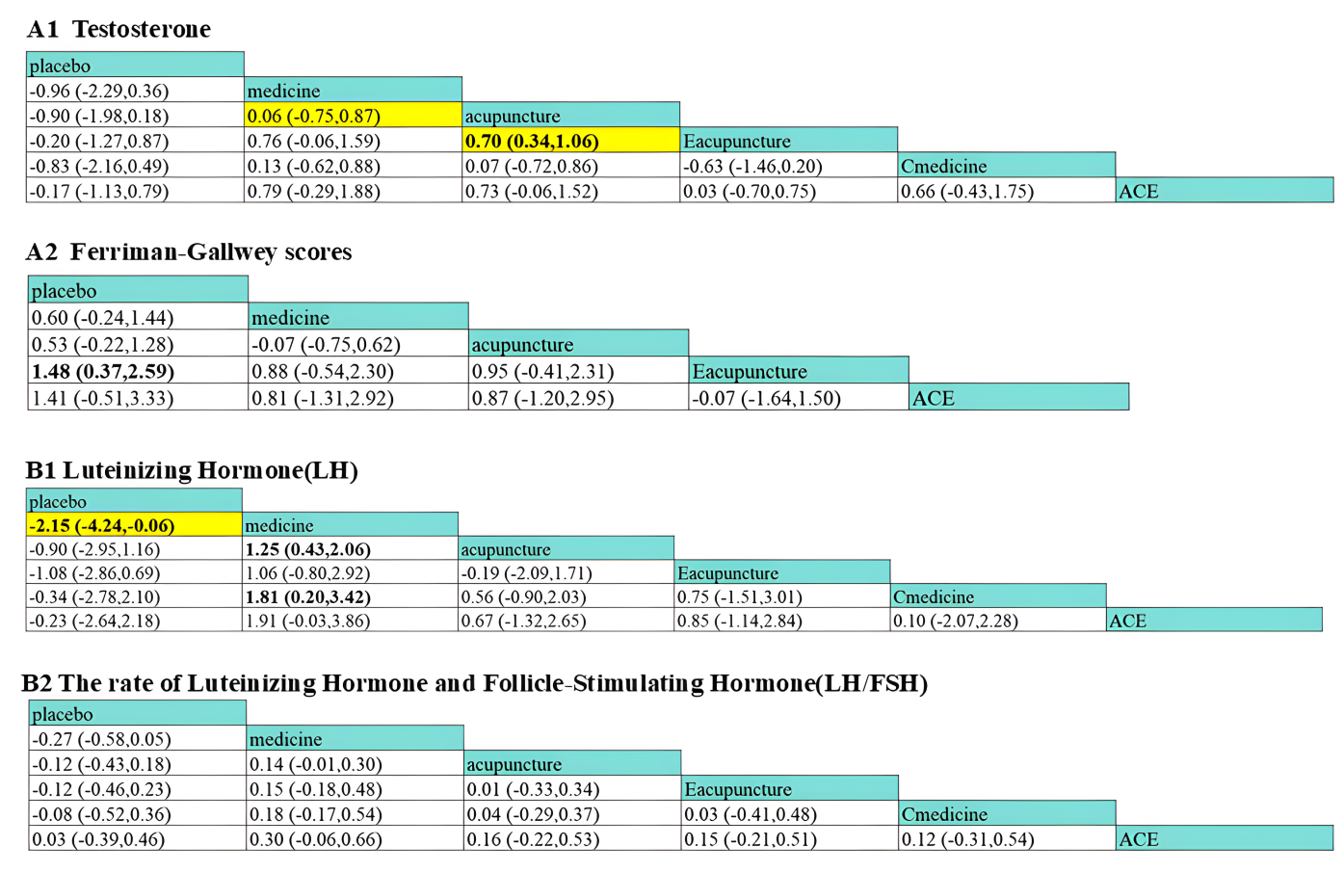
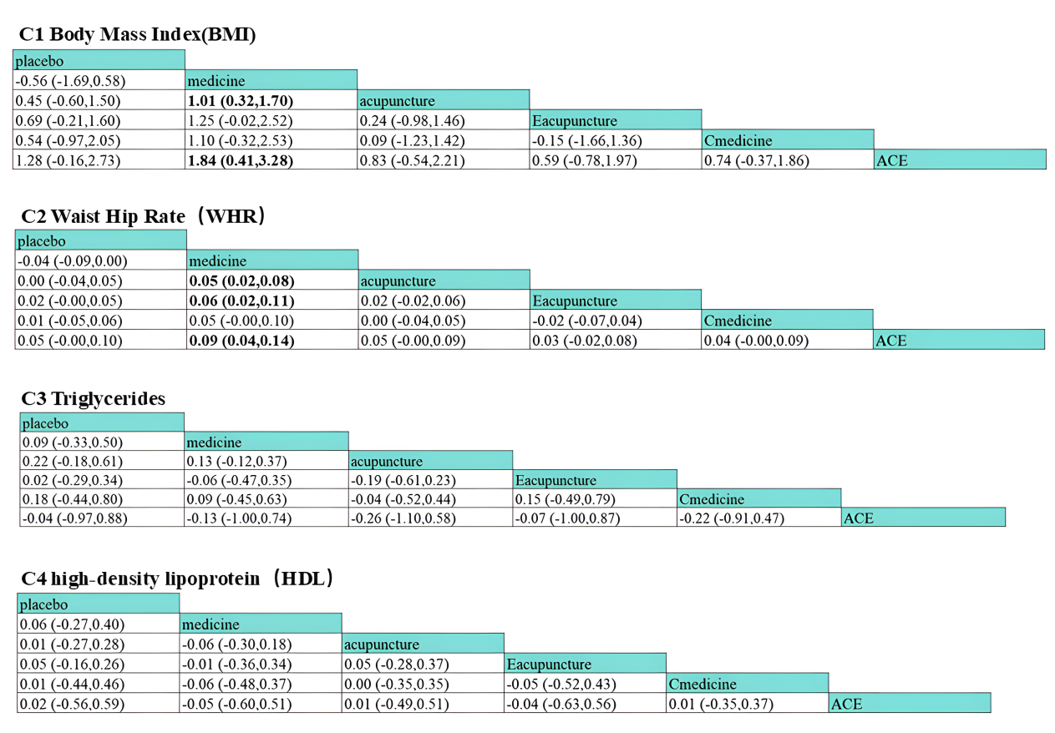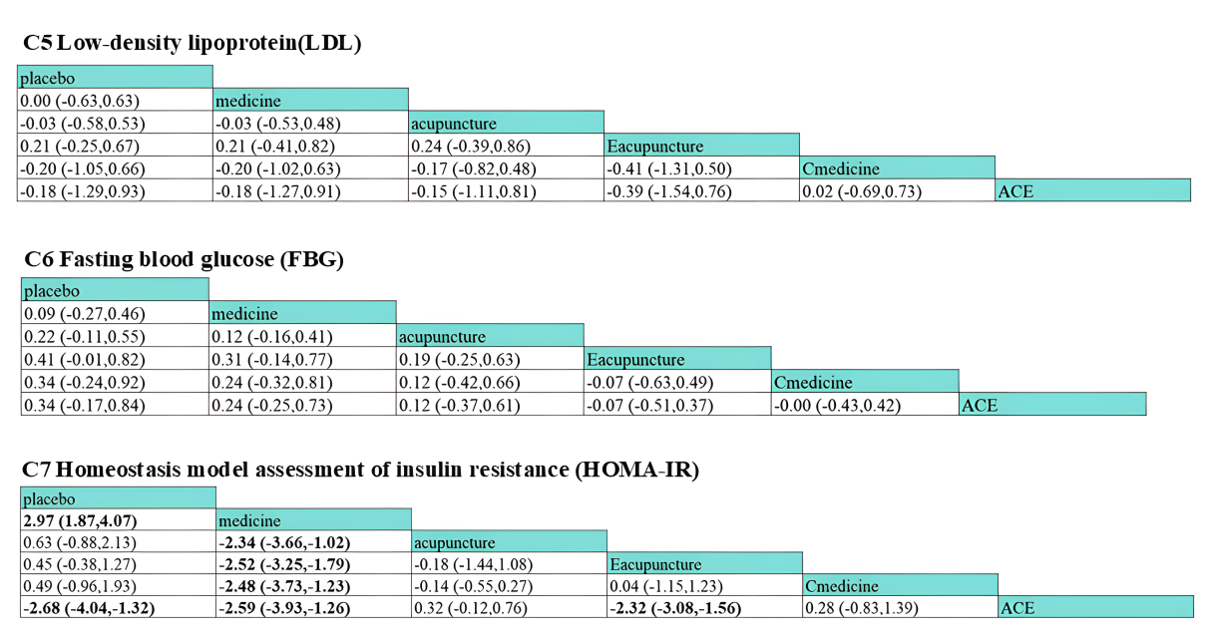
Figure S1. The results of league table (Sensitivity analysis). (A1) Testosterone; (A2) Ferriman-Gallwey score (FG score); (B1) Luteinizing Hormone(LH)level; (B2) the rate of Luteinizing Hormone and Follicle-Stimulating Hormone(LH/FSH); (C1) Body Mass Index (BMI); (C2) Waist Hip Rate(WHR); (C3) Triglyceride; (C4) High-density lipoprotein (HDL) level; (C5) Low-density lipoprotein (LDL) level; (C6) Fasting blood-glucose (FBG) level; (C7) Homeostasis model assessment of insulin resistance level (HOMA-IR level).

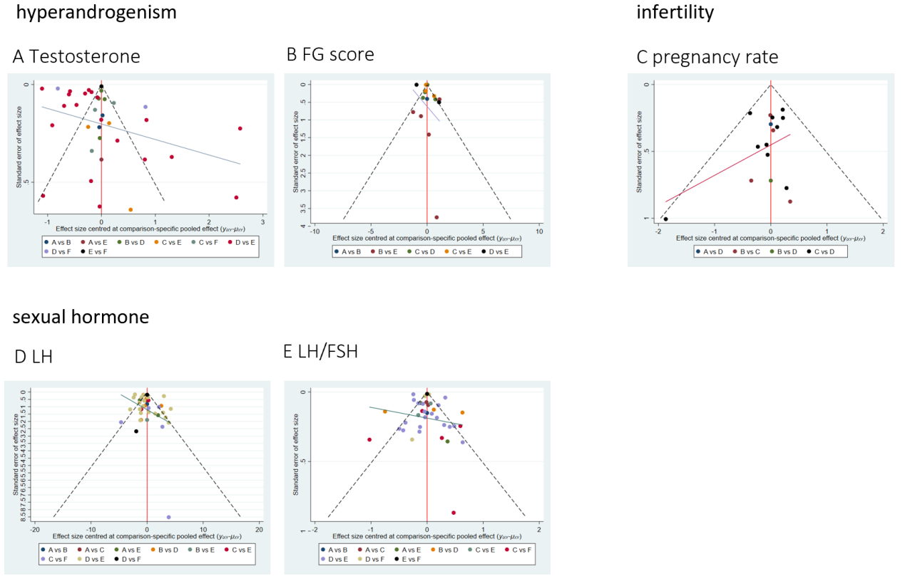
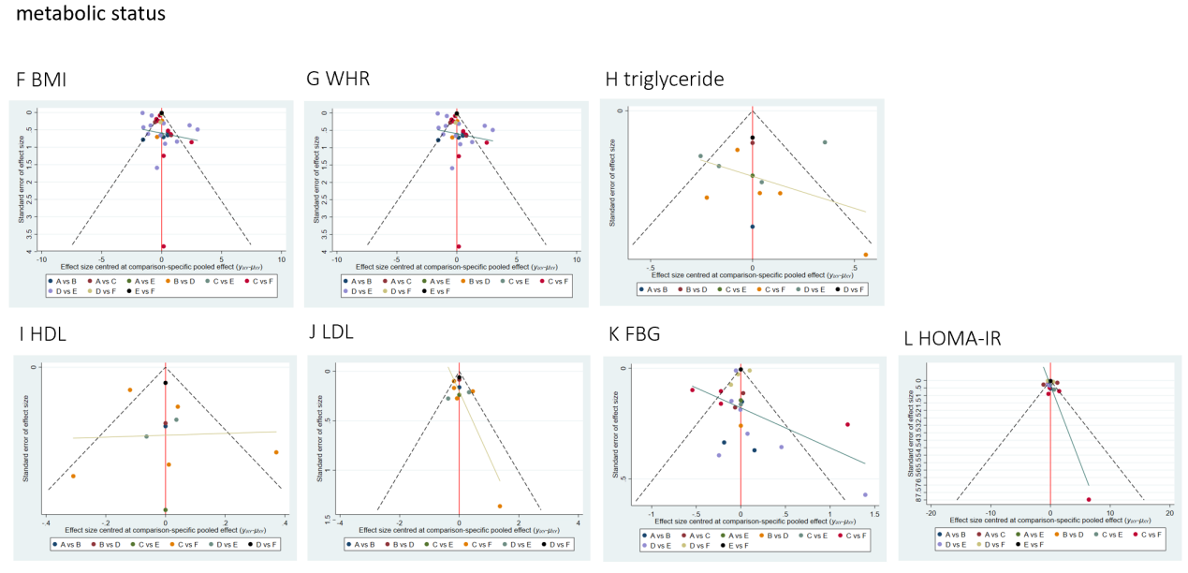
Figure S2. Funnel plot. (A) Testosterone; (B) Ferriman-Gallwey score (FG score); (C) pregnancy rate; (D) luteinizing hormone (LH) level; (E) luteinizing hormone/follicle-stimulating hormone ratio (LH/FSH); (F) body mass index (BMI); (G) waist-to-hip ratio (WHR); (H) triglyceride; (I) high-density lipoprotein (HDL) level; (J) low-density lipoprotein (LDL) level; (K) fasting blood glucose (FBG) level; (L) homeostasis model assessment of insulin resistance (HOMA-IR).

