Additional file 2
Questionnaire
Instruction: Please respond to the questions as follows:
Participant number ……………….
Section I: Demographic data
1. What is your age? ……………………….(years)
2. What is your gender? Male Female
3. What is your pharmacy education?
Bachelor's degree
Bachelor's degree with a Certificate in Pharmacy
Specialized residency in Pharmacotherapy
Specialized fellowship in Pharmacotherapy
Specialized fellowship in Pharmacotherapy with a Certificate in Pharmacy
Master's degree
Master's degree with a Certificate in Pharmacy
Other (please explain) …………………………………………………..
4. How long have you been working at King Chulalongkorn Memorial Hospital? …………(years/months)
5. Which sector do you primarily work in?
Outpatient pharmacy
Ambulatory care
Acute care
Drug Information Center
Antibiotic stewardship program
Adverse Drug Reaction Monitoring Center
Other (please explain) ……………………………………………………

Section II: Please provide your opinion on the draft framework for pharmaceutical care practices involving herbal and dietary supplements in hospitals.
Do you agree with the framework for pharmaceutical care practices of herbal and dietary supplements in hospitals, as depicted in the picture below?
Response: 1 to 5 (1 means strongly disagree and 5 means strongly agree)

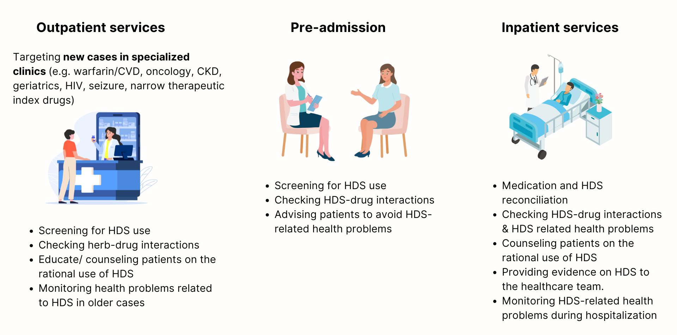
Note:
- CVD = CardioVascular Disease, CKD = Chronic Kidney Disease, HIV = Human Immunodeficiency Virus, HDS = Herbal and Dietary Supplement
- Pharmaceutical care means the pharmacist’s role in helping patients use medicines effectively and improve their health.

Other comments (please explain) (optional)
…………………………………………………………………………………………………………………………..
…………………………………………………………………………………………………………………………..
…………………………………………………………………………………………………………………………..
…………………………………………………………………………………………………………………………..
…………………………………………………………………………………………………………………………..
Section III: Pharmaceutical activities associated with herbal and dietary supplements in the hospital
Could you tell us about your experience with herbal and dietary supplements in your pharmacy practice over the last six months?
…………………………………………………………………………………………………………………………..
…………………………………………………………………………………………………………………………..
…………………………………………………………………………………………………………………………..
…………………………………………………………………………………………………………………………..
…………………………………………………………………………………………………………………………..
…………………………………………………………………………………………………………………………..
…………………………………………………………………………………………………………………………..
…………………………………………………………………………………………………………………………..

Other comments (please explain) (optional)
…………………………………………………………………………………………………………………………..
…………………………………………………………………………………………………………………………..
…………………………………………………………………………………………………………………………..
…………………………………………………………………………………………………………………………..
…………………………………………………………………………………………………………………………..
…………………………………………………………………………………………………………………………..

