Phytochemical Investigation and Evaluation of Anti-Inflammatory and Wound Healing Activities of Plantago major subsp. intermedia (Gilib.) Lange
Hilal Bacanak ^{1,2,3*}, Zeynep Dogan¹, Esra Küpeli⁴, Akito Nagatsu³, Iclal Saracoglu^{1,5}
¹ Hacettepe University, Faculty of Pharmacy, Department of Pharmacognosy, 06100 Ankara, Türkiye
² Tokat Gaziosmanpasa University, Faculty of Pharmacy, Department of Pharmacognosy, 60100 Tokat, Türkiye
³ Kinjo Gakuin University, College of Pharmacy, Department of Pharmacognosy, 463‑8521 Nagoya, Japan
⁴ Gazi University, Faculty of Pharmacy, Department of Pharmacognosy, 06330 Ankara, Türkiye
⁵ Lokman Hekim University, Faculty of Pharmacy, Department of Pharmacognosy, 06510 Ankara, Türkiye

Table of Contents
 |  | Page
Figure S1 | Chemical structure of compounds isolated from Plantago major subsp. intermedia | 1
Table S1 | ¹H and ¹³C NMR (CD₃OD) data: chemical shift (δ, ppm) and coupling constant (J, Hz) for isotachioside (1). | 2
Table S2 | ¹³C (CD₃OD) data: aucubin (2), 10-hydroxymajoroside (3) and 10-acetoxymajoroside (4). | 3
Table S3 | ¹H NMR (CD₃OD) data: chemical shift (δ, ppm) and coupling constant (J, Hz) for aucubin (2), 10-hydroxymajoroside (3) and 10-acetoxymajoroside (4). | 4
Table S4 | ¹³C NMR (CD₃OD) data: acteoside (6) | 5
Table S5 | ¹H NMR (CD₃OD) data: chemical shift (δ, ppm) and coupling constant (J, Hz) for martynoside (5) and acteoside (6) | 6

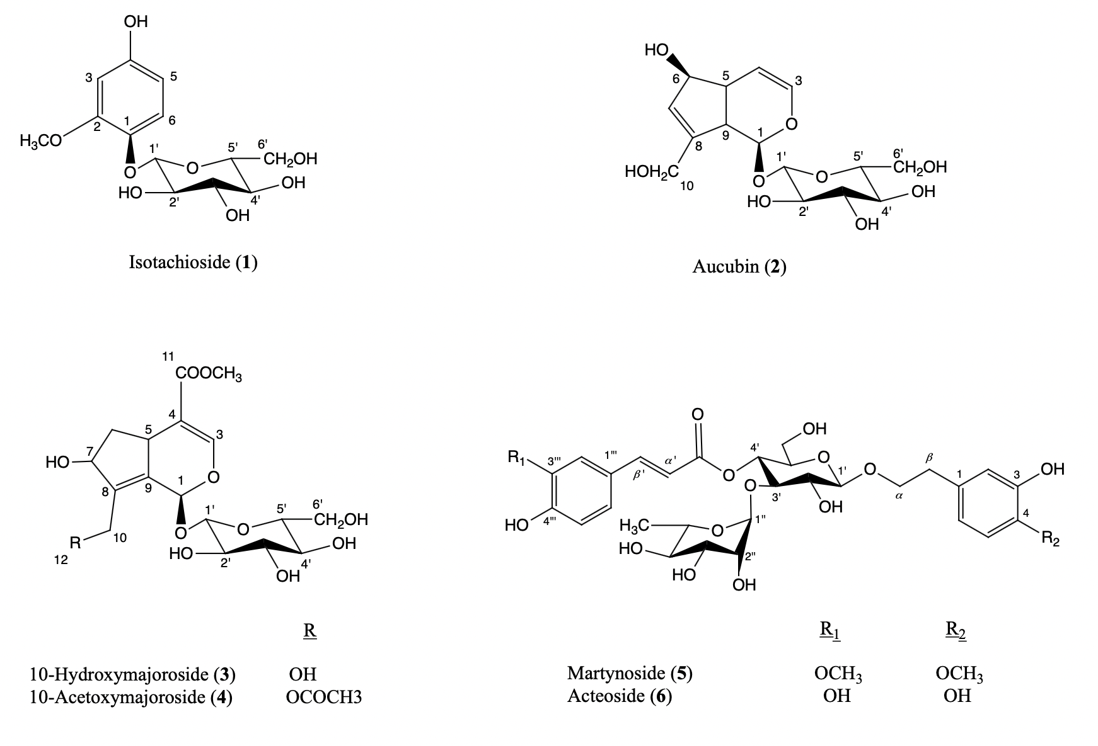
Figure S1. Chemical structure of compounds isolated from Plantago major subsp. intermedia

Table S1. ¹H and ¹³C NMR (CD₃OD) data: chemical shift (δ, ppm) and coupling constant (J, Hz) for isotachioside (1).
C/H | δ_{c} ppm | δ_{H} ppm (mult., int., J, Hz)
Aglycon
1 | 141.3 | -
2 | 152.3 | -
3 | 102.1 | 6.46 (1H, d, 2.4 Hz)
4 | 155.2 | -
5 | 107.9 | 6.29 (1H, dd, 11.4 / 3.0 Hz)
6 | 120.8 | 7.01 (1H, d, 8.4 Hz)
OCH₃ | 56.8 | 3.80 (3H, s)
Glucose
1' | 104.6 | 4.69 (1H, d, 7.2 Hz)
2' | 75.4 | 3.32-3.44 † (1H)
3' | 78.4 | 3.32-3.44 † (1H)
4' | 71.7 | 3.32-3.44 † (1H)
5' | 78.2 | 3.42 (1H, d, 4.2 Hz)
6' | 62.9 | 3.89 (1H, dd, 2.4 / 12.0 Hz)
6' | 62.9 | 3.68 (1H, dd, 5.4 / 12.0 Hz)
†: The J value could not be calculated due to interference

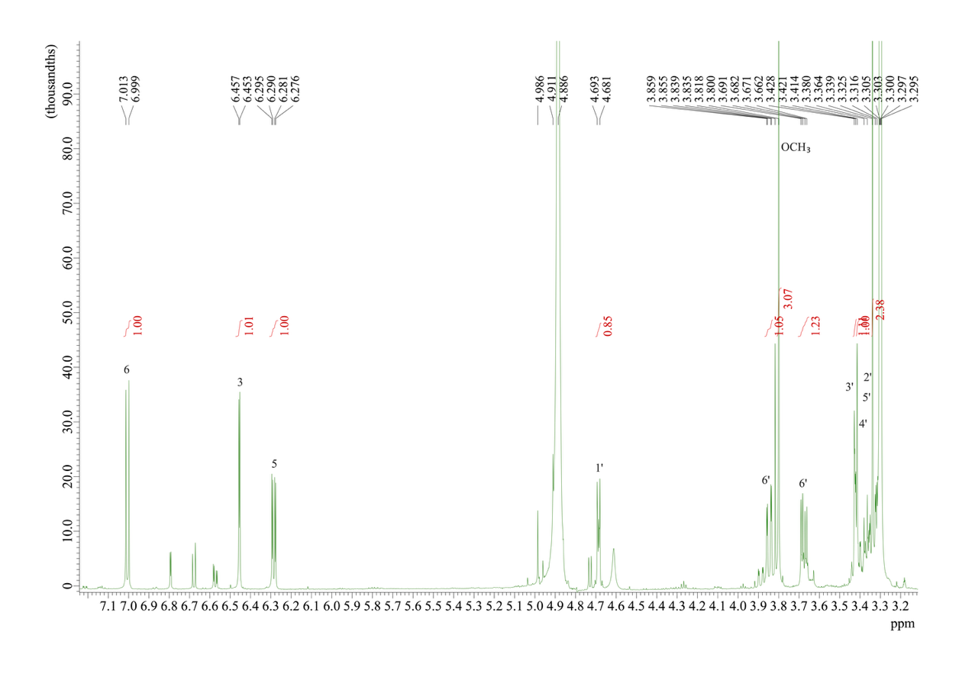
Figure S2. ¹H-NMR spectrum of isotachioside (CD₃OD; 600 MHz).

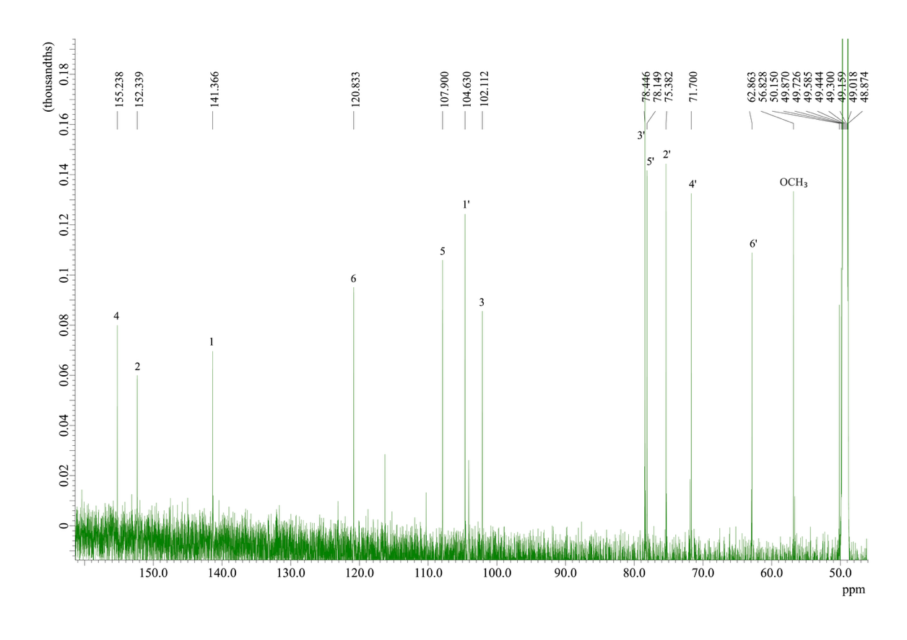
Figure S3. ¹³C-NMR spectrum of isotachioside (CD₃OD; 600 MHz).

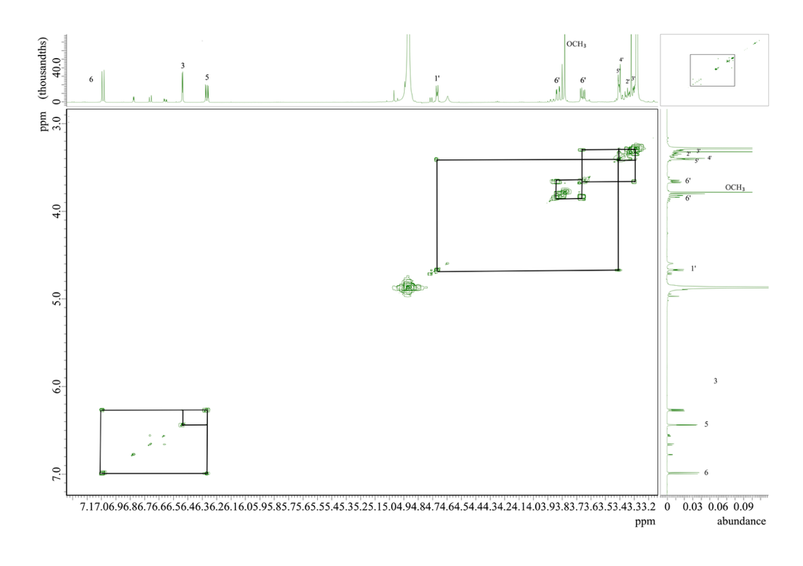
Figure S4. COSY spectrum of isotachioside.

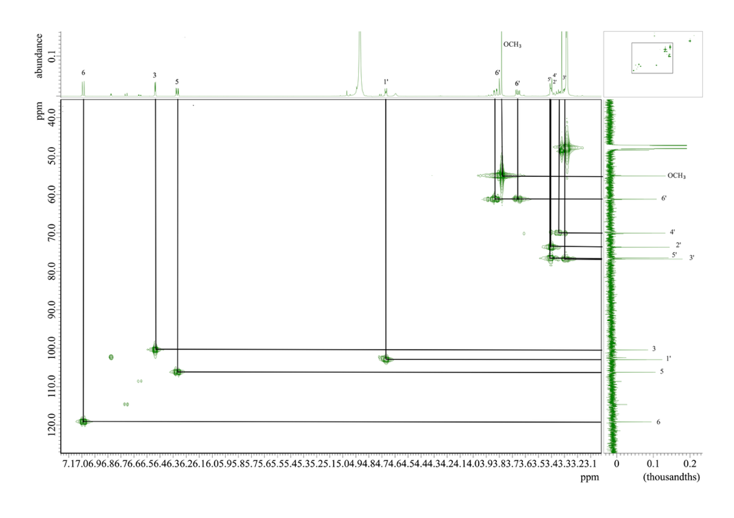
Figure S5. HMQC spectrum of isotachioside.

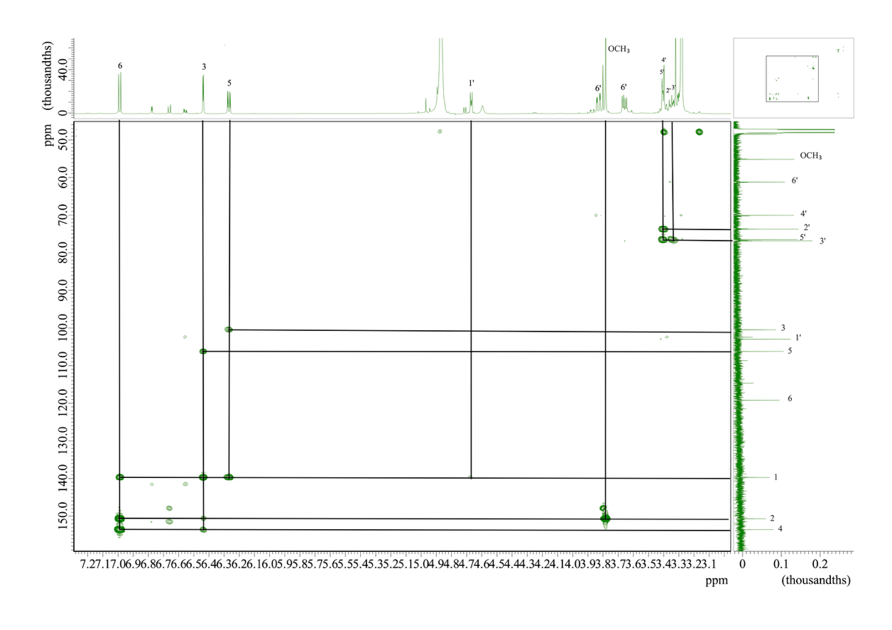
Figure S6. HMBC spectrum of isotachioside.

Table S2. ¹³C (CD₃OD) data: aucubin (2), 10-hydroxymajoroside (3) and 10-acetoxymajoroside (4).
Positions | 2 | 3 | 4
Aglycon
1 | 98.0 | 92.4 | 92.1
3 | 141.9 | 152.3 | 152.2
4 | 106.0 | 114.0 | 113.9
5 | 46.6 | 37.3 | 37.3
6 | 83.1 | 41.8 | 41.6
7 | 130.5 | 77.4 | 77.5
8 | 148.3 | 143.0 | 139.1
9 | 48.2 | 136.0 | 138.2
10 | 61.7 | 57.7 | 59.3
11 | - | 169.3 | 169.1
OCH₃ | - | 51.9 | 52.0
Glucose
1' | 100.2 | 100.5 | 100.3
2' | 75.2 | 75.0 | 75.0
3' | 78.2 | 78.3 | 78.3
4' | 71.9 | 71.8 | 71.8
5' | 78.6 | 78.6 | 78.7
6' | 63.0 | 63.0 | 63.0
CH₃OCO | - | - | 172.9
CH₃OCO | - | - | 21.0

Table S3. ¹H NMR (CD₃OD) data: chemical shift (δ, ppm) and coupling constant (J, Hz) for aucubin (2), 10-hydroxymajoroside (3) and 10-acetoxymajoroside (4).
Positions | 2 | 3 | 4
Aglycon
1 | 4.94 (1H, d, 7.2 Hz) | 6.41 (1H, s) | 6.34 (1H, s)
3 | 6.30 (1H, dd, 1.8/6.0 Hz) | 7.37 (1H, d, 1.8 Hz) | 7.37 (1H, d, 1.8 Hz)
4 | 5.08 (1H, dd, 3.6/6.0 Hz) | - | -
5 | 2.64 (1H, m) | 3.84 (1H, t, 7.2 Hz) | 3.85 (1H, t, 6.6 Hz)
6 | 4.43 (1H, m) | 1.71 (1H, m) | 1.66 (1H, m)
6 | 4.43 (1H, m) | 2.44 (1H, dd, 6.6/13.8 Hz) | 2.44 (1H, dd, 6.6/13.8 Hz)
7 | 5.75 (1H, brs) | 4.76 (1H, d, 6.6 Hz) | 4.72 (1H, d, 2.4 Hz)
9 | 2.88 (1H, t, 7.2 Hz) | - | -
10 | 4.34 (1H, d, 15.6 Hz) | 4.22 (1H, dd, 3.0/14.4 Hz) | 4.92 (1H, d, 13.2 Hz)
10 | 4.15 (1H, d, 15.0 Hz) | 4.42 (1H, d, 12.0 Hz) | 4.71 (1H, d, 4.2 Hz)
OCH₃ | - | 3.69 (3H, s) | 3.69 (3H, s)
Glucose
1' | 4.67 (1H, d, 8.4 Hz) | 4.68 (1H, d, 7.8 Hz) | 4.69 (1H, d, 8.4 Hz)
2' | 3.20 (1H, t, 7.8 Hz) | 3.15 (1H, t, 8.4 Hz) | 3.16 (1H, t, 7.8 Hz)
3' | 3.37 (1H, t, 8.4 Hz) | 3.35 (1H, d, 9.0 Hz) | 3.30-3.39† (1H)
4' | 3.27† (1H) | 3.26† (1H) | 3.30-3.39† (1H)
5' | 3.26† (1H) | 3.28† (1H) | 3.30-3.39† (1H)
6' | 3.63 (1H, dd, 5.4/12.0 Hz) | 3.66 (1H, dd, 5.4/12.0 Hz) | 3.67 (1H, dd 6.6/12.0)
 | 3.85 (1H, dd, 1.8/12.0 Hz) | 3.89 (1H, dd, 2.4/12.0 Hz) | 3.90 (1H, dd, 2.4/12.0 Hz)
CH₃ | - | - | 2.06 (3H, s)
†: The J value could not be calculated due to interference.

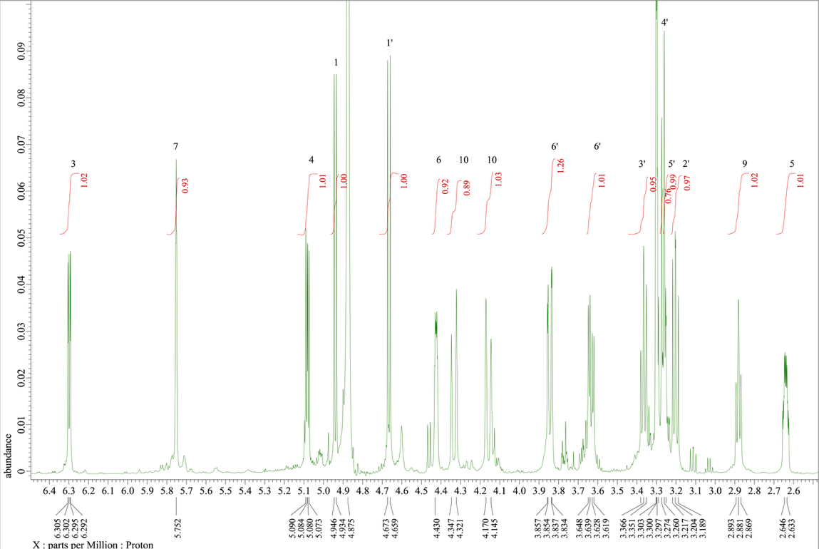
Figure S7. ¹H-NMR spectrum of aucubin (CD₃OD; 600 MHz).

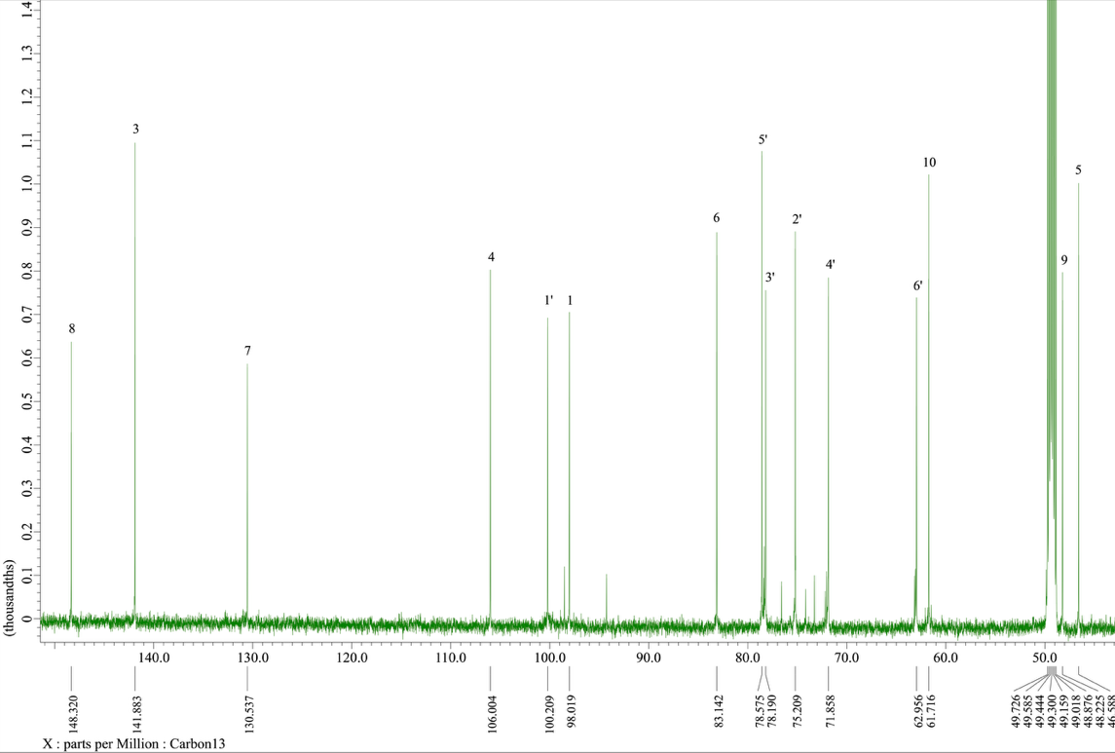
Figure S8. ¹³C-NMR spectrum of aucubin (CD₃OD; 600 MHz).

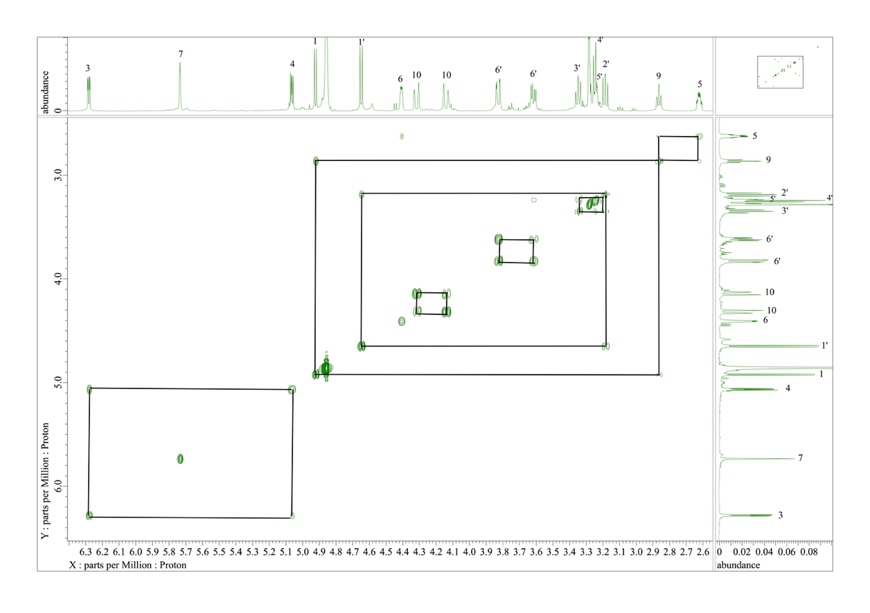
Figure S9. COSY spectrum of aucubin.

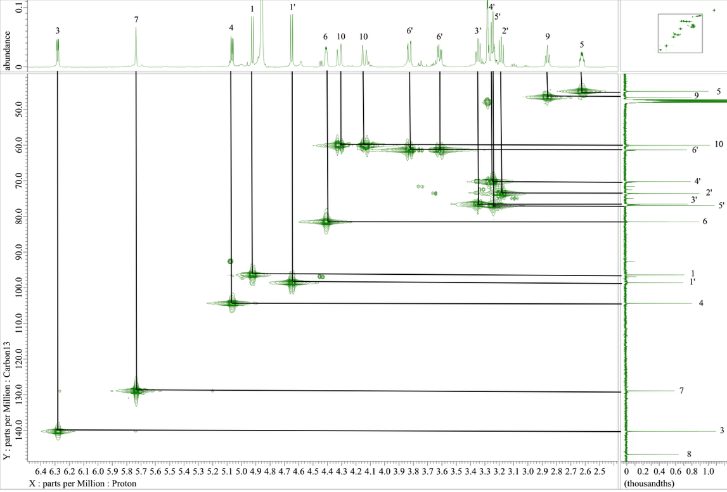
Figure S10. HMQC spectrum of aucubin.

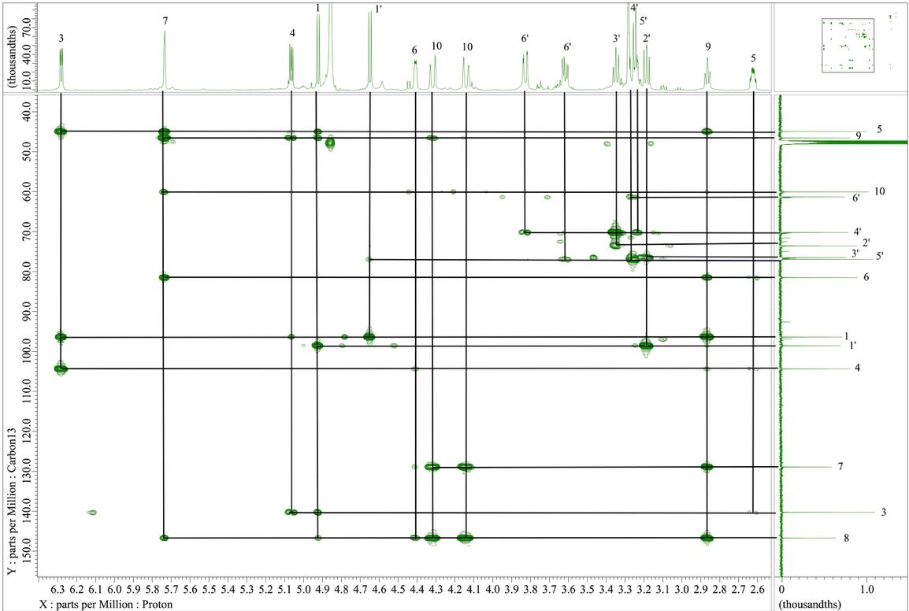
Figure S11. HMBC spectrum of aucubin.

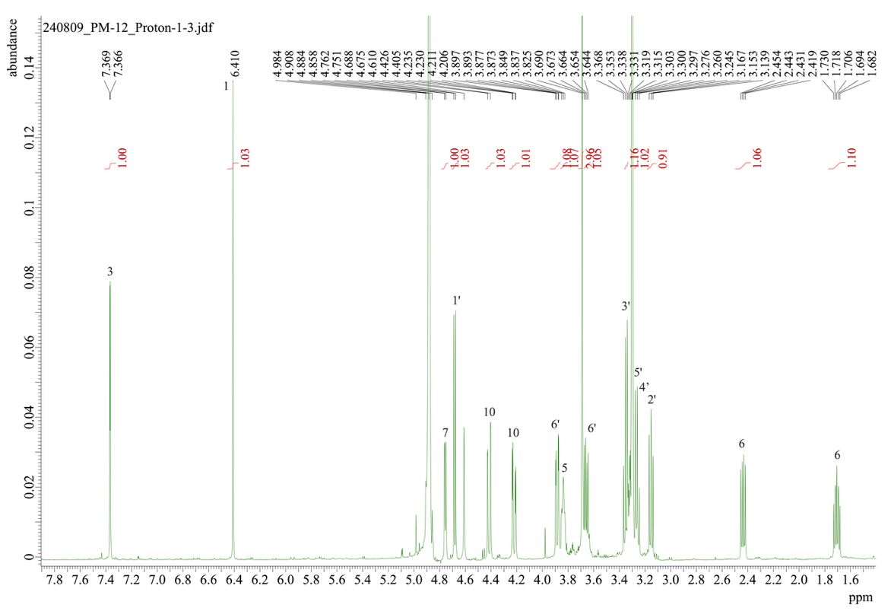
Figure S12. ¹H-NMR spectrum of 10-hydroxymajoroside (CD₃OD; 600 MHz).

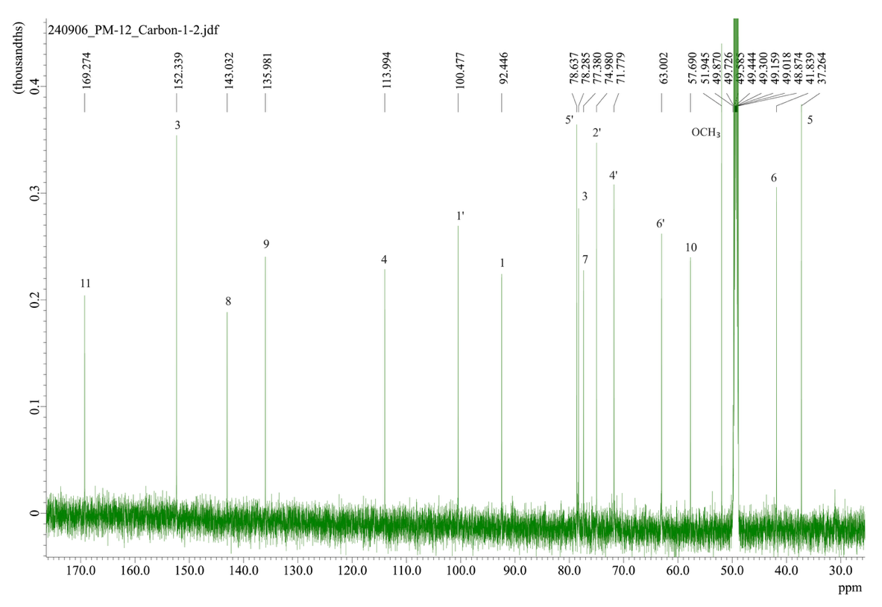
Figure S13. ¹³C-NMR spectrum of 10-hydroxymajoroside (CD₃OD; 600 MHz).

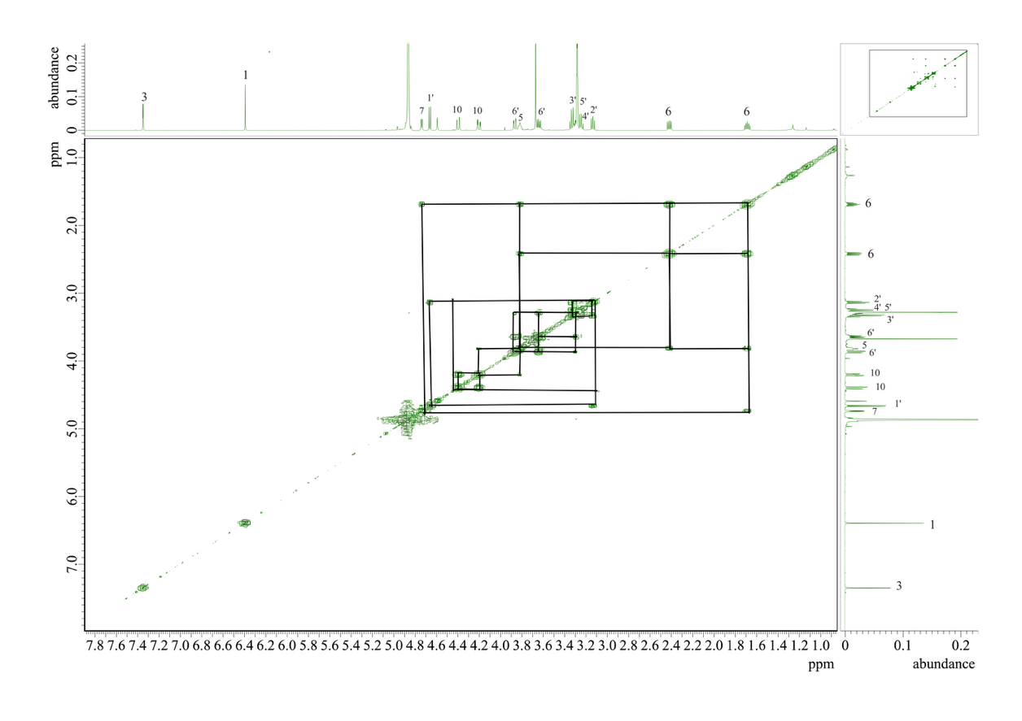
Figure S14. COSY spectrum of 10-hydroxymajoroside.

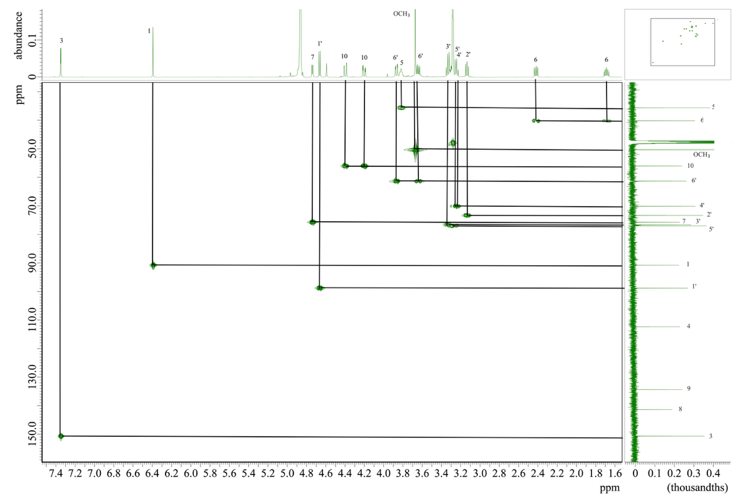
Figure S15. HMQC spectrum of 10-hydroxymajoroside.

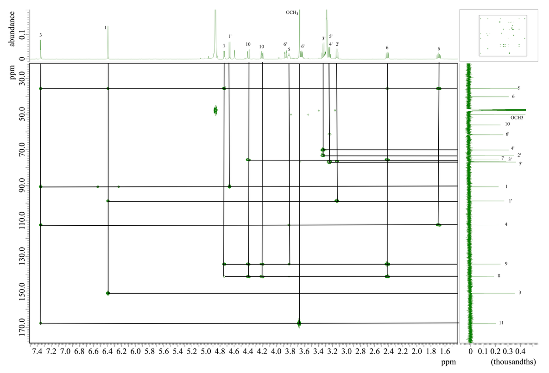
Figure S16. HMBC spectrum of 10-hydroxymajoroside.

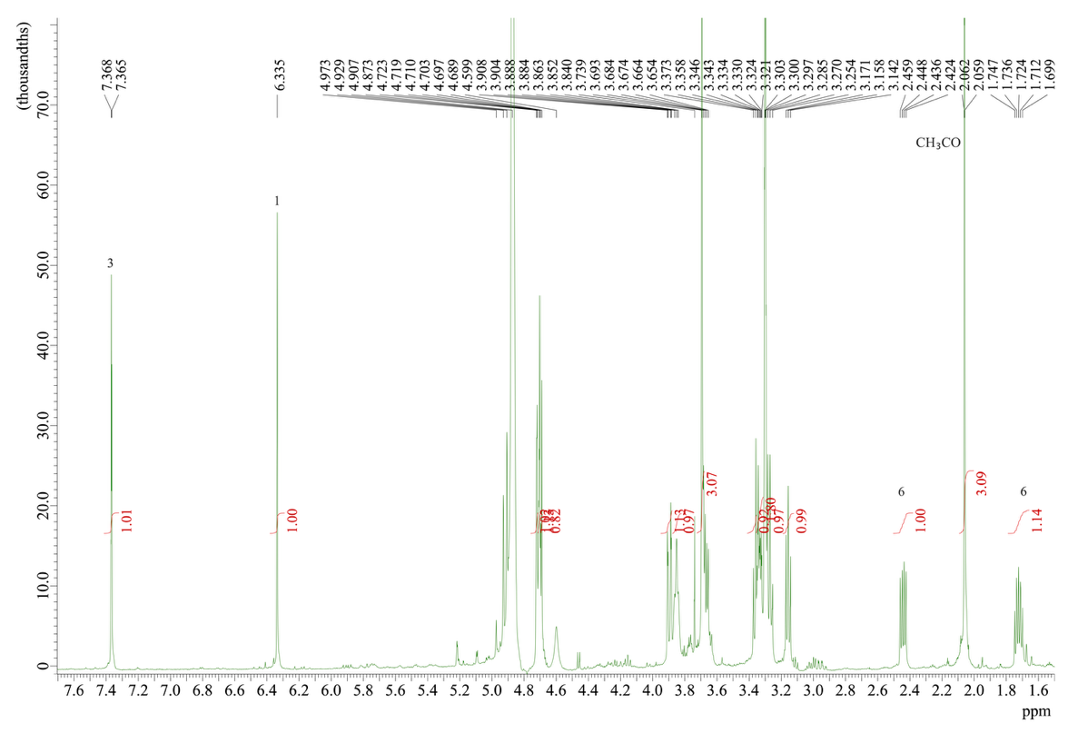
Figure S17. ¹H-NMR spectrum of 10-acetoxymajoroside (CD₃OD; 600 MHz).

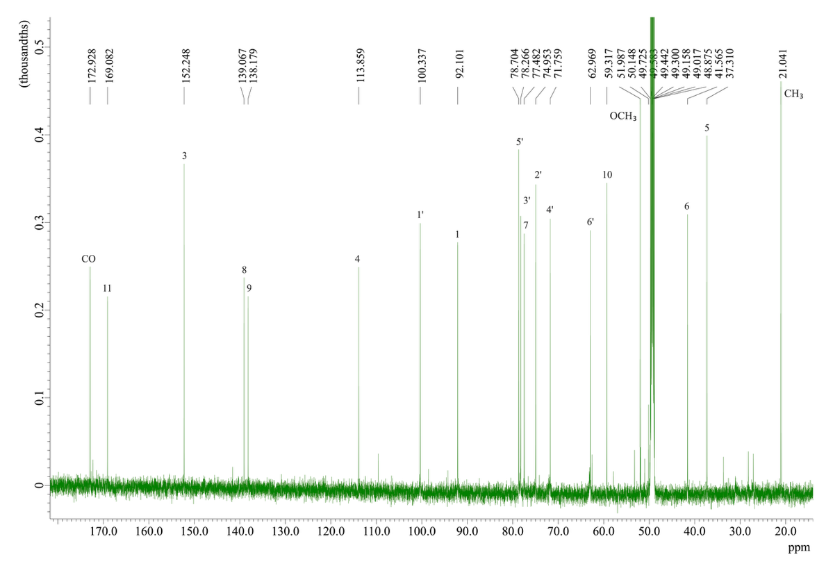
Figure S18. ¹³C-NMR spectrum of 10-acetoxymajoroside (CD₃OD; 600 MHz).

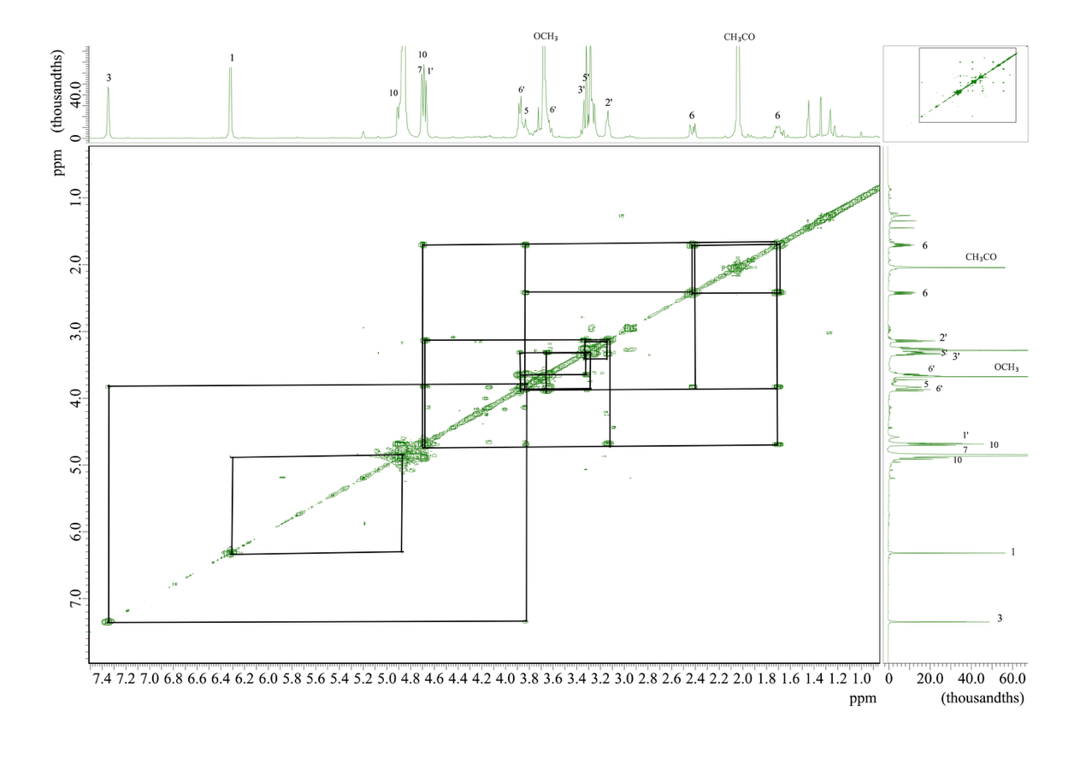
Figure S19. COSY spectrum of 10-acetoxymajoroside.

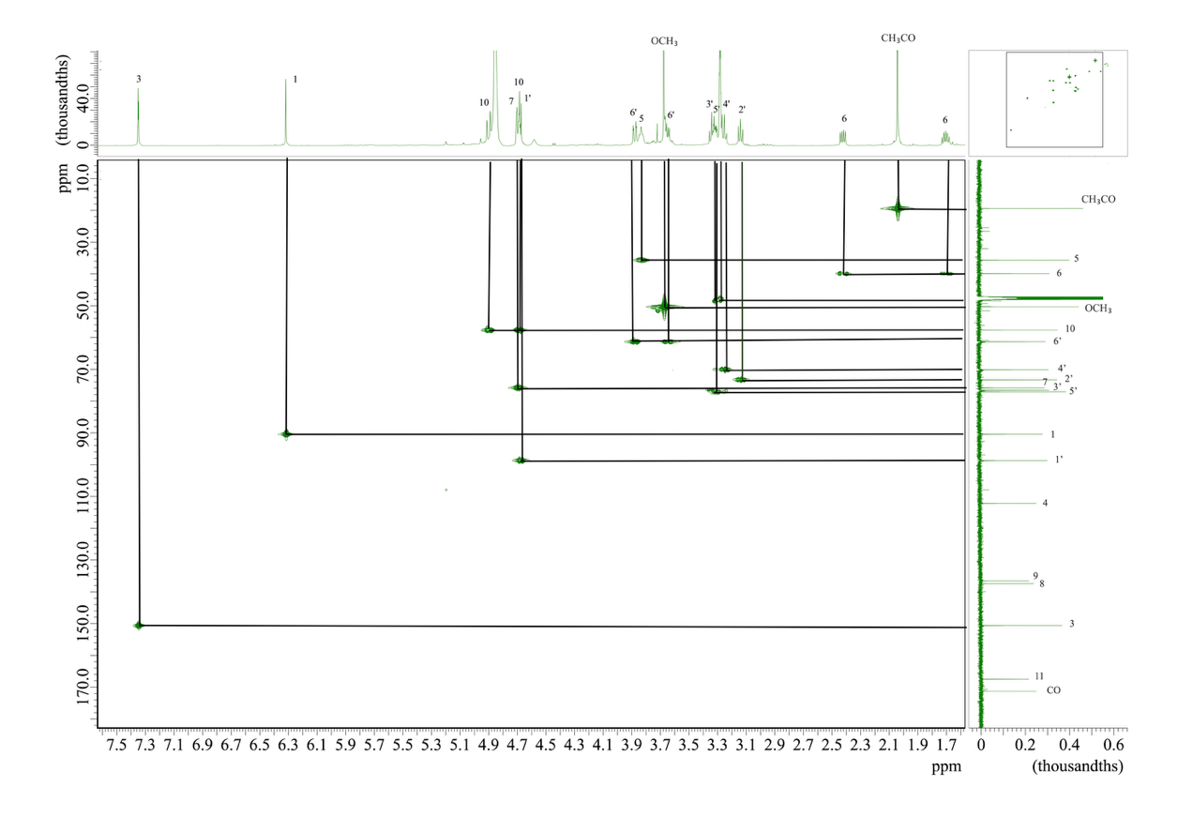
Figure S20. HMQC spectrum of 10-acetoxymajoroside.

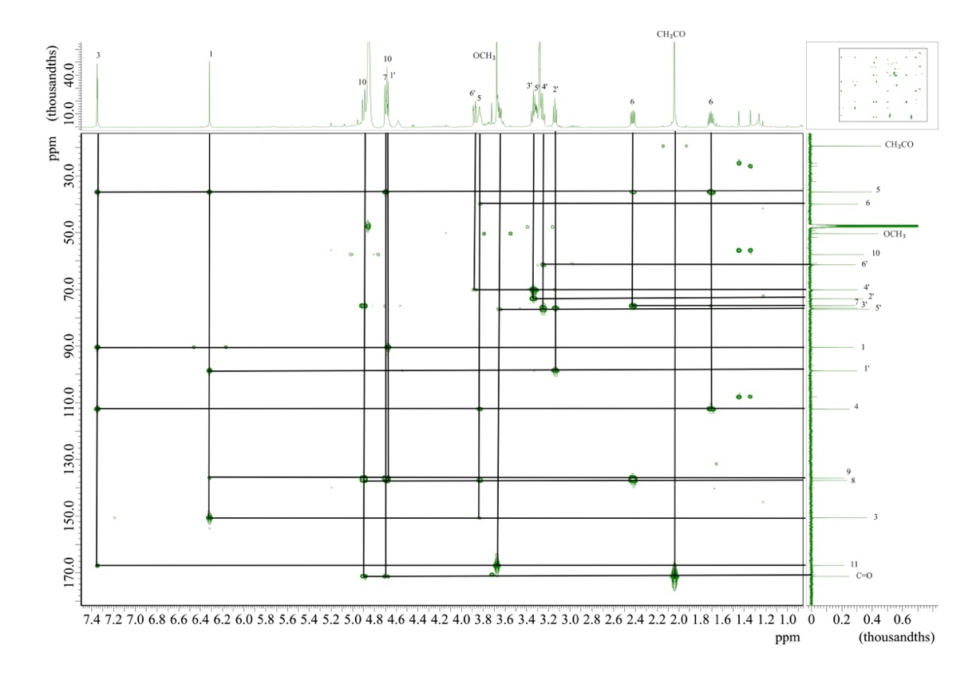
Figure S21. HMBC spectrum of 10- acetoxymajoroside.

Table S4. ¹³C NMR (CD₃OD) data: acteoside (6)
C/H Atom | 6
1 | 131.8
2 | 117.4
3 | 146.5
4 | 145.0
5 | 116.6
6 | 121.5
a | 72.6
b | 36.9
Glucose
1' | 104.5
2' | 76.5
3' | 81.9
4' | 70.8
5' | 76.3
6' | 62.7
Rhamnose
1'' | 103.3
2'' | 72.7
3'' | 72.4
4'' | 74.1
5'' | 70.7
6'' | 18.8
Acyl moiety
1''' | 128.0
2''' | 115.5
3''' | 147.2
4''' | 150.2
5''' | 116.8
6''' | 123.5
a' | 115.0
b ' | 148.3
C=O | 168.6

Table S5. ¹H NMR (CD₃OD) data: chemical shift (δ, ppm) and coupling constant (J, Hz) for martynoside (5) and acteoside (6)
C/H Atom | 5 | 6
1 | - | -
2 | 6.73 (1H, d, 2.4 Hz) | 6.68 (1H, d, 1.8 Hz)
3 | - | -
4 | - | -
5 | 6.82 (1H, d, 7.8 Hz) | 6.66 (1H, d, 7.8 Hz)
6 | 6.68 (1H, dd, 2.4/8.4 Hz) | 6.56 (1H, dd, 1.8/7.8 Hz)
α | 4.04 (1H, m) | 4.04 (1H, m)
 | 3.91 (1H, m) | 3.71 (1H, m)
β | 2.81 (1H, m) | 2.79 (2H, m)
OCH₃ | 3.80 (3H, s) | -
Glucose
1' | 4.38 (1H, d, 7.8 Hz) | 4.37 (1H, d, 7.8 Hz)
2' | 3.38 (1H, brd, 9.6 Hz) | 3.38 (1H, brt, 9.0 Hz)
3' | 3.78 -3.81† | 3.80 (1H, t, 9.6 Hz)
4' | 4.99 (1H, t, 9.6 Hz) | 4.98 (1H, t, 9.6 Hz)
5' | 3.51-3.56† | 3.50 (1H, d, 5.4 Hz)
6' | 3.65† | 3.61 (1H, dd, 4.8/13.8 Hz)
 | 3.53† | 3.52 (1H, dd, 2.4/12.0 Hz)
Rhamnose
1'' | 5.18 (1H, brs) | 5.18 (1H, d, 1.2 Hz)
2'' | 3.98† | 3.90 (1H, brt, 3.0 Hz)
3'' | 3.57 (1H, dd, 3.6/9.6 Hz) | 3.56 (1H, dd, 3.6/9.6 Hz)
4'' | 3.28 (1H, d, 9.6 Hz) | 3.27 (1H, d, 9.0 Hz)
5'' | 3.51-3.56† | 3.53-3.56†
6'' | 1.09 (1H, d, 6.0 Hz) | 1.08 (1H, d, 6.6 Hz)
Acyl moiety
1'''' | - | -
2'''' | 7.18 (1H, brs) | 7.04 (1H, d, 1.8 Hz)
3'''' | - | -
4'''' | - | -
5'''' | 6.79 (1H, d, 7.8 Hz) | 6.76 (1H, d, 8.4 Hz)
6'''' | 7.07 (1H, dd, 1.8/8.4 Hz) | 6.95 (1H, dd, 2.4/8.4 Hz)
α ' | 6.36 (1H, d, 16.0 Hz) | 6.26 (1H, d, 16.0 Hz)
β ' | 7.65 (1H, d, 16.0 Hz) | 7.58 (1H, d, 16.0 Hz)
C=O | - | -
OCH₃ | 3.88 (3H, s) | -
†: The J value could not be calculated due to interference.

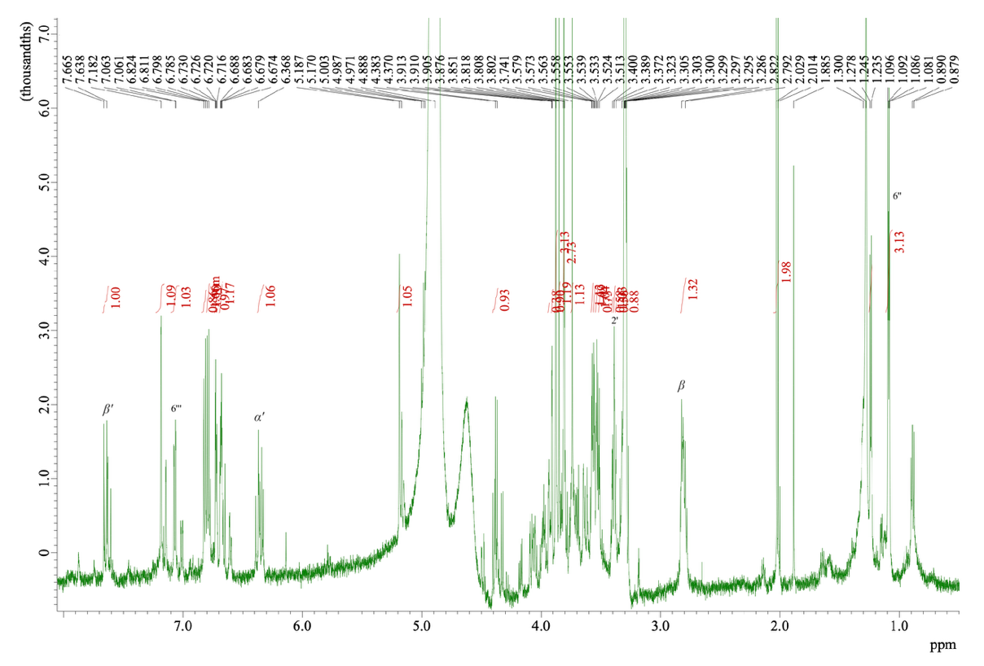
Figure S22. ¹H-NMR spectrum of martynoside (CD₃OD; 600 MHz).

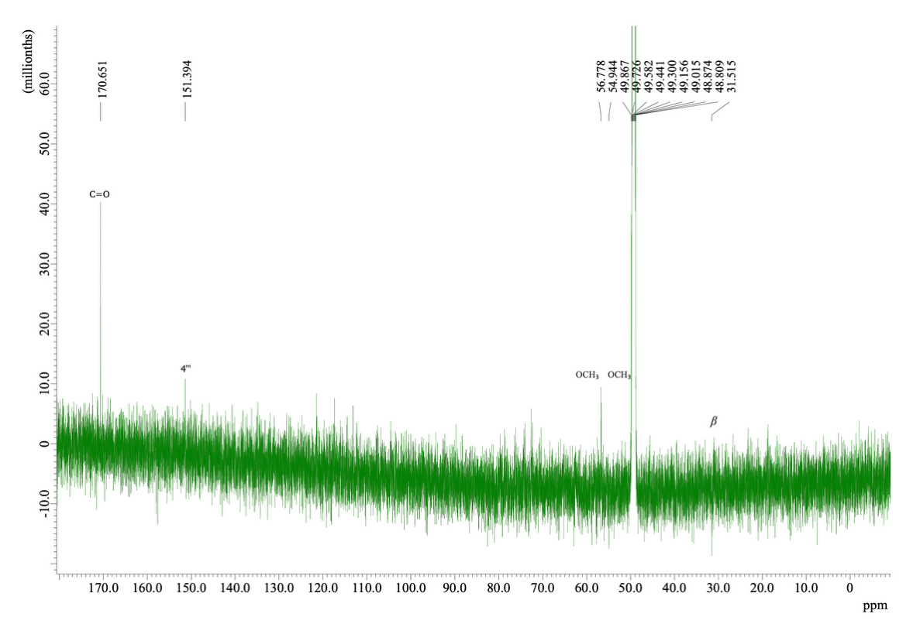
Figure S23. ¹³C-NMR spectrum of martynoside (CD₃OD; 600 MHz).

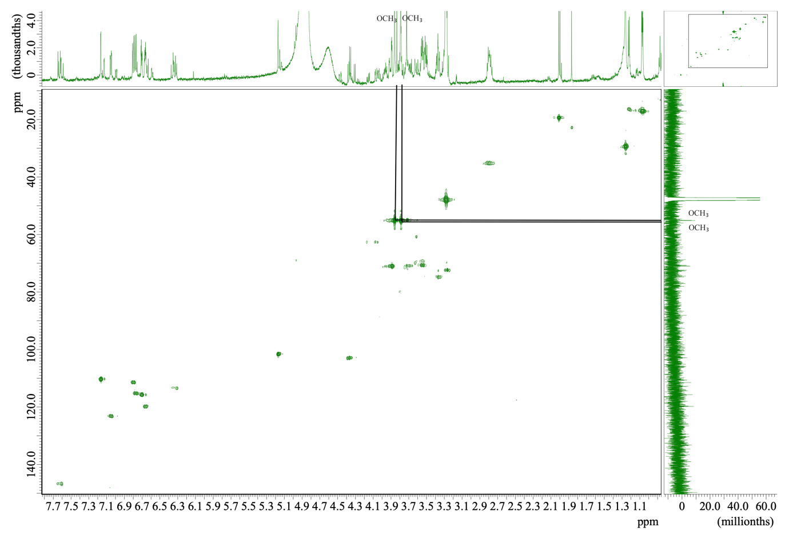Figure S24. HMQC spectrum of martynoside

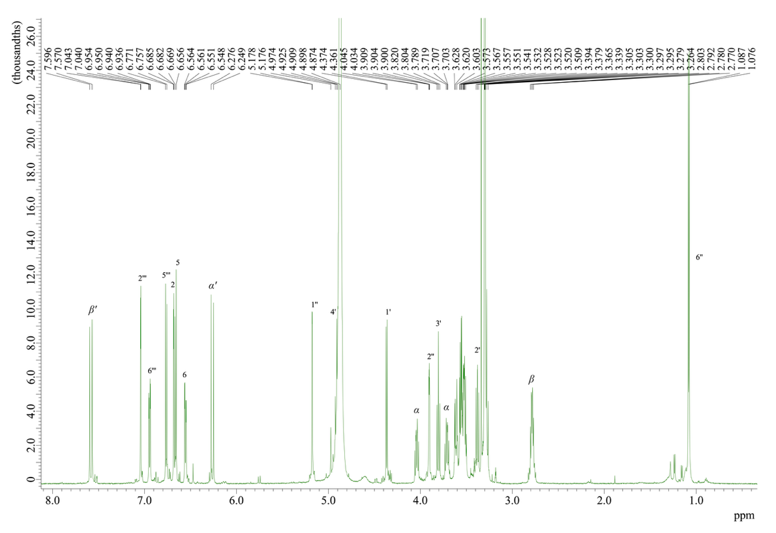
Figure S25. ¹H-NMR spectrum of acteoside (CD₃OD; 600 MHz).

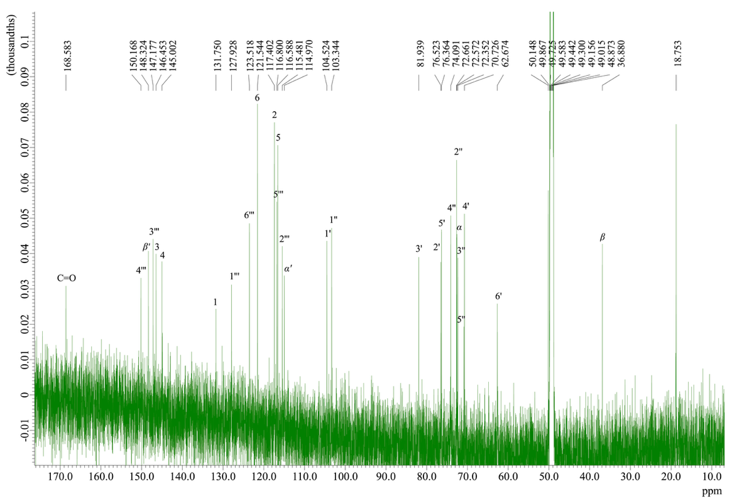
Figure S26. ¹³C-NMR spectrum of acteoside (CD₃OD; 600 MHz).

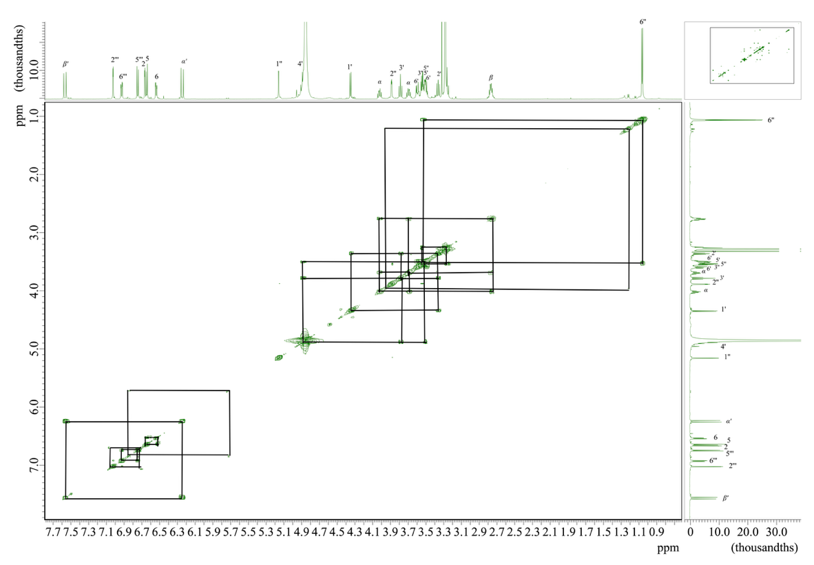
Figure S27. COSY spectrum of acteoside.

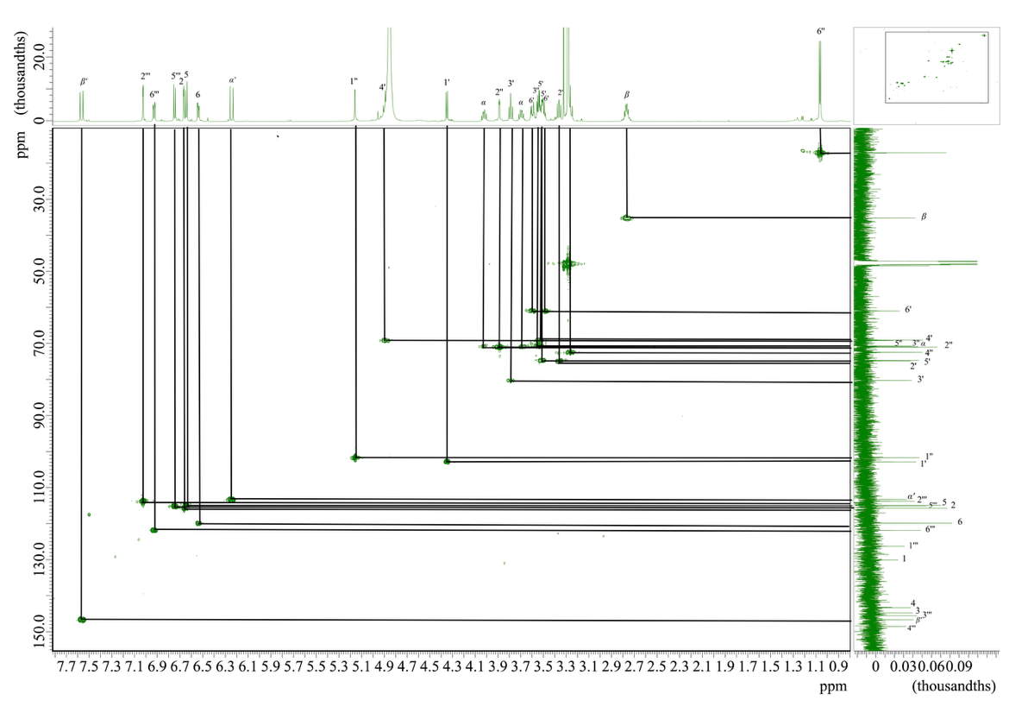
Figure S28. HMQC spectrum of acteoside.

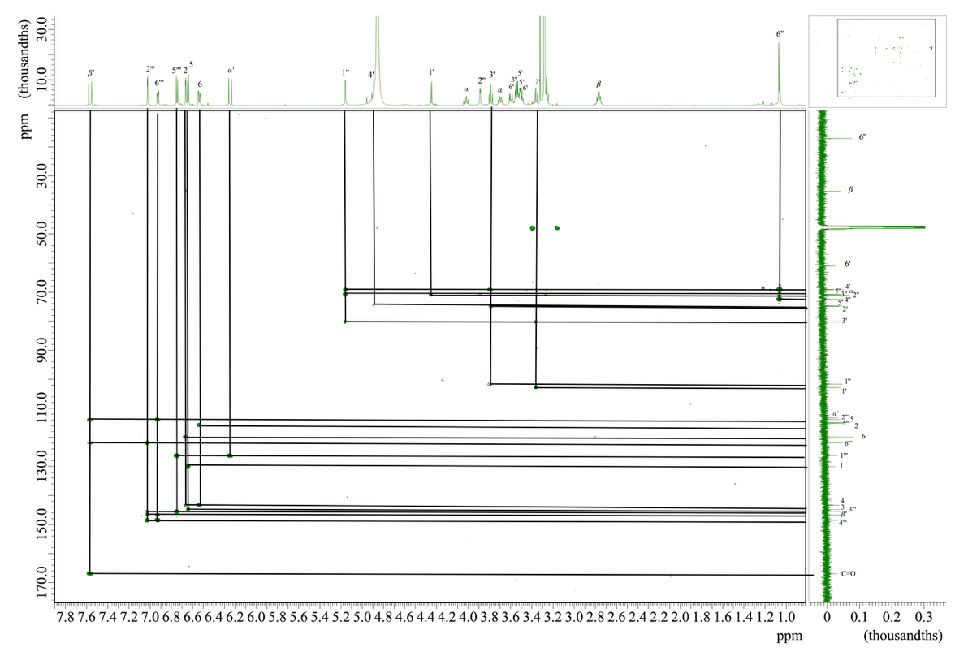
Figure S29. HMBC spectrum of acteoside.

Table S6. Effects of test and reference materials on wound contraction with circular excision model
Material | Extract type | Wound area ± S.E.M. (Contraction %)
Material | Extract type | 0 | 2 | 4 | 6 | 8 | 10 | 12
Vehicle | - | 18.27 ± 2.13 | 18.34 ±2.90 | 16.25 ± 1.86 | 14.26 ± 1.93 | 8.21 ± 1.34 | 5.08 ± 1.23 | 4.22 ± 0.91
Negative Control | - | 18.34 ± 2.19 | 19.07 ± 2.46 | 16.92 ± 2.11 | 13.67 ± 1.71 | 9.83 ± 1.62 | 7.21 ± 1.32 | 4.80 ± 1.16
Plantago major subsp. intermedia | MeOH | 18.41 ± 2.11 | 18.31 ± 1.93 | 15.28 ± 2.14  (5.9) | 12.34 ± 1.03  (13.5) | 7.60 ± 1.15  (7.4) | 4.14 ± 0.63  (18.5) | 3.37 ±0.47  (20.1)
Plantago major subsp. intermedia | 80% EtOH | 18.16 ± 3.25 | 17.15 ±2.11  (6.5) | 14.64 ± 1.16  (9.9) | 11.95 ± 1.18  (16.2) | 7.24 ± 1.24  (11.8) | 4.09 ± 1.37  (19.4) | 3.23 ± 0.35  (23.4)
Plantago major subsp. intermedia | Water | 18.11 ± 2.37 | 18.44 ± 1.75 | 16.23 ± 1.88 | 15.61 ± 1.30 | 9.31 ± 1.88 | 5.15 ± 1.02 | 4.36 ± 0.61
Madecassol® |  | 18.34 ± 2.01 | 14.23 ± 2.34  (22.5) | 11.37 ± 2.02  (30.0)* | 7.16 ± 1.92  (49.7)** | 4.03 ± 0.97  (50.9)** | 1.18 ± 0.24  (76.8)*** | 0.00 ± 0.00  (100.00)***
Mean ± SEM; comparison with vehicle group and negative control; *: p <0.05; **: p <0.01; ***: p <0.001

