Table S1. CSSO-Derived Fatty Acid Profiles: PubChem CID and 2D Structures
CSSO-derived Fatty Acids | PubChem CID | 2D Structure
(C16:0) Palmitic acid | 985 | 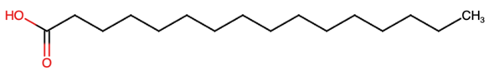
(C18:0) Stearic acid | 5281 | 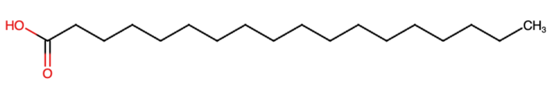
(C18:1) Oleic acid | 445639 | 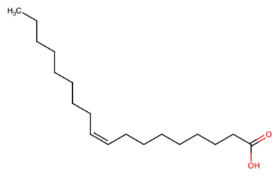
(C18:2) Linoleic acid | 5280450 | 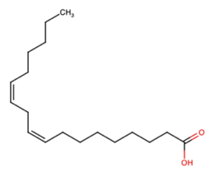
(C20:0) Arachidic acid | 10467 | 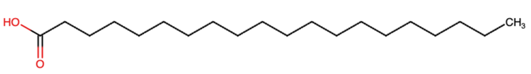
(C18:3n6) Linolenic acid | 5280933 | 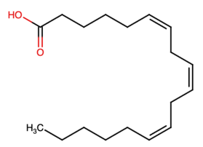
(C20:1) Eicosenoic acid | 5282768 | 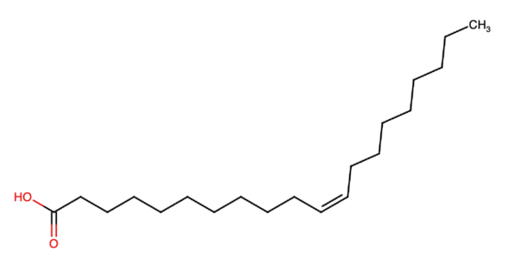
(C22:0) Behenic acid | 8215 | 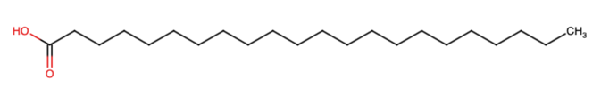

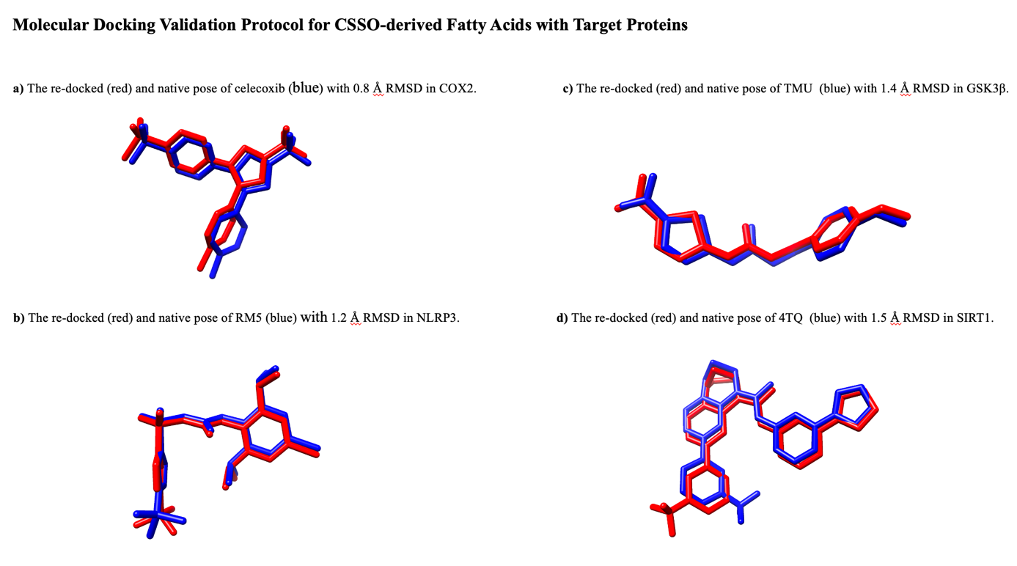
Fig. S1. Molecular docking validation protocol for CSSO-derived fatty acids with target proteins. Native and re-docked ligands are shown in blue and red, respectively.
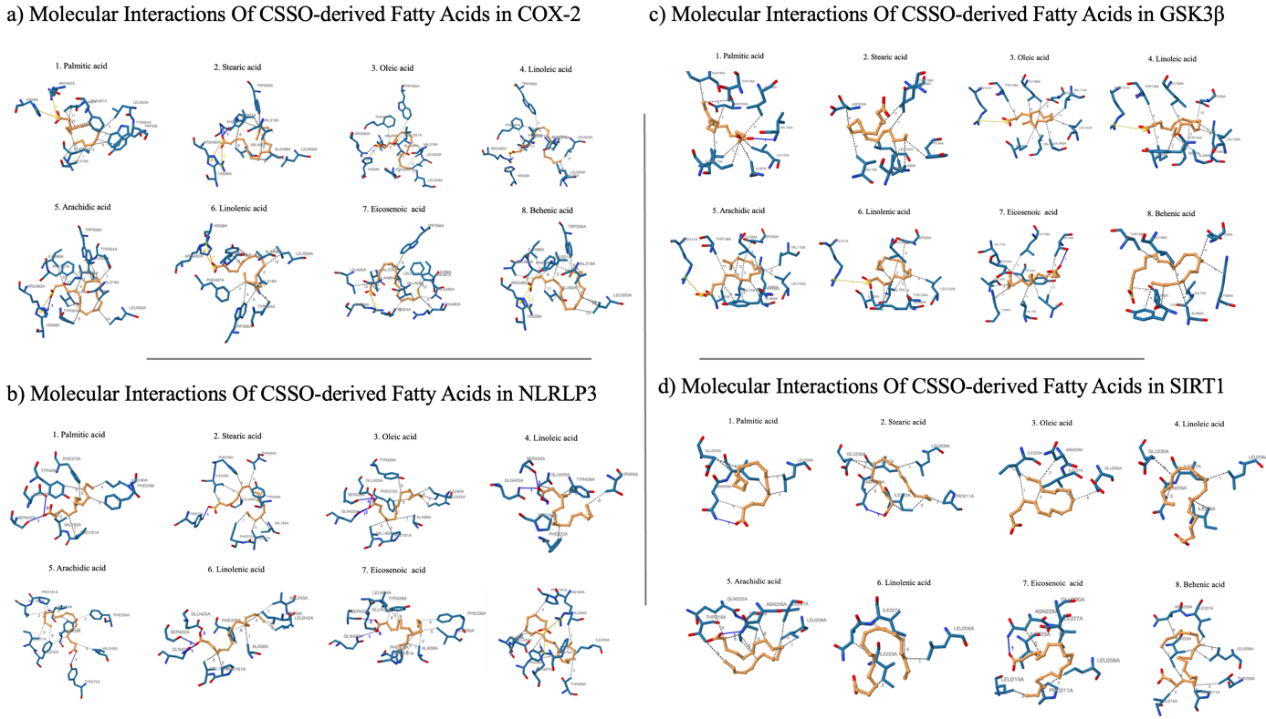
Fig. S2. Molecular interaction of all tested CSSO-derived fatty acids in target proteins.

