Synergistic anti-cancer activity of Artemisia vulgaris L. aqueous extract with cisplatin against A549 Lung cancer cell line

Seham Salah El-Din Elhawary¹, Hadeel Nabil Ahmed^{1, *}, Mouchira A. Choucry ^{2,1}, Rasha M. Allam³, Osama G. Mohamed^{1,4}, Kamel Mahmoud Kamel^{5 #}, Amira K. Elmotayam^{1*, #}
¹ Department of Pharmacognosy, Faculty of Pharmacy, Cairo University, Kasr el-Aini Street, Cairo, 11562, Egypt
² Department of Pharmacognosy, Faculty of Pharmacy and Drug Technology, Egyptian Chinese University, 11786 Cairo, Egypt
³ Pharmacology Department, Medical Research Institute, National Research Center, 33 El-Bohouth St., Dokki, P.O.12622, Cairo, Egypt.
⁴ Natural Products Discovery Core, Life Sciences Institute, University of Michigan, Ann Arbor, MI 48109, USA
⁵ Department of pharmacognosy, Faculty of Pharmaceutical Sciences & Drug Manufacturing, Misr University for Science and Technology, Giza, Egypt
*Corresponding authors emails: hadeelnabil248@gmail.com, Amira.kamal@pharma.cu.edu.eg
# The last two authors contributed equally to this work

Figure S1: MS/MS chromatogram of quinic acid
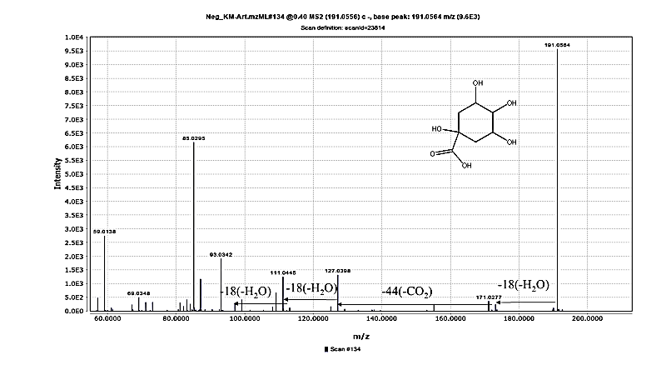 MS/MS chromatogram of quinic acid detected in A. vulgaris aqueous extract under negative ionization mode using UHPLC-QTOF-MS/MS.

Figure S2: MS/MS chromatogram of chlorogenic acid
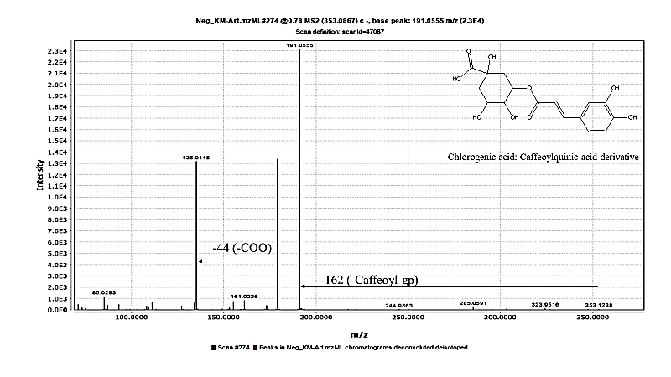MS/MS chromatogram of chlorogenic acid identified in A. vulgaris aqueous extract under negative ionization mode.

Figure S3: MS/MS chromatogram of dihydroxybenzoic acid hexoside isomer
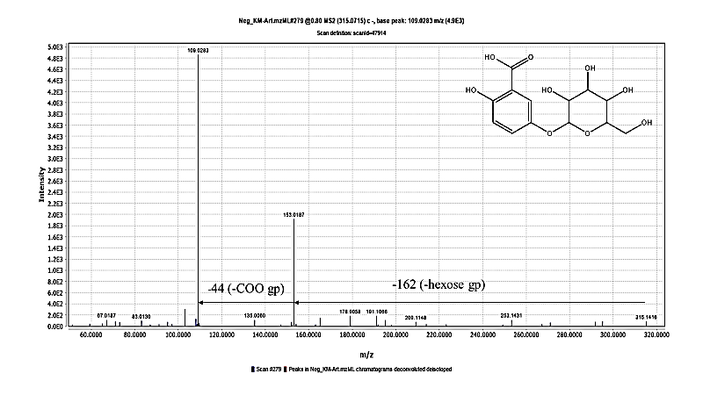
MS/MS chromatogram of dihydroxybenzoic acid hexoside isomer detected in A. vulgaris aqueous extract under negative ionization mode.
Figure S4: MS/MS chromatogram of dihydroxy benzoic acid
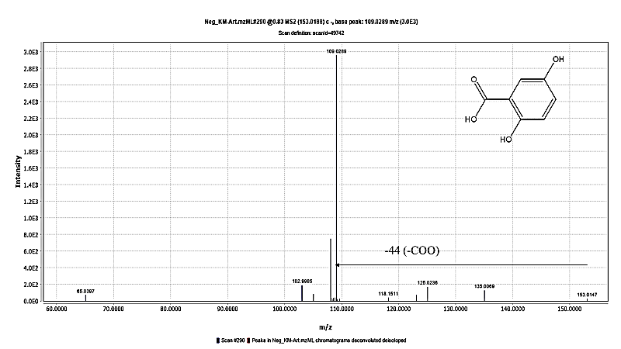
MS/MS chromatogram of dihydroxybenzoic acid identified in A. vulgaris aqueous extract under negative ionization mode.

Figure S5: MS/MS chromatogram of caffeic acid
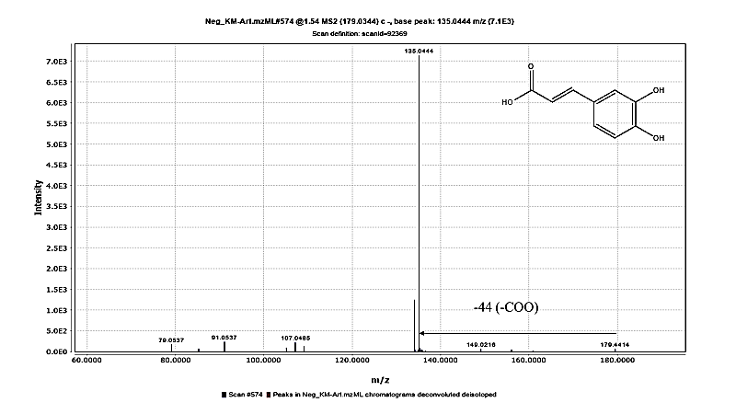MS/MS chromatogram of caffeic acid detected in A. vulgaris aqueous extract under negative ionization mode.
Figure S6: MS/MS chromatogram of coumaroylquinic acid
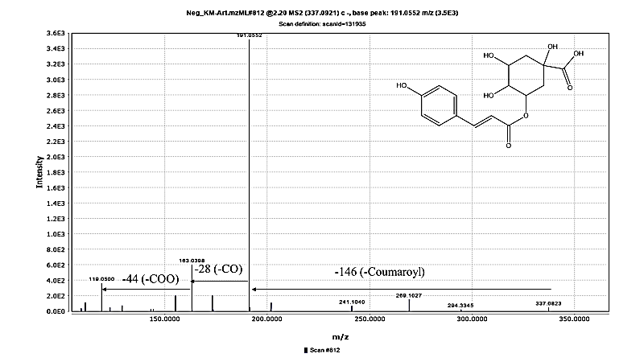MS/MS chromatogram of coumaroylquinic acid identified in A. vulgaris aqueous extract under negative ionization mode.

Figure S7: MS/MS chromatogram of feruloylquinic acid
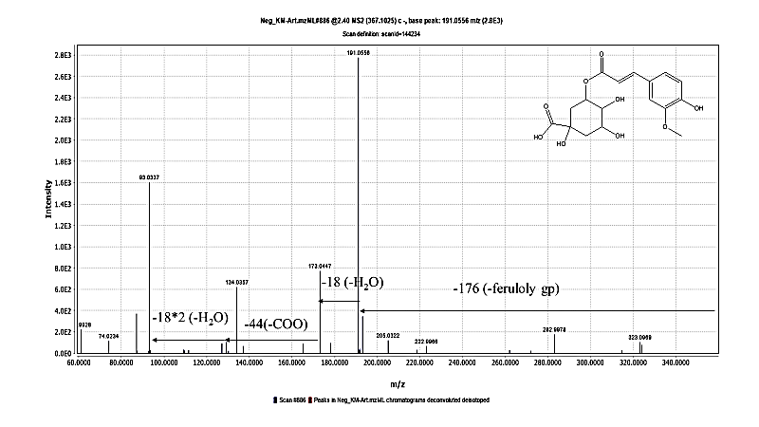MS/MS chromatogram of feruloylquinic acid detected in A. vulgaris aqueous extract under negative ionization mode.
Figure S8: MS/MS chromatogram of dicaffeoylquinic acid
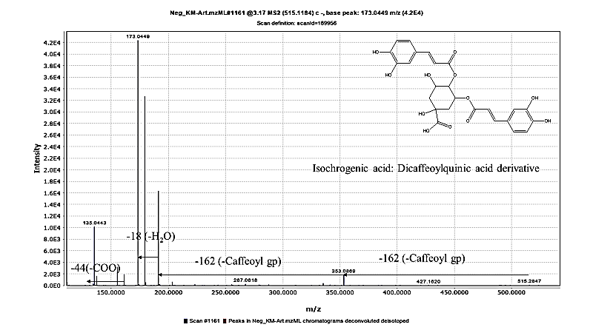
MS/MS chromatogram of dicaffeoylquinic acid identified in A. vulgaris aqueous extract under negative ionization mode.

Figure S9: MS/MS chromatogram of tricaffeoylhexaric acid isomer
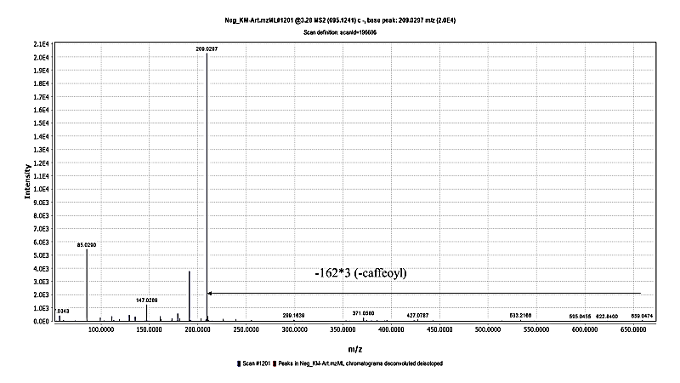MS/MS chromatogram of tricaffeoylhexaric acid isomer detected in A. vulgaris aqueous extract under negative ionization mode.

Figure S10: MS/MS chromatogram of coumaroylcaffeoylquinic acid isomer
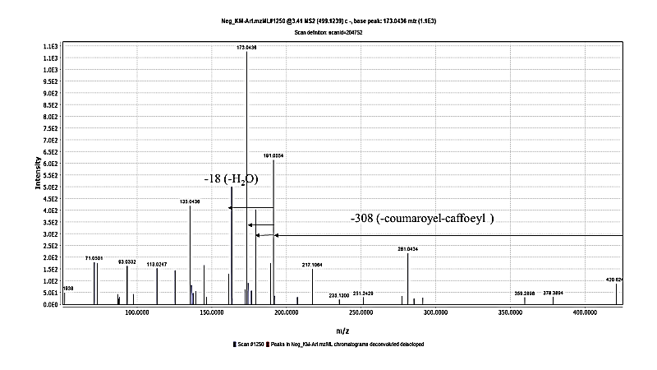MS/MS chromatogram of coumaroylcaffeoylquinic acid isomer identified in A. vulgaris aqueous extract under negative ionization mode.

Figure S11: MS/MS chromatogram of aesculin
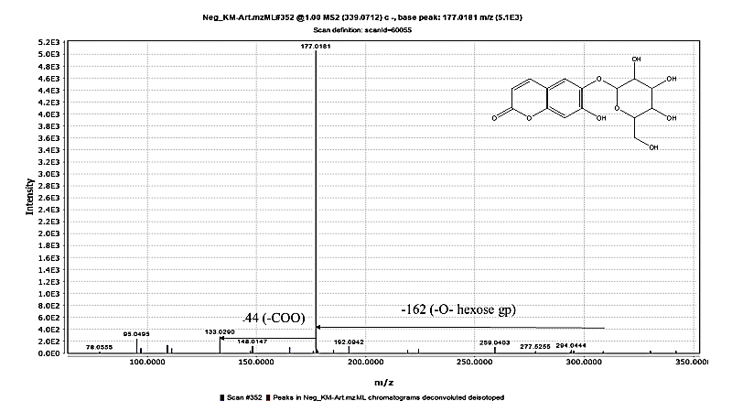MS/MS chromatogram of aesculin detected in A. vulgaris aqueous extract under negative ionization mode.

Figure S12: MS/MS chromatogram of umbelliferone
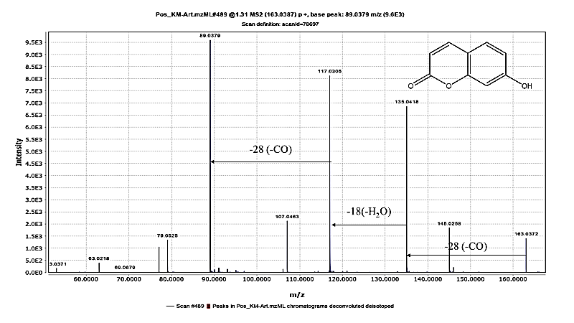MS/MS chromatogram of umbelliferone identified in A. vulgaris aqueous extract under positive ionization mode.

Figure S13: MS/MS chromatogram of aescultin
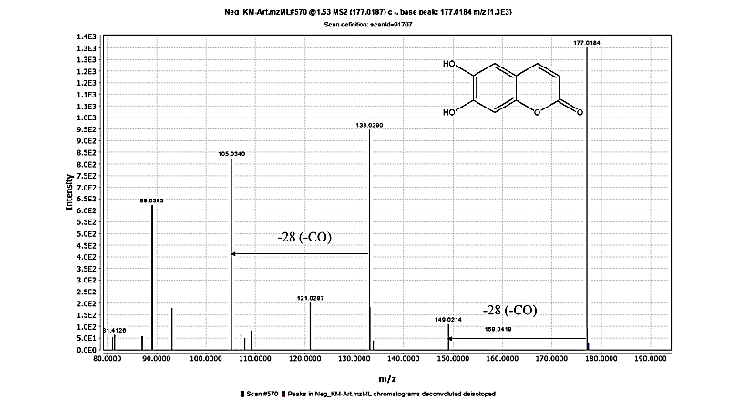MS/MS chromatogram of aesculetin detected in A. vulgaris aqueous extract under negative ionization mode.

Figure S14: MS/MS chromatogram of Vicenin 2
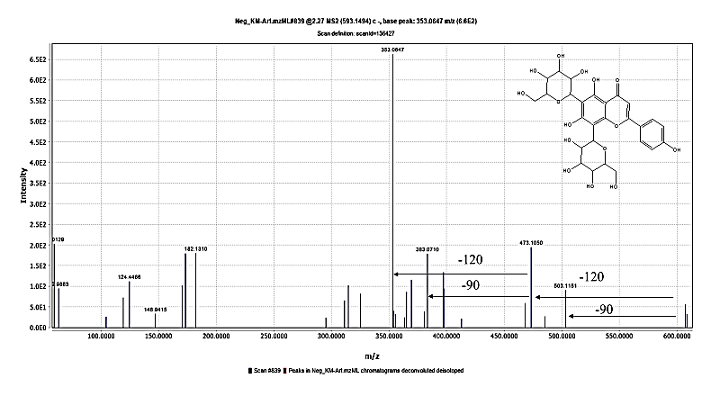MS/MS chromatogram of vicenin II identified in A. vulgaris aqueous extract under negative ionization mode.

Figure S15: MS/MS chromatogram of rutin
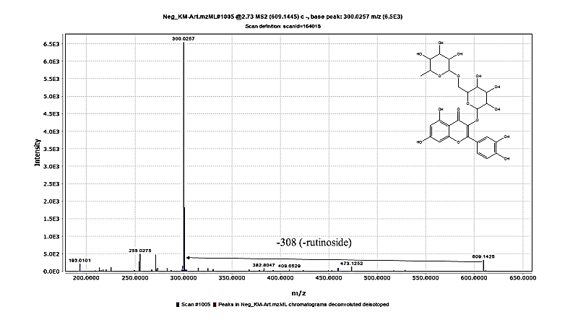
MS/MS chromatogram of rutin identified in A. vulgaris aqueous extract under negative ionization mode.
Figure S16: MS/MS chromatogram of hyperoside
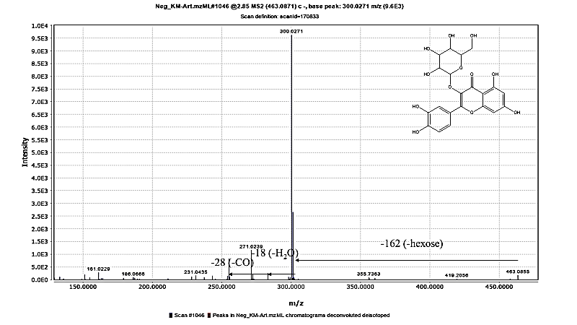MS/MS chromatogram of hyperoside identified in A. vulgaris aqueous extract under negative ionization mode.

Figure S17: MS/MS chromatogram of luteolin
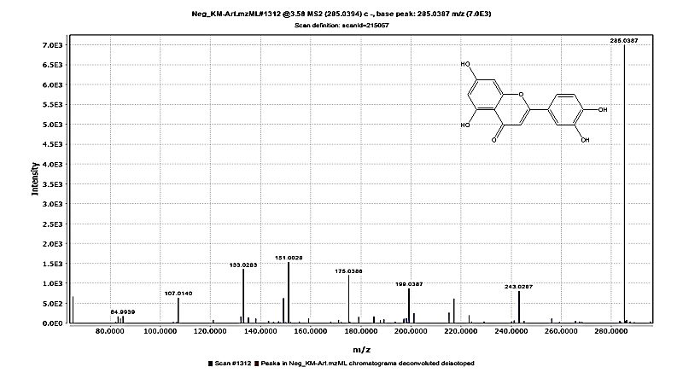MS/MS chromatogram of luteolin identified in A. vulgaris aqueous extract under negative ionization mode.

Figure S18: MS/MS chromatogram of isorhamntin
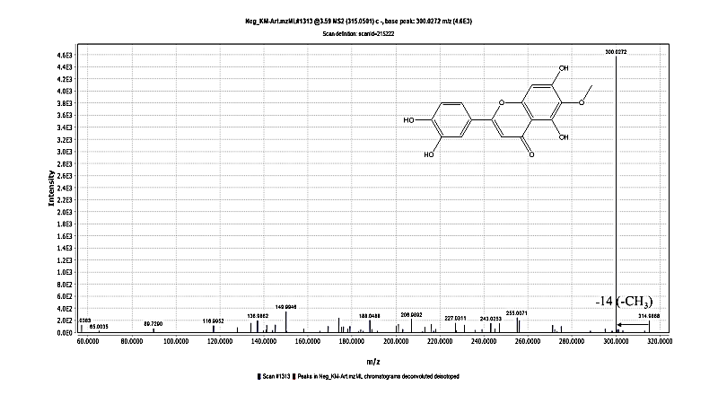
MS/MS chromatogram of isorhamntin identified in A. vulgaris aqueous extract under negative ionization mode.

Figure S19: MS/MS chromatogram of apigenin
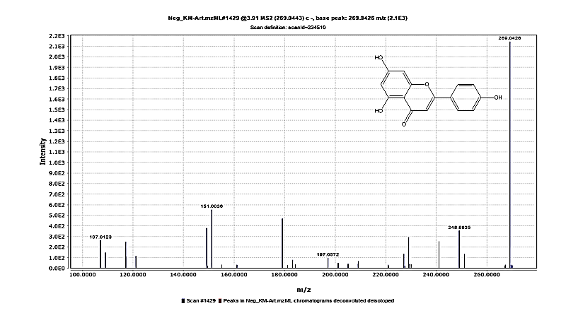MS/MS chromatogram of apigenin identified in A. vulgaris aqueous extract under negative ionization mode.

Figure S20: MS/MS chromatogram of psilostachyin
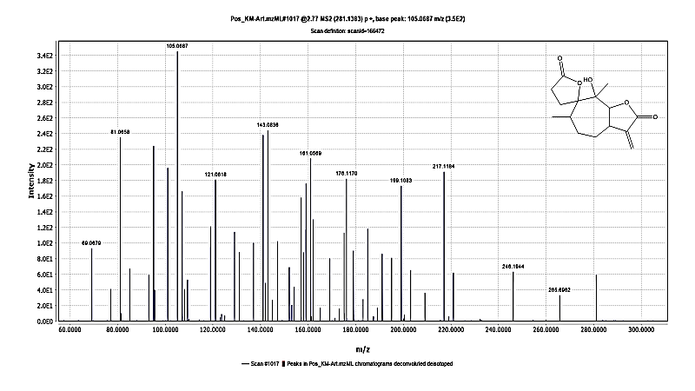MS/MS chromatogram of psilostachyin identified in A. vulgaris aqueous extract under positive ionization mode.

Figure S21: MS/MS chromatogram of vulgarolide
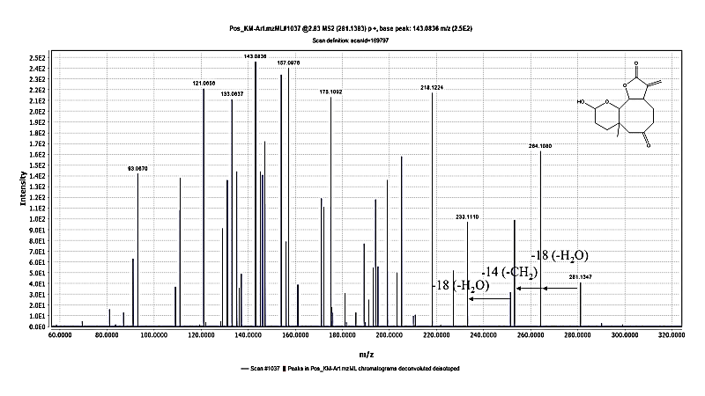MS/MS chromatogram of vulgarolide identified in A. vulgaris aqueous extract under positive ionization mode.

Figure S22: MS/MS positive chromatogram of artemisinin
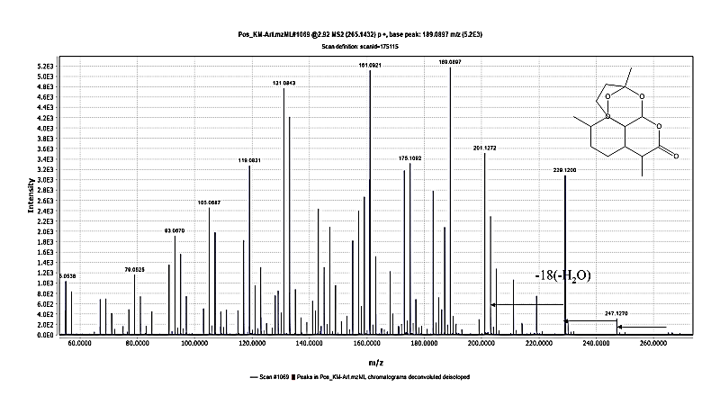MS/MS chromatogram of artemisinin identified in A. vulgaris aqueous extract under positive ionization mode.

Figure S23: MS/MS negative chromatogram of artemisinin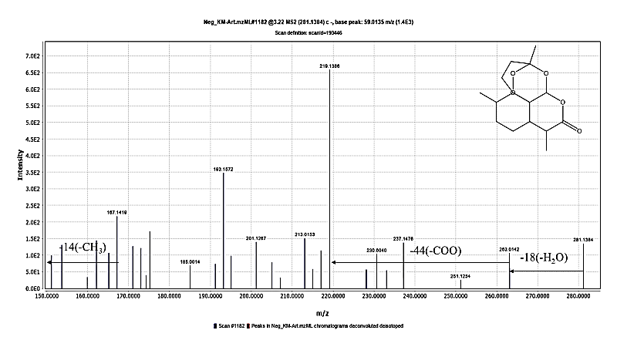MS/MS chromatogram of artemisinin identified in A. vulgaris aqueous extract under negative ionization mode.

Figure S24: MS/MS chromatogram of vulgarin

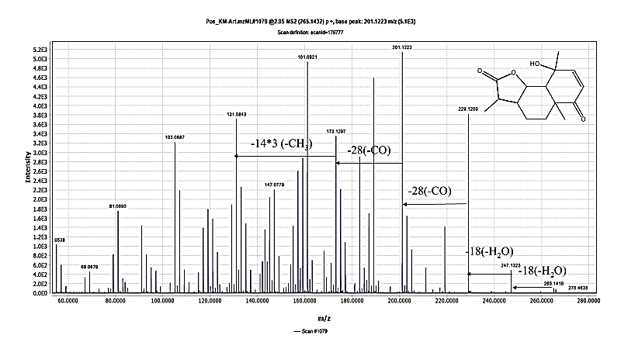MS/MS chromatogram of vulgarin identified in A. vulgaris aqueous extract under positive ionization mode.

Figure S25: MS/MS chromatogram of artemisin
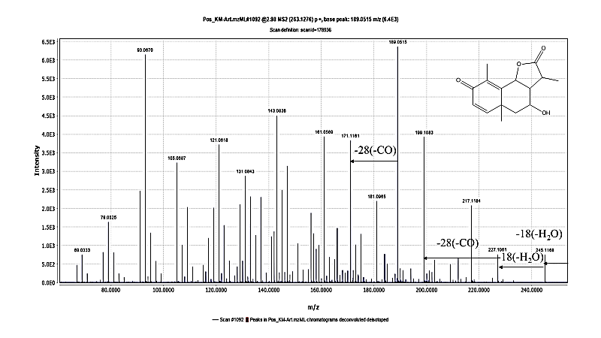MS/MS chromatogram of artemisin identified in A. vulgaris aqueous extract under positive ionization mode.

Figure S26: MS/MS chromatogram of artemin
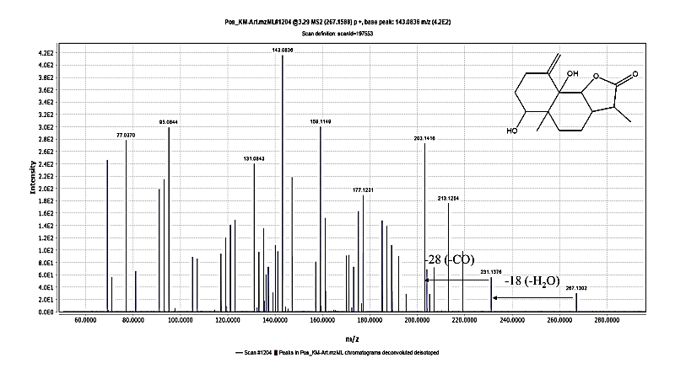MS/MS chromatogram of artemin identified in A. vulgaris aqueous extract under positive ionization mode.

Figure S27: MS/MS chromatogram of artemisinic acid
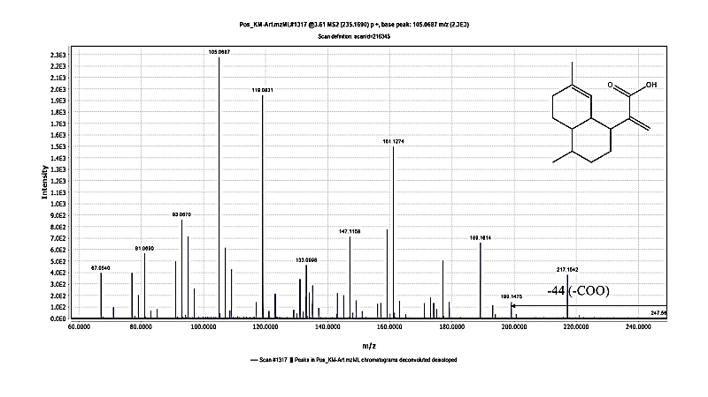MS/MS chromatogram of artemisinic acid identified in A. vulgaris aqueous extract under positive ionization mode.

Figure S28: MS/MS chromatogram of arteannuin b
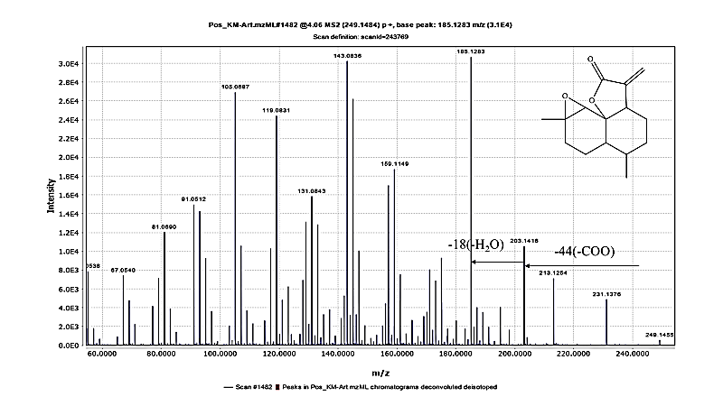MS/MS chromatogram of arteannuin b identified in A. vulgaris aqueous extract under positive ionization mode.

Figure S29: MS/MS chromatogram of α-epoxydihydroartemisinic
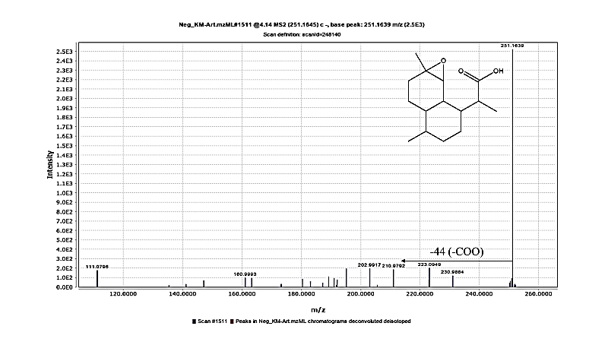MS/MS chromatogram of α-epoxydihydroartemisinic identified in A. vulgaris aqueous extract under negative ionization mode.

Figure S30: MS/MS chromatogram of santonin
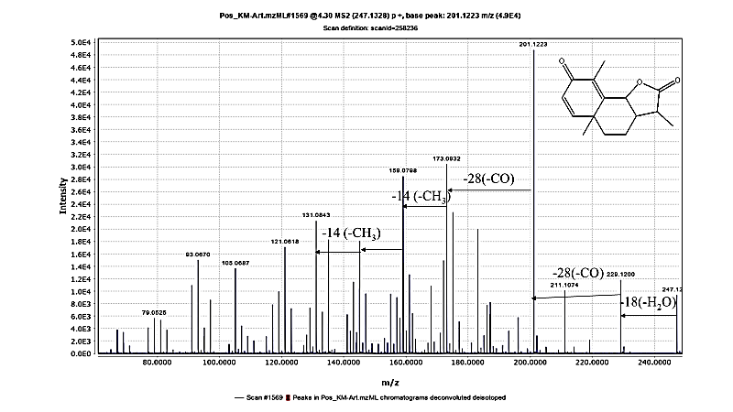MS/MS chromatogram of santonin identified in A. vulgaris aqueous extract under positive ionization mode.

Figure S31: MS/MS chromatogram of costunolide
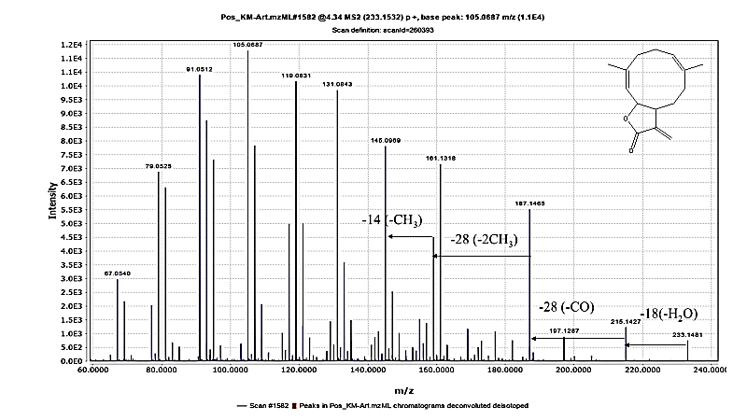
MS/MS chromatogram of costunolide identified in A. vulgaris aqueous extract under positive ionization mode.

Figure S32: MS/MS chromatogram of dihydroartemisinic acid
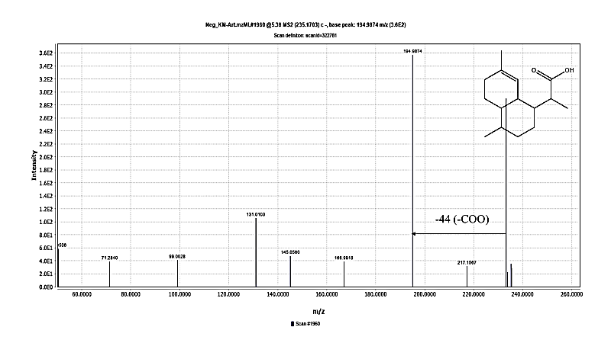MS/MS chromatogram of dihydroartemisinic acid identified in A. vulgaris aqueous extract under negative ionization mode.

Figure S33: MS/MS chromatogram of linolenic acid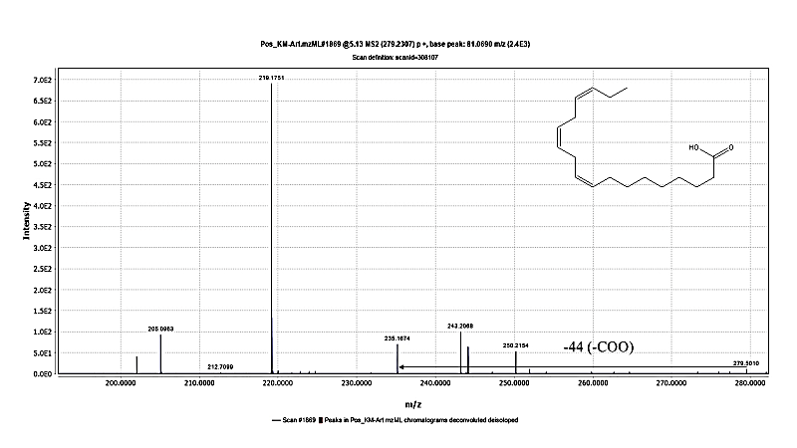
MS/MS chromatogram of linolenic acid identified in A. vulgaris aqueous extract under positive ionization mode.

Table S1: Secondary metabolites identified in Artemisia vulgaris aqueous extract using UHPLC-QTOF-MS/MS in negative and positive mode.
Peak. | RT | Molecular formula | m/z (–)  detected | Mass error (ppm) | MS fragments (m/z) | [M−H]−/ [M+H]+, m/z | Identification
Phenolic acids
1 | 0.4 | C₇H₁₂O₆ | 191.0556 | -2.68 | 173.0448/127.0398/93.0342/ 85.0295/59.0138 | [M−H]− | Quinic acid
2 | 0.78 | C₁₆H₁₈O₉ | 353.0867 | -3.13 | 191.0555/179.0345/173.0445/ 161.0226/155.0346/137.0231/135.0445/129.0551/111.0435/93.0335 | [M−H]− | Caffeoylquinic acid
3 | 0.8 | C₁₃H₁₆O₉ | 315.0715 | -2.08 | 153.0187/109.0283/108.0204 | [M−H]− | Dihydroxybenzoic  acid hexoside isomer
4 | 0.83 | C₇H₆O₄ | 153.0188 | -3.48 | 109.0289/108.0203 | [M−H]− | Dihydroxy benzoic acid
5 | 1.54 | C₉H₈O₄ | 179.0344 | -2.69 | 135.0445/134.0361/107.0485/79.0553 | [M−H]− | Caffeic acid
6 | 2.2 | C₁₆H₁₈O₈ | 337.0921 | -2.35 | 191.0552/173.0443/163.0398/119.0500 /97.0273/93.0338/85.0291 | [M−H]− | Coumaroylquinic acid
7 | 2.4 | C₁₇H₂₀O₉ | 367.1025 | -2.6 | 191.0556/173.0447/129.0185/93.0337 | [M−H]− | Feruloylquinic acid
8 | 3.17 | C₂₅H₂₄O₁₂ | 515.119 | -2.13 | 353.0869/191.0554/173.0449/161.0241/137.0235/135.0443 /111.0449 | [M−H]− | DiCaffeoylquinic acid
9 | 3.28 | C₃₃H₂₈O₁₇ | 695.1241 | -1.83 | 533.2166/371.0580/209.0297 | [M−H]− | Tricaffoylhexaric acid
10 | 3.41 | C₂₅H₂₄O₁₁ | 499.1239 | -1.37 | 191.0554/179.0340/173.0436/163.0399 | [M−H]− | Coumaroylcaffeoylquinic acid
Coumarins
11 | 1 | C₁₅H₁₆O₉ | 339.0712 | -1.93 | 295.0557/177.0818/148.0147/133.0290 | [M−H]− | Aesculin
12 | 1.31 | C₉H₆O₃ | 163.0387 | -1.66 | 145.0258/135.0418/117.0306/107.0463/89.0379/79.0525 | [M+H]+ | Umbelliferenone
13 | 1.53 | C₉H₆O₄ | 177.0187 | -3.01 | 177.0184/149.0214 /133.0290/105.0340/ 89.0393 | [M−H]− | Aesculetin
Flavonoids
14 | 2.27 | C₂₇H₃₀O₁₅ | 593.1494 | -3.02 | 503.1151/473.1050/397.0354/383.0710/365.0205/353.0647/325.0691 | [M−H]− | Vicenin 2
15 | 2.73 | C₂₇H₃₀O₁₆ | 609.1445 | -2.64 | 609.1425/301.0339/300.0257 | [M−H]− | Rutin
16 | 2.85 | C₂₁H₂₀O₁₂ | 463.0877 | -2.73 | 301.0337/300.0271/271.0239/255.0287/178.9952 /151.0006 | [M−H]− | Hyperoside
17 | 3.58 | C₁₅H₁₀O₆ | 285.0394 | -3.72 | 285.0387/243.0287/241.0482/199.0387/175.0386/151.0028/133.0283/107.0140 | [M−H]− | Luteolin
18 | 3.59 | C₁₆H₁₂O₇ | 315.0501 | -2.94 | 301.1266/300.0272/272.0266/255.0071/243.0253/227.0311/136.9862 | [M−H]− | Isorhamnetin
19 | 3.91 | C₁₅H₁₀O₅ | 269.0443 | -4.63 | 269.0426//201.0543/181.0585/151.0036/149.0223/117.0316/107.0123 | [M−H]− | Apigenin
Sesquiterpenes
20 | 2.77 | C₁₅H₂₀O₅ | 281.1383 | -0.18 | 265.6962/ 246.1944/ 217.1184/ 199.1083 | [M+H]+ | Psilostachyin
21 | 2.83 | C₁₅H₂₀O₅ | 281.1383 | -0.18 | 281.1347/ 264.1080/ 253.1020/233.1110/ 218.1224 | [M+H]+ | Vulgarolide
22 | 2.92 | C₁₅H₂₁O₄ | 265.1432 | -0.89 | 265.1432/ 247.1270/ 229.1200/ 211.1074 | [M+H-H₂O]+ | Artemisinin
22 | 3.22 | C₁₅H₂₂O₅ | 281.1384 | -3.73 | 237.1476/219.1386 | [M−H]− | Artemisinin
23 | 2.95 | C₁₅H₂₀O₄ | 265.1432 | -0.89 | 247.1325/229.1200/201.1223/173.1297/131.0843 | [M+H]+ | Vulgarin
24 | 2.98 | C₁₅H₁₈O₄ | 263.1276 | -0.71 | 245.1168/233.1110/ 227.1061/ 199.1083/171.1161/91.0512/72.2907 | [M+H]+ | Artemisin
25 | 3.29 | C₁₅H₂₂O₄ | 267.1588 | -1.07 | 231.1376/203.1416 | [M+H]+ | Artemin
26 | 3.61 | C₁₅H₂₂O₂ | 235.1690 | -1.09 | 217.1542/199.1475 | [M+H]+ | Artemisinic acid
27 | 4.06 | C₁₅H₂₀O₃ | 249.1484 | -0.49 | 231.1376/203.1416/185.1283/173.0932/157.0976/145.0969/131.0843/117.0681/111.0788/105.0687 | [M+H]+ | Arteannuin B
28 | 4.14 | C₁₅H₂₄O₃ | 251.1645 | -3.06 | 205.5379/191.6805 | [M−H]− | α-Epoxy dihydroartemisinic
29 | 4.3 | C₁₅H₁₈O₃ | 247.1328 | -0.29 | 229.1200/201.1223/173.0932/168.0906/159.0798/153.0673/145.0969/135.0781/131.0843 | [M+H]+ | Santonin
30 | 4.34 | C₁₅H₂₀O₂ | 233.1532 | -1.74 | 215.1427/187.1465/159.1149/145.0969/131.0843/119.0831/105.0687/95.0844/81.0690 | [M+H]+ | Costunolide
31 | 5.38 | C₁₅H₂₄O₂ | 235.1703 | -0.23 | 217.1567/194.9874 | [M−H]− | Dihydroartemisinic acid
Fatty acids
32 | 5.13 | C₁₈H₃₀O₂ | 279.2307 | 7.68 | 243.2068/235.1674/219.1751/137.1321/123.0798/109.0641/95.0844/81.0690/67.0540 | [M+H]+ | α-linolenic acid
Identified secondary metabolites in A. vulgaris aqueous extract using UHPLC-QTOF-MS/MS analysis in both negative and positive ionization modes. RT: retention time; m/z: mass-to-charge ratio; ppm: parts per million. Fragment ions are presented as detected MS/MS peaks. Identification was based on molecular formula, fragmentation pattern, and comparison with reported literature.

Table S2: Molecular docking of compounds exhibiting the strongest interactions against apoptotic and autophagic targeted proteins.
Protein | Compound | 2D | 3D | binding energy (kcal/mol) | Amino acid residue interaction | Bonding type
Apoptosis proteins
BCL2 | Co-crystallized ligand | 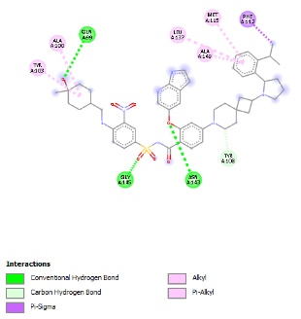 | 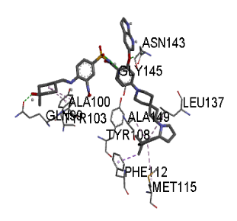 | -10.5 | ALA A:100 ALA A:149  ASN A:143 GLN A:99 GLY A:145 LEU A:137 MET A:115  PHE A:112  TYR A:103  TYR A:108 | Alkyl bond  π -Alkyl bond  Conventional H- bond  Conventional H- bond Conventional H- bond  π -Alkyl bond  π -Alkyl bond  π -sigma  Alkyl bond  Carbon H- bond
BCL2 | *Aesculin | 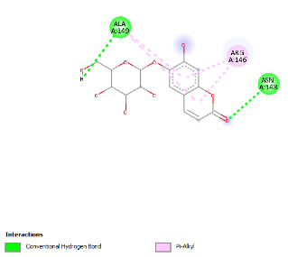 | 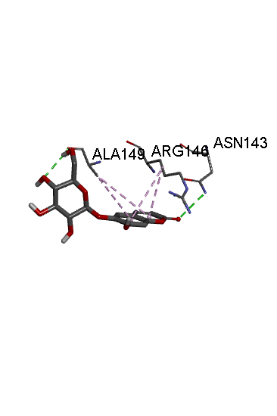 | -6.4 | *ALA A:149  ARG A:146 *ASN A:143 | Conventional H- bond & π -Alkyl bond  π -Alkyl bond  Conventional H- bond
BCL2 | *Coumaroylquinic acid | 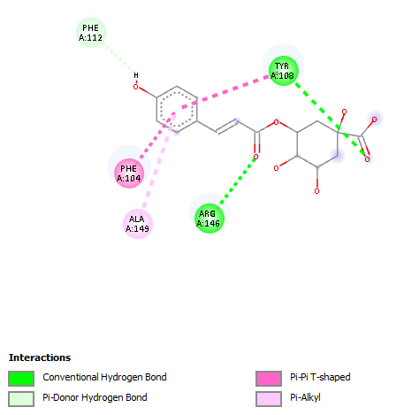 | 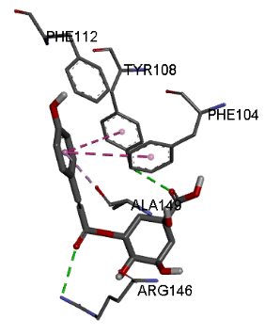 | -7.0 | *ALA A:149  ARG A:146 PHE A:104 PHE A:112 *TYR A:108 | π -Alkyl bond  Conventional H- bond  π–π T-shaped  π-Doner H- bond  Conventional H- bond & π–π T-shaped
BCL2 | *Luteolin | 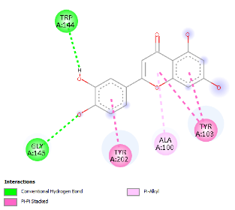 | 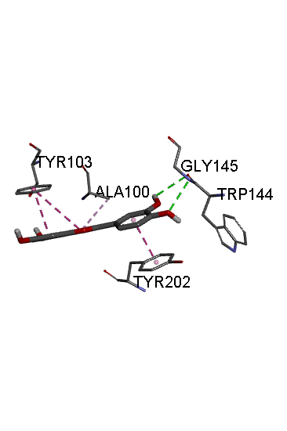 | -6.3 | *ALA A:100 *GLY A:145  TRP A:144 *TYR A:103 TYR A: 202 | π -Alkyl bond  Conventional H- bond  Conventional H- bond  π–π Stacked  π–π Stacked
P53 | Co-crystallized ligand | 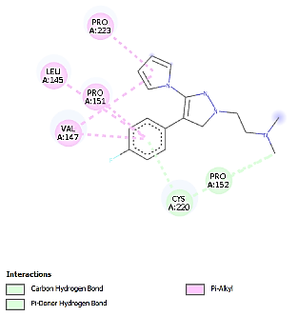 | 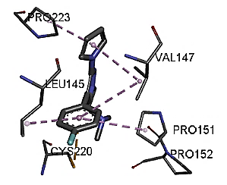 | -7.4 | CYS A:220  PRO A:152  LEU A:145  PRO A:151  PRO A:223  VAL A:147 | Carbon H- bond & π-doner H-bond  π- Alkyl  π- Alkyl  π- Alkyl  π- Alkyl
 | *Aesculin | 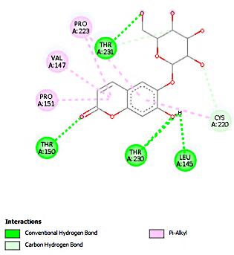 | 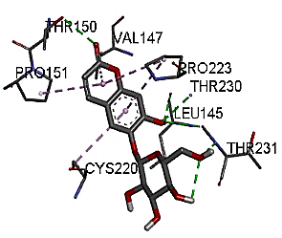 | -7.4 | *CYS A:220  *LEU A:145  *PRO A: 151  *PRO A:223  THR A:150  THR A:230  THR A:231  *VAL A:147 | Carbon H- bond & π- Alkyl  Conventional H-bond  π- Alkyl  π- Alkyl  Conventional H-bond  Conventional H-bond  Conventional H-bond & carbon H-bond  π- Alkyl
 | *Chlorogenic acid | 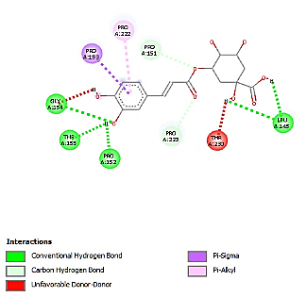 | 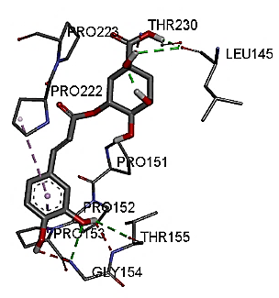 | -7.3 | GLY A:154  *LEU A:145  *PRO A:151  *PRO A:152  PRO A:153  PRO A:222  *PRO A:223  THR A:155  THR A:230 | Conventional H-bond & unfavorable D-D  Conventional H-bond  Carbon H-bond  Conventional H-bond  π-Sigma  π- Alkyl  Carbon H-bond  Conventional H-bond  unfavorable D-D
 | *Coumaroylquinic acid | 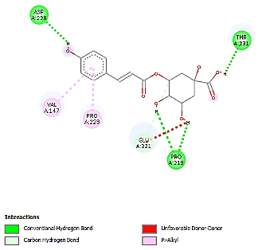 | 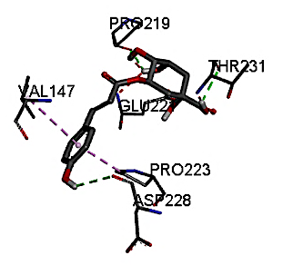 | -7.3 | ASP A:228  GLU A:221  PRO A:219  *PRO A:223  THR A:231  *VAL A:147 | Conventional H-bond  Carbon H-bond &  Unfavorable D-D  Conventional H-bond  π- Alkyl  Conventional H-bond  π- Alkyl
Autophagy proteins
LC3C | Co-crystallized ligand | 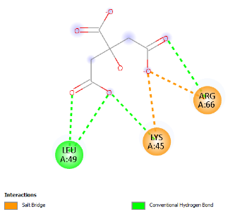 | 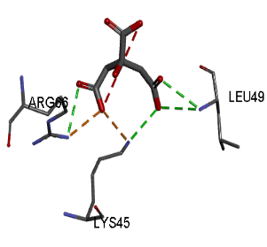 | -3.8 | ARG A:66  LEU A:49  LYS A:45 | Conventional H-bond & Salt bridge  Conventional H-bond  Conventional H-bond & Salt bridge
LC3C | *Chlorogenic acid | 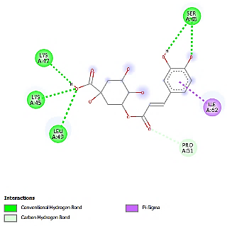 | 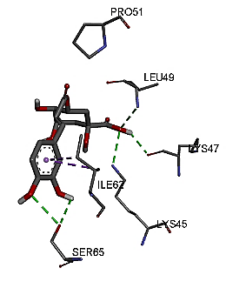 | -4.7 | ILE A:62  *LEU A:49 *LYS A:45  LYS A:47  PRO A:51  SER A:65 | π- Sigma  Conventional H-bond  Conventional H-bond  Conventional H-bond  Carbon H-bond  Conventional H-bond
LC3C | *Coumaroylquinic acid | 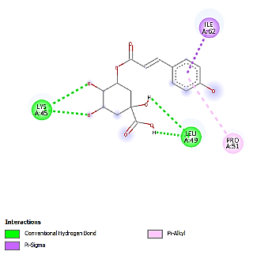 | 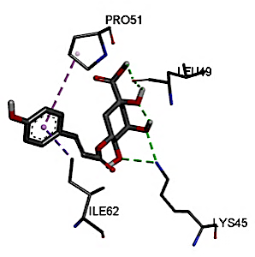 | -4.7 | ILE A:62  *LEU A:49 *LYS A:45  PRO A:51 | π- Sigma  Conventional H-bond  Conventional H-bond  π-Alkyl
LC3C | *Umbelliferone | 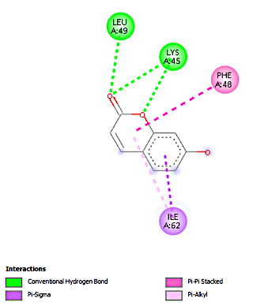 | 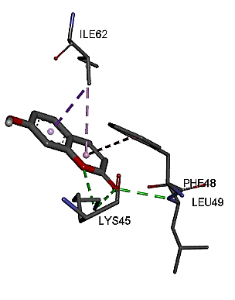 | -4.8 | ILE A:62  *LEU A:49  *LYS A:45  PHE A:48 | π- Sigma & π- Alkyl  Conventional H-bond  Conventional H-bond  π- π- Stacked
MTOR | Co-crystallized ligand | 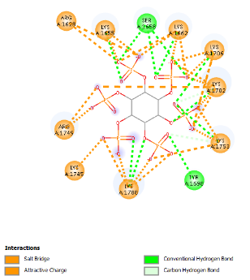 | 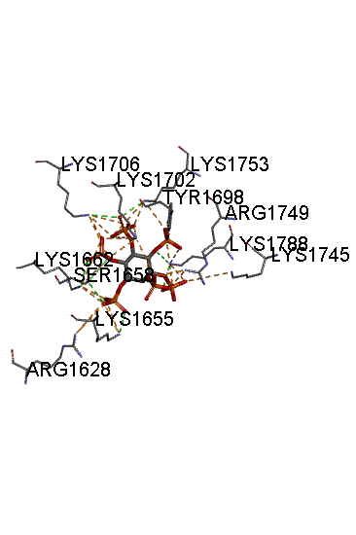 | -5.9 | ARG A:1628  ARG A:1749  LYS A:1655 LYS A:1745  LYS A:1788 LYS A:1662 LYS A:1702 LYS A:1706 LYS A:1753 SER A:1658 TYR A:1698 | Attractive charge& salt bridge  Attractive charge& salt bridge  Conventional H- bond  Attractive charge& salt bridge  Conventional H-bond  Conventional H-bond  Conventional H-bond  Conventional H-bond  Conventional H-bond  Conventional H-bond  Conventional H-bond & Carbon H-bond
MTOR | *Aesculin | 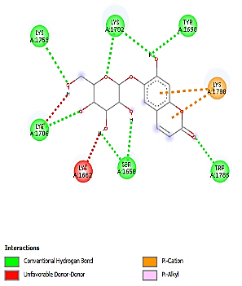 | 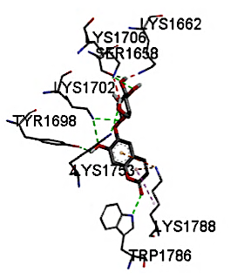 | -5.1 | *LYS A:1702 *LYS A:1706  *LYS A:1753 *SER A:1658 *TYR A:1698 TRP A:1786. *LYS A:1788, *LYS A:1662 | Conventional H- bond  Conventional H- bond &unfavorable D-D  Conventional H- bond  Conventional H- bond  Conventional H- bond  Conventional H- bond  π -Cation  unfavorable D-D
MTOR | *Artemisinin | 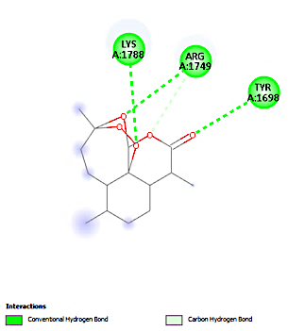 | 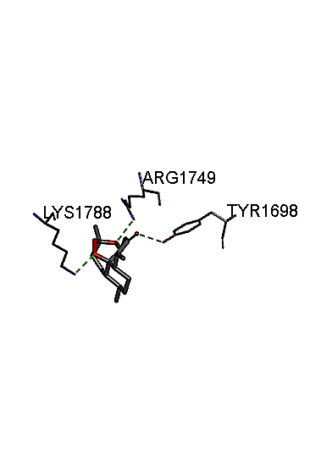 | -5.4 | *ARG A:1749  *LYS A:1788 *TYR A:1698 | Conventional H- bond  & Carbon H-bond  Conventional H- bond  Conventional H- bond
MTOR | *Rutin | 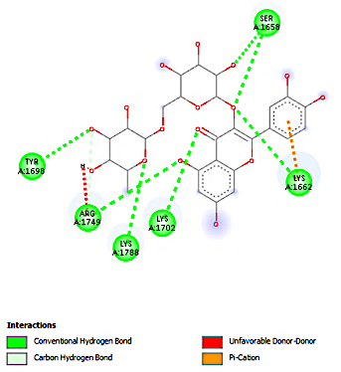 | 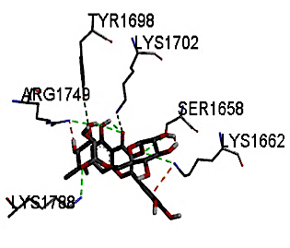 | -6 | *ARG A:1749  *LYS A:1662  *LYS A:1702 *LYS A:1788 *SER A:1658 *TYR A:1698 | Conventional H- bond &unfavorable D-D & Cabon H- bond  Conventional H- bond & π -Cation  Conventional H- bond  Conventional H- bond  Conventional H- bond  Conventional H- bond
Molecular docking results of selected compounds showing the strongest binding interactions with apoptosis- (BCL2, P53) and autophagy-related (LC3C, mTOR) proteins. Binding energy is expressed in kcal/mol. Amino acid residues involved in ligand–protein interactions and types of bonding (e.g., hydrogen bonding, π-alkyl, π–π interactions) are presented. Co-crystallized ligands were used as reference standards.

