Synergistic anti-cancer activity of Artemisia vulgaris L. aqueous extract with cisplatin against A549 Lung cancer cell line

Seham Salah El-Din Elhawary¹, Hadeel Nabil Ahmed^{1, *}, Mouchira A. Choucry ^{2,1}, Rasha M. Allam³, Osama G. Mohamed^{1,4}, Kamel Mahmoud Kamel^{5 #}, Amira K. Elmotayam^{1 #}
¹ Department of Pharmacognosy, Faculty of Pharmacy, Cairo University, Kasr el-Aini Street, Cairo, 11562, Egypt
² Department of Pharmacognosy, Faculty of Pharmacy and Drug Technology, Egyptian Chinese University, 11786 Cairo, Egypt
³ Pharmacology Department, Medical Research Institute, National Research Center, 33 El-Bohouth St., Dokki, P.O.12622, Cairo, Egypt.
⁴ Natural Products Discovery Core, Life Sciences Institute, University of Michigan, Ann Arbor, MI 48109, USA
⁵ Department of pharmacognosy, Faculty of Pharmaceutical Sciences & Drug Manufacturing, Misr University for Science and Technology, Giza, Egypt
*Corresponding authors emails: Hadeel Nabil (hadeelnabil248@gmail.com)
# The last two authors contributed equally to this work

Figure S1: Calibration curve of quercetin standard for total flavonoid content determination

Calibration curve constructed using quercetin standard solutions at different concentrations. Absorbance was measured at 420 nm using the aluminum chloride colorimetric assay. The regression equation was y = 0.003572x + 0.0837 with a correlation coefficient (R²) of 0.9992

Figure S2: Calibration curve of gallic acid standard for total phenolic content determination

Calibration curve constructed using gallic acid standard solutions at different concentrations. Absorbance was measured at 630 nm using the Folin–Ciocalteu assay. The regression equation was y = 0.004644x + 0.01193 with a correlation coefficient (R²) of 0.9991.

Figure S3: MS/MS chromatogram of quinic acid
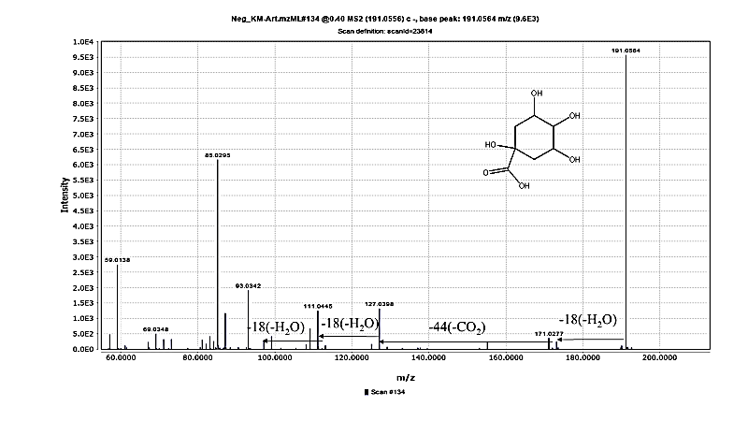 MS/MS chromatogram of quinic acid detected in A. vulgaris aqueous extract under negative ionization mode using UHPLC-QTOF-MS/MS.

Figure S4: MS/MS chromatogram of chlorogenic acid
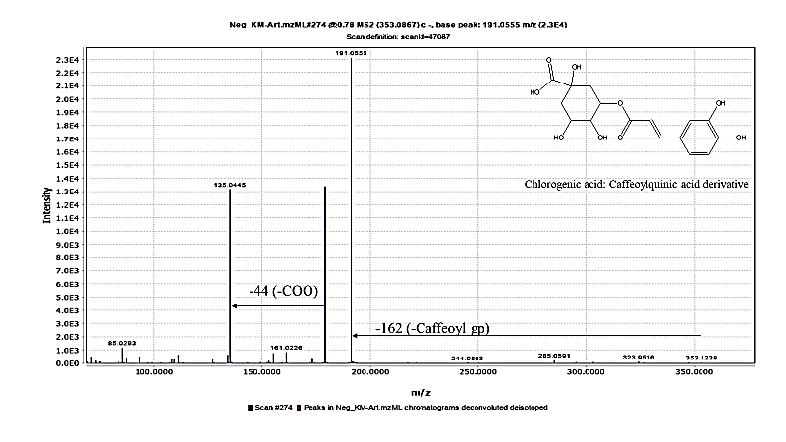MS/MS chromatogram of chlorogenic acid identified in A. vulgaris aqueous extract under negative ionization mode.

Figure S5: MS/MS chromatogram of dihydroxybenzoic acid hexoside isomer
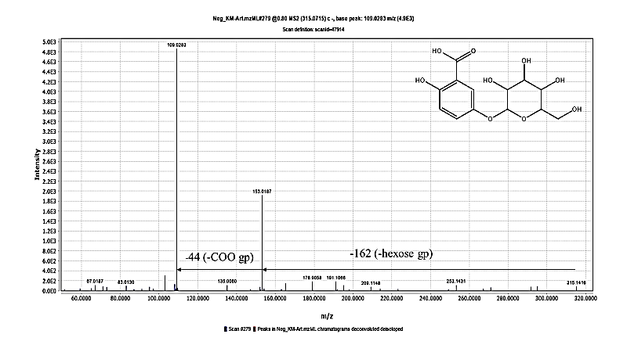
MS/MS chromatogram of dihydroxybenzoic acid hexoside isomer detected in A. vulgaris aqueous extract under negative ionization mode.
Figure S6: MS/MS chromatogram of dihydroxy benzoic acid
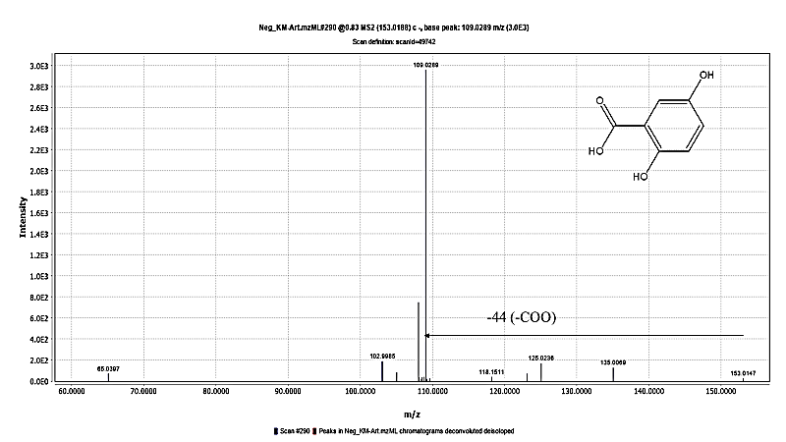
MS/MS chromatogram of dihydroxybenzoic acid identified in A. vulgaris aqueous extract under negative ionization mode.

Figure S7: MS/MS chromatogram of caffeic acid
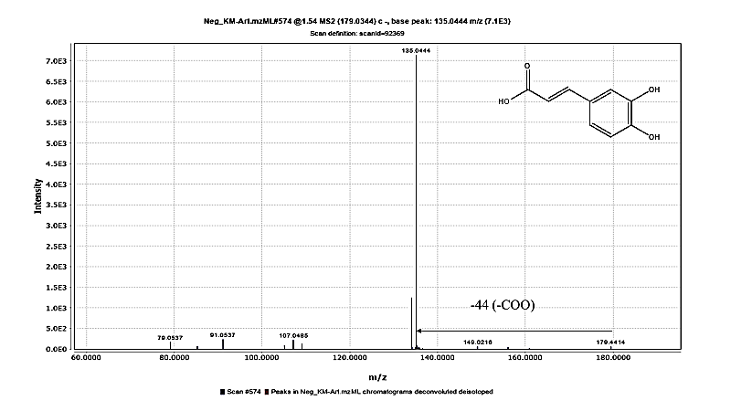MS/MS chromatogram of caffeic acid detected in A. vulgaris aqueous extract under negative ionization mode.
Figure S8: MS/MS chromatogram of coumaroylquinic acid
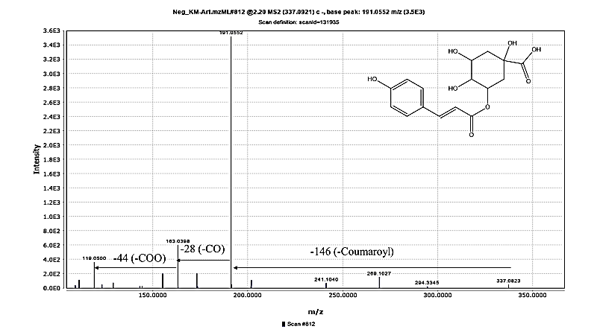MS/MS chromatogram of coumaroylquinic acid identified in A. vulgaris aqueous extract under negative ionization mode.

Figure S9: MS/MS chromatogram of feruloylquinic acid
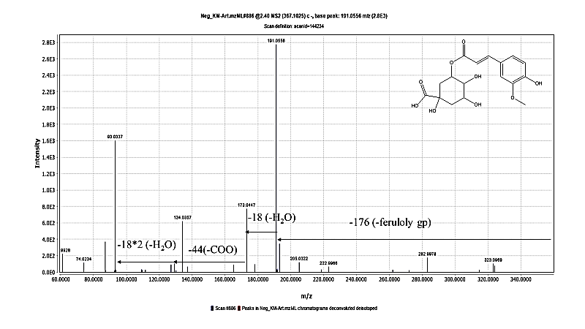MS/MS chromatogram of feruloylquinic acid detected in A. vulgaris aqueous extract under negative ionization mode.
Figure S10: MS/MS chromatogram of dicaffeoylquinic acid
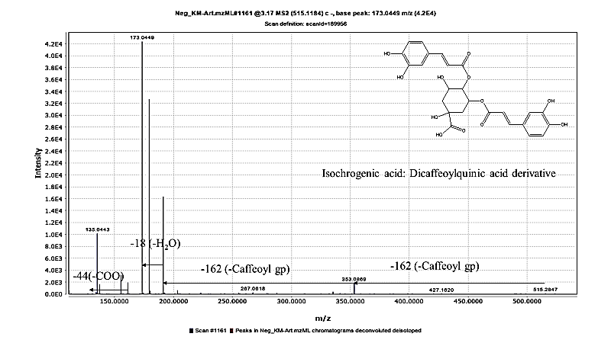
MS/MS chromatogram of dicaffeoylquinic acid identified in A. vulgaris aqueous extract under negative ionization mode.

Figure S11: MS/MS chromatogram of tricaffeoylhexaric acid isomer
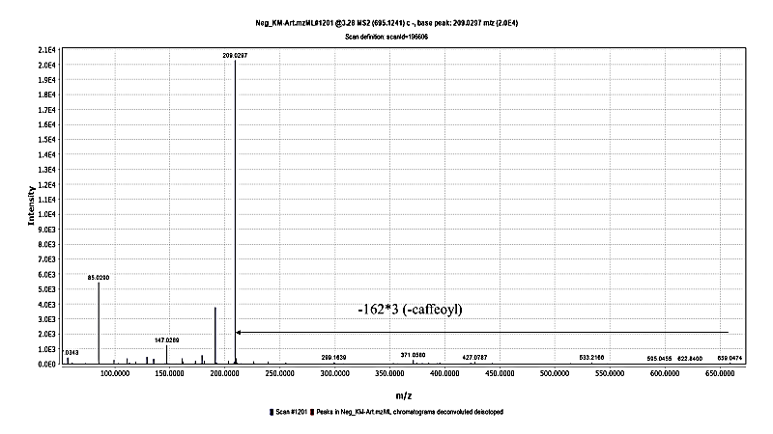MS/MS chromatogram of tricaffeoylhexaric acid isomer detected in A. vulgaris aqueous extract under negative ionization mode.

Figure S12: MS/MS chromatogram of coumaroylcaffeoylquinic acid isomer
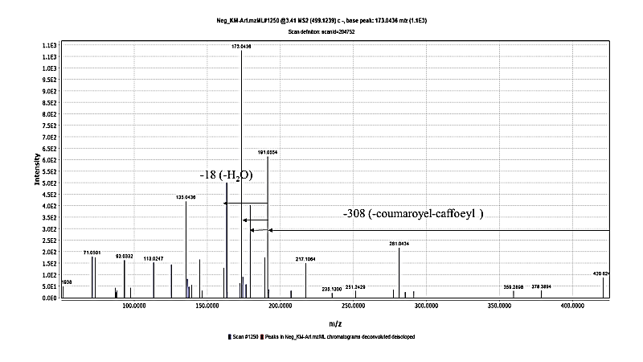MS/MS chromatogram of coumaroylcaffeoylquinic acid isomer identified in A. vulgaris aqueous extract under negative ionization mode.

Figure S13: MS/MS chromatogram of aesculin
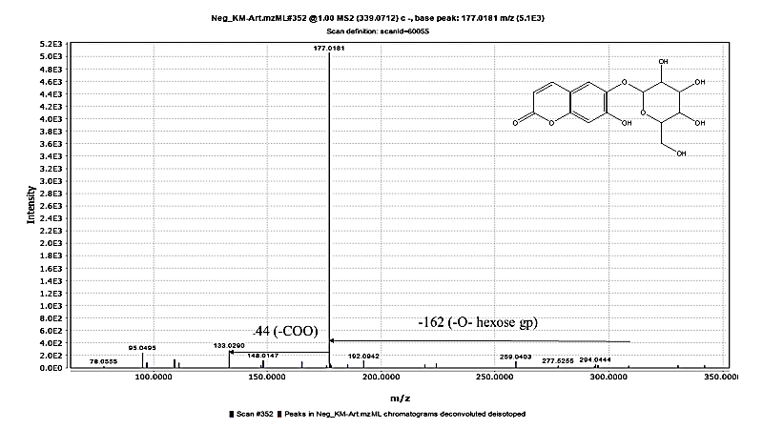MS/MS chromatogram of aesculin detected in A. vulgaris aqueous extract under negative ionization mode.

Figure S14: MS/MS chromatogram of umbelliferone
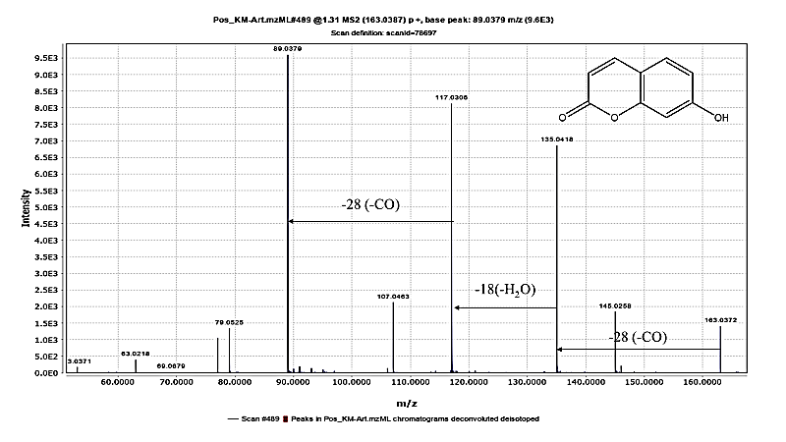MS/MS chromatogram of umbelliferone identified in A. vulgaris aqueous extract under positive ionization mode.

Figure S15: MS/MS chromatogram of aescultin
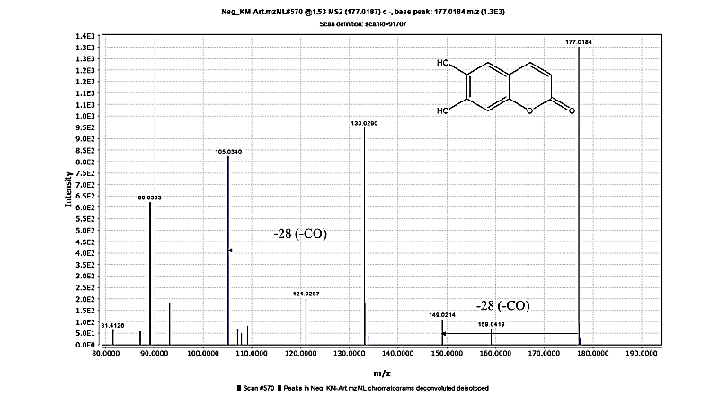MS/MS chromatogram of aesculetin detected in A. vulgaris aqueous extract under negative ionization mode.

Figure S16: MS/MS chromatogram of Vicenin 2
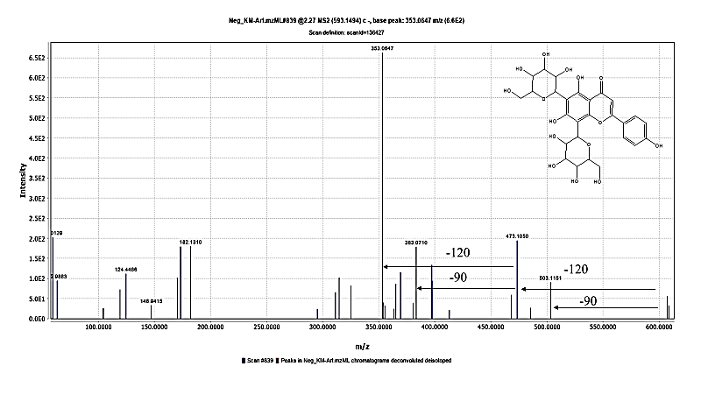MS/MS chromatogram of vicenin II identified in A. vulgaris aqueous extract under negative ionization mode.

Figure S17: MS/MS chromatogram of rutin
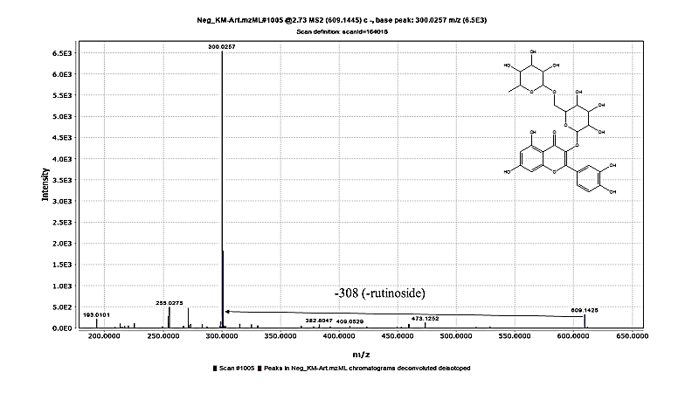
MS/MS chromatogram of rutin identified in A. vulgaris aqueous extract under negative ionization mode.
Figure S18: MS/MS chromatogram of hyperoside
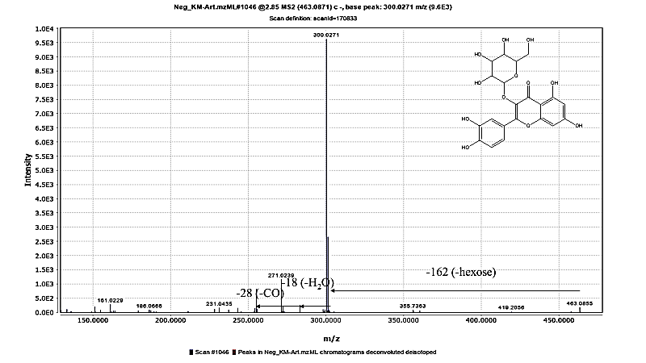MS/MS chromatogram of hyperoside identified in A. vulgaris aqueous extract under negative ionization mode.

Figure S19: MS/MS chromatogram of luteolin
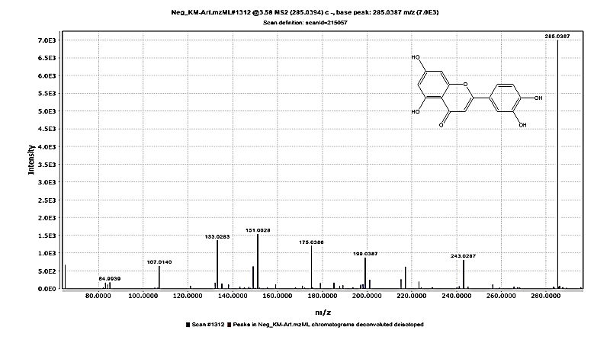MS/MS chromatogram of luteolin identified in A. vulgaris aqueous extract under negative ionization mode.

Figure S20: MS/MS chromatogram of isorhamntin
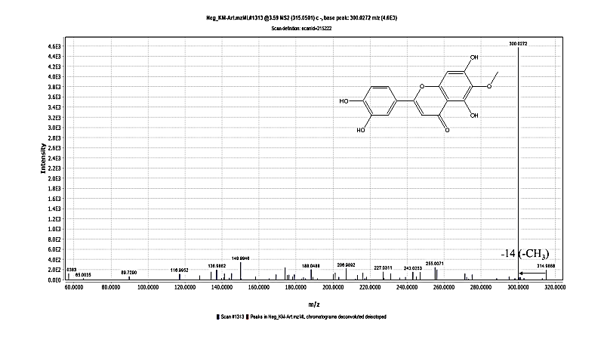
MS/MS chromatogram of isorhamntin identified in A. vulgaris aqueous extract under negative ionization mode.

Figure S21: MS/MS chromatogram of apigenin
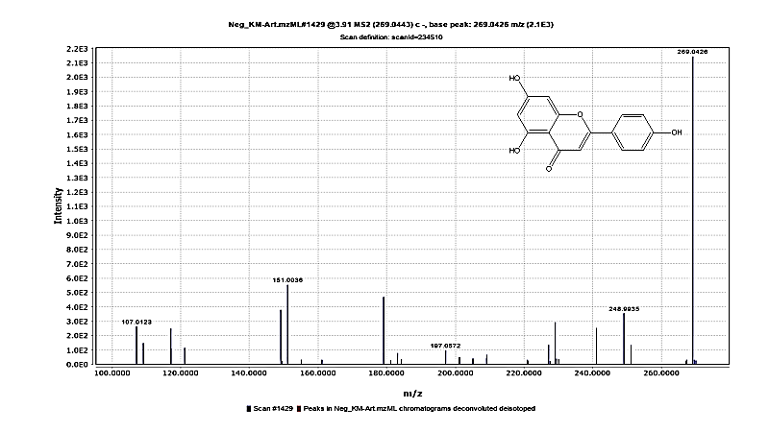MS/MS chromatogram of apigenin identified in A. vulgaris aqueous extract under negative ionization mode.

Figure S22: MS/MS chromatogram of psilostachyin
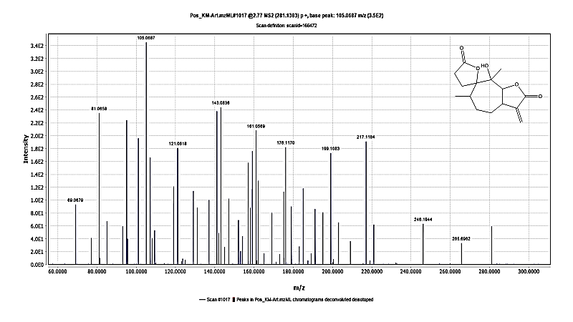MS/MS chromatogram of psilostachyin identified in A. vulgaris aqueous extract under positive ionization mode.

Figure S23: MS/MS chromatogram of vulgarolide
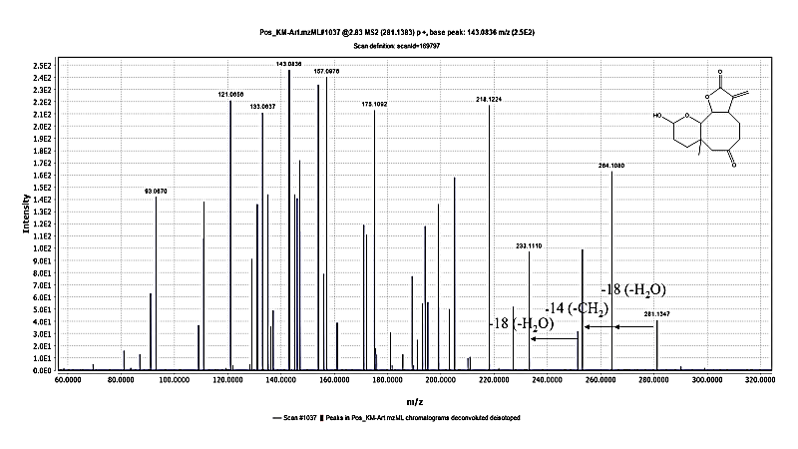MS/MS chromatogram of vulgarolide identified in A. vulgaris aqueous extract under positive ionization mode.

Figure S24: MS/MS positive chromatogram of artemisinin
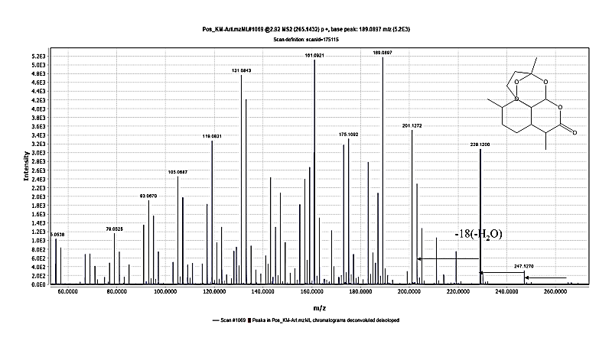MS/MS chromatogram of artemisinin identified in A. vulgaris aqueous extract under positive ionization mode.

Figure S25: MS/MS negative chromatogram of artemisinin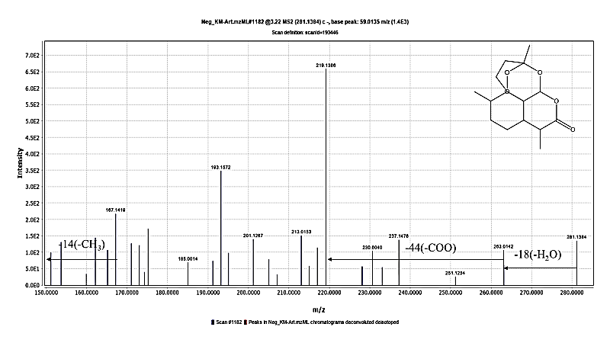MS/MS chromatogram of artemisinin identified in A. vulgaris aqueous extract under negative ionization mode.

Figure S26: MS/MS chromatogram of vulgarin

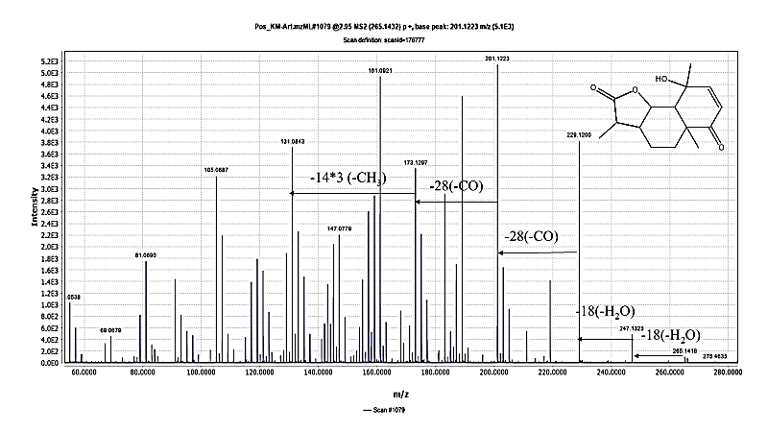MS/MS chromatogram of vulgarin identified in A. vulgaris aqueous extract under positive ionization mode.

Figure S27: MS/MS chromatogram of artemisin
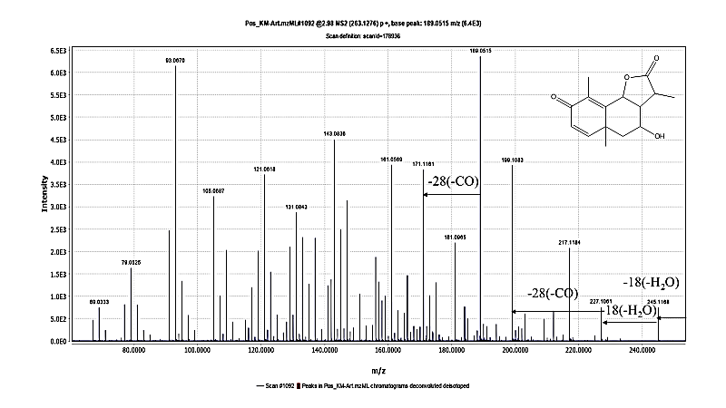MS/MS chromatogram of artemisin identified in A. vulgaris aqueous extract under positive ionization mode.

Figure S28: MS/MS chromatogram of artemin
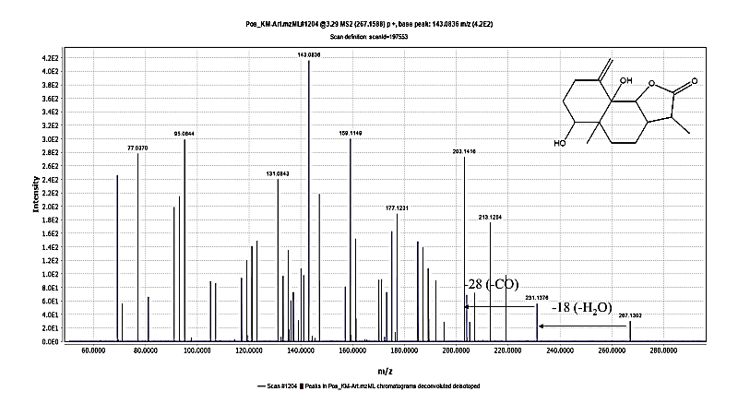MS/MS chromatogram of artemin identified in A. vulgaris aqueous extract under positive ionization mode.

Figure S29: MS/MS chromatogram of artemisinic acid
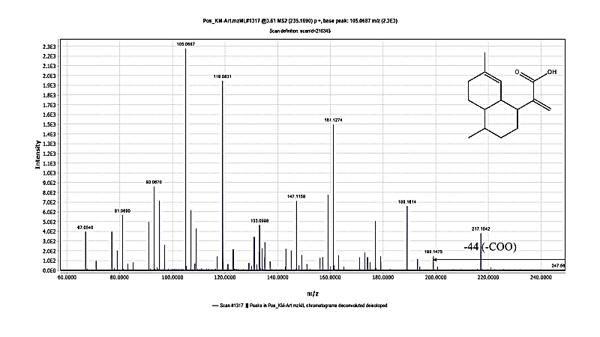MS/MS chromatogram of artemisinic acid identified in A. vulgaris aqueous extract under positive ionization mode.

Figure S30: MS/MS chromatogram of arteannuin b
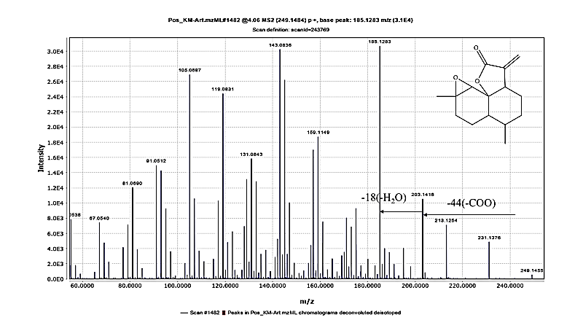MS/MS chromatogram of arteannuin b identified in A. vulgaris aqueous extract under positive ionization mode.

Figure S31: MS/MS chromatogram of α-epoxydihydroartemisinic
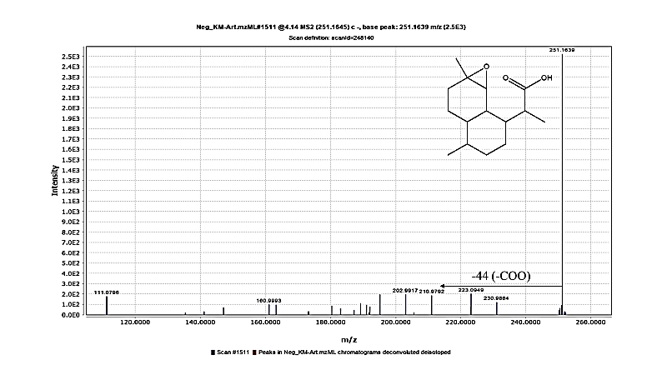MS/MS chromatogram of α-epoxydihydroartemisinic identified in A. vulgaris aqueous extract under negative ionization mode.

Figure S32: MS/MS chromatogram of santonin
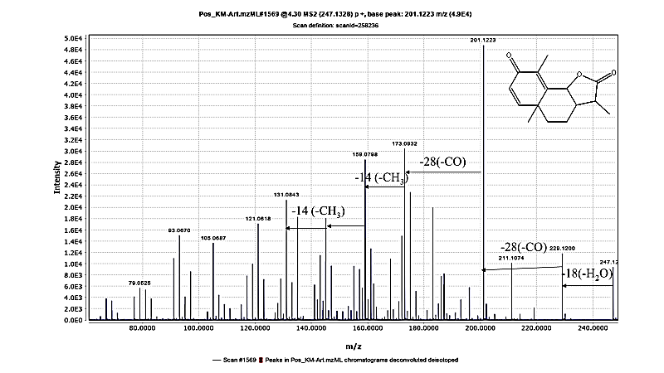MS/MS chromatogram of santonin identified in A. vulgaris aqueous extract under positive ionization mode.

Figure S33: MS/MS chromatogram of costunolide
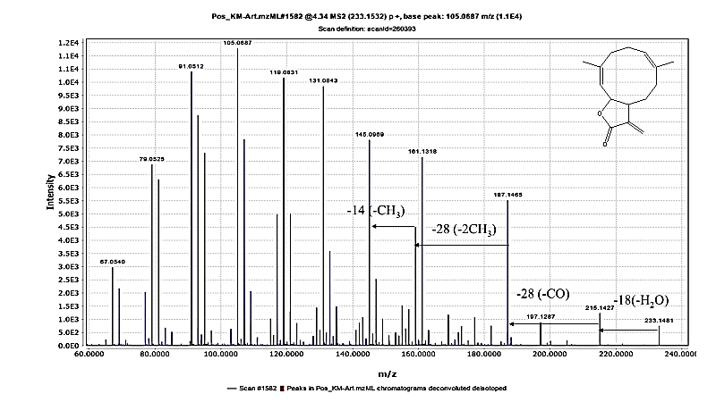
MS/MS chromatogram of costunolide identified in A. vulgaris aqueous extract under positive ionization mode.

Figure S34: MS/MS chromatogram of dihydroartemisinic acid
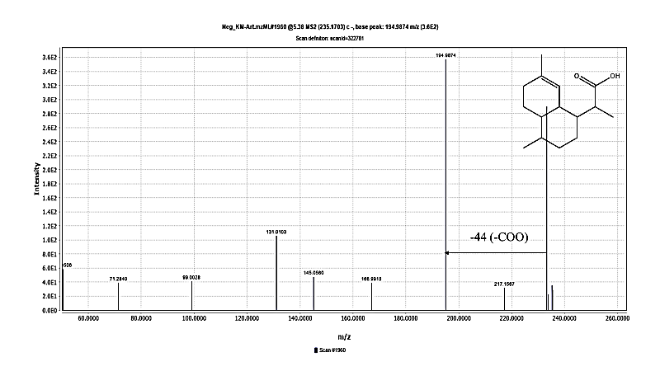MS/MS chromatogram of dihydroartemisinic acid identified in A. vulgaris aqueous extract under negative ionization mode.

Figure S35: MS/MS chromatogram of linolenic acid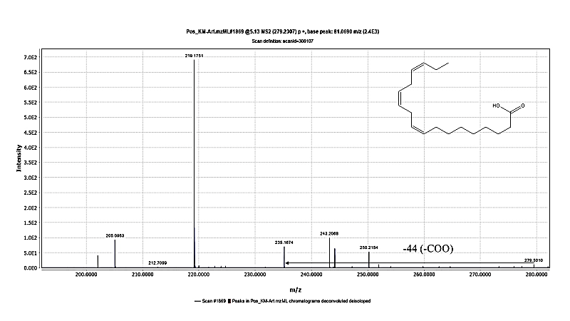
MS/MS chromatogram of linolenic acid identified in A. vulgaris aqueous extract under positive ionization mode.

Figure S36. Raw gating data of apoptosis results
(A) Control cells. (B) A. vulgaris extract (ART)-treated cells. (C) Cisplatin (CIS)-treated cells. (D) ART–CIS combination-treated cells.

Figure S37: Compusyn report
Complete CompuSyn report for Chou–Talalay analysis of the interaction between Artemisia vulgaris aqueous extract (ART) and cisplatin (CIS) in A549 cells. The report includes the dose–effect curves, median-effect analysis, combination index (CI) analysis, isobologram, dose reduction index (DRI) analysis, Fa–CI plots, and the complete numerical output generated by CompuSyn software for the fixed-ratio combination (ART: CIS = 30:1).

Table S1: Secondary metabolites identified in Artemisia vulgaris aqueous extract using UHPLC-QTOF-MS/MS in negative and positive mode.
Peak. | RT | Molecular formula | m/z (–)  detected | Mass error (ppm) | MS fragments (m/z) | [M−H]−/ [M+H]+, m/z | Identification
Phenolic acids
1 | 0.4 | C₇H₁₂O₆ | 191.0556 | -2.68 | 173.0448/127.0398/93.0342/ 85.0295/59.0138 | [M−H]− | Quinic acid
2 | 0.78 | C₁₆H₁₈O₉ | 353.0867 | -3.13 | 191.0555/179.0345/173.0445/ 161.0226/155.0346/137.0231/135.0445/129.0551/111.0435/93.0335 | [M−H]− | Caffeoylquinic acid
3 | 0.8 | C₁₃H₁₆O₉ | 315.0715 | -2.08 | 153.0187/109.0283/108.0204 | [M−H]− | Dihydroxybenzoic  acid hexoside isomer
4 | 0.83 | C₇H₆O₄ | 153.0188 | -3.48 | 109.0289/108.0203 | [M−H]− | Dihydroxy benzoic acid
5 | 1.54 | C₉H₈O₄ | 179.0344 | -2.69 | 135.0445/134.0361/107.0485/79.0553 | [M−H]− | Caffeic acid
6 | 2.2 | C₁₆H₁₈O₈ | 337.0921 | -2.35 | 191.0552/173.0443/163.0398/119.0500 /97.0273/93.0338/85.0291 | [M−H]− | Coumaroylquinic acid
7 | 2.4 | C₁₇H₂₀O₉ | 367.1025 | -2.6 | 191.0556/173.0447/129.0185/93.0337 | [M−H]− | Feruloylquinic acid
8 | 3.17 | C₂₅H₂₄O₁₂ | 515.119 | -2.13 | 353.0869/191.0554/173.0449/161.0241/137.0235/135.0443 /111.0449 | [M−H]− | DiCaffeoylquinic acid
9 | 3.28 | C₃₃H₂₈O₁₇ | 695.1241 | -1.83 | 533.2166/371.0580/209.0297 | [M−H]− | Tricaffoylhexaric acid
10 | 3.41 | C₂₅H₂₄O₁₁ | 499.1239 | -1.37 | 191.0554/179.0340/173.0436/163.0399 | [M−H]− | Coumaroylcaffeoylquinic acid
Coumarins
11 | 1 | C₁₅H₁₆O₉ | 339.0712 | -1.93 | 295.0557/177.0818/148.0147/133.0290 | [M−H]− | Aesculin
12 | 1.31 | C₉H₆O₃ | 163.0387 | -1.66 | 145.0258/135.0418/117.0306/107.0463/89.0379/79.0525 | [M+H]+ | Umbelliferenone
13 | 1.53 | C₉H₆O₄ | 177.0187 | -3.01 | 177.0184/149.0214 /133.0290/105.0340/ 89.0393 | [M−H]− | Aesculetin
Flavonoids
14 | 2.27 | C₂₇H₃₀O₁₅ | 593.1494 | -3.02 | 503.1151/473.1050/397.0354/383.0710/365.0205/353.0647/325.0691 | [M−H]− | Vicenin 2
15 | 2.73 | C₂₇H₃₀O₁₆ | 609.1445 | -2.64 | 609.1425/301.0339/300.0257 | [M−H]− | Rutin
16 | 2.85 | C₂₁H₂₀O₁₂ | 463.0877 | -2.73 | 301.0337/300.0271/271.0239/255.0287/178.9952 /151.0006 | [M−H]− | Hyperoside
17 | 3.58 | C₁₅H₁₀O₆ | 285.0394 | -3.72 | 285.0387/243.0287/241.0482/199.0387/175.0386/151.0028/133.0283/107.0140 | [M−H]− | Luteolin
18 | 3.59 | C₁₆H₁₂O₇ | 315.0501 | -2.94 | 301.1266/300.0272/272.0266/255.0071/243.0253/227.0311/136.9862 | [M−H]− | Isorhamnetin
19 | 3.91 | C₁₅H₁₀O₅ | 269.0443 | -4.63 | 269.0426//201.0543/181.0585/151.0036/149.0223/117.0316/107.0123 | [M−H]− | Apigenin
Sesquiterpenes
20 | 2.77 | C₁₅H₂₀O₅ | 281.1383 | -0.18 | 265.6962/ 246.1944/ 217.1184/ 199.1083 | [M+H]+ | Psilostachyin
21 | 2.83 | C₁₅H₂₀O₅ | 281.1383 | -0.18 | 281.1347/ 264.1080/ 253.1020/233.1110/ 218.1224 | [M+H]+ | Vulgarolide
22 | 2.92 | C₁₅H₂₁O₄ | 265.1432 | -0.89 | 265.1432/ 247.1270/ 229.1200/ 211.1074 | [M+H-H₂O]+ | Artemisinin
22 | 3.22 | C₁₅H₂₂O₅ | 281.1384 | -3.73 | 237.1476/219.1386 | [M−H]− | Artemisinin
23 | 2.95 | C₁₅H₂₀O₄ | 265.1432 | -0.89 | 247.1325/229.1200/201.1223/173.1297/131.0843 | [M+H]+ | Vulgarin
24 | 2.98 | C₁₅H₁₈O₄ | 263.1276 | -0.71 | 245.1168/233.1110/ 227.1061/ 199.1083/171.1161/91.0512/72.2907 | [M+H]+ | Artemisin
25 | 3.29 | C₁₅H₂₂O₄ | 267.1588 | -1.07 | 231.1376/203.1416 | [M+H]+ | Artemin
26 | 3.61 | C₁₅H₂₂O₂ | 235.1690 | -1.09 | 217.1542/199.1475 | [M+H]+ | Artemisinic acid
27 | 4.06 | C₁₅H₂₀O₃ | 249.1484 | -0.49 | 231.1376/203.1416/185.1283/173.0932/157.0976/145.0969/131.0843/117.0681/111.0788/105.0687 | [M+H]+ | Arteannuin B
28 | 4.14 | C₁₅H₂₄O₃ | 251.1645 | -3.06 | 205.5379/191.6805 | [M−H]− | α-Epoxy dihydroartemisinic
29 | 4.3 | C₁₅H₁₈O₃ | 247.1328 | -0.29 | 229.1200/201.1223/173.0932/168.0906/159.0798/153.0673/145.0969/135.0781/131.0843 | [M+H]+ | Santonin
30 | 4.34 | C₁₅H₂₀O₂ | 233.1532 | -1.74 | 215.1427/187.1465/159.1149/145.0969/131.0843/119.0831/105.0687/95.0844/81.0690 | [M+H]+ | Costunolide
31 | 5.38 | C₁₅H₂₄O₂ | 235.1703 | -0.23 | 217.1567/194.9874 | [M−H]− | Dihydroartemisinic acid
Fatty acids
32 | 5.13 | C₁₈H₃₀O₂ | 279.2307 | 7.68 | 243.2068/235.1674/219.1751/137.1321/123.0798/109.0641/95.0844/81.0690/67.0540 | [M+H]+ | α-linolenic acid
Identified secondary metabolites in A. vulgaris aqueous extract using UHPLC-QTOF-MS/MS analysis in both negative and positive ionization modes. RT: retention time; m/z: mass-to-charge ratio; ppm: parts per million. Fragment ions are presented as detected MS/MS peaks. Identification was based on molecular formula, fragmentation pattern, and comparison with reported literature.

Table S2: Molecular docking of compounds exhibiting the strongest interactions against apoptotic and autophagic targeted proteins.
Protein | Compound | 2D | 3D | binding energy (kcal/mol) | Amino acid residue interaction | Bonding type
Apoptosis proteins
BCL2 | Co-crystallized ligand | 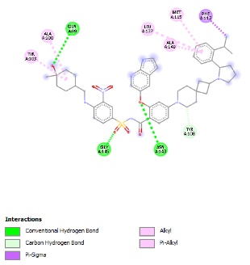 | 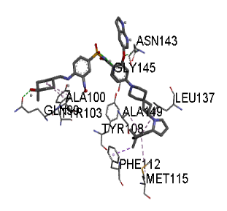 | -10.5 | ALA A:100 ALA A:149  ASN A:143 GLN A:99 GLY A:145 LEU A:137 MET A:115  PHE A:112  TYR A:103  TYR A:108 | Alkyl bond  π -Alkyl bond  Conventional H- bond  Conventional H- bond Conventional H- bond  π -Alkyl bond  π -Alkyl bond  π -sigma  Alkyl bond  Carbon H- bond
BCL2 | *Aesculin | 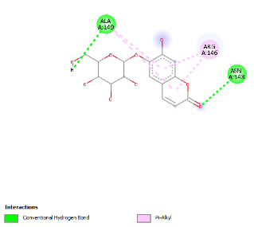 | 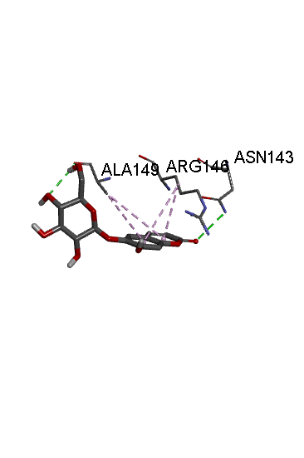 | -6.4 | *ALA A:149  ARG A:146 *ASN A:143 | Conventional H- bond & π -Alkyl bond  π -Alkyl bond  Conventional H- bond
BCL2 | *Coumaroylquinic acid | 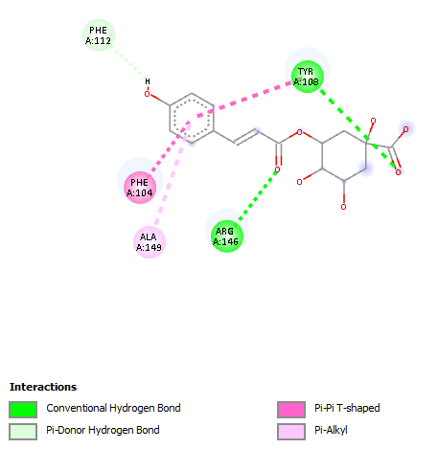 | 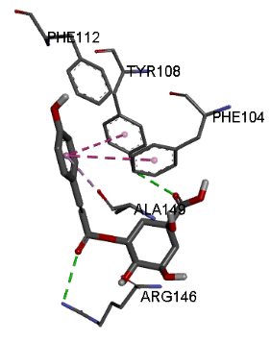 | -7.0 | *ALA A:149  ARG A:146 PHE A:104 PHE A:112 *TYR A:108 | π -Alkyl bond  Conventional H- bond  π–π T-shaped  π-Doner H- bond  Conventional H- bond & π–π T-shaped
BCL2 | *Luteolin | 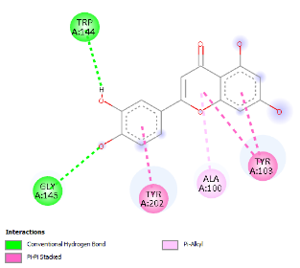 | 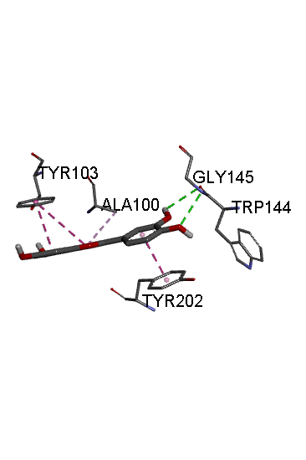 | -6.3 | *ALA A:100 *GLY A:145  TRP A:144 *TYR A:103 TYR A: 202 | π -Alkyl bond  Conventional H- bond  Conventional H- bond  π–π Stacked  π–π Stacked
P53 | Co-crystallized ligand | 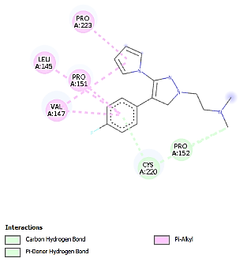 | 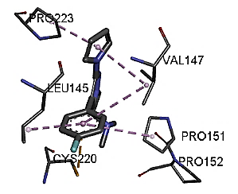 | -7.4 | CYS A:220  PRO A:152  LEU A:145  PRO A:151  PRO A:223  VAL A:147 | Carbon H- bond & π-doner H-bond  π- Alkyl  π- Alkyl  π- Alkyl  π- Alkyl
 | *Aesculin | 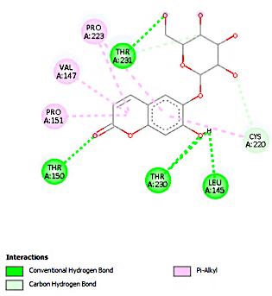 | 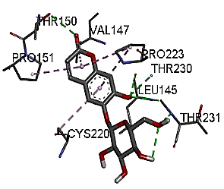 | -7.4 | *CYS A:220  *LEU A:145  *PRO A: 151  *PRO A:223  THR A:150  THR A:230  THR A:231  *VAL A:147 | Carbon H- bond & π- Alkyl  Conventional H-bond  π- Alkyl  π- Alkyl  Conventional H-bond  Conventional H-bond  Conventional H-bond & carbon H-bond  π- Alkyl
 | *Chlorogenic acid | 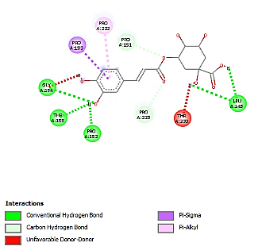 | 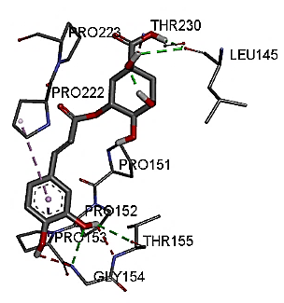 | -7.3 | GLY A:154  *LEU A:145  *PRO A:151  *PRO A:152  PRO A:153  PRO A:222  *PRO A:223  THR A:155  THR A:230 | Conventional H-bond & unfavorable D-D  Conventional H-bond  Carbon H-bond  Conventional H-bond  π-Sigma  π- Alkyl  Carbon H-bond  Conventional H-bond  unfavorable D-D
 | *Coumaroylquinic acid | 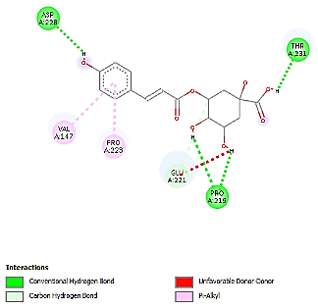 | 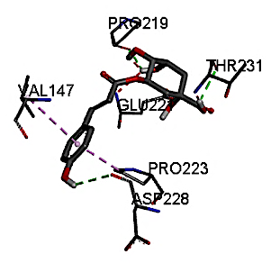 | -7.3 | ASP A:228  GLU A:221  PRO A:219  *PRO A:223  THR A:231  *VAL A:147 | Conventional H-bond  Carbon H-bond &  Unfavorable D-D  Conventional H-bond  π- Alkyl  Conventional H-bond  π- Alkyl
Autophagy proteins
LC3C | Co-crystallized ligand | 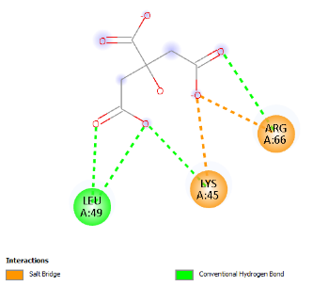 | 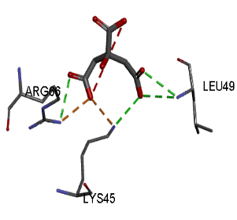 | -3.8 | ARG A:66  LEU A:49  LYS A:45 | Conventional H-bond & Salt bridge  Conventional H-bond  Conventional H-bond & Salt bridge
LC3C | *Chlorogenic acid | 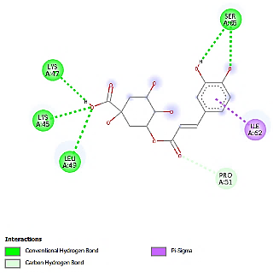 | 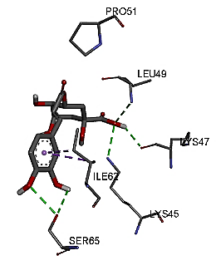 | -4.7 | ILE A:62  *LEU A:49 *LYS A:45  LYS A:47  PRO A:51  SER A:65 | π- Sigma  Conventional H-bond  Conventional H-bond  Conventional H-bond  Carbon H-bond  Conventional H-bond
LC3C | *Coumaroylquinic acid | 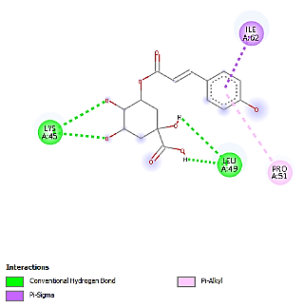 | 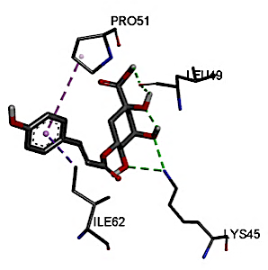 | -4.7 | ILE A:62  *LEU A:49 *LYS A:45  PRO A:51 | π- Sigma  Conventional H-bond  Conventional H-bond  π-Alkyl
LC3C | *Umbelliferone | 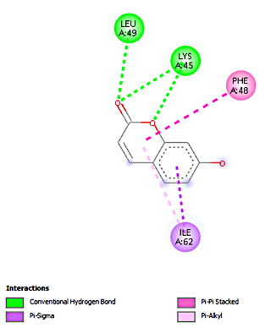 | 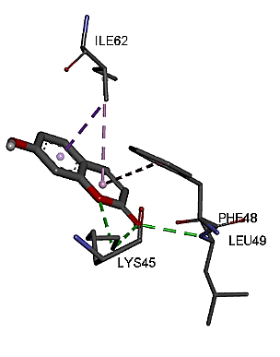 | -4.8 | ILE A:62  *LEU A:49  *LYS A:45  PHE A:48 | π- Sigma & π- Alkyl  Conventional H-bond  Conventional H-bond  π- π- Stacked
MTOR | Co-crystallized ligand | 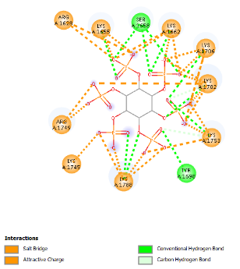 | 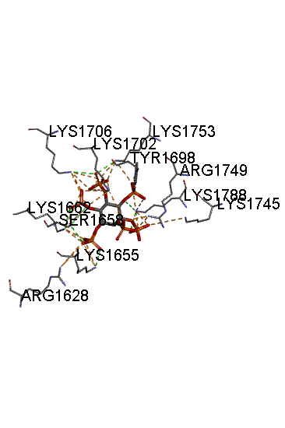 | -5.9 | ARG A:1628  ARG A:1749  LYS A:1655 LYS A:1745  LYS A:1788 LYS A:1662 LYS A:1702 LYS A:1706 LYS A:1753 SER A:1658 TYR A:1698 | Attractive charge& salt bridge  Attractive charge& salt bridge  Conventional H- bond  Attractive charge& salt bridge  Conventional H-bond  Conventional H-bond  Conventional H-bond  Conventional H-bond  Conventional H-bond  Conventional H-bond  Conventional H-bond & Carbon H-bond
MTOR | *Aesculin | 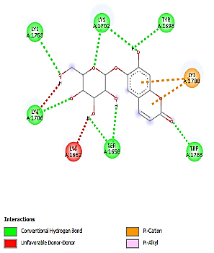 | 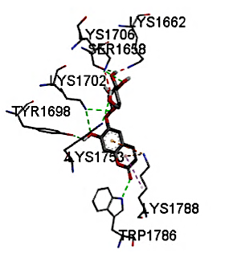 | -5.1 | *LYS A:1702 *LYS A:1706  *LYS A:1753 *SER A:1658 *TYR A:1698 TRP A:1786. *LYS A:1788, *LYS A:1662 | Conventional H- bond  Conventional H- bond &unfavorable D-D  Conventional H- bond  Conventional H- bond  Conventional H- bond  Conventional H- bond  π -Cation  unfavorable D-D
MTOR | *Artemisinin | 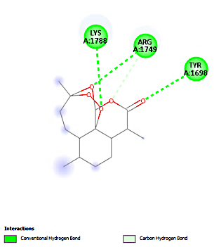 | 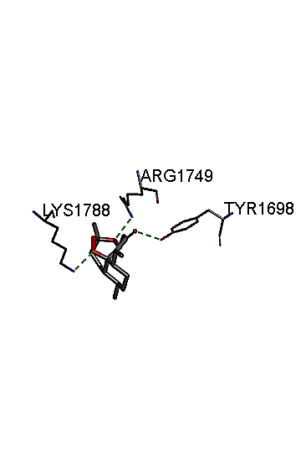 | -5.4 | *ARG A:1749  *LYS A:1788 *TYR A:1698 | Conventional H- bond  & Carbon H-bond  Conventional H- bond  Conventional H- bond
MTOR | *Rutin | 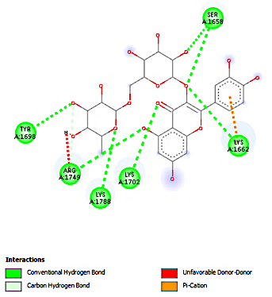 | 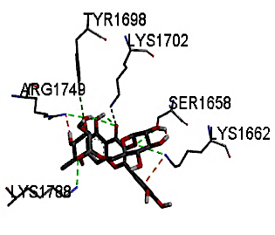 | -6 | *ARG A:1749  *LYS A:1662  *LYS A:1702 *LYS A:1788 *SER A:1658 *TYR A:1698 | Conventional H- bond &unfavorable D-D & Cabon H- bond  Conventional H- bond & π -Cation  Conventional H- bond  Conventional H- bond  Conventional H- bond  Conventional H- bond
Molecular docking results of selected compounds showing the strongest binding interactions with apoptosis- (BCL2, P53) and autophagy-related (LC3C, mTOR) proteins. Binding energy is expressed in kcal/mol. Amino acid residues involved in ligand–protein interactions and types of bonding (e.g., hydrogen bonding, π-alkyl, π–π interactions) are presented. Co-crystallized ligands were used as reference standards.

