Table S3: The interactions between compounds and Apoptosis and Autophagy proteins
 |  |  |  | Apoptosis |  | Autophagy
Class | Name | Pubchem id | Structure | BCL2 | P53 | LC3C | mtor
 | Co-crystallized ligand |  |  | -10.5 | -7.4 | -3.8 | -5.9
Phenolic acids | Quinic acid | 6508 | 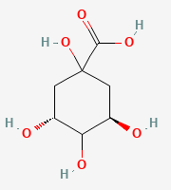 | -4.6 | -5.7 | -4.0 | -3.9
Phenolic acids | Coumaroylquinic acid | 6441280 | 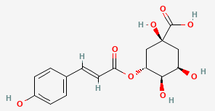 | -6.3 | -7.3 | -4.7 | -4.7
Phenolic acids | Chlorogenic acid | 1794427 | 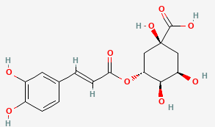 | -6.5 | -7.3 | -4.7 | -4.9
Coumarins | Aesculetin | 5281416 | 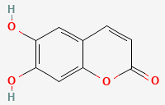 | -5.4 | -5.9 | -5.0 | -4.3
Coumarins | Aesculin | 5281417 | 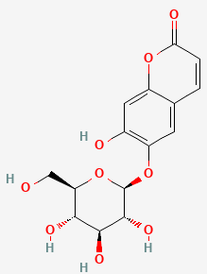 | -6.4 | -7.4 | -5.4 | -5.1
Coumarins | Umbelliferone | 5281426 | 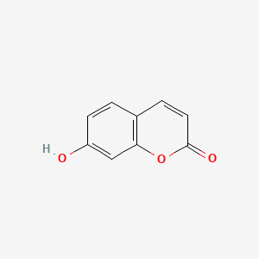 | -5.8 | -5.8 | -4.8 | -4.0
Flavonoids | Apigenin | 5280443 | 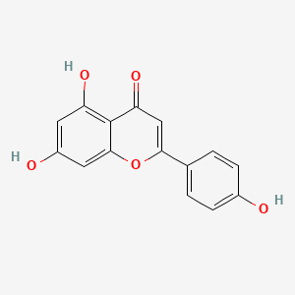 | -7.1 | -7.4 | -5.3 | -4.7
Flavonoids | Luteolin | 5280445 | 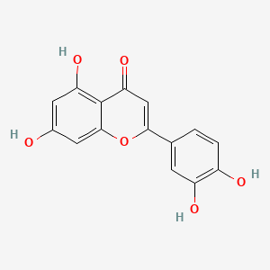 | -7.0 | -7.8 | -5.2 | -4.9
Flavonoids | Rutin | 6728944 | 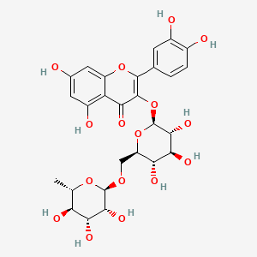 | -6.4 | -8.2 | -3.2 | -6.0
sesquiterpene | Vulgarin | 94253 | 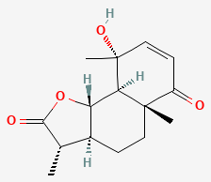 | -7.0 | -5.6 | -5.3 | -4.6
sesquiterpene | Santonin | 221071 | 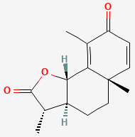 | -7.1 | -6 | -5.6 | -5.0
sesquiterpene | Costunolide | 5281437 | 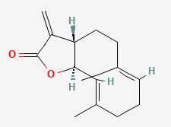 | -7.3 | -5.7 | -5.3 | -4.6
sesquiterpene | Artemisinin | 68827 | 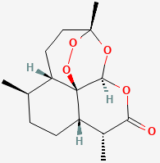 | -6.9 | -6 | -5.6 | -5.4
Comparative binding energies (kcal/mol) of selected phytoconstituents against apoptosis (BCL2, P53) and autophagy (LC3C, mTOR) target proteins. Compounds are classified according to their chemical classes. Binding energies approaching that of the co-crystallized ligand suggest stronger predicted binding affinity.
Table S4: Molecular docking of the 13 compounds against BCL2 apoptotic protein
Compound Name | 2D | 3D
Aesculetin | 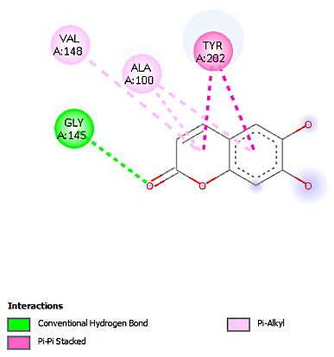 | 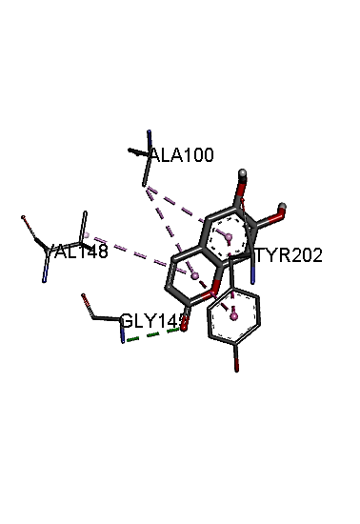
Aesculin | 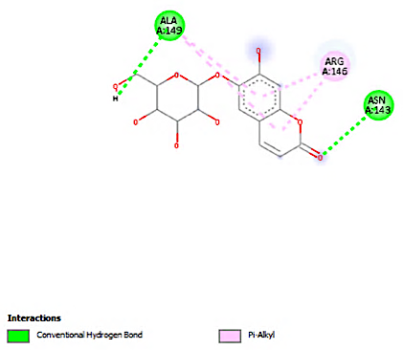 | 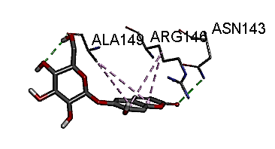
Apiginin | 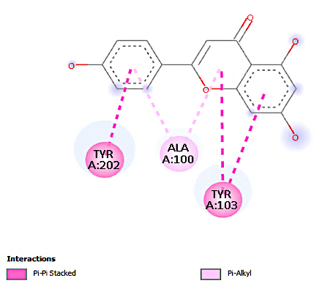 | 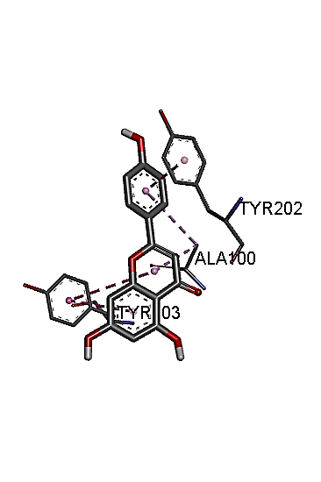
Artemisinin | 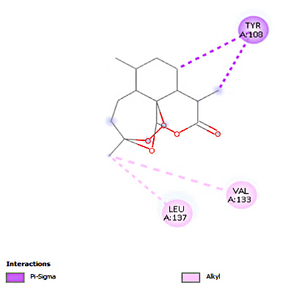 | 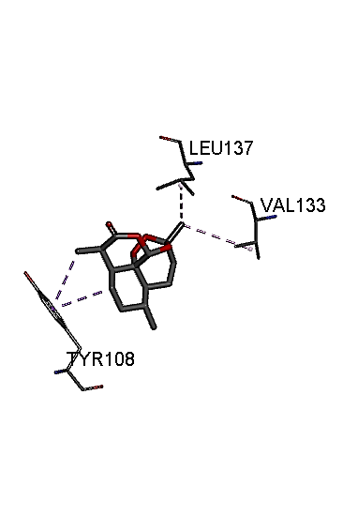
Chloroginic acid | 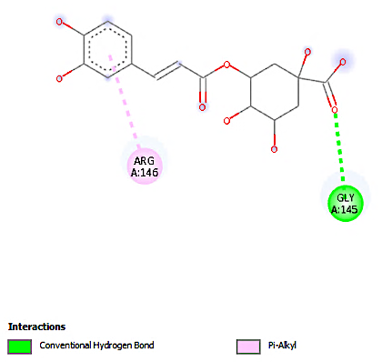 | 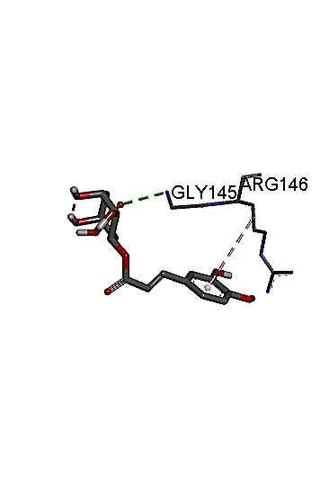
Costunolide | 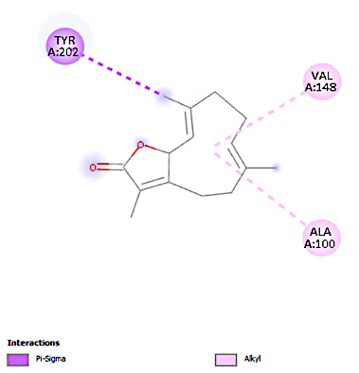 | 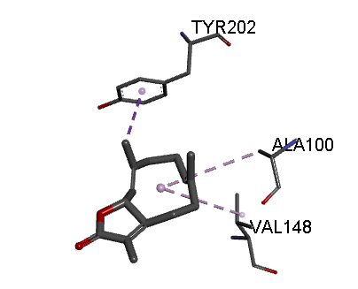
Coumaroylquinic acid | 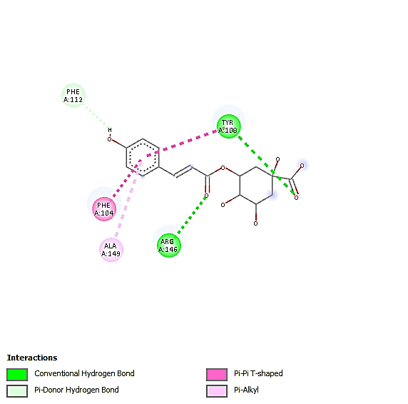 | 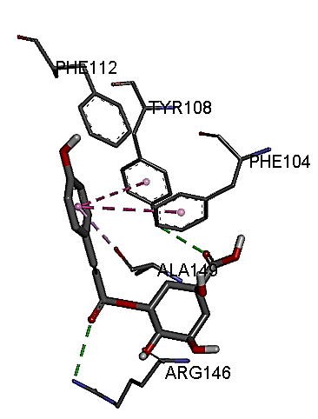
Luteolin | 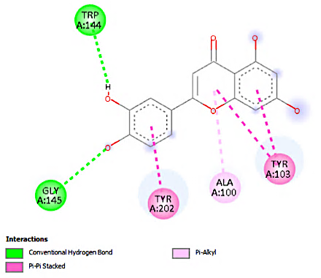 | 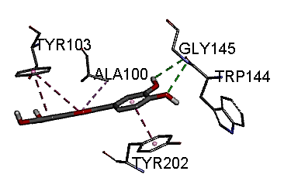
Prepared legand | 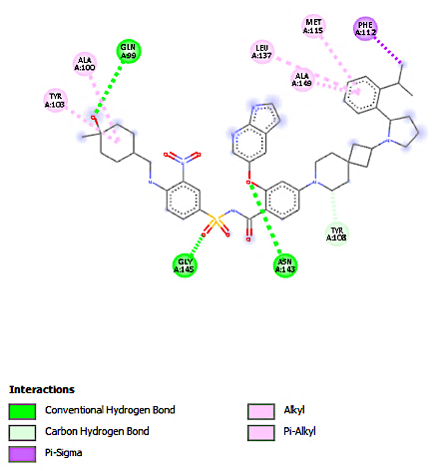 | 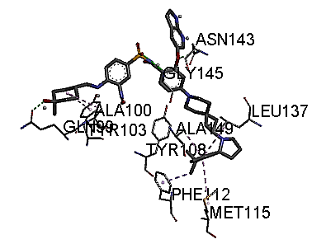
Quinic acid | 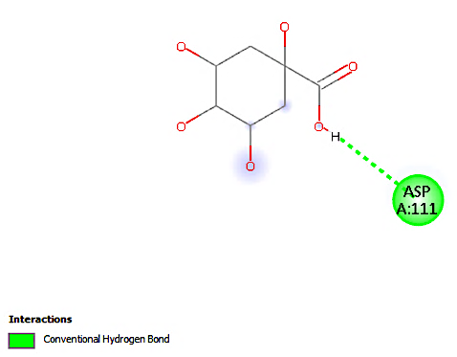 | 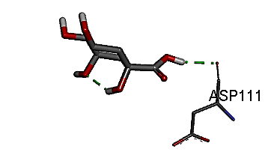
Rutin | 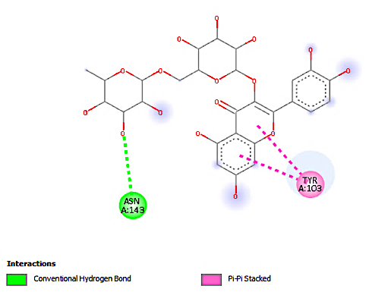 | 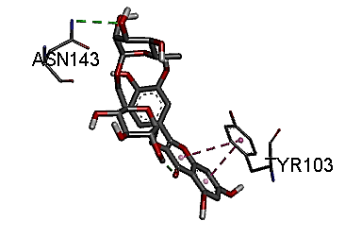
Santonin | 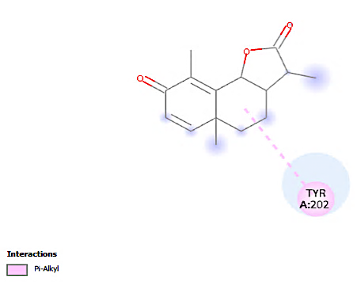 | 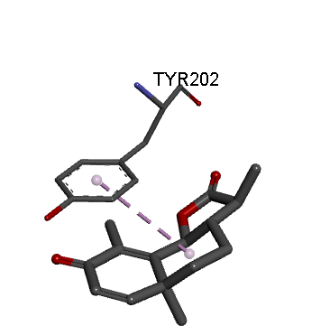
Umbelliferone | 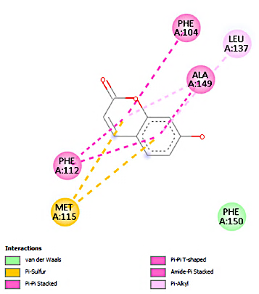 | 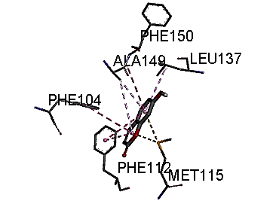
Vulgarin | 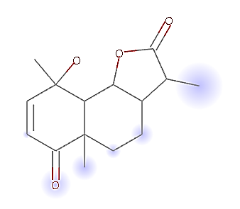 | 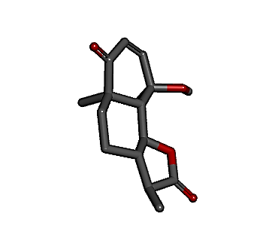
2D and 3D binding interactions of selected compounds docked against BCL2 apoptotic protein. The prepared ligand represents the co-crystallized reference ligand used for comparison. Visualizations illustrate binding orientation and key interaction sites within the active pocket.
Table S5: Molecular docking of the 13 compounds against P53 apoptotic protein
Compound name | 2D | 3D
Aesculetin | 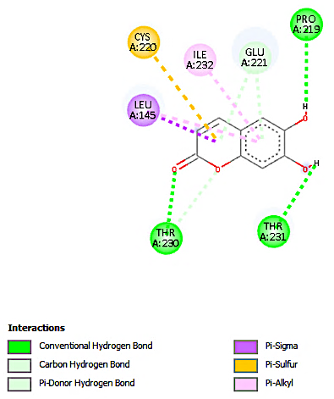 | 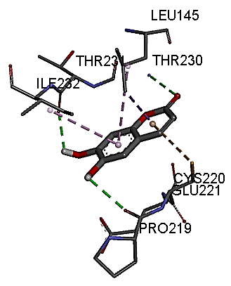
Aesculin | 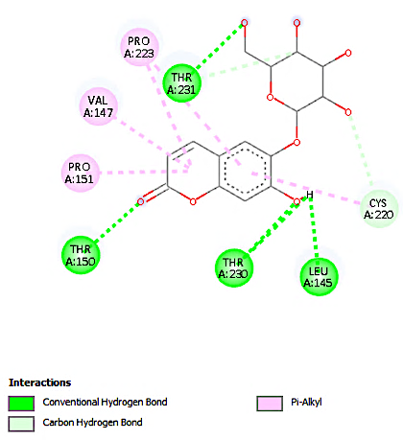 | 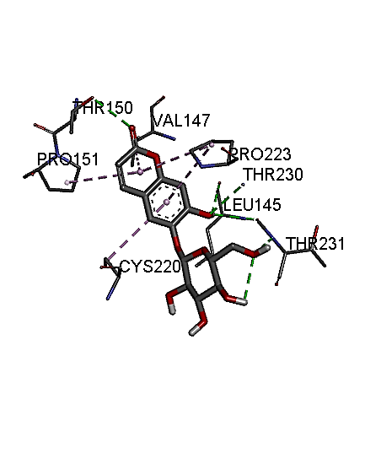
Apigenin | 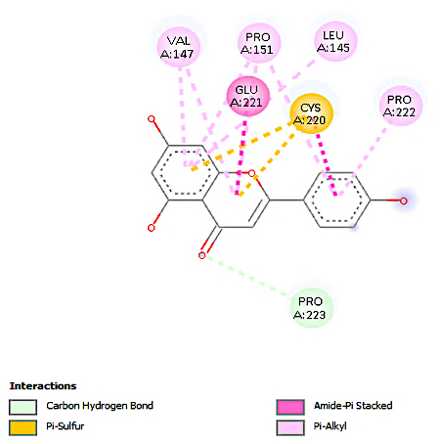 | 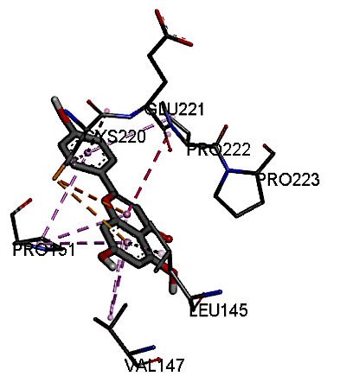
Artemisinin | 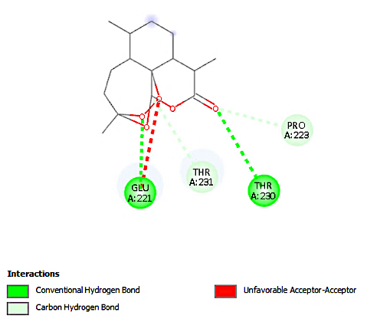 | 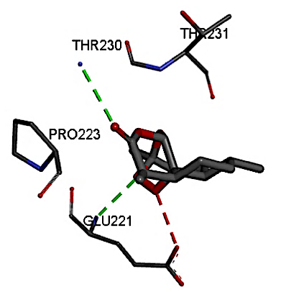
Chlorogenic acid | 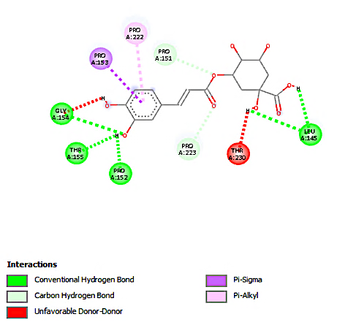 | 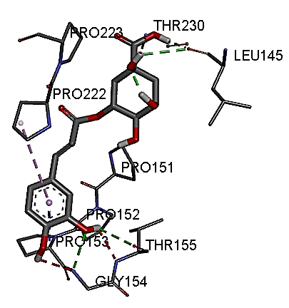
Costunolide | 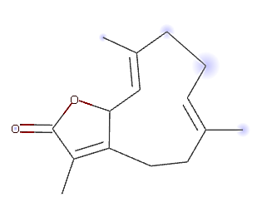 | 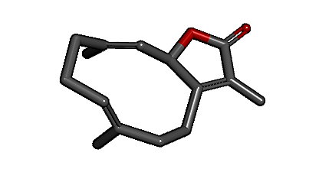
Coumaroylquinic acid | 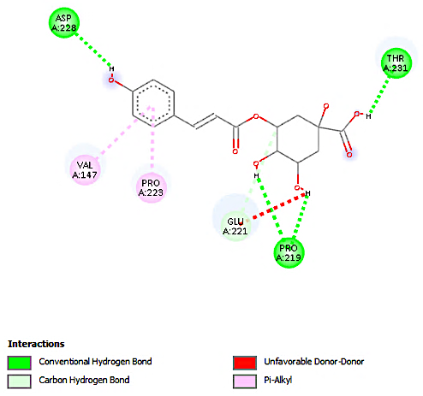 | 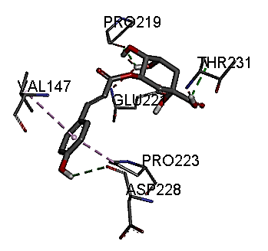
Luteolin | 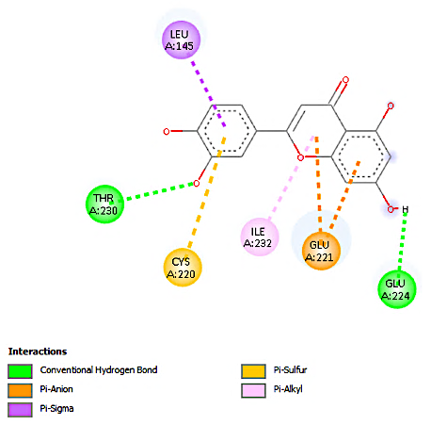 | 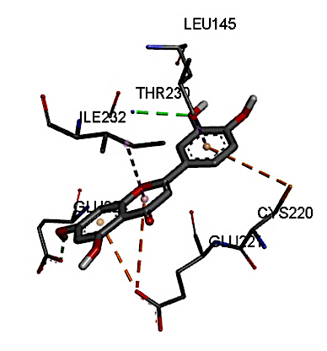
Prepared ligand | 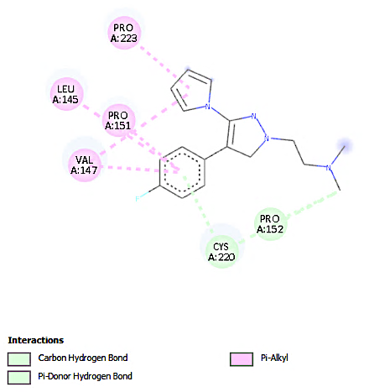 | 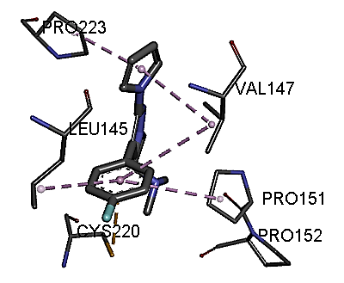
Quinic acid | 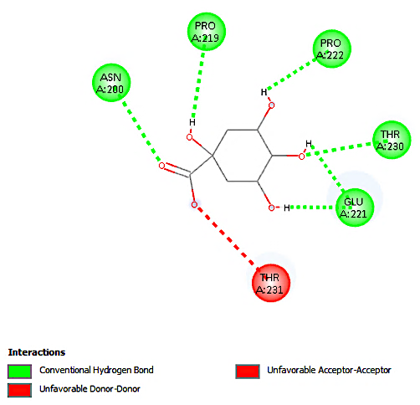 | 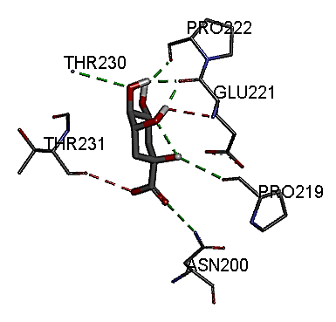
Rutin | 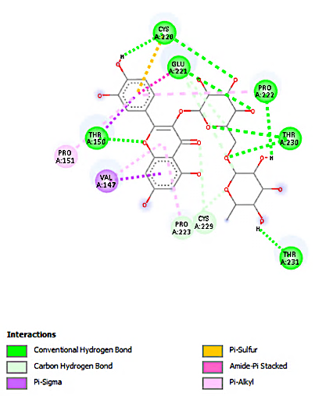 | 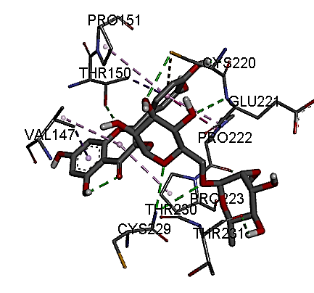
Santonin | 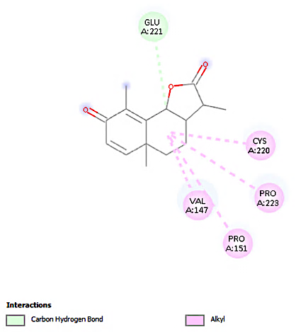 | 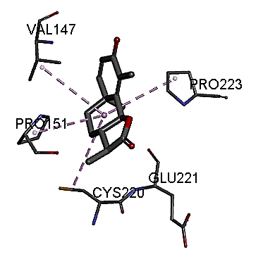
Umbelliferone | 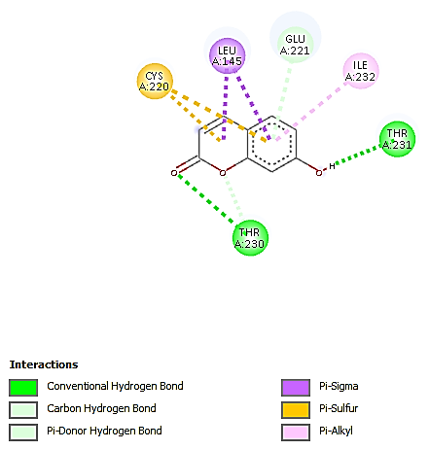 | 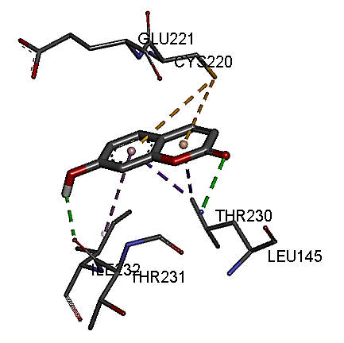
Vulgarin | 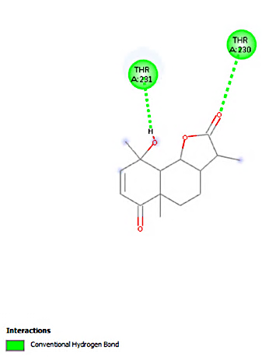 | 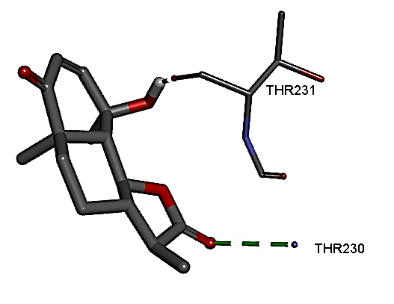
2D and 3D molecular docking interactions of selected compounds with P53 apoptotic protein. The prepared ligand corresponds to the co-crystallized reference ligand. Interaction diagrams highlight key residues involved in ligand binding.
Table S6: Molecular docking of the 13 compounds against LC3C autophagic protein
Compound name | 2D | 3D
Aesculetin | 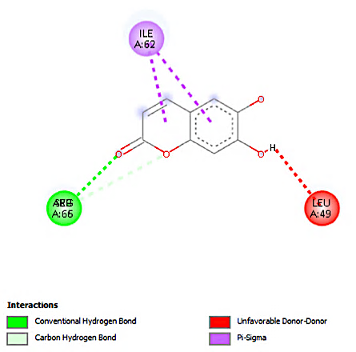 | 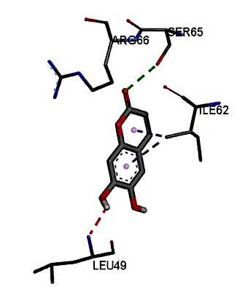
Aesculin | 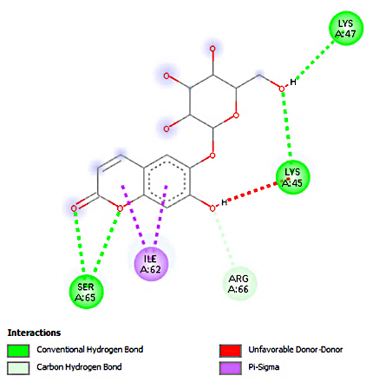 | 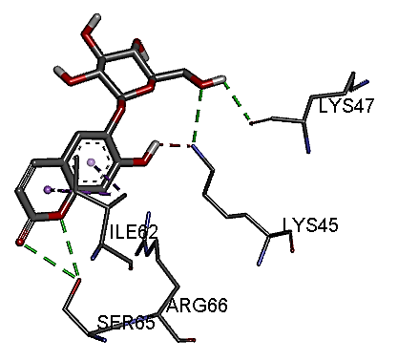
Apigenin | 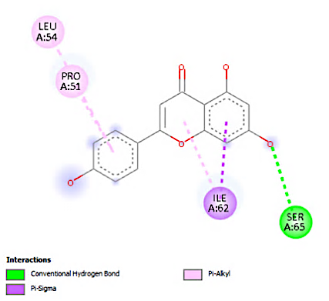 | 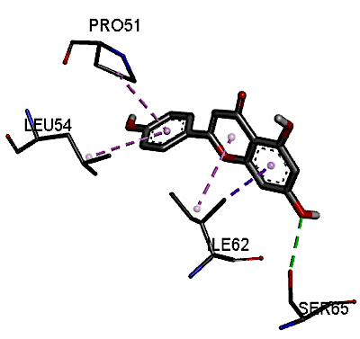
Artemisinin | 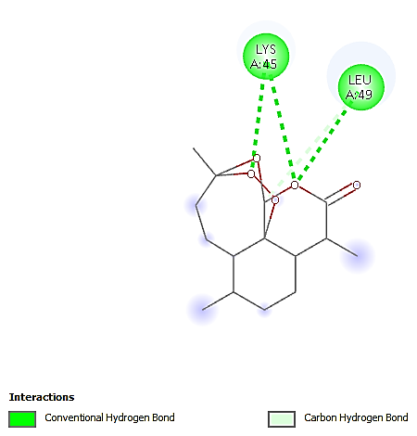 | 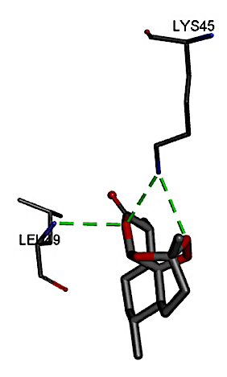
Chlorogenic acid | 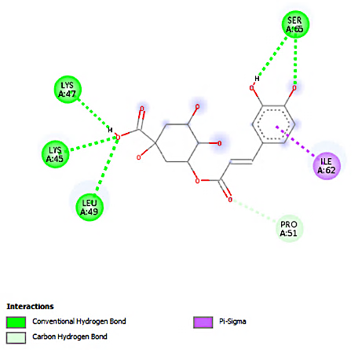 | 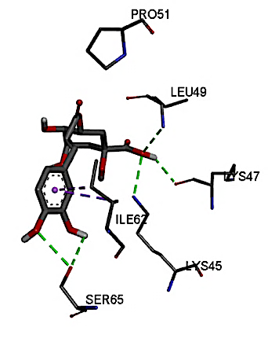
Costunolide | 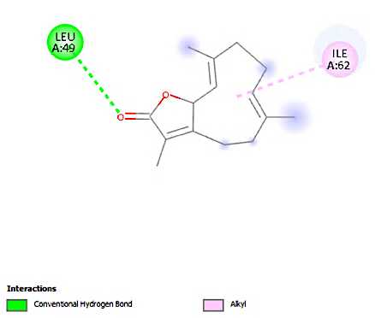 | 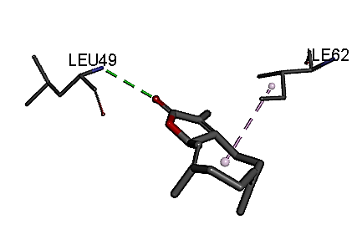
Coumaroylquinic acid | 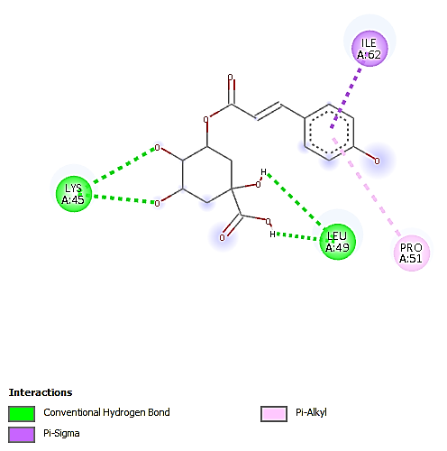 | 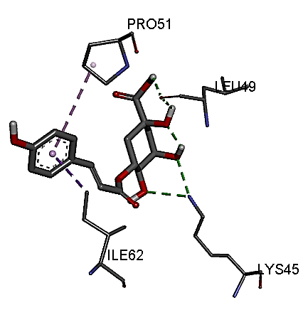
Luteolin | 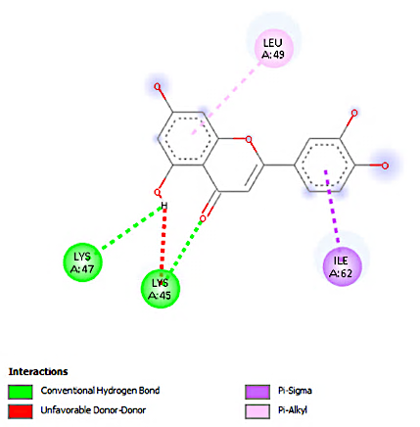 | 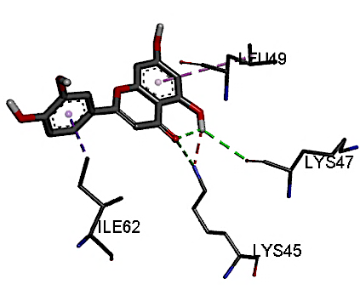
Prepared ligand | 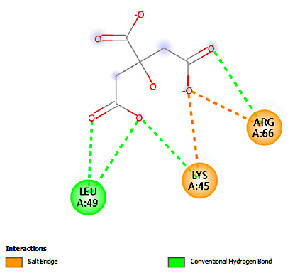 | 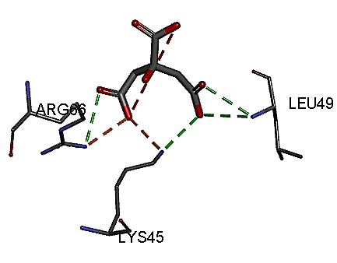
Quinic acid | 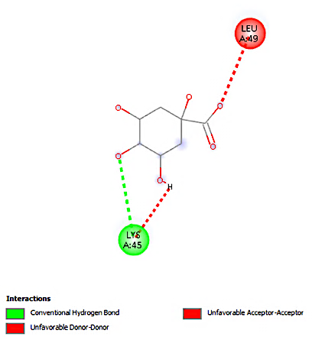 | 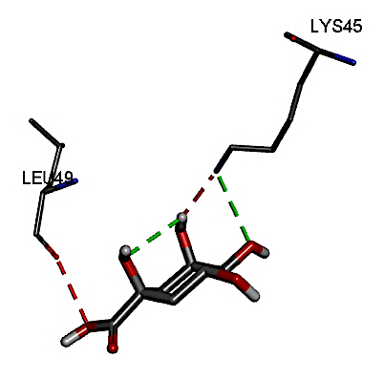
Rutin | 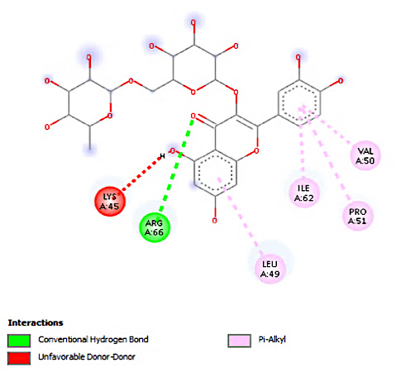 | 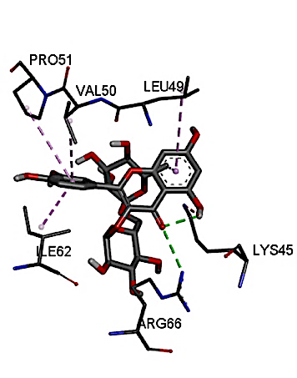
Santonin | 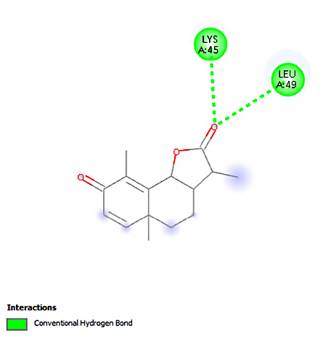 | 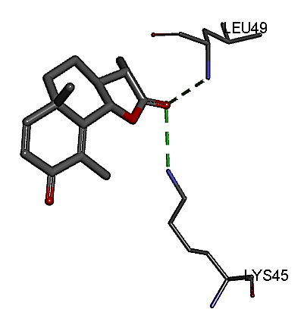
Umbelliferone | 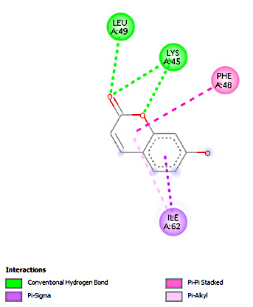 | 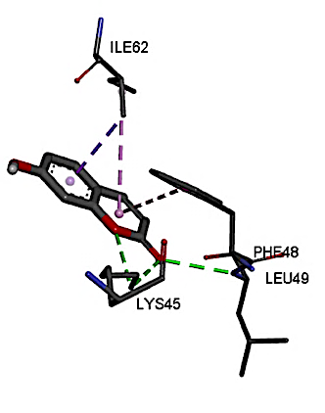
Vulgarin | 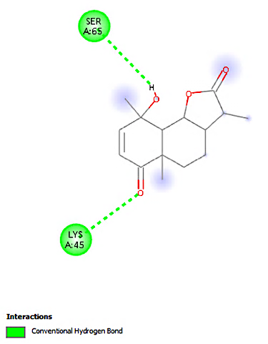 | 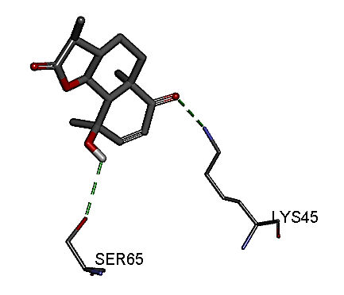
2D and 3D docking interactions of selected compounds with LC3C autophagy-related protein. The prepared ligand represents the reference ligand. Binding poses and interactions with active site residues are illustrated.
Table S7: Molecular docking of the 13 compounds against mTOR autophagic protein
Compound name | 2D | 3D
Aesculetin | 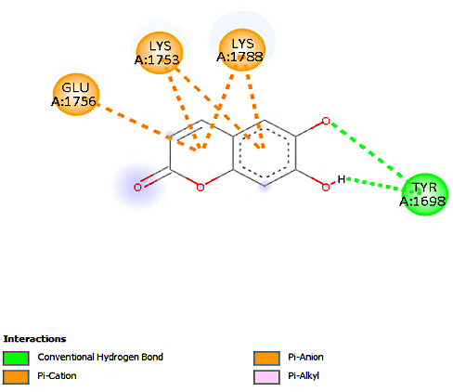 | 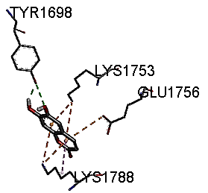
Aesculin | 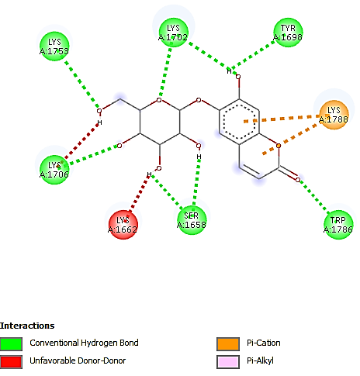 | 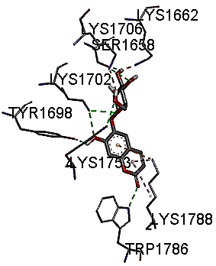
Apigenin | 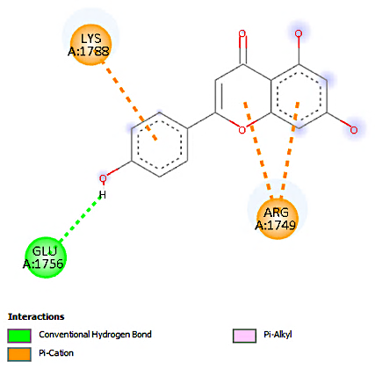 | 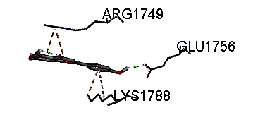
Artemisinin | 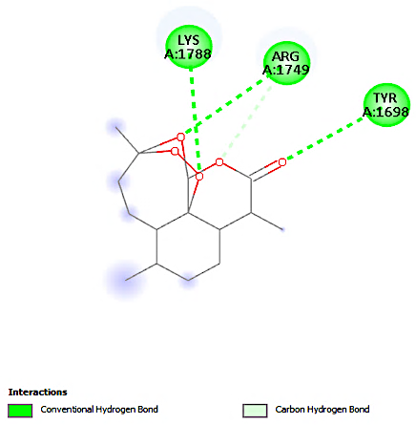 | 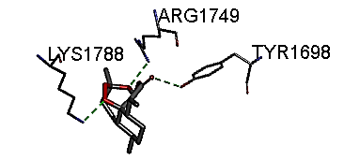
Chlorogenic acid | 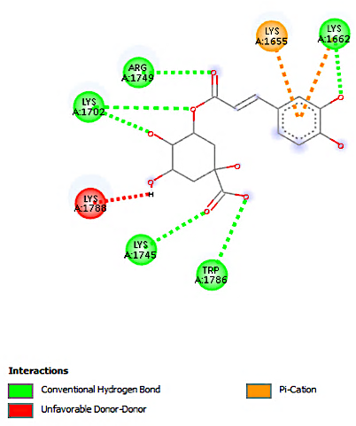 | 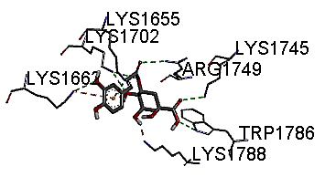
Costunolide | 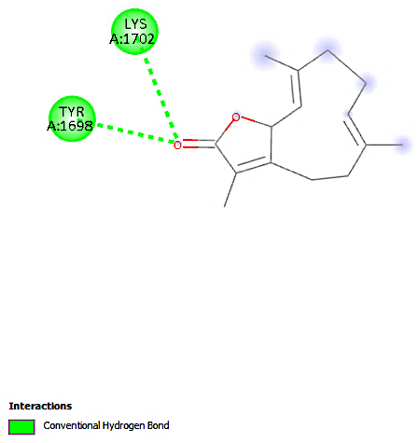 | 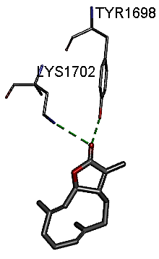
Coumaroylquinic acid | 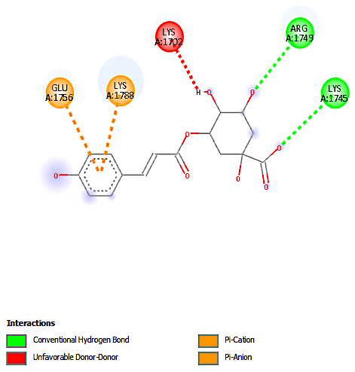 | 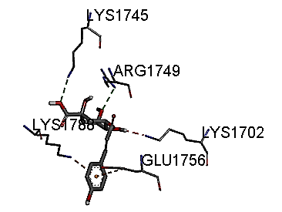
Luteolin | 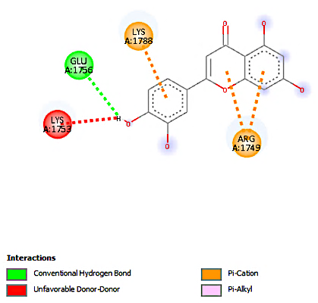 | 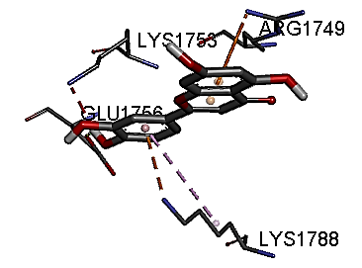
Prepared ligand | 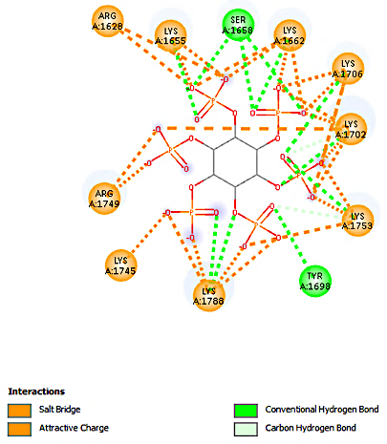 | 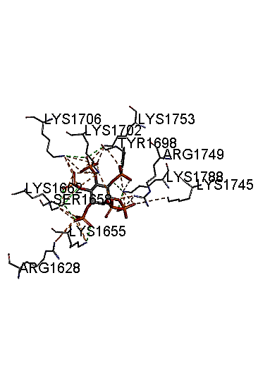
Quinic acid | 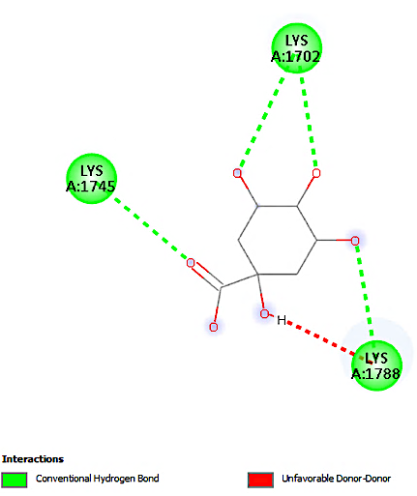 | 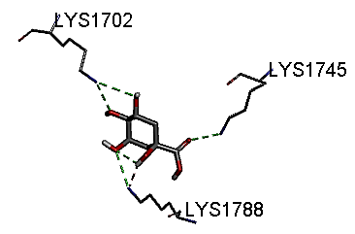
Rutin | 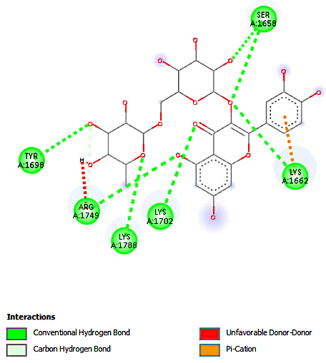 | 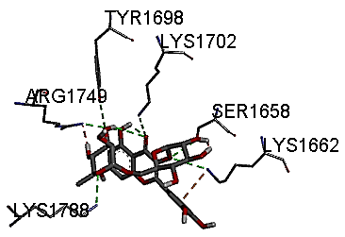
Santonin | 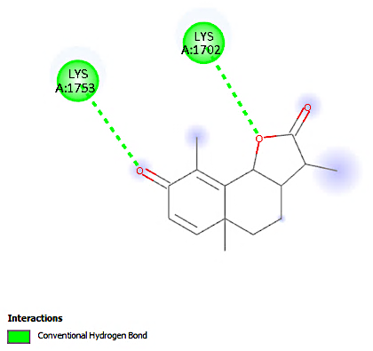 | 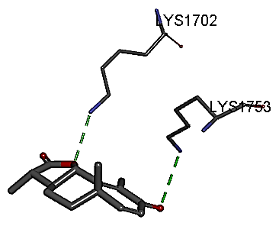
Umbelliferone | 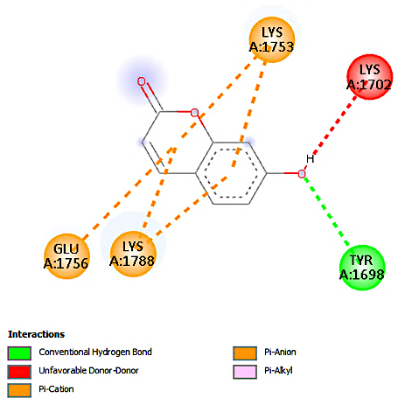 | 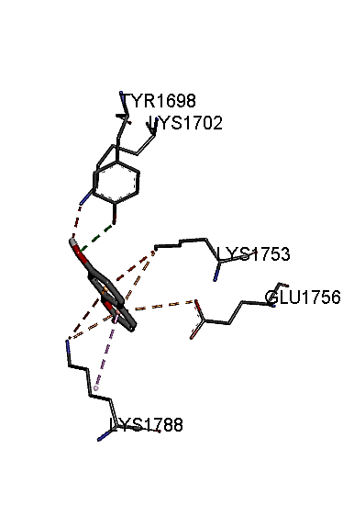
Vulgarin | 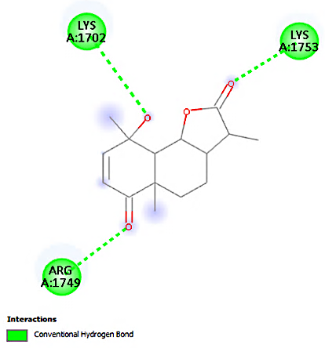 | 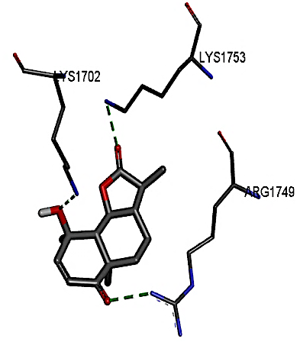
2D and 3D molecular docking interactions of selected compounds with mTOR autophagy-related protein. The prepared ligand serves as the reference ligand. Key interactions and binding orientations within the active site are presented.
Table S8: Alignment of co-crystallized ligand with the docked ligand pose (yellow)
BCL-2 | P53
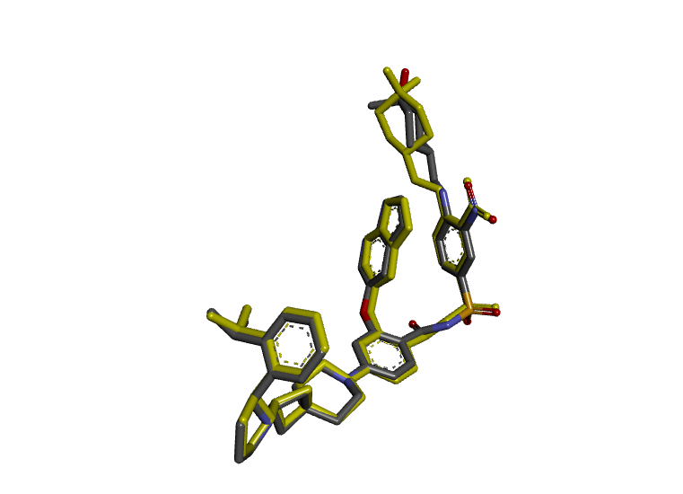 | 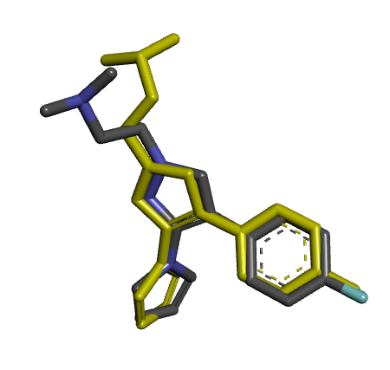
Rmsd: 0.724 | Rmsd: 1.361
LC3C | mTOR
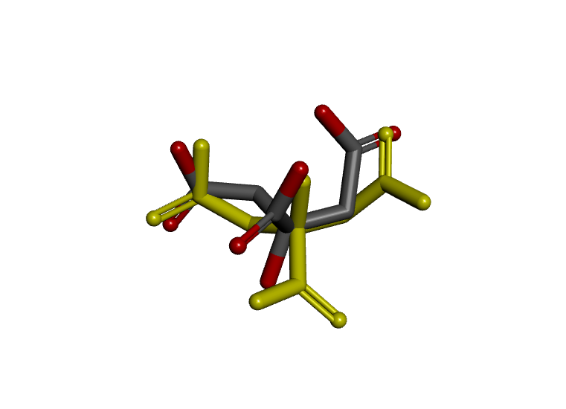 | 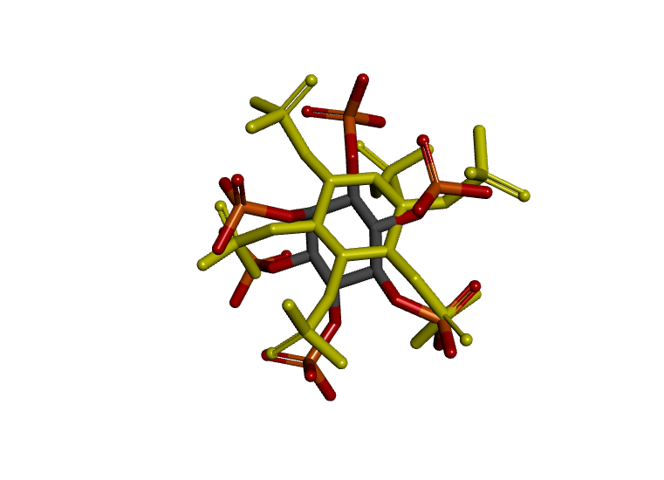
Rmsd: 1.901 | Rmsd: 2.690

