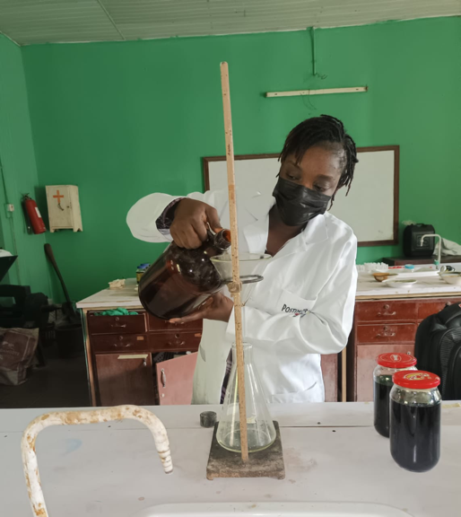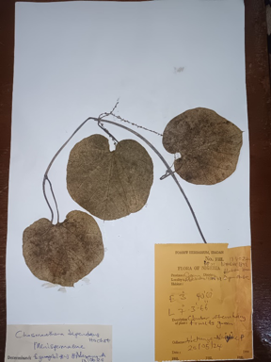
A B
A B
A B
A

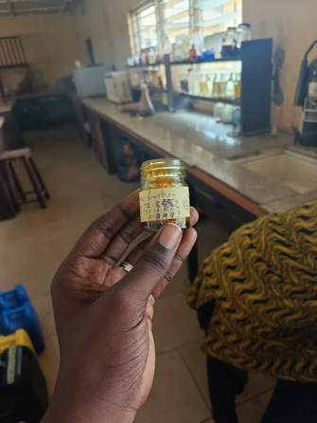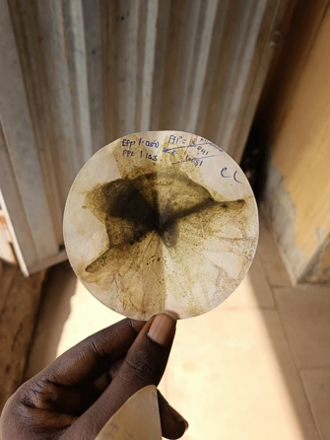
C D
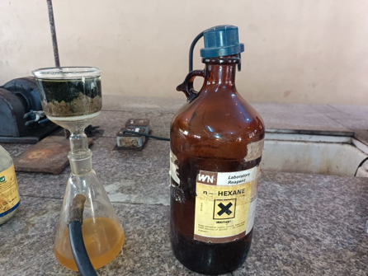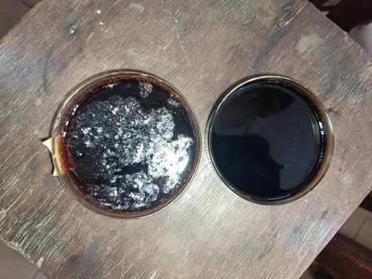
E F

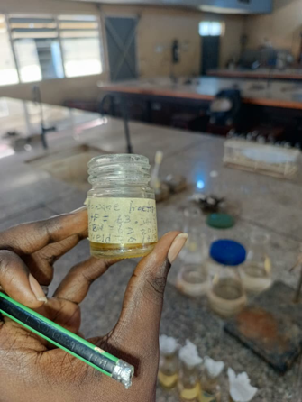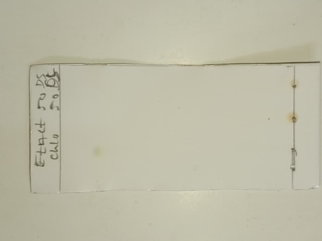
G H
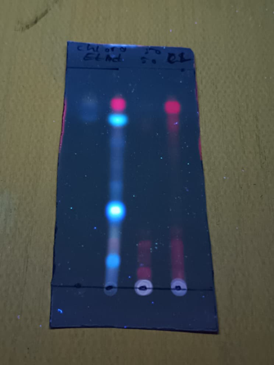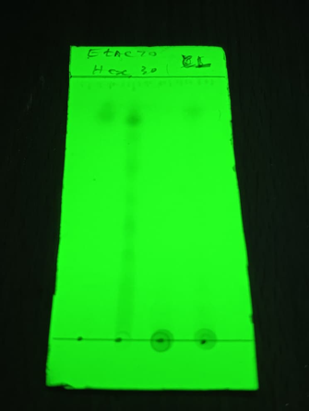
I J

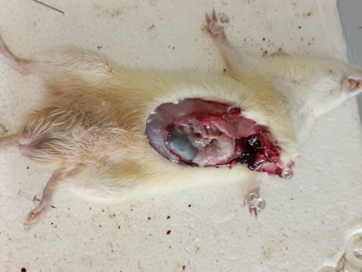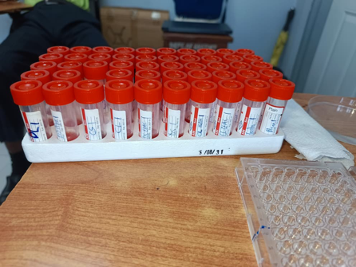
K L

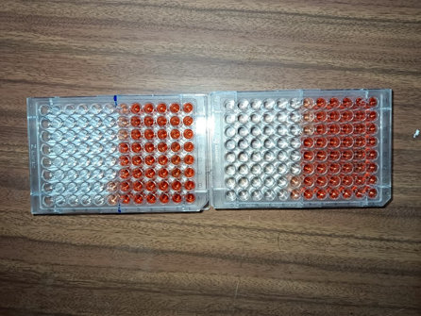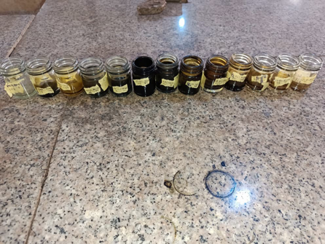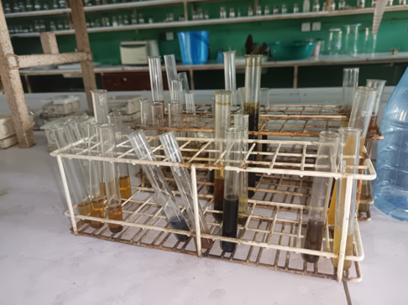
M N
O N

KEY:
A: Extraction process to obtain Chasmanthera dependens crude extract
B: Voucher specimen for Chasmanthera dependens Hochst.
C: A picture showing the n-Hexane fraction of C. dependens, ready for GC-MS analysis
D: Quantitative phytochemical screening
E: Fractionation process to obtain the n-Hexane fraction of C. dependens
F: Ethyl acetate and methanol fractions of C. dependens
G: A picture showing the n-Hexane fraction of C. dependens, ready for GC-MS analysis
H: Thin layer chromatographic fingerprint of C. dependens leaf
Solvent system: Ethyl acetate : Methanol (80:20)
Visualization under daylight
I: Thin layer chromatographic fingerprint of C. dependens leaf
Solvent system: Ethyl acetate : Methanol (80:20)
Visualization after development at 365 nm
J: Thin layer chromatographic fingerprint of C. dependens leaf
Solvent system: Ethyl acetate : Methanol (80:20)
Visualization after development at 254 nm
K: Anaesthetized male wistar rate ready for blood collection
L: Membrane stabilisation assay
M: Samples ready for absorbance reading in a microplate reader
N: A picture showing fractions of C. dependens leaf
O: Qualitative phytochemical screening

