The fingerprint of Fructus aurantii (FA) has been studied in the previous research [1]. The specific methods/data are as follows:
1 Materials and methods
1.1 Plant material
FA was collected from different regions (Table S13).
Table S13 Sources of Fructus aurantii
FA | Origin
S1 | Hunan province
S2 | Jiangxi (Jiangzhong TCM Decoction Tablets Company)
S3 | Zhejiang (Foshan Nanhai Beisha Pharmaceutical Processing Plant)
S4 | Zhejiang (Foshan Nanhai Beisha Pharmaceutical Processing Plant)
S5 | Jiangxi Province (Guangzhou Zhixin Pharmaceutical Group)
S6 | Hushan Town, Yichun, Jiangxi Province
S7 | Yichun lou Town, Jiangxi
S8 | Liugong Town, Yichun, Jiangxi Province
S9 | Hunan (Foshan Nanhai Beisha Pharmaceutical Processing Plant)
S10 | Zhejiang (Foshan Nanhai Beisha Pharmaceutical Processing Plant)

Notes: S1 to S10 stands for FA.
1.2 Establishment of HPLC fingerprint of FA
1.2.1 Preparation of reference standard solution
Hesperidin (Batch No. 110721-201617, 20 mg, purity of 96.1%), naringin (Batch No. 110722-201714, 20 mg, purity of 93.4%), and neohesperidin (Batch No. 111857-201703, 20 mg, purity of 99.2%) were purchased from the National Institutes for Food and Drug Control of China. Naringenin (Batch No. BWB50920, 20 mg, purity ≥ 98%), hesperetin (Batch No. BWB50172, 20 mg, purity ≥ 98%), and nobiletin (Batch No. BWB0620, 20 mg, purity ≥ 98%) were obtained from Beijing Century Aoke Biotechnology Co., Ltd. Appropriate amounts of the above six reference standards were accurately weighed and dissolved in methanol to prepare a mixed reference standard solution containing 80 μg of each component per 1 mL.
1.2.2 Preparation of sample solutions and standard solutions
1 g of FA powder was added to volumetric flasks and extracted by refluxing in 90 mL of methanol for 1.5 h. Next, the lost weight was compensated with methanol, and the solution was passed through 0.22 μm membrane filters for HPLC fingerprints. Chromatographic separation was performed with acetonitrile (A) and 0.1% phosphoric acid aqueous solution (B) at a flow rate of 1.00 mL/min using an Inertsil ODS-3 High Performance Liquid Chromatography column (250 × 4.6 mm, 5 µm). The injection volume was 3 µL, and the elution program was as follows: 5%~6% A for 10 min; linear increase from 6% to 15% A in 10-20 min; linear increase from 15% to 27% A in 20-75 min; linear increase to 65% A in 75-120 min; a 4-min isocratic period, followed by reversion to initial conditions for 5 min. Meanwhile, the detection wavelength was 283 nm at 25℃. The chromatogram of reference standard solution is shown in Fig. S1A.
1.2.3 Methodological validation
The test solution (S10) was injected and determined six times under the chromatographic conditions described in “1.2.2”. The relative standard deviation (RSD) values of relative peak areas for all common peaks were less than 3%, indicating good precision of the instrument. Six batches of test solutions were prepared in accordance with the procedure described in “1.2.2” and analyzed under the chromatographic conditions of “1.2.2”. The RSD values of relative peak areas of all common peaks were below 3%, demonstrating satisfactory repeatability of the method. A test solution was prepared following the method under “1.2.2”, and injected for determination at 0, 2, 4, 6, 12 and 24 h under the chromatographic conditions of “1.2.2”. The RSD values of relative peak areas for all common peaks were less than 3%, which suggested that the test solution remained stable within 24 h.
2. Results
2.1 Similarity assessment and HPLC fingerprints
The chromatograms of 10 batches of samples were imported into the “TCM chromatographic fingerprint similarity evaluation System (version 2008A)”, which was used to calculate the similarity between a test sample and a reference one for similarity evaluation of different chromatographic fingerprintss. The fingerprints of FA (Fig. S1B) and the control fingerprints (R) were obtained by using the average method with S6 as the reference fingerprint. The generated reference fingerprints were used as the fusion fingerprints of each batch and as the control map (R), and it indicated that the quality of the samples used in the experiment was stable and controllable. The similarity data were shown in Table S14. The calculated similarity was between 0.991 and 0.999 which indicated the consistency of the samples used in this experiment and was conducive to subsequent data analysis.

Table S14 Calculation results of fingerprint similarity of 10 batches of FA
sample | S1 | S2 | S3 | S4 | S5 | S6 | S7 | S8 | S9 | S10 | control map
S1 | 1
S2 | 0.982 | 1
S3 | 0.989 | 0.993 | 1
S4 | 0.971 | 0.993 | 0.994 | 1
S5 | 0.984 | 0.998 | 0.997 | 0.997 | 1
S6 | 0.986 | 0.998 | 0.997 | 0.994 | 0.999 | 1
S7 | 0.985 | 0.998 | 0.996 | 0.993 | 0.998 | 0.999 | 1
S8 | 0.999 | 0.997 | 0.997 | 0.991 | 0.998 | 0.999 | 1 | 1
S9 | 0.983 | 0.994 | 0.999 | 0.997 | 0.998 | 0.997 | 0.996 | 0.996 | 1
S10 | 0.992 | 0.992 | 0.999 | 0.992 | 0.996 | 0.996 | 0.996 | 0.997 | 0.997 | 1
control map | 0.999 | 0.997 | 0.999 | 0.994 | 0.999 | 0.999 | 0.999 | 0.999 | 0.998 | 0.999 | 1

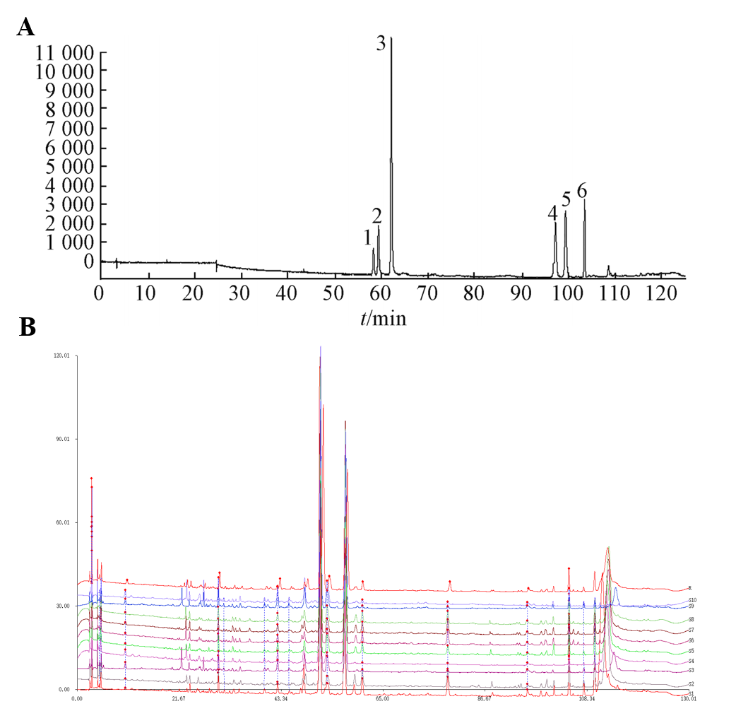
Fig. S1. HPLC chromatograms and fingerprints. (A) Mixed reference standards: 1. Naringin, 2. Hesperidin, 3. Neohesperidin, 4. Naringenin, 5. Hesperetin, 6. Nobiletin;
(B) HPLC fingerprint of FA sample.
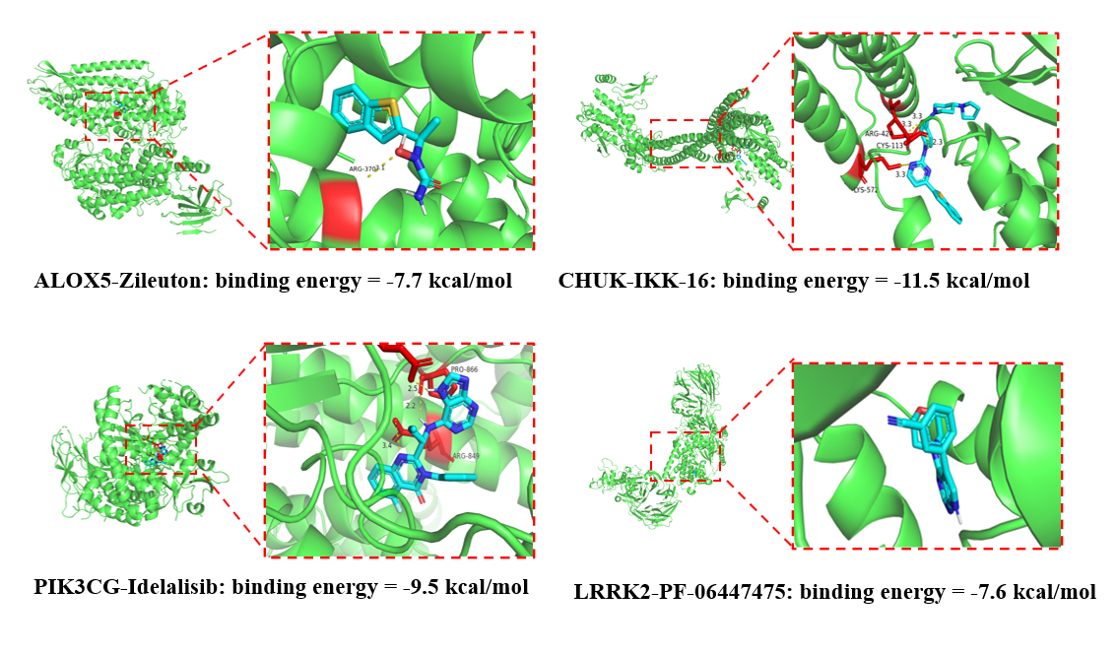
Fig. S2. Molecular docking of positive‑control inhibitors against target proteins. Four well‑characterized known inhibitors (Zileuton for ALOX5, IKK‑16 for CHUK, Idelalisib for PIK3CG, PF‑06447475 for LRRK2) were docked to their corresponding target proteins with identical docking parameters.
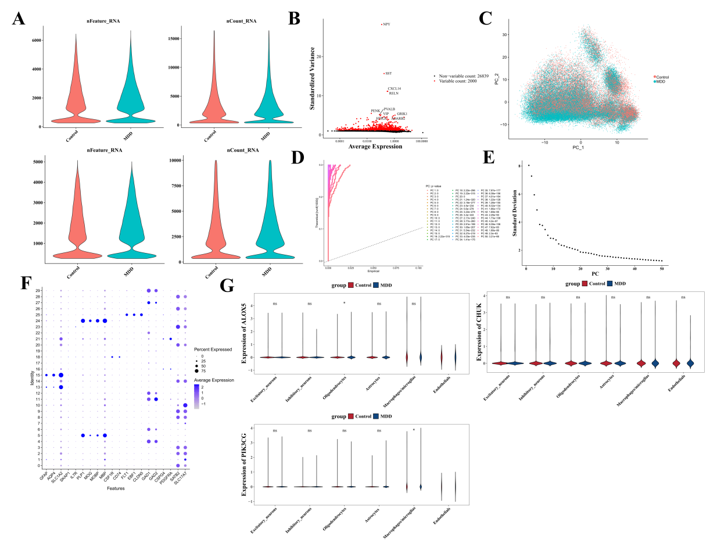
Fig. S3. Single-cell dataset analysis of major depressive disorder (MDD). (A). The distribution of nFeature_RNA and nCount_RNA across different samples, indicating good data quality within reasonable ranges. (B). Scatter plot showing high variable genes. The top 2,000 genes with the highest variation in gene expression were marked in red. (C). Batch effect was eliminated after standardization in the MDD and control groups. There were no significant differences between the samples. (D). Jackstraw permutation test plot. (E). Scree plot of the top 30 principal components (PCs). (F). Expression levels of marker genes in different cell clusters. (G). Violin plot showing the expression trends of ALOX5, PIK3CG, and CHUK across six cell types. “ns” indicates p ≥ 0.05. *p < 0.05.

References
1. H. Wang, P. Zhong, J. Liang, M. Zhou, K. Chen and Q. Xia. Correlation analysis between HPLC fingerprint and small intestinal propelling of processed Fructus aurantii Chinese Traditional Patent Medicine. 2021;43(3):5.

