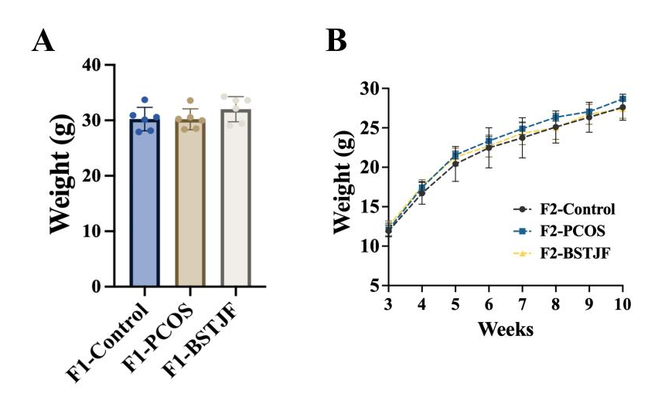
Figure S1. The weight change in the first-generation (F1) and second-generation (F2) male offspring of the polycystic ovary syndrome (PCOS) murine model.
Notes: A. The weight of F1 mice in adulthood, statistical analysis was performed using one-way ANOVA followed by Dunnett’s multiple comparisons test; B. The weight of F2 mice form 3-10 weeks old, two-way repeated-measures ANOVA followed by Dunnett’s multiple comparisons test was used for statistical analysis in F2. N = 6 per group. Data are presented as mean ± SD.
Figure S2. The mean islet area in first-generation (F1) and second-generation (F2) male offspring of thepolycystic ovary syndrome (PCOS) murine model.
Notes: A. The mean islet area of F1 mice in adulthood; B. The mean islet area of F2 mice form 3-10 weeks old. N = 5 per group. Data are presented as mean ± SD. Statistical analysis was performed using one-way ANOVA followed by Dunnett’s multiple comparisons test.
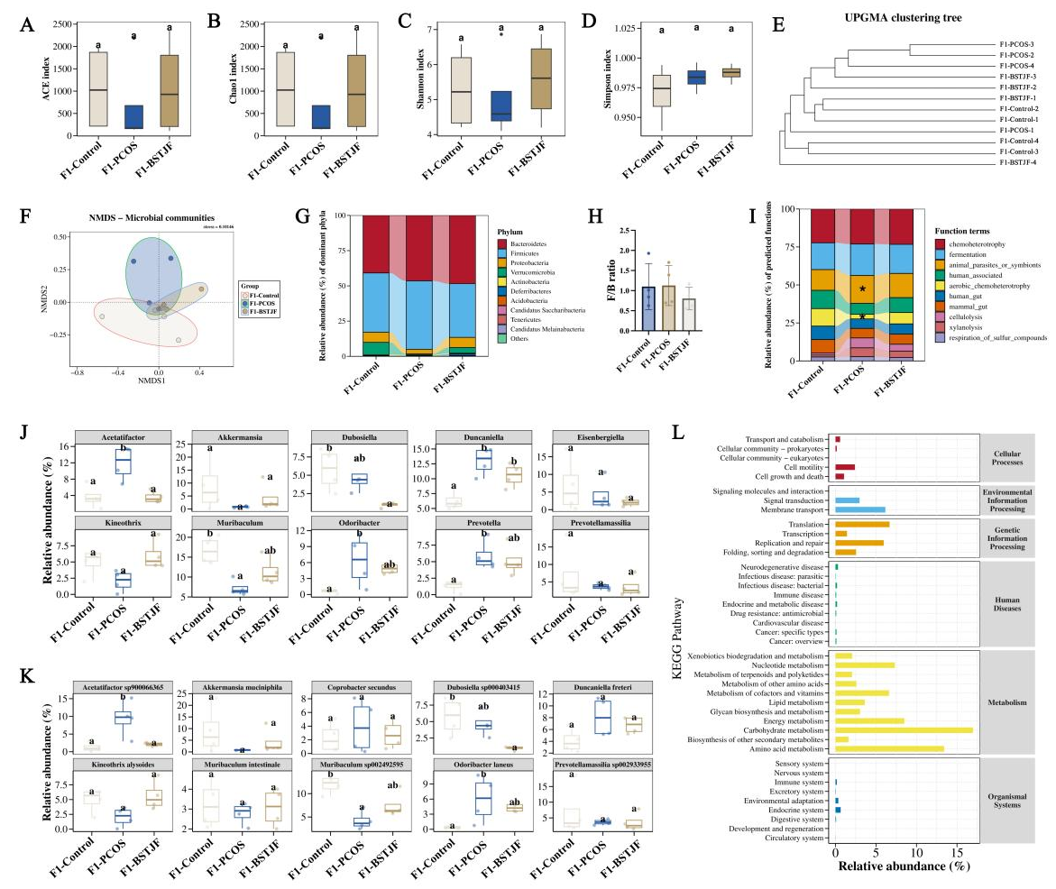
Figure S3. The bioinformatics analysis of first-generation (F1) male offspring’s 16S rRNA gene sequencing results.
Notes: A-B. The ACE and Chao1were the richness indices in alpha diversity analysis; C-D: The Shannon and Simpson were diversity indices in alpha diversity analysis; E. The unweighted pair group method with arithmetic mean (UPGMA) clustering analysis in beta diversity analysis; F.The nonmetric multidimensional scaling (NMDS) analysis in beta diversity analysis; G.The relative abundance (%) of Top10 dominant phylum in F1 Groups; H. The ratio of Firmicutes/ Bacteroidetes (F/B) in phylum level among groups in F1 male offspring, without significantly difference based on one-way ANOVA; I. The FAPROTAX functional prediction analysis; J. The relative abundance (%) of Top10 dominant genera, different symbols mean significant difference; K.The relative abundance (%) of Top10 dominant speciese, different symbols mean significant difference; L. The relative richness of Kyoto Encyclopedia of Genes and Genomes (KEGG) pathways in level 3 of Phylogenetic Investigation of Communities by Reconstruction of Unobserved States (PICRUSt2) functional prediction. For comparisons among three groups, the Tukey’s HSD tests were used and the significance was defined as adjusted P-value < 0.05 (* or different symbols).
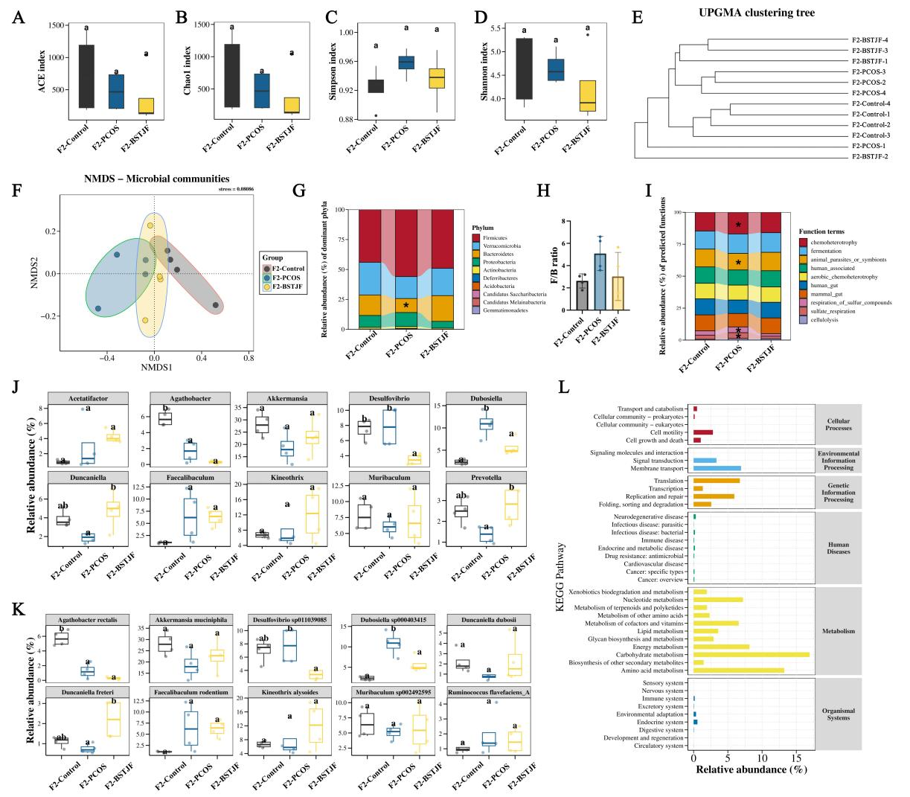
Figure S4. The bioinformatics analysis of second-generation (F2) male offspring’s 16S rRNA gene sequencing results.
Notes: A-B. The ACE and Chao1 were the richness indices in alpha diversity analysis; C-D: The Shannon and Simpson were diversity indices in alpha diversity analysis; E. The unweighted pair group method with arithmetic mean (UPGMA) clustering analysis in beta diversity analysis; F.The nonmetric multidimensional scaling (NMDS) analysis in beta diversity analysis; G.The relative abundance (%) of Top10 dominant phylum in F2 Groups; H. The ratio of Firmicutes/ Bacteroidetes (F/B) in phylum level among groups in F2 male offspring, without significantly difference based on one-way ANOVA; I. The FAPROTAX functional prediction analysis; J. The relative abundance (%) of Top10 dominant genera, different symbols mean significant difference; K.The relative abundance (%) of Top10 dominant speciese, different symbols mean significant difference; L. The relative richness of Kyoto Encyclopedia of Genes and Genomes (KEGG) pathways in level 3 of Phylogenetic Investigation of Communities by Reconstruction of Unobserved States (PICRUSt2) functional prediction. For comparisons among three groups, the Tukey’s HSD tests were used and the significance was defined as adjusted P-value < 0.05 (* or different symbols).
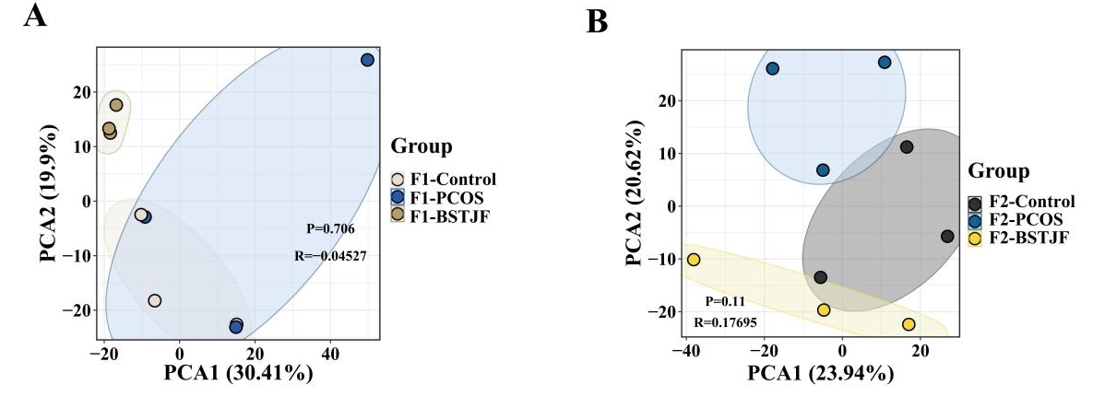
Figure S5. The PCA for the hepatic untargeted metabolomics of first-generation (F1) and second-generation (F2) male offspring of the polycystic ovary syndrome (PCOS) murine model.
Notes: The principal component analysis (PCA) of hepatic metabolomics of three groups in F1 and F2 male mice.

