Supplementary Table S1.
Gene sequences for Real-time polymerase chain reaction (PCR).
Gene |  | Sequences | Annealing temperature
C2C12 myotubes
Gapdh | F | AAATGGTGAAGGTCGGTGTG | 57°C
Gapdh | R | GAATTTGCCGTGAGTGGAGT | 57°C
Mstn | F | CTGTAACCTTCCCAGGACCA | 56°C
Mstn | R | TCTTTTGGGTGCGATAATCC | 56°C
Myh1 | F | CGGTCGAAGTTGCATCCCTA | 57°C
Myh1 | R | TAGTTCCGCCTTCGGTCTTG | 57°C
Quadriceps muscle
Atp5fb | F | GCACCGTCAGAACTATTGCT | 60°C
Atp5fb | R | GAATTCAGGAGCCTCAGCAT | 60°C
Fbxo32 | F | AGACCGGCTACTGTGGAAGAG | 60°C
Fbxo32 | R | CCGTGCATGGATCAGTG | 60°C
Gapdh | F | TGCACCACCAACTGCTTA | 60°C
Gapdh | R | GGATGCAGGGATGATGTTC | 60°C
Mtor | F | CAGGACGAGCGAGTGAT | 58°C
Mtor | R | CGAGTTGGTGGACAGAGG | 58°C
Pi3k | F | GCCTGCTCTGTAGTGGTAGATG | 52°C
Pi3k | R | GGAGGTGTGTTGGTAATGTAGC | 52°C
Trim63 | F | ACAACCTCTGCCGGAAGTGT | 55°C
Trim63 | R | CCGCGGTTGGTCCAGTAG | 55°C
Slc2a4 | F | GCTTCTGTTGCCCTTCTGTC | 60°C
Slc2a4 | R | TGGACGCTCTCTTTCCAACT | 60°C
Atp5fb, ATP synthase F1 subunit beta; Fbxo32, muscle atrophy F-box; Gapdh, glyceraldehyde-3-phosphate dehydrogenase; Mstn, myostatin; Mtor, mammalian target of rapamycin; Myh1, myosin heavy chain 1; Pi3k, phosphatidylinositol-3 kinase; Trim63, muscle-specific RING finger protein 1; Slc2a4, solute carrier family 2 member 4.

Supplementary Table S2.
Major amino acids identified in mung bean protein hydrolysate.
Types of amino acids | Amino acid content (g/100 g sample)
Essential Amino Acids
Threonine | 2.47
Methionine | 1.12
Phenylalanine | 6.20
Histidine | 2.41
Lysine | 5.44
Valine | 4.00
Isoleucine | 3.41
Leucine | 7.84
Tryptophan | 0.77
Cystine | 0.15
Non-essential Amino Acids
Serine | 3.48
Glycine | 2.34
Glutamic acid | 8.88
Proline | 3.18
Alanine | 3.12
Tyrosine | 2.75
Arginine | 4.25
Aspartic acid | 7.22
Supplementary Figure S1.
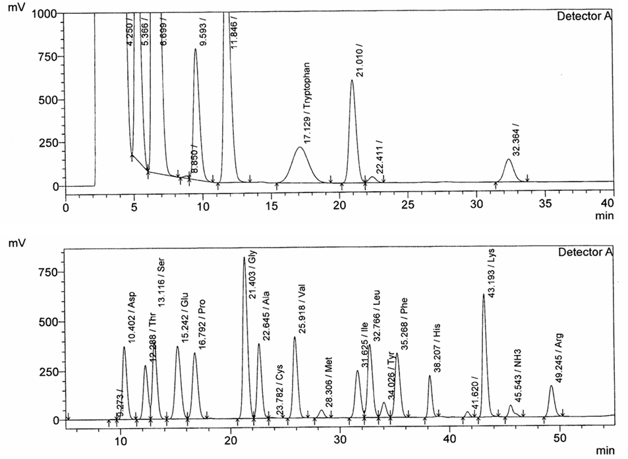
Supplementary Figure S1. High Performance Liquid Chromatography of protein hydrolysate of mung bean protein.

Supplementary Figure S2.
Supplementary Figure S2. Total phenolic content and free-radical scavenging activity of mung bean protein. (A) Total phenolic content. (B) Inhibition of DPPH radical activity. All data are presented as the mean ± standard error of the mean (n = 3 per group). ªp < 0.05 versus mung bean concentration at 0 mg/mL; ^{b}p < 0.05 versus mung bean concentration at 0.15625 mg/ml; ^{c}p < 0.05 versus mung bean concentration at 0.3125 mg/ml; ^{d}p < 0.05 versus mung bean concentration at 0.625 mg/ml; ^{e}p < 0.05 versus mung bean concentration at 1.25 mg/ml; ^{f}p < 0.05 versus mung bean concentration at 2.5 mg/ml.

Supplementary Figure S3.
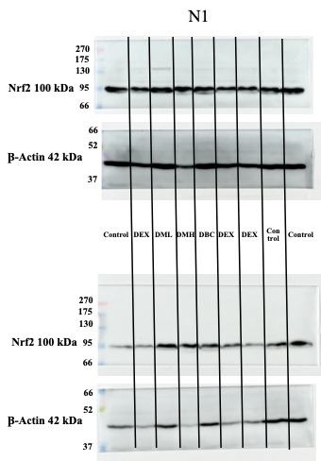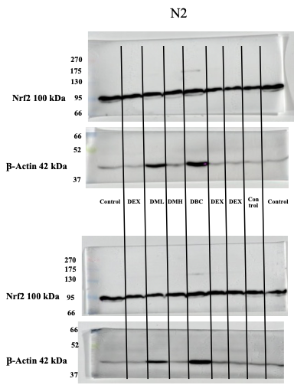
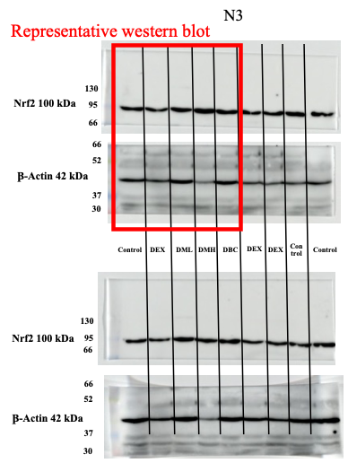
Supplementary Figure S3. Original western blot images for Nrf2 and β-actin. Full-length, unprocessed western blot images corresponding to the representative blots and quantitative analysis presented in Fig. 5 of the main manuscript.

