Supplementary Appendix

Comparative Efficacy of Plant Extracts as Adjuncts to Scaling and Root Planing for Periodontitis: A Systematic Review and Network Meta-analysis of Randomized Controlled Trials

Table of Contents
Appendix 1: Search strategy
Appendix 2: Characteristics of included studies
Appendix 3: List of data extracted from the included randomized clinical trials
Appendix 4: Risk of bias of randomized clinical trials
Appendix 5: Evaluation of inconsistency and heterogeneity
Appendix 6: SUCRA and cumulative probability plots
Appendix 7: League tables of Summary Estimates for Plant Extracts in Periodontitis Derived from Network Meta-analysis
Appendix 8: CINeMA Assessment
Appendix 9: Funnel plots
Appendix 10: Sensitivity analyses
Appendix 11: Subgroup analyses by route of administration
Appendix 12: Subgroup analyses by study design

Appendix 1: Search strategy
Table S1: Search strategy of PubMed
# | Searches
1 | ("Periodontal Diseases"[Mesh]) OR ("Periodontitis"[Mesh]) OR ("Chronic Periodontitis"[Mesh]) OR ("Aggressive Periodontitis"[Mesh]) OR ("Gingivitis"[Mesh]) OR ("Periodontal Pocket"[Mesh]) OR ("Alveolar Bone Loss"[Mesh])
2 | (periodontit*[tiab]) OR (gingivit*[tiab]) OR (parodontit*[tiab]) OR ("periodontal disease*"[tiab]) OR ("periodontal pocket*"[tiab]) OR ("periodontal inflammat*"[tiab]) OR ("gingival inflammat*"[tiab]) OR ("alveolar bone loss"[tiab]) OR ("attachment loss"[tiab]) OR ("bleeding on probing"[tiab]) OR ("gingival index"[tiab]) OR ("plaque index"[tiab])
3 | (#1) OR (#2)
4 | ("Plant Extracts"[Mesh]) OR ("Plants, Medicinal"[Mesh]) OR ("Herbal Medicine"[Mesh]) OR ("Phytotherapy"[Mesh]) OR ("Plant Preparations"[Mesh]) OR ("Drugs, Chinese Herbal"[Mesh])
5 | ("plant extract*"[tiab]) OR ("medicinal plant*"[tiab]) OR ("herbal medicine*"[tiab]) OR (phytotherapy[tiab]) OR (phytomedicine*[tiab]) OR ("herbal extract*"[tiab]) OR ("herbal preparation*"[tiab]) OR ("botanical extract*"[tiab]) OR ("essential oil*"[tiab]) OR (herb*[tiab]) OR (botanical*[tiab]) OR (nutraceutical*[tiab]) OR (polyherbal[tiab])
6 | ("Aloe vera"[tiab]) OR ("Aloe barbadensis"[tiab]) OR ("Azadirachta indica"[tiab]) OR (Neem[tiab]) OR ("Boswellia serrata"[tiab]) OR (Frankincense[tiab]) OR ("Camellia sinensis"[tiab]) OR ("Green tea"[tiab]) OR (Cinnamomum[tiab]) OR (Cinnamon[tiab]) OR ("Curcuma longa"[tiab]) OR (Turmeric[tiab]) OR (Curcumin[tiab]) OR ("Eucalyptus globulus"[tiab]) OR ("Ficus religiosa"[tiab]) OR ("Glycyrrhiza glabra"[tiab]) OR (Licorice[tiab]) OR ("Matricaria chamomilla"[tiab]) OR (Chamomile[tiab]) OR ("Ocimum sanctum"[tiab]) OR ("Ocimum basilicum"[tiab]) OR (Tulsi[tiab]) OR (Basil[tiab]) OR ("Origanum vulgare"[tiab]) OR (Oregano[tiab]) OR ("Psidium guajava"[tiab]) OR (Guava[tiab]) OR ("Punica granatum"[tiab]) OR (Pomegranate[tiab]) OR ("Rosmarinus officinalis"[tiab]) OR (Rosemary[tiab]) OR ("Salvadora persica"[tiab]) OR (Miswak[tiab]) OR ("Salvia officinalis"[tiab]) OR (Sage[tiab]) OR ("Syzygium aromaticum"[tiab]) OR (Clove[tiab]) OR ("Zingiber officinale"[tiab]) OR (Ginger[tiab]) OR (Propolis[tiab])
7 | (#4) OR (#5) OR (#6)
8 | (randomized controlled trial[pt] OR controlled clinical trial[pt] OR randomized[tiab] OR placebo[tiab] OR drug therapy[sh] OR randomly[tiab] OR trial[tiab] OR groups[tiab])
9 | (animals[mh] NOT humans[mh])
10 | (#8) NOT (#9)
11 | (#3) AND (#7) AND (#10)

Table S2: Search strategy of Embase (Ovid)
# | Searches
1 | (exp periodontal disease/ OR exp periodontitis/ OR exp gingivitis/ OR exp tooth socket/ OR exp jaw alveolar bone loss/)
2 | (periodontit* OR gingivit* OR parodontit* OR "periodontal disease*" OR "periodontal pocket*" OR "periodontal inflammat*" OR "gingival inflammat*" OR "alveolar bone loss" OR "attachment loss" OR "bleeding on probing" OR "gingival index" OR "plaque index").ti,ab,kw.
3 | 1 OR 2
4 | (exp plant extract/ OR exp medicinal plant/ OR exp herbal medicine/ OR exp phytotherapy/ OR exp unclassified drug/ OR exp essential oil/)
5 | ("plant extract*" OR "medicinal plant*" OR "herbal medicine*" OR phytotherapy OR phytomedicine* OR "herbal extract*" OR "herbal preparation*" OR "botanical extract*" OR "essential oil*" OR herb* OR botanical* OR nutraceutical* OR polyherbal).ti,ab,kw.
6 | ("Aloe vera" OR "Aloe barbadensis" OR "Azadirachta indica" OR Neem OR "Boswellia serrata" OR Frankincense OR "Camellia sinensis" OR "Green tea" OR Cinnamomum OR Cinnamon OR "Curcuma longa" OR Turmeric OR Curcumin OR "Eucalyptus globulus" OR "Ficus religiosa" OR "Glycyrrhiza glabra" OR Licorice OR "Mangifera indica" OR Mango OR "Matricaria chamomilla" OR Chamomile OR "Medicago sativa" OR "Moringa oleifera" OR "Ocimum sanctum" OR "Ocimum basilicum" OR Tulsi OR Basil OR "Origanum vulgare" OR Oregano OR "Plantago major" OR "Pongamia pinnata" OR "Psidium guajava" OR Guava OR "Punica granatum" OR Pomegranate OR "Rosmarinus officinalis" OR Rosemary OR "Salvadora persica" OR Miswak OR "Salvia officinalis" OR Sage OR "Scutellaria baicalensis" OR "Syzygium aromaticum" OR Clove OR "Trifolium pratense" OR "Zingiber officinale" OR Ginger OR Propolis).ti,ab,kw.
7 | 4 OR 5 OR 6
8 | 'randomized controlled trial'/exp OR 'controlled clinical trial'/de OR random*:ti,ab,kw OR 'randomization'/de OR 'intermethod comparison'/de OR placebo:ti,ab,kw OR (compare:ti,ab,kw AND (group:ti,ab,kw OR trial:ti,ab,kw))
9 | (animal/ OR animal experiment/ OR nonhuman/) NOT human/
10 | 8 NOT 9
11 | 3 AND 7 AND 10

Table S3: Search strategy of Cochrane CENTRAL
# | Searches
1 | [mh "Periodontal Diseases"]
2 | [mh "Periodontitis"]
3 | [mh "Gingivitis"]
4 | (periodontit* OR gingivit* OR parodontit* OR "periodontal disease*" OR "periodontal pocket*" OR "periodontal inflammat*" OR "gingival inflammat*" OR "alveolar bone loss" OR "attachment loss" OR "bleeding on probing"):ti,ab,kw
5 | #1 OR #2 OR #3 OR #4
6 | [mh "Plant Extracts"]
7 | [mh "Plants, Medicinal"]
8 | [mh "Herbal Medicine"]
9 | [mh "Phytotherapy"]
10 | ("plant extract*" OR "medicinal plant*" OR "herbal medicine*" OR phytotherapy OR phytomedicine* OR "herbal extract*" OR "botanical extract*" OR "essential oil*" OR herb* OR botanical* OR polyherbal):ti,ab,kw
11 | ("Aloe vera" OR Neem OR "Boswellia serrata" OR "Camellia sinensis" OR "Green tea" OR Cinnamon OR "Curcuma longa" OR Turmeric OR Curcumin OR "Eucalyptus globulus" OR "Glycyrrhiza glabra" OR Licorice OR "Matricaria chamomilla" OR Chamomile OR Tulsi OR Oregano OR "Psidium guajava" OR Guava OR "Punica granatum" OR Pomegranate OR Rosemary OR "Salvadora persica" OR Miswak OR "Salvia officinalis" OR Sage OR Clove OR Ginger OR Propolis):ti,ab,kw
12 | #6 OR #7 OR #8 OR #9 OR #10 OR #11
13 | #5 AND #12

Table S4: Search strategy of Web of Science (Core Collection)

# | Searches
1 | TS=(periodontit* OR gingivit* OR parodontit* OR "periodontal disease*" OR "periodontal pocket*" OR "periodontal inflammat*" OR "gingival inflammat*" OR "alveolar bone loss" OR "attachment loss" OR "bleeding on probing" OR "gingival index" OR "plaque index")
2 | TS=("plant extract*" OR "medicinal plant*" OR "herbal medicine*" OR phytotherapy OR phytomedicine* OR "herbal extract*" OR "herbal preparation*" OR "botanical extract*" OR "essential oil*" OR herb* OR botanical* OR nutraceutical* OR polyherbal)
3 | TS=("Aloe vera" OR "Aloe barbadensis" OR "Azadirachta indica" OR Neem OR "Boswellia serrata" OR Frankincense OR "Camellia sinensis" OR "Green tea" OR Cinnamomum OR Cinnamon OR "Curcuma longa" OR Turmeric OR Curcumin OR "Eucalyptus globulus" OR "Ficus religiosa" OR "Glycyrrhiza glabra" OR Licorice OR "Matricaria chamomilla" OR Chamomile OR "Ocimum sanctum" OR "Ocimum basilicum" OR Tulsi OR Basil OR "Origanum vulgare" OR Oregano OR "Psidium guajava" OR Guava OR "Punica granatum" OR Pomegranate OR "Rosmarinus officinalis" OR Rosemary OR "Salvadora persica" OR Miswak OR "Salvia officinalis" OR Sage OR "Syzygium aromaticum" OR Clove OR "Zingiber officinale" OR Ginger OR Propolis)
4 | #2 OR #3
5 | TS=(random* OR placebo* OR "clinical trial" OR "controlled trial" OR double-blind OR single-blind OR "randomised controlled trial" OR "randomized controlled trial" OR randomly)
6 | #1 AND #4 AND #5

Appendix 2: Characteristics of included studies
Table S2.1: Characteristics of the included studies
Study | Country | Study design | Age (T/C) | Sample size (T/C) | Clinical characteristics | Intervention (T) | Comparator (C) | Follow-up | Outcomes reported
Chapple 2012 | United Kingdom | Three-arm parallel RCT | 30–60 / 30–60 | 20 / 20 | Non-smokers; non-diabetic | SRP + FVJ (oral) | SRP + placebo | 2, 5, and 8 months | CAL, PPD
Reddy 2015 | India | Parallel controlled trial | 35–50 / 35–50 | 20 / 20 | Non-smokers; type 2 diabetes | SRP + Lycopene (oral) | SRP + placebo | 2 and 6 months | CAL, PPD, GI
Babaei 2018 | Iran | Parallel controlled trial | 25–57 / 25–57 | 20 / 20 | Non-smokers; non-diabetic | SRP + chicory leaf methanol extract (oral) | SRP + placebo | 8 weeks | PPD
Kudva 2011 | India | Split-mouth self-controlled | 30–55 / 30–55 | 14 / 14 | Non-smokers; non-diabetic | SRP + Green tea (local) | SRP alone | 3 weeks | PPD, GI, PI
Hattarki 2013 | India | Split-mouth self-controlled | Adults / Adults | 20 / 20 | Non-smokers; non-diabetic | SRP + Green tea (local) | SRP alone | 5 weeks | PPD, GI, PI
Rattanasuwan 2016 | Thailand | Parallel controlled trial | 49.2 ± 8.3 / 51.4 ± 8.8 | 23 / 19 | Non-smokers; non-diabetic | SRP + Green tea (local) | SRP + placebo | 3 and 6 months | CAL, PPD, GI, PI
Hrishi 2016 | India | Parallel controlled trial | 18–60 / 18–60 | 15 / 15 | Non-smokers; non-diabetic | SRP + Green tea (local) | SRP + fluoride-triclosan toothpaste | 4 weeks | CAL, PPD, GI, PI
Gottumukkala 2013 | India | Parallel controlled trial | 30–55 / 30–55 | 23 / 23 | Non-smokers; non-diabetic | SRP + Curcumin (local) | SRP + placebo | 1, 3, and 6 months | PPD, PI
Bhatia 2014 | India | Split-mouth self-controlled | 21–45 / 21–45 | 50 / 50 | Non-smokers; non-diabetic | SRP + Curcumin (local) | SRP alone | 1, 3, and 6 months | CAL, PPD
Anuradha 2015 | India | Split-mouth self-controlled | 25–60 / 25–60 | 30 / 30 | Non-smokers; non-diabetic | SRP + Curcumin (local) | SRP alone | 30 and 45 days | CAL, PPD, GI, PI
Nagasri 2015 | India | Split-mouth self-controlled | 35–60 / 35–60 | 30 / 30 | Non-smokers; non-diabetic | SRP + Curcumin (local) | SRP alone | 4 weeks | CAL, PPD, GI, PI
Sreedhar 2015 | India | Split-mouth self-controlled | 35–55 / 35–55 | 15 / 15 | Non-smokers; non-diabetic | SRP + Curcumin (local) | SRP alone | 1 and 3 months | CAL, PPD, PI
Nasra 2017 | Egypt | Parallel controlled trial | 35–55 / 35–55 | 10 / 10 | Smoking: not reported; diabetes: not reported | SRP + Curcumin (local) | SRP alone | 1 month | PPD
Ivanaga 2019 | Brazil | Split-mouth self-controlled | 55.0 ± 10.2 / 55.0 ± 10.2 | 25 / 25 | Non-smokers; type 2 diabetes | SRP + Curcumin (local) | SRP + placebo | 3 and 6 months | CAL, PPD
Jaswal 2014 | India | Split-mouth self-controlled | 21–55 / 21–55 | 15 / 15 | Non-smokers; non-diabetic | SRP + Curcumin (local) | SRP alone | 7, 30, and 45 days | CAL, PPD, GI, PI
Behal 2011 | India | Split-mouth self-controlled | Adults / Adults | 30 / 30 | Smoking: not reported; diabetes: not reported | SRP + Curcumin (local) | SRP alone | 30 and 45 days | CAL, PPD, GI, PI
Jalaluddin 2019 | India | Parallel controlled trial | 25–45 / 25–45 | 20 / 20 | Non-smokers; non-diabetic | SRP + Curcumin (local) | SRP alone | 14 days and 4 weeks | PPD
Abdel-Fatah 2023 | Egypt | Parallel controlled trial | 40.83 ± 6.05 / 40.61 ± 6.51 / 39.17 ± 5.66 | 18 / 18 | Non-smokers; non-diabetic | SRP + Curcumin (local) | SRP alone | 6 weeks | PPD
Pérez-Pacheco 2020 | Brazil | Split-mouth self-controlled | 48.98 ± 6.46 / 48.98 ± 6.46 | 16 / 16 | Non-smokers; non-diabetic | SRP + Curcumin (local) | SRP + placebo | 1, 2, and 6 months | CAL, PPD
Hirasawa 2002 | Japan | Split-mouth self-controlled | 41–64 / 41–64 | 6 / 6 | Smoking: not reported; non-diabetic | SRP + Green tea (local) | SRP + placebo | 7–8 weeks | PPD
Rassameemasmaung 2008 | Thailand | Parallel controlled trial | 47.31 / 45.8 | 16 / 15 | Non-smokers; non-diabetic | SRP + Garcinia mangostana (local) | SRP alone | 3 months | CAL, PPD
Yaghini 2014 | Iran | Parallel controlled trial | 31–52 / 31–52 | 18 / 18 | Non-smokers; non-diabetic | SRP + OCE (local) | SRP + placebo | 1 and 3 months | CAL, PPD
Grover 2016 | India | Parallel controlled trial | 40.10 ± 7.71 / 44.70 ± 7.79 | 20 / 20 | Non-smokers; non-diabetic | SRP + Emblica officinalis (local) | SRP + placebo | 2 and 3 months | CAL, PPD, GI, PI
Mahendra 2017 | India | Parallel controlled trial | 30–65 / 30–65 | 25 / 25 | Non-smokers; non-diabetic | SRP + Garcinia mangostana gel (local) | SRP + placebo | 3 months | CAL, PPD,PI
Kurian 2018 | India | Parallel controlled trial | 33.26 ± 4.87 / 31.66 ± 5.33 / 32.7 ± 5.2 | 30 / 30 | Non-smokers; non-diabetic | SRP + Aloe vera gel (local) | SRP + placebo | 6 and 12 months | CAL,PPD, PI
Warad 2013 | India | Parallel controlled trial | 43.9 ± 5.4 / 43.9 ± 5.4 | 15 / 15 | Non-smokers; non-diabetic | SRP + LEOG (local) | SRP alone | 1 and 3 months | CAL, PPD
Deshpande 2012 | India | Parallel controlled trial | 21–43 / 21–43 | 10 / 10 | Non-smokers; non-diabetic | SRP + Green tea (oral) | SRP alone | 3 and 6 months | PI, PBI
Chopra 2016 | India | Parallel controlled trial | 20–50 / 20–50 | 60 / 60 | Non-smokers; non-diabetic | SRP + Green tea (oral) | SRP + placebo | 12 weeks | GI, PI
Arora 2013 | India | Parallel controlled trial | 25–52 / 25–52 | 21 / 21 | Non-smokers; non-diabetic | SRP + Lycopene (oral) | SRP + placebo | 8 weeks | CAL, PPD, GI, PI
Nafade 2022 | India | Parallel controlled trial | 20–60 / 20–60 | 30 / 30 | Non-smokers; non-diabetic | SRP + Oolong tea (oral) | SRP alone | 1 and 3 months | CAL, PPD
Taleghani 2018 | Iran | Parallel controlled trial | 45 / 45 | 15 / 15 | Non-smokers; non-diabetic | SRP + Green tea (oral) | SRP alone | 6 weeks | PPD, PI
Raghava 2019 | India | Split-mouth self-controlled | 25–40 / 25–40 | 10 / 10 | Non-smokers; non-diabetic | SRP + Curcumin (local) | SRP alone | 4 weeks | CAL, PPD, GI, PI
Sharma 2016 | India | Split-mouth self-controlled | 25–30 / 25–30 | 20 / 20 | Non-smokers; non-diabetic | SRP + Curcumin (local) | SRP alone | 2 weeks | GI, PI
Sastravaha 2005 | Thailand | Split-mouth self-controlled | 32–68 / 32–68 | 15 / 15 | Smoking: NR; non-diabetic | SRP + Centella asiatica and pomegranate (SRP + CAP) (local) | SRP alone | 3 and 6 months | CAL, PPD
Sastravaha 2003 | Thailand | Split-mouth self-controlled | 35–65 / 35–65 | 20 / 20 | Non-smokers; non-diabetic | SRP + Centella asiatica and pomegranate (local) | SRP + placebo | 2, 4, 6, and 12 weeks | CAL, PPD, GI, PI
Funosas 2005 | Argentina | Split-mouth self-controlled | Adults / Adults | 50 / 50 | Smoking: NR; diabetes: NR | SRP + Green tea (local) | SRP + placebo | 3 months | CAL, PPD, GI
Nagate 2020 | India | Split-mouth self-controlled | 20–40 / 20–40 | 20 / 20 | Non-smokers; non-diabetic | SRP + Green tea (local) | SRP alone | 14 days and 4 weeks | PPD, GI, PI
Singh 2016 | India | Split-mouth self-controlled | 30–50 / 30–50 | 20 / 20 | Non-smokers; non-diabetic | SRP + Aloe vera gel | SRP alone | 1, 2, and 3 months | PPD, GI, PI
Abbreviations: T, treatment group; C, control group; SRP, scaling and root planing; CAL, clinical attachment level; PPD, probing pocket depth; GI, gingival index; PI, plaque index; PBI, papillary bleeding index; NR, not reported.

Table S2.2: Trial-level safety, adverse-event, and attrition information
Study | Safety-reporting category | Trial-level safety or tolerability findings | Serious adverse events | Withdrawals/attrition, n | Reasons and relationship to intervention
Chapple 2012 | C | Difficulty swallowing or intolerance of study capsules was reported. One participant considered the capsules too large; another reported swallowing difficulty in the presence of a concurrent respiratory tract infection. | No event was explicitly classified as an SAE. Unrelated medical problems were mentioned but not described. | 6 | Reasons included capsules being too large to swallow, relocation, difficulty attending appointments, unrelated medical problems, loss to follow-up for an unknown reason, and swallowing difficulty. One withdrawal was clearly related to capsule size; causality for the second swallowing-related withdrawal was uncertain. One withdrawn participant was replaced by the 61st enrollee.
Reddy 2015 | A | No adverse effects were reported with lycopene supplementation. | No SAE reported. | 0 | No participants were lost to follow-up at 2 or 6 months.
Babaei 2018 | A | Participants did not report any adverse effects or symptoms; compliance was 100%. | No SAE reported. | 0 | All 40 participants completed the intervention.
Kudva 2011 | D | Participants were instructed to report irritation or discomfort, but the results did not report whether such events occurred. | NR | NR | Fourteen participants were included; no participant-flow or withdrawal information was reported.
Hattarki 2013 | D | No trial-level adverse-event or tolerability information was reported. | NR | NR | Twenty participants were included; withdrawals were not reported.
Rattanasuwan 2016 | A | None of the participants complained of or experienced adverse reactions after gel application. | One participant withdrew after a diagnosis of a brain tumour. It was not classified as an SAE or attributed to the intervention. | 6 | Four withdrew because of bacterial pharyngitis requiring antibiotics, one because of a brain tumour, and one because contact was lost. No withdrawal was attributed to the study gel.
Hrishi 2016 | C | Green-tea dentifrice was reported not to be associated with adverse effects, although tooth staining occurred in one participant. | No SAE reported. | 0 | All 30 participants completed the study.
Gottumukkala 2013 | D | No trial-level safety outcome was reported. Statements concerning fewer side effects were general comparisons rather than observed trial results. | NR | 3 | Three of 26 participants were eliminated at day 7 because of inadequate oral-hygiene maintenance. This was a protocol/compliance exclusion, not an adverse event.
Bhatia 2014 | D | No trial-level adverse-event result was reported. Statements about high-dose curcumin having no side effects referred to previous evidence rather than this trial. | NR | NR | Twenty-five participants/50 sites were included; no withdrawal information was reported.
Anuradha 2015 | A | The experimental material was well accepted. Neither complications nor allergic reactions were found. | No SAE reported. | NR | Thirty participants were studied; no withdrawal or loss-to-follow-up statement was provided.
Nagasri 2015 | D | No trial-level adverse-event, side-effect or tolerability result was located in the article. | NR | NR | Thirty participants were included; participant flow and withdrawals were not reported.
Sreedhar 2015 | D | Participants were informed about possible pressure, pain or irritation, but the article did not report whether these symptoms occurred. | NR | NR | Fifteen participants/60 sites were included; withdrawal information was not reported.
Nasra 2017 | B | No evidence of burning sensation, dryness/soreness or ulcer formation was observed. No overall adverse-event statement was provided. | NR | NR | Ten participants per comparison were reported; withdrawals were not described.
Ivanaga 2019 | A | No adverse effects related to therapy, pain or discomfort were reported after treatment. | No SAE reported. | 2 | One participant did not complete the 90-day evaluation and one was excluded from the 180-day evaluation; both required antibiotics for systemic medical conditions. The exclusions were not attributed to the study intervention.
Jaswal 2014 | A | The turmeric gel showed good biological acceptability without side effects. | No SAE reported. | NR | Fifteen participants were included; no withdrawal information was reported.
Behal 2011 | A | All sites healed uneventfully. Neither complications nor allergic reactions related to treatment were observed. The authors additionally reported no side effects in any participant. | No SAE reported. | 0 reported | All 30 participants/60 sites were evaluated through 45 days; no loss was described.
Jalaluddin 2019 | D | No trial-level safety or adverse-event findings were reported. | NR | NR | Sixty participants were allocated across three groups; participant-flow and withdrawal information was not reported.
Abdel-Fatah 2023 | A | No adverse effects were reported during the whole study period; the conclusion also stated that there were no reported side effects. | No SAE reported. | 0 reported | Fifty-four participants entered the study groups. No post-enrolment loss was described. The 16 patients excluded before study-group inclusion should not be counted as withdrawals.
Pérez-Pacheco 2020 | A | No adverse effects were reported. | No SAE reported. | 4 | Four of the 20 enrolled participants failed to attend follow-up. Specific reasons were not reported, and no causal relationship could be assessed.
Hirasawa 2002 | B | No morbidity was observed in the catechin or placebo groups without mechanical treatment. This was not an overall adverse-event statement. | NR | 0 reported | All six participants were represented in the study results; no withdrawal was described.
Rassameemasmaung 2008 | B | No participant in the test group complained of treatment-related problems, and no adverse tissue reaction was observed. No overall safety statement covering all events/groups was provided. | NR | 0 reported | Thirty-one participants completed the study; no withdrawal was described.
Yaghini 2014 | D | The article stated generally that herbal products are safe compared with synthetic treatments, but did not report trial-level adverse events. | NR | NR | Eighteen participants and 74 sites were evaluated; participant withdrawals were not reported.
Grover 2016 | A | No adverse event was observed clinically or reported during treatment with Emblica officinalis gel. | No SAE reported. | 6 | Five participants were lost to follow-up—three in the test group and two in the control group—and one control participant withdrew because systemic antibiotic treatment was required. No withdrawal was attributed to the gel.
Mahendra 2017 | A | All participants tolerated the drug well; no complications or adverse reactions were observed, and soft tissues healed satisfactorily. | No SAE reported. | 0 | All 50 participants remained until completion.
Kurian 2018 | A | No adverse effects or discomfort were reported in any group. | No SAE reported. | 0 | All 90 enrolled participants completed the study. Seven ineligible patients and eight unwilling patients were excluded before enrolment and should not be counted as withdrawals.
Warad 2013 | D | Although the intervention was described as safe/effective, no trial-level adverse-event or tolerability results were provided. | NR | NR | Fifteen participants per comparison were reported; withdrawals were not described.
Deshpande 2012 | D | The statement that green tea was “absolutely safe” and had “no hazardous effects” was a general statement, not a trial-level adverse-event result. | NR | NR | Participant-flow and withdrawal information was not reported.
Chopra 2016 | D | No trial-level adverse-event or safety result was reported. | NR | 5 | In the green-tea group, one participant was lost to follow-up and three discontinued the intervention; in the control group, one participant was lost to follow-up. Reasons for discontinuing the intervention were not provided, so causality cannot be assessed.
Arora 2013 | A | No adverse events or discontinuations owing to adverse events were reported in either group. | No SAE reported. | 4 | Two participants in each group were lost to follow-up because work schedules or domestic commitments made attendance difficult. These losses were unrelated to adverse reactions.
Nafade 2022 | B | Participants reported no discomfort with daily oolong-tea intake, and no visible tooth staining was found. No overall adverse-event statement was provided. | NR | 0 | No participants were lost to follow-up or discontinued the intervention.
Taleghani 2018 | D | No trial-level adverse-event or tolerability information was reported. | NR | NR | Thirty participants were included; withdrawals were not reported.
Raghava 2019 | D | No trial-level safety or adverse-event information was reported. | NR | NR | Ten participants were included; no participant-flow statement was provided.
Sharma 2016 | D | The article discussed side effects of conventional plaque-control agents but did not report trial-level adverse events associated with the study intervention. | NR | NR | Twenty participants were included; withdrawal information was not reported.
Sastravaha 2005 | C | A few participants reported mild, transient gingival discomfort after chip placement. The authors stated that no adverse reactions occurred. | No SAE reported. | 1 | One of 16 participants was dropped because antibiotic treatment was required. The reason for antibiotic treatment was not specified and was not attributed to the study intervention.
Sastravaha 2003 | A* | A subsequent report by Sastravaha et al. stated that the previous 2003 trial had confirmed no adverse reactions in any participant. | No SAE reported in the subsequent description. | NR | Participant-level withdrawal information was not available. The no-adverse-reaction statement is reported in the subsequent 2005 publication rather than independently verified in the primary full-text report.
Funosas 2005 | D | No trial-level adverse-event or tolerability information was reported. | NR | NR | Fifty participants were included in the reported analyses; no explicit withdrawal statement was provided.
Nagate 2020 | D | No trial-level safety, adverse-event or tolerability findings were reported. | NR | NR | Twenty participants were included; participant-flow and withdrawal information was not reported.
Singh 2016 | D | No trial-level safety or adverse-event information was reported. | NR | NR | Twenty participants were included; withdrawals were not reported.
Abbreviations: Safety-reporting categories were mutually exclusive. Category A indicates an explicit trial-level report of no adverse events, side effects, complications, or adverse reactions; category B indicates that selected local symptoms were reported as absent without an overall adverse-event statement; category C indicates that an adverse or tolerability finding was reported; and category D indicates that no trial-level safety information was provided. General statements that an intervention was “safe” were not considered equivalent to an explicit report of no adverse events. Attrition included withdrawals, loss to follow-up, discontinuation, or post-enrolment exclusion. Pre-enrolment exclusions were not counted. AE, adverse event; SAE, serious adverse event; NR, not reported. *For Sastravaha 2003, the no-adverse-reaction statement was reported in the subsequent Sastravaha 2005 publication and was not independently verified in the primary full-text report.

Table S2.3: Study-level characteristics relevant to the assessment of transitivity

Study | Baseline periodontal status/severity | Smoking and diabetes status | Intervention and administration route | Formulation/delivery vehicle | Dose/concentration | Application frequency and treatment duration | Follow-up
Chapple 2012 | Chronic periodontitis, with ≥2 sites per quadrant showing PPD or CAL >6 mm; full-mouth examination at six sites per tooth, with additional analysis of sites >4 mm | Non-smokers; non-diabetic | SRP + FVJ or SRP + FVB; oral administration | Encapsulated fruit and vegetable or fruit, vegetable and berry juice-powder concentrates; matching placebo capsules | NR | Administered daily during standard non-surgical periodontal treatment and continued for 9 months | 2, 5, and 8 months
Reddy 2015 | Type 2 diabetes mellitus with chronic periodontitis; six Ramfjord teeth measured at six sites per tooth | Non-smokers; type 2 diabetes | SRP + lycopene; oral administration | Lycopene soft-gel capsules; matching placebo capsules | 8 mg/day | Administered once daily for 8 weeks after SRP | 2 and 6 months
Babaei 2018 | Chronic periodontitis, with PD ≥4 mm involving at least three-quarters of the mouth; six sites per tooth | Non-smokers; non-diabetic | SRP + chicory leaf methanolic extract; oral administration | Chicory leaf methanolic-extract capsules; matching placebo capsules | 1 g per dose | Administered with meals twice daily for 8 weeks | 8 weeks
Kudva 2011 | Chronic periodontitis; contralateral periodontal-pocket sites with PPD 5–8 mm | Non-smokers; non-diabetic | SRP + green tea; local administration | Green-tea catechin sustained-release strips placed in periodontal pockets | NR | Applied to the experimental sites after full-mouth scaling and root planing; application frequency NR | 3 weeks
Hattarki 2013 | Chronic periodontitis; contralateral periodontal-pocket sites with PPD ≥5 mm | Non-smokers; non-diabetic | SRP + green tea; local administration | Green-tea catechin sustained-release strips placed in periodontal pockets | NR | Applied to the experimental sites after full-mouth scaling and root planing; application frequency NR | 5 weeks
Rattanasuwan 2016 | Chronic periodontitis; periodontal pockets with PPD 5–10 mm and without furcation involvement, caries, or restorations | Non-smokers; non-diabetic | SRP + green tea; local administration | Thermosensitive gel containing green-tea extract | 12% green-tea extract | Subgingival application at baseline, week 1, and week 2 | 3 and 6 months
Hrishi 2016 | Mild-to-moderate chronic periodontitis; ≥6 periodontal sites with PPD >4 mm and CAL 1–4 mm | Non-smokers; non-diabetic | SRP + green tea; local administration | Self-prepared toothpaste containing green-tea extract; fluoride-triclosan toothpaste as comparator | 1.4% green-tea extract | Used daily for toothbrushing for 4 weeks | 4 weeks
Gottumukkala 2013 | Chronic periodontitis; one non-adjacent periodontal-pocket site with PPD ≥5 mm selected in each of three different quadrants | Non-smokers; non-diabetic | SRP + curcumin; local administration | Curcumin solution delivered by subgingival irrigation | 1% curcumin solution | Multiple subgingival irrigations after SRP; exact application schedule NR | 1, 3, and 6 months
Bhatia 2014 | Chronic periodontitis; bilateral symmetrical periodontal pockets with PPD >5 mm | Non-smokers; non-diabetic | SRP + curcumin; local administration | Curcumin gel placed subgingivally into periodontal pockets | 1% curcumin gel | Applied at baseline and repeated at 1, 3, and 6 months | 1, 3, and 6 months
Anuradha 2015 | Localised or generalised chronic periodontitis; two non-adjacent periodontal-pocket sites with PPD 5–7 mm per participant | Non-smokers; non-diabetic | SRP + curcumin; local administration | Curcumin gel placed in the periodontal pocket and covered with a periodontal dressing | NR | Applied after subgingival scaling and root planing; repetition schedule NR | 30 and 45 days
Nagasri 2015 | Chronic periodontitis; two contralateral periodontal-pocket sites with PPD ≥5 mm per participant | Non-smokers; non-diabetic | SRP + curcumin; local administration | Curcumin gel placed subgingivally in the experimental site | NR | Single application after scaling and root planing | 4 weeks
Sreedhar 2015 | Chronic periodontitis; the deepest periodontal pocket with PPD ≥5 mm selected in each quadrant | Non-smokers; non-diabetic | SRP + curcumin; local administration | Curcumin gel, with or without 470-nm blue-light photodynamic activation | NR | Curcumin gel was applied as a single or multiple application, with or without photodynamic therapy; exact schedule NR | 1 and 3 months
Nasra 2017 | Adult moderate-to-severe chronic periodontitis; a single isolated periodontal pocket with PD 5 mm and bleeding on probing | NR; NR | SRP + curcumin; local administration | Curcumin in-situ gel injected in a cold liquid state and forming a gel at body temperature | 2% curcumin | Applied once weekly for 3 consecutive weeks | 1 month
Ivanaga 2019 | Type 2 diabetes mellitus with chronic periodontitis; ≥1 residual periodontal pocket per quadrant with PD ≥5 mm and positive BOP | Non-smokers; type 2 diabetes | SRP + curcumin; local administration | Curcumin solution delivered by subgingival irrigation, LED irradiation, or combined antimicrobial photodynamic therapy | NR | Applied after SRP; LED irradiation for 60 seconds with a 1-minute pre-irradiation period for aPDT; application frequency NR | 3 and 6 months
Jaswal 2014 | Localised or generalised chronic periodontitis; three non-adjacent periodontal pockets with PPD 5–7 mm in different quadrants | Non-smokers; non-diabetic | SRP + curcumin; local administration | Whole-turmeric gel placed in the periodontal pocket and covered with a periodontal dressing | 2% whole-turmeric gel | Single application after SRP | 7, 30, and 45 days
Behal 2011 | Localised or generalised chronic periodontitis; ≥2 non-adjacent periodontal pockets with PPD 5–7 mm per participant | NR; NR | SRP + curcumin; local administration | Whole-turmeric in-situ gel injected in a cold state, forming a gel at oral temperature, and covered with Coe-Pak | 2% whole-turmeric gel | Applied after SRP; repetition schedule NR | 30 and 45 days
Jalaluddin 2019 | Chronic periodontitis with PPD ≥5 mm; ≥1 periodontal pocket with PPD ≥5 mm selected in different quadrants | Non-smokers; non-diabetic | SRP + curcumin; local administration | Curcuma longa extract solution delivered by subgingival irrigation | 1% Curcuma longa extract solution | Applied after SRP and repeated on days 7 and 14 | 14 days and 4 weeks
Abdel-Fatah 2023 | Stage II, Grade A periodontitis; one selected periodontal pocket with PPD 3–5 mm and CAL 3–4 mm | Non-smokers; non-diabetic | SRP + curcumin; local administration | Curcumin gel injected subgingivally into the selected periodontal pocket | 2% curcumin gel | Applied once weekly for 4 consecutive weeks | 6 weeks
Pérez-Pacheco 2020 | Generalised Stage III, Grade A periodontitis; four periodontal pockets with PPD 5–8 mm and positive BOP distributed across two quadrants | Non-smokers; non-diabetic | SRP + curcumin; local administration | Nanocurcumin or blank nanoparticle solution injected into periodontal pockets and forming a gel at body temperature | 100 μL per selected pocket; concentration NR | Single application after full-mouth SRP | 1, 2, and 6 months
Hirasawa 2002 | Severe periodontitis; bilateral symmetrical deep periodontal pockets with baseline PD of approximately 5 mm in a split-mouth design | NR; non-diabetic | SRP + green tea; local administration | Hydroxypropyl-cellulose sustained-release strips containing green-tea catechins; drug-free strips as comparator | 5% green-tea catechins | Applied once weekly for 7 consecutive weeks | 7–8 weeks
Rassameemasmaung 2008 | Chronic periodontitis involving single-rooted teeth; at least two sites with PPD 5–6 mm and two sites with PPD 7–9 mm, radiographic bone loss, and BOP or suppuration | Non-smokers; non-diabetic | SRP + Garcinia mangostana; local administration | Garcinia mangostana pericarp-extract gel injected into periodontal pockets | NR | Two applications, at baseline and 1 week | 3 months
Yaghini 2014 | Moderate chronic periodontitis; single-rooted teeth with periodontal pockets of 3–5 mm and ≥4 periodontal pockets | Non-smokers; non-diabetic | SRP + OCE; local administration | Gel containing oak and coriander extracts; matching placebo gel | 20% oak extract and 1% coriander extract | Two applications, at baseline and 1 week | 1 and 3 months
Grover 2016 | Chronic periodontitis in participants aged ≥30 years with ≥8 sites showing PPD ≥5 mm | Non-smokers; non-diabetic | SRP + Emblica officinalis; local administration | Sustained-release Emblica officinalis gel injected into deep periodontal pockets; placebo gel as comparator; no periodontal dressing | 10% Emblica officinalis gel | Single application 7 days after SRP | 2 and 3 months
Mahendra 2017 | Generalised chronic periodontitis with PPD ≥5 mm; periodontal-pocket sites with PPD ≥5 mm | Non-smokers; non-diabetic | SRP + Garcinia mangostana; local administration | Garcinia mangostana gel injected into periodontal pockets | 10 μL of 4% Garcinia mangostana gel | Applied after SRP; repetition schedule NR | 3 months
Kurian 2018 | Moderate-to-severe chronic periodontitis with vertical bone defects ≥3 mm | Non-smokers; non-diabetic | SRP + Aloe vera gel; local administration | Aloe vera gel injected into the periodontal pocket using a 26-gauge blunt needle; no periodontal dressing | 0.1 mL per selected site; concentration NR | Applied after SRP at one site per participant; repetition schedule NR | 6 and 12 months
Warad 2013 | Chronic periodontitis with PD 5–8 mm; at least four independent periodontal pockets with PD 5–8 mm per participant | Non-smokers; non-diabetic | SRP + LEOG; local administration | Lemongrass essential-oil gel injected subgingivally to the base of the periodontal pocket using a bent blunt needle | 2% lemongrass essential-oil gel | Applied after SRP; repetition schedule NR | 1 and 3 months
Deshpande 2012 | Chronic periodontitis; full-mouth assessment | Non-smokers; non-diabetic | SRP + green tea; oral administration | Green-tea beverage prepared from commercial tea bags | 1.75 g per tea bag; four cups/day | Consumed daily for 6 months | 3 and 6 months
Chopra 2016 | Mild-to-moderate chronic periodontitis; six sites per tooth, with the tooth/site showing the greatest CAL selected for clinical assessment | Non-smokers; non-diabetic | SRP + green tea; oral administration | Green-tea beverage prepared by steeping a tea bag in 240 mL hot water for 1–2 minutes; cellulose placebo tea bag as comparator | Two cups/day; 240 mL per cup | Consumed daily for 12 weeks | 12 weeks
Arora 2013 | Chronic periodontitis; full-mouth assessment | Non-smokers; non-diabetic | SRP + lycopene; oral administration | Lycopene soft-gel capsules; matching placebo capsules | 8 mg/day | Administered daily for 2 months after full-mouth SRP | 8 weeks
Nafade 2022 | Mild-to-moderate chronic periodontitis; full-mouth assessment | Non-smokers; non-diabetic | SRP + oolong tea; oral administration | Oolong-tea beverage; participants rinsed for 1 minute before swallowing | 2 g tea leaves in 300 mL hot water per serving; two cups/day | Consumed daily for 30 days after NSPT | 1 and 3 months
Taleghani 2018 | Chronic periodontitis; full-mouth assessment | Non-smokers; non-diabetic | SRP + green tea; oral administration | Commercial green-tea beverage | NR | Consumed twice daily, in the morning and evening, for 6 weeks | 6 weeks
Raghava 2019 | Severe chronic periodontitis; periodontal pockets with PPD ≥5 mm in two contralateral quadrants | Non-smokers; non-diabetic | SRP + curcumin; local administration | Undiluted curcumin gel injected into the periodontal pocket and covered with Coe-Pak | 2 mg undiluted curcumin gel | Single application after full-mouth SRP | 4 weeks
Sharma 2016 | Plaque-induced gingivitis or mild periodontitis; randomly selected quadrants | Non-smokers; non-diabetic | SRP + curcumin; local administration | Topically applied Curcuma longa extract | NR | Applied twice daily for 2 weeks after SRP | 2 weeks
Sastravaha 2005 | Chronic periodontitis in patients receiving periodontal maintenance; at least one tooth per quadrant with PD 5–8 mm | Smoking status NR; non-diabetic | SRP + Centella asiatica and pomegranate extracts (CAP); local administration | Biodegradable drug-delivery chip containing Centella asiatica and pomegranate extracts | NR | Applied after supportive periodontal treatment and repeated at 3 months | 3 and 6 months
Sastravaha 2003 | Chronic periodontitis; at least one tooth per quadrant with PD 5–8 mm | Non-smokers; non-diabetic | SRP + Centella asiatica and pomegranate extracts; local administration | Biodegradable drug-delivery chip containing Centella asiatica and pomegranate extracts; placebo chip as comparator | NR | Applied after SRP and repeated at 1 and 2 months as booster applications | 2, 4, 6, and 12 weeks
Funosas 2005 | Chronic periodontitis; ≥3 periodontal pockets per quadrant with PD ≥5 mm and attachment loss ≥2 mm | Smoking status NR; diabetes status NR | SRP + green tea; local administration | Green-tea extract gel delivered subgingivally using a blunt needle; placebo gel as comparator | 1% green-tea extract gel | Applied at baseline after oral cleaning; repetition schedule NR | 3 months
Nagate 2020 | Chronic periodontitis; molar periodontal pockets with PD 4–6 mm | Non-smokers; non-diabetic | SRP + green tea; local administration | PF-127 thermosensitive gel containing green-tea catechins, placed in periodontal pockets | NR | Applied after SRP and repeated on day 14 | 14 days and 4 weeks
Singh 2016 | Chronic periodontitis; three tooth sites with PD >5 mm and <8 mm | Non-smokers; non-diabetic | SRP + Aloe vera gel; local administration | Aloe vera gel delivered into periodontal pockets using a blunt needle; 25% metronidazole gel was used as an additional active comparator | Aloe vera concentration NR | Applied after full-mouth SRP and repeated on day 7 | 1, 2, and 3 months
Abbreviations: aPDT, antimicrobial photodynamic therapy; BOP, bleeding on probing; CAL, clinical attachment level; CAP, Centella asiatica plus pomegranate extracts; CLE, chicory leaf methanolic extract; FVB, fruit, vegetable and berry preparation; FVJ, fruit and vegetable juice-powder preparation; LED, light-emitting diode; LEOG, lemongrass essential-oil gel; NR, not reported; NSPT, non-surgical periodontal therapy; OCE, oak and coriander extracts; PD, probing depth; PPD, probing pocket depth; SRP, scaling and root planing. Information was extracted as reported in the study-characteristics dataset. Missing or unclear information was recorded as NR and was not inferred

Table S2.4: Characteristics of included studies grouped by plant-derived intervention type
Plant Extract Type | Study | Country | Study Design (Parallel/Split-mouth) | Sample Size (T/C) | Intervention Details (Local/Oral, Dosage form) | Follow-up | Outcomes reported
Curcumin | Abdel-Fatah 2023 | Egypt | Parallel | 18 / 18 | Curcumin (local) | 6 weeks | PPD
Curcumin | Anuradha 2015 | India | Split-mouth | 30 / 30 | Curcumin (local) | 30 and 45 days | CAL, PPD, GI, PI
Curcumin | Behal 2011 | India | Split-mouth | 30 / 30 | Curcumin (local) | 30 and 45 days | CAL, PPD, GI, PI
Curcumin | Bhatia 2014 | India | Split-mouth | 50 / 50 | Curcumin (local) | 1, 3, and 6 months | CAL, PPD
Curcumin | Gottumukkala 2013 | India | Parallel | 23 / 23 | Curcumin (local) | 1, 3, and 6 months | PPD, PI
Curcumin | Ivanaga 2019 | Brazil | Split-mouth | 25 / 25 | Curcumin (local) | 3 and 6 months | CAL, PPD
Curcumin | Jalaluddin 2019 | India | Parallel | 20 / 20 | Curcumin (local) | 14 days and 4 weeks | PPD
Curcumin | Jaswal 2014 | India | Split-mouth | 15 / 15 | Curcumin (local) | 7, 30, and 45 days | CAL, PPD, GI, PI
Curcumin | Nagasri 2015 | India | Split-mouth | 30 / 30 | Curcumin (local) | 4 weeks | CAL, PPD, GI, PI
Curcumin | Nasra 2017 | Egypt | Parallel | 10 / 10 | Curcumin (local) | 1 month | PPD
Curcumin | Pérez-Pacheco 2020 | Brazil | Split-mouth | 16 / 16 | Curcumin (local) | 1, 2, and 6 months | CAL, PPD
Curcumin | Raghava 2019 | India | Split-mouth | 10 / 10 | Curcumin (local) | 4 weeks | CAL, PPD, GI, PI
Curcumin | Sharma 2016 | India | Split-mouth | 20 / 20 | Curcumin (local) | 2 weeks | GI, PI
Curcumin | Sreedhar 2015 | India | Split-mouth | 15 / 15 | Curcumin (local) | 1 and 3 months | CAL, PPD, PI
Tea Extract | Chopra 2016 | India | Parallel | 60 / 60 | Green tea  (oral) | 12 weeks | GI, PI
Tea Extract | Deshpande 2012 | India | Parallel | 10 / 10 | Green tea  (oral) | 3 and 6 months | PI, PBI
Tea Extract | Funosas 2005 | Argentina | Split-mouth | 50 / 50 | Green tea (local) | 3 months | CAL, PPD, GI
Tea Extract | Hattarki 2013 | India | Split-mouth | 20 / 20 | Green tea (local) | 5 weeks | PPD, GI, PI
Tea Extract | Hirasawa 2002 | Japan | Split-mouth | 6 / 6 | Green tea (local) | 7–8 weeks | PPD
Tea Extract | Hrishi 2016 | India | Parallel | 15 / 15 | Green tea (local) | 4 weeks | CAL, PPD, GI, PI
Tea Extract | Kudva 2011 | India | Split-mouth | 14 / 14 | Green tea (local) | 3 weeks | PPD, GI, PI
Tea Extract | Nafade 2022 | India | Parallel | 30 / 30 | Oolong tea (oral) | 1 and 3 months | CAL, PPD
Tea Extract | Nagate 2020 | India | Split-mouth | 20 / 20 | Green tea (local) | 14 days and 4 weeks | PPD, GI, PI
Tea Extract | Rattanasuwan 2016 | Thailand | Parallel | 23 / 19 | Green tea (local) | 3 and 6 months | CAL, PPD, GI, PI
Tea Extract | Taleghani 2018 | Iran | Parallel | 15 / 15 | Green tea (oral) | 6 weeks | PPD, PI
Lycopene | Arora 2013 | India | Parallel | 21 / 21 | Lycopene (oral) | 8 weeks | CAL, PPD, GI, PI
Lycopene | Reddy 2015 | India | Parallel | 20 / 20 | Lycopene (oral) | 2 and 6 months | CAL, PPD, GI
Aloe vera | Kurian 2018 | India | Parallel | 30 / 30 | Aloe vera gel (local) | 6 and 12 months | CAL,PPD, PI
Aloe vera | Singh 2016 | India | Split-mouth | 20 / 20 | Aloe vera gel (local) | 1, 2, and 3 months | PPD, GI, PI
Garcinia mangostana | Mahendra 2017 | India | Parallel | 25 / 25 | Garcinia mangostana gel (local) | 3 months | CAL, PPD,PI
Garcinia mangostana | Rassameemasmaung 2008 | Thailand | Parallel | 16 / 15 | Garcinia mangostana (local) | 3 months | CAL, PPD
Centella asiatica plus Punica granatum (CAP) | Sastravaha 2003 | Thailand | Split-mouth | 20 / 20 | Centella asiatica and pomegranate (local) | 2, 4, 6, and 12 weeks | CAL, PPD, GI, PI
Centella asiatica plus Punica granatum (CAP) | Sastravaha 2005 | Thailand | Split-mouth | 15 / 15 | Centella asiatica and pomegranate (CAP) (local) | 3 and 6 months | CAL, PPD
Chicory leaf extract | Babaei 2018 | Iran | Parallel | 20 / 20 | chicory leaf methanol extract (oral) | 8 weeks | PPD
Emblica officinalis | Grover 2016 | India | Parallel | 20 / 20 | Emblica officinalis (local) | 2 and 3 months | CAL, PPD, GI, PI
OCE | Yaghini 2014 | Iran | Parallel | 18 / 18 | OCE (local) | 1 and 3 months | CAL, PPD
LEOG | Warad 2013 | India | Parallel | 15 / 15 | LEOG (local) | 1 and 3 months | CAL, PPD
FVJ | Chapple 2012 | United Kingdom | Parallel | 20 / 20 | FVJ（Oral） | 2, 5, and 8 months | CAL, PPD
FVB | Chapple 2012 | United Kingdom | Parallel | 20 / 20 | FVB（Oral） | 2, 5, and 8 months | CAL, PPD
Abbreviations: aPDT, antimicrobial photodynamic therapy; BOP, bleeding on probing; CAL, clinical attachment level; CAP, Centella asiatica plus pomegranate extracts; CLE, chicory leaf methanolic extract; FVB, fruit, vegetable and berry preparation; FVJ, fruit and vegetable juice-powder preparation; LED, light-emitting diode; LEOG, lemongrass essential-oil gel; NR, not reported; NSPT, non-surgical periodontal therapy; OCE, oak and coriander extracts; PD, probing depth; PPD, probing pocket depth; SRP, scaling and root planing. Information was extracted as reported in the study-characteristics dataset. Missing or unclear information was recorded as NR and was not inferred

Appendix 3: List of data extracted from the included randomized clinical trials
Data category | List of variables
Study | First author, publication year, country/region, randomization method, blinding, administration route, study design, treatment duration
Patients | Age, sex, disease characteristics, sample size, number of sites, smoking status, diabetes status
Interventions | Intervention and control measures, plant extract type, treatment details, dosage form, protocol
Periodontal outcomes | CAL, PPD, GI, PI, PBI, BOP, with baseline-to-endpoint mean values, standard deviations, and sample sizes
Biochemical outcomes | T-AOC, MDA, CRP, serum calcium, 25(OH)D, blood glucose, insulin
Clinical follow-up outcomes | Need for surgery, need for additional periodontal treatment, periodontal disease progression risk grade
Safety and attrition | Adverse events, serious adverse events, tolerability findings, withdrawals, treatment discontinuations, loss to follow-up, post-enrolment exclusions, reported reasons, and relationship to the intervention
Abbreviations: SRP, scaling and root planing; CAL, clinical attachment level; PPD, probing pocket depth; GI, gingival index; PI, plaque index; PBI, papillary bleeding index; BOP, bleeding on probing; T-AOC, total antioxidant capacity; MDA, malondialdehyde; CRP, C-reactive protein.

Appendix 4: Risk of bias of randomized clinical trials
Figure S4: Risk-of-bias judgments presented as percentages of the 38 included studies for each RoB 2 domain and overall judgment. Green = Low risk, Red = High risk, Yellow = Some concerns.
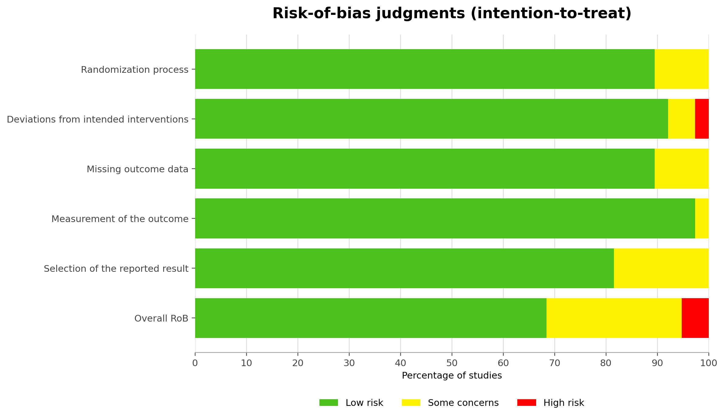

Table S4.1: Study level risk of bias assessment using Cochrane risk of bias tool 2.0 for assessing risk of bias of randomized clinical trials.
First author, year | DOI | D1 Randomization process | D2 Deviations from intended interventions | D3 Missing outcome data | D4 Measurement of the outcome | D5 Selection of the reported result | Overall RoB 2 judgment
Chapple, 2012 | 10.1111/j.1600-051X.2011.01793.x | Low risk | Low risk | Low risk | Low risk | Low risk | Low risk
Reddy, 2015 | 10.4103/2231-0762.156520 | Low risk | Low risk | Low risk | Low risk | Low risk | Low risk
Babaei, 2018 | 10.1080/07315724.2018.1437371 | Low risk | Low risk | Low risk | Low risk | Low risk | Low risk
Kudva, 2011 | 10.4103/0972-124X.82269 | Low risk | Some concerns | Low risk | Low risk | Low risk | Some concerns
Hattarki, 2013 | 10.4103/0972-124X.113071 | Low risk | Low risk | Low risk | Low risk | Low risk | Low risk
Rattanasuwan, 2016 | 10.1007/s10266-014-0190-1 | Low risk | Low risk | Low risk | Low risk | Low risk | Some concerns
Hrishi, 2016 | 10.1111/idh.12131 | Some concerns | Low risk | Low risk | Low risk | Some concerns | Some concerns
Gottumukkala, 2013 | 10.4103/0976-237X.114874 | Low risk | Low risk | Some concerns | Low risk | Some concerns | Some concerns
Bhatia, 2014 | 10.7860/JCDR/2014/8231.5343 | Low risk | Low risk | Low risk | Low risk | Low risk | Low risk
Anuradha, 2015 | NR | Low risk | Low risk | Low risk | Low risk | Low risk | Low risk
Nagasri, 2015 | 10.4103/0975-7406.163537 | Low risk | Low risk | Low risk | Low risk | Low risk | Low risk
Sreedhar, 2015 | 10.4103/0976-9668.166100 | Low risk | Low risk | Low risk | Low risk | Low risk | Low risk
Nasra, 2017 | 10.1080/10717544.2016.1233591 | Low risk | Low risk | Low risk | Low risk | Low risk | Low risk
Ivanaga, 2019 | 10.1016/j.pdpdt.2019.07.005 | Low risk | Low risk | Low risk | Low risk | Low risk | Low risk
Jaswal, 2014 | 10.4103/0972-124X.142445 | Low risk | Low risk | Low risk | Low risk | Low risk | Low risk
Behal, 2011 | 10.4103/0972-124X.82264 | Low risk | Low risk | Low risk | Low risk | Low risk | Low risk
Jalaluddin, 2019 | 10.4103/jpbs.JPBS_295_18 | Low risk | Low risk | Low risk | Low risk | Low risk | Low risk
Abdel-Fatah, 2023 | 10.1186/s12903-023-03512-y | Low risk | Low risk | Low risk | Low risk | Low risk | Low risk
Pérez-Pacheco, 2020 | 10.1007/s00784-020-03652-3 | Low risk | Low risk | Some concerns | Low risk | Low risk | Some concerns
Hirasawa, 2002 | 10.1046/j.1600-0765.2002.01640.x | Low risk | Low risk | Low risk | Low risk | Low risk | Low risk
Rassameemasmaung, 2008 | 10.1016/j.ctim.2007.12.004 | Low risk | Low risk | Low risk | Low risk | Low risk | Low risk
Yaghini, 2014 | 10.4103/2279-042X.137076 | Low risk | Low risk | Low risk | Low risk | Low risk | Low risk
Grover, 2016 | 10.1002/ptr.5600 | Low risk | Low risk | Some concerns | Low risk | Low risk | Some concerns
Mahendra, 2017 | 10.1111/jicd.12262 | Low risk | Low risk | Low risk | Low risk | Low risk | Low risk
Kurian, 2018 | 10.1111/jicd.12324 | Low risk | Low risk | Low risk | Low risk | Low risk | Low risk
Warad, 2013 | 10.4103/0257-7941.131973 | Low risk | Low risk | Low risk | Low risk | Low risk | Low risk
Deshpande, 2012 | 10.4103/2229-5194.100603 | Low risk | Low risk | Low risk | Low risk | Low risk | Low risk
Chopra, 2016 | 10.3290/j.ohpd.a36100 | Some concerns | Low risk | Low risk | Low risk | Some concerns | Some concerns
Arora, 2013 | 10.3290/j.qi.a29188 | Low risk | Low risk | Low risk | Low risk | Some concerns | Some concerns
Nafade, 2022 | 10.34172/jhp.2022.30 | Low risk | Low risk | Low risk | Low risk | Low risk | Low risk
Taleghani, 2018 | 10.1016/j.jormas.2018.04.010 | Some concerns | Some concerns | Low risk | Some concerns | Some concerns | High risk
Raghava, 2019 | 10.5005/jp-journals-10024-2608 | Low risk | Low risk | Low risk | Low risk | Low risk | Low risk
Sharma, 2016 | 10.4103/0976-4003.191725 | Low risk | Low risk | Low risk | Low risk | Low risk | Low risk
Sastravaha, 2005 | NR | Low risk | Low risk | Some concerns | Low risk | Low risk | Some concerns
Sastravaha, 2003 | NR | Some concerns | Low risk | Low risk | Low risk | Some concerns | Some concerns
Funosas, 2005 | 10.4321/S0213-12852005000300005 | Low risk | Low risk | Low risk | Low risk | Low risk | Low risk
Singh, 2016 | 10.2047/jioh-08-03-14 | Low risk | Low risk | Low risk | Low risk | Low risk | Low risk
Nagate, 2020 | 10.4314/tjpr.v19i2.27 | Low risk | High risk | Low risk | Low risk | Some concerns | High risk

Appendix 5: Evaluation of inconsistency and heterogeneity
Table S5.1: Global consistency

Clinical outcome | Chi square | P value | tau²
PPD | 8.24 | 0.411 | 0.0121
CAL | 3.1 | 0.782 | 0.0319
GI | 14.67 | 0.112 | 0.012
PI | 4.66 | 0.308 | 0.032

Appendix 6: SUCRA and cumulative probability plots
Figure S6.1: Cumulative ranking curve plots of plant extracts for probing pocket depth (PPD) in periodontitis.

Table S6.1: SUCRA values for the effects of plant extracts on probing pocket depth (PPD) in periodontitis.

Treatment | SUCRA | PrBest | MeanRank
SRP | 23.3 | 0 | 10.2
SRP + Aloe vera gel | 17.1 | 0 | 10.9
SRP + CAP | 31.8 | 0.2 | 9.2
SRP + CLE | 91.9 | 48 | 2
SRP + Curcumin | 52.3 | 0 | 6.7
SRP + Emblica officinalis | 57.9 | 3.3 | 6.1
SRP + FVB | 23.1 | 0.2 | 10.2
SRP + FVJ | 28 | 0.3 | 9.6
SRP + Garcinia mangostana | 88.8 | 28.9 | 2.3
SRP + LEOG | 73.4 | 15.8 | 4.2
SRP + Lycopene | 68.6 | 2 | 4.8
SRP + OCE | 37.9 | 1.2 | 8.4
SRP + Tea Extract | 55.8 | 0 | 6.3
Abbreviations: SUCRA, surface under the cumulative ranking curve.

Figure S6.2: Cumulative ranking curve plots of plant extracts for clinical attachment level (CAL) in periodontitis.

Table S6.2: SUCRA values for the effects of plant extracts on clinical attachment level (CAL) in periodontitis.

Treatment | SUCRA | PrBest | MeanRank
SRP | 23.7 | 0 | 9.4
SRP + Aloe vera gel | 76.5 | 23 | 3.6
SRP + CAP | 50.4 | 12.7 | 6.5
SRP + Curcumin | 25.7 | 0 | 9.2
SRP + Emblica officinalis | 78 | 29.3 | 3.4
SRP + FVB | 29.8 | 1.1 | 8.7
SRP + FVJ | 35.1 | 1.9 | 8.1
SRP + Garcinia mangostana | 60.7 | 4.9 | 5.3
SRP + LEOG | 69.1 | 19.9 | 4.4
SRP + Lycopene | 44.3 | 0.8 | 7.1
SRP + OCE | 49.3 | 5.5 | 6.6
SRP + Tea Extract | 57.1 | 0.9 | 5.7
Abbreviations: SUCRA, surface under the cumulative ranking curve.

Figure S6.3: Cumulative ranking curve plots of plant extracts for gingival index (GI) in periodontitis.

Table S6.3: SUCRA values for the effects of plant extracts on gingival index (GI) in periodontitis.

Treatment | SUCRA | PrBest | MeanRank
SRP | 21.2 | 0 | 4.9
SRP + Aloe vera gel | 2.6 | 0 | 5.9
SRP + Curcumin | 73.4 | 15.5 | 2.3
SRP + Emblica officinalis | 89.5 | 73.9 | 1.5
SRP + Lycopene | 46.9 | 3.4 | 3.7
SRP + Tea Extract | 66.3 | 7.2 | 2.7
Abbreviations: SUCRA, surface under the cumulative ranking curve.

Figure S6.4: Cumulative ranking curve plots of plant extracts for plaque index (PI) in periodontitis.

Table S6.4: SUCRA values for the effects of plant extracts on plaque index (PI) in periodontitis.

Treatment | SUCRA | PrBest | MeanRank
SRP | 26.2 | 0 | 5.4
SRP + Aloe vera gel | 15.7 | 1.4 | 6.1
SRP + Curcumin | 72.4 | 15.3 | 2.7
SRP + Emblica officinalis | 80 | 54.2 | 2.2
SRP + Garcinia mangostana | 40.6 | 8.6 | 4.6
SRP + Lycopene | 49.6 | 12.1 | 4
SRP + Tea Extract | 65.6 | 8.5 | 3.1
Abbreviations: SUCRA, surface under the cumulative ranking curve.

Appendix 7: League Table of Summary Estimates for Plant Extracts in Periodontitis Derived from Network Meta-analysis

Table S7.1: PPD
SRP
-0.20  (-0.91,0.51) | Aloe vera gel
0.07  (-0.61,0.75) | 0.27  (-0.72,1.25) | CAP
1.13  (0.44,1.82) | 1.33  (0.34,2.32) | 1.06  (0.09,2.03) | CLE
0.35  (0.12,0.57) | 0.55  (-0.20,1.30) | 0.28  (-0.44,1.00) | -0.78  (-1.51,-0.06) | Curcumin
0.46  (-0.30,1.21) | 0.66  (-0.38,1.69) | 0.39  (-0.63,1.40) | -0.67  (-1.70,0.35) | 0.11  (-0.68,0.89) | Emblica officinalis
-0.10  (-0.89,0.69) | 0.10  (-0.97,1.17) | -0.17  (-1.21,0.88) | -1.23  (-2.28,-0.18) | -0.45  (-1.27,0.38) | -0.56  (-1.65,0.54) | FVB
-0.00  (-0.78,0.78) | 0.20  (-0.85,1.25) | -0.07  (-1.10,0.97) | -1.13  (-2.17,-0.09) | -0.35  (-1.16,0.46) | -0.46  (-1.54,0.63) | 0.10  (-1.01,1.21) | FVJ
1.00  (0.43,1.56) | 1.20  (0.29,2.11) | 0.93  (0.04,1.82) | -0.13  (-1.03,0.76) | 0.65  (0.04,1.26) | 0.54  (-0.40,1.48) | 1.10  (0.12,2.07) | 1.00  (0.03,1.96) | G.mangostana
0.73  (-0.17,1.63) | 0.93  (-0.21,2.07) | 0.66  (-0.46,1.79) | -0.40  (-1.53,0.73) | 0.38  (-0.54,1.30) | 0.27  (-0.90,1.45) | 0.83  (-0.37,2.03) | 0.73  (-0.46,1.92) | -0.27  (-1.33,0.79) | LEOG
0.59  (0.07,1.11) | 0.79  (-0.09,1.67) | 0.52  (-0.34,1.38) | -0.54  (-1.41,0.32) | 0.24  (-0.33,0.81) | 0.13  (-0.78,1.05) | 0.69  (-0.26,1.64) | 0.59  (-0.35,1.52) | -0.41  (-1.18,0.36) | -0.14  (-1.18,0.89) | Lycopene
0.13  (-0.79,1.05) | 0.33  (-0.83,1.49) | 0.06  (-1.08,1.20) | -1.00  (-2.15,0.15) | -0.22  (-1.16,0.73) | -0.33  (-1.51,0.86) | 0.23  (-0.98,1.44) | 0.13  (-1.07,1.33) | -0.87  (-1.95,0.21) | -0.60  (-1.88,0.68) | -0.46  (-1.51,0.60) | OCE
0.39  (0.12,0.65) | 0.59  (-0.17,1.35) | 0.32  (-0.41,1.05) | -0.74  (-1.48,-0.01) | 0.04  (-0.31,0.38) | -0.07  (-0.87,0.73) | 0.49  (-0.35,1.32) | 0.39  (-0.43,1.21) | -0.61  (-1.24,0.02) | -0.34  (-1.28,0.59) | -0.20  (-0.79,0.38) | 0.26  (-0.70,1.21) | Tea Extract
The league table shows pairwise comparisons for the PPD outcome derived from the network meta-analysis.
Note: Aloe vera = SRP + Aloe vera gel;CAP=SRP +CAP;CLE=SRP +CLE;Curcumin=SRP +Curcumin; Emblica = SRP + Emblica officinalis; Garcinia mangostana = SRP + Garcinia mangostana;LEOG=SRP +LEOG;Lycopene=SRP +Lycopene;OCE=SRP +OCE;Tea Extract=SRP +Tea Extract.
Each cell reports the mean difference (95% CI) for the column treatment versus the row treatment. For outcomes in which lower values indicate improvement, negative values favour the column treatment and positive values favour the row treatment.

Table S7.2: CAL

The league table shows pairwise comparisons for the CAL outcome derived from the network meta-analysis.
SRP
0.97  (-0.20,2.14) | Aloe vera gel
0.42  (-1.34,2.18) | -0.55  (-2.66,1.56) | CAP
0.02  (-0.34,0.37) | -0.95  (-2.17,0.27) | -0.40  (-2.20,1.39) | Curcumin
1.04  (-0.25,2.32) | 0.07  (-1.67,1.80) | 0.62  (-1.56,2.79) | 1.02  (-0.31,2.35) | Emblica officinalis
0.00  (-1.18,1.18) | -0.97  (-2.63,0.69) | -0.42  (-2.54,1.70) | -0.02  (-1.25,1.22) | -1.04  (-2.78,0.71) | FVB
0.10  (-1.07,1.27) | -0.87  (-2.52,0.78) | -0.32  (-2.43,1.79) | 0.08  (-1.14,1.31) | -0.94  (-2.67,0.80) | 0.10  (-1.56,1.76) | FVJ
0.59  (-0.32,1.49) | -0.38  (-1.86,1.09) | 0.17  (-1.81,2.14) | 0.57  (-0.40,1.54) | -0.45  (-2.02,1.12) | 0.59  (-0.90,2.07) | 0.49  (-0.99,1.96) | Garcinia mangostana
0.83  (-0.49,2.15) | -0.14  (-1.90,1.62) | 0.41  (-1.79,2.61) | 0.81  (-0.55,2.18) | -0.21  (-2.05,1.63) | 0.83  (-0.94,2.60) | 0.73  (-1.03,2.49) | 0.24  (-1.35,1.84) | LEOG
0.30  (-0.52,1.12) | -0.67  (-2.09,0.75) | -0.12  (-2.06,1.82) | 0.28  (-0.61,1.18) | -0.74  (-2.26,0.78) | 0.30  (-1.14,1.74) | 0.20  (-1.23,1.63) | -0.29  (-1.51,0.93) | -0.53  (-2.08,1.02) | Lycopene
0.38  (-0.87,1.63) | -0.59  (-2.30,1.12) | -0.04  (-2.19,2.11) | 0.36  (-0.93,1.66) | -0.66  (-2.45,1.13) | 0.38  (-1.33,2.09) | 0.28  (-1.43,1.99) | -0.21  (-1.75,1.33) | -0.45  (-2.26,1.36) | 0.08  (-1.41,1.57) | OCE
0.49  (-0.06,1.05) | -0.48  (-1.76,0.81) | 0.07  (-1.77,1.92) | 0.48  (-0.18,1.13) | -0.54  (-1.94,0.85) | 0.49  (-0.81,1.80) | 0.39  (-0.90,1.69) | -0.09  (-1.15,0.97) | -0.34  (-1.76,1.09) | 0.20  (-0.79,1.18) | 0.11  (-1.25,1.48) | Tea Extract

Note: Aloe vera = SRP + Aloe vera gel;CAP=SRP +CAP;Curcumin=SRP +Curcumin; Emblica = SRP + Emblica officinalis; Garcinia mangostana = SRP + Garcinia mangostana;LEOG=SRP +LEOG;Lycopene=SRP +Lycopene;OCE=SRP +OCE;Tea Extract=SRP +Tea Extract.
Each cell reports the mean difference (95% CI) for the column treatment versus the row treatment. For outcomes in which lower values indicate improvement, negative values favour the column treatment and positive values favour the row treatment.

Table S7.3: GI

The league table shows pairwise comparisons for the GI outcome derived from the network meta-analysis.
SRP
-0.16  (-0.38,0.06) | Aloe vera gel
0.21  (0.10,0.32) | 0.37  (0.12,0.62) | Curcumin
0.34  (0.02,0.66) | 0.50  (0.11,0.89) | 0.13  (-0.20,0.47) | Emblica officinalis
0.11  (-0.08,0.29) | 0.27  (-0.02,0.56) | -0.10  (-0.32,0.12) | -0.23  (-0.60,0.13) | Lycopene
0.18  (0.09,0.28) | 0.34  (0.10,0.59) | -0.02  (-0.17,0.12) | -0.16  (-0.48,0.17) | 0.08  (-0.13,0.29) | Tea Extract

Note: Aloe vera = SRP + Aloe vera gel; Curcumin=SRP +Curcumin; Emblica = SRP + Emblica officinalis; Lycopene=SRP +Lycopene;OCE=SRP +OCE;Tea Extract=SRP +Tea Extract.
Each cell reports the mean difference (95% CI) for the column treatment versus the row treatment. For outcomes in which lower values indicate improvement, negative values favour the column treatment and positive values favour the row treatment.

Table S7.4: PI

The league table shows pairwise comparisons for the PI outcome derived from the network meta-analysis.
SRP
-0.12  (-0.48,0.24) | Aloe vera gel
0.19  (0.05,0.33) | 0.31  (-0.08,0.70) | Curcumin
0.29  (-0.13,0.71) | 0.41  (-0.14,0.96) | 0.10  (-0.34,0.54) | Emblica officinalis
0.04  (-0.34,0.42) | 0.16  (-0.36,0.68) | -0.15  (-0.56,0.25) | -0.25  (-0.81,0.31) | Garcinia mangostana
0.09  (-0.27,0.45) | 0.21  (-0.30,0.72) | -0.10  (-0.49,0.29) | -0.20  (-0.75,0.35) | 0.05  (-0.47,0.57) | Lycopene
0.16  (0.01,0.31) | 0.28  (-0.11,0.67) | -0.03  (-0.23,0.17) | -0.13  (-0.57,0.31) | 0.12  (-0.29,0.53) | 0.07  (-0.32,0.46) | Tea Extract

Note: Aloe vera = SRP + Aloe vera gel;Curcumin=SRP +Curcumin; Emblica = SRP + Emblica officinalis; Garcinia mangostana = SRP + Garcinia mangostana;Lycopene=SRP +Lycopene;Tea Extract=SRP +Tea Extract.
Each cell reports the mean difference (95% CI) for the column treatment versus the row treatment. For outcomes in which lower values indicate improvement, negative values favour the column treatment and positive values favour the row treatment.

Appendix 8: CINeMA Assessment

Major concerns in the incoherence domain primarily reflect the inability to assess local incoherence in networks with few or no closed loops, rather than detected disagreement between direct and indirect evidence.

Figure S8.1: CAL

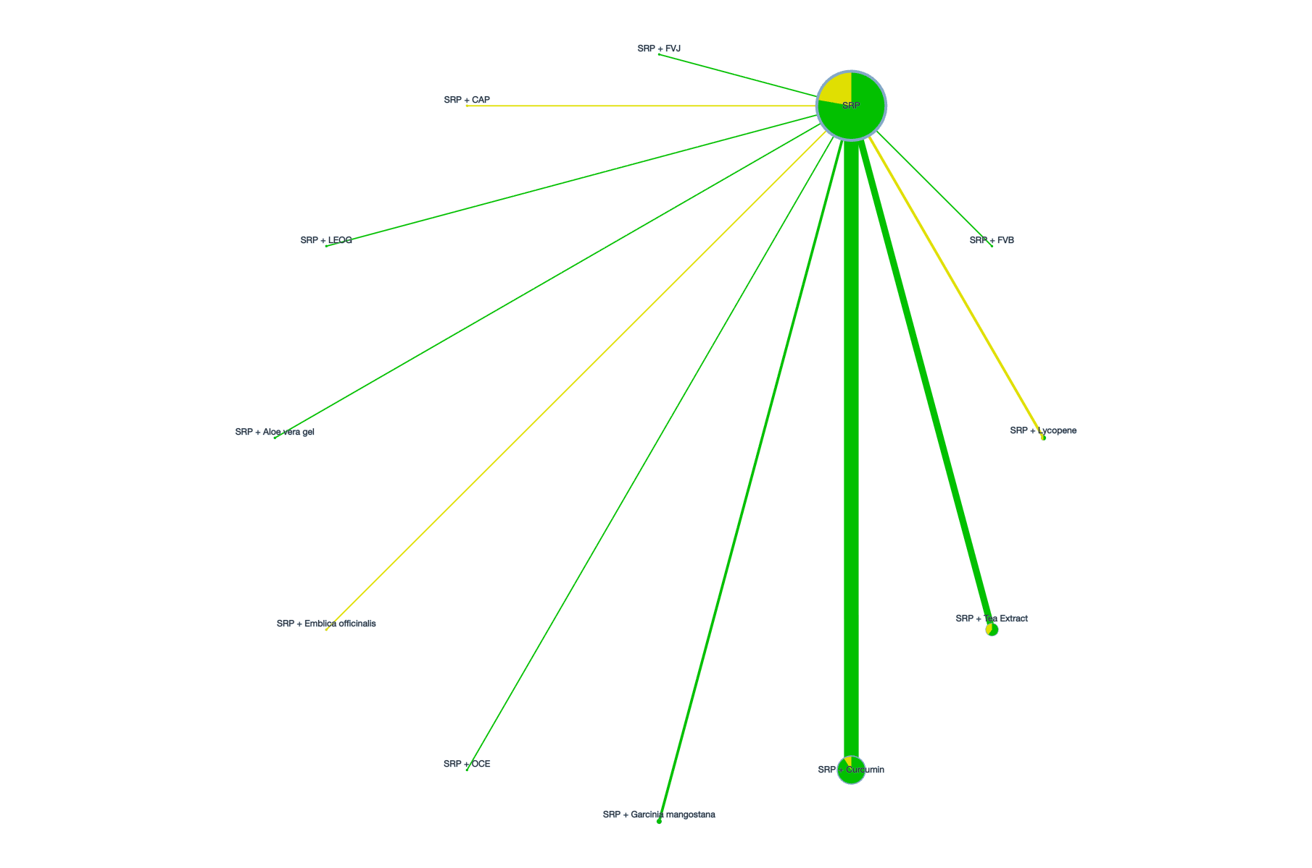

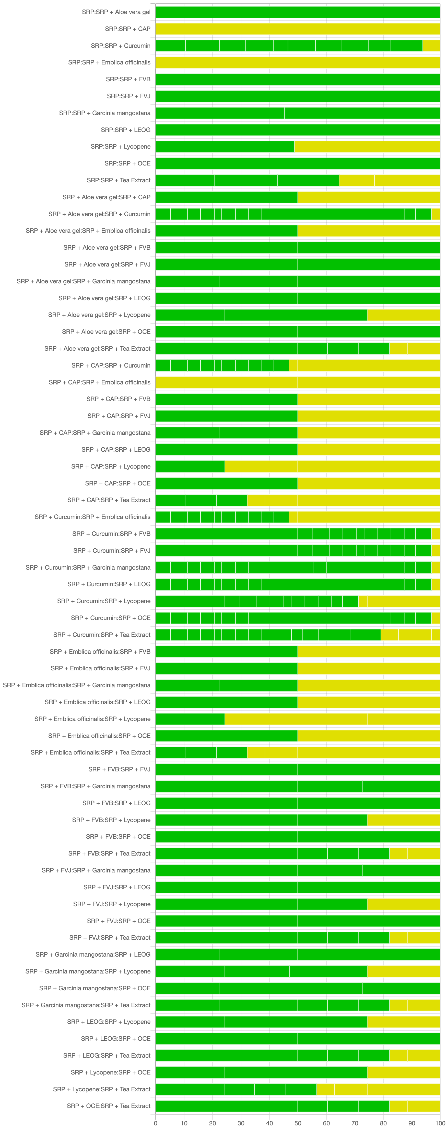

Figure S8.2: PPD

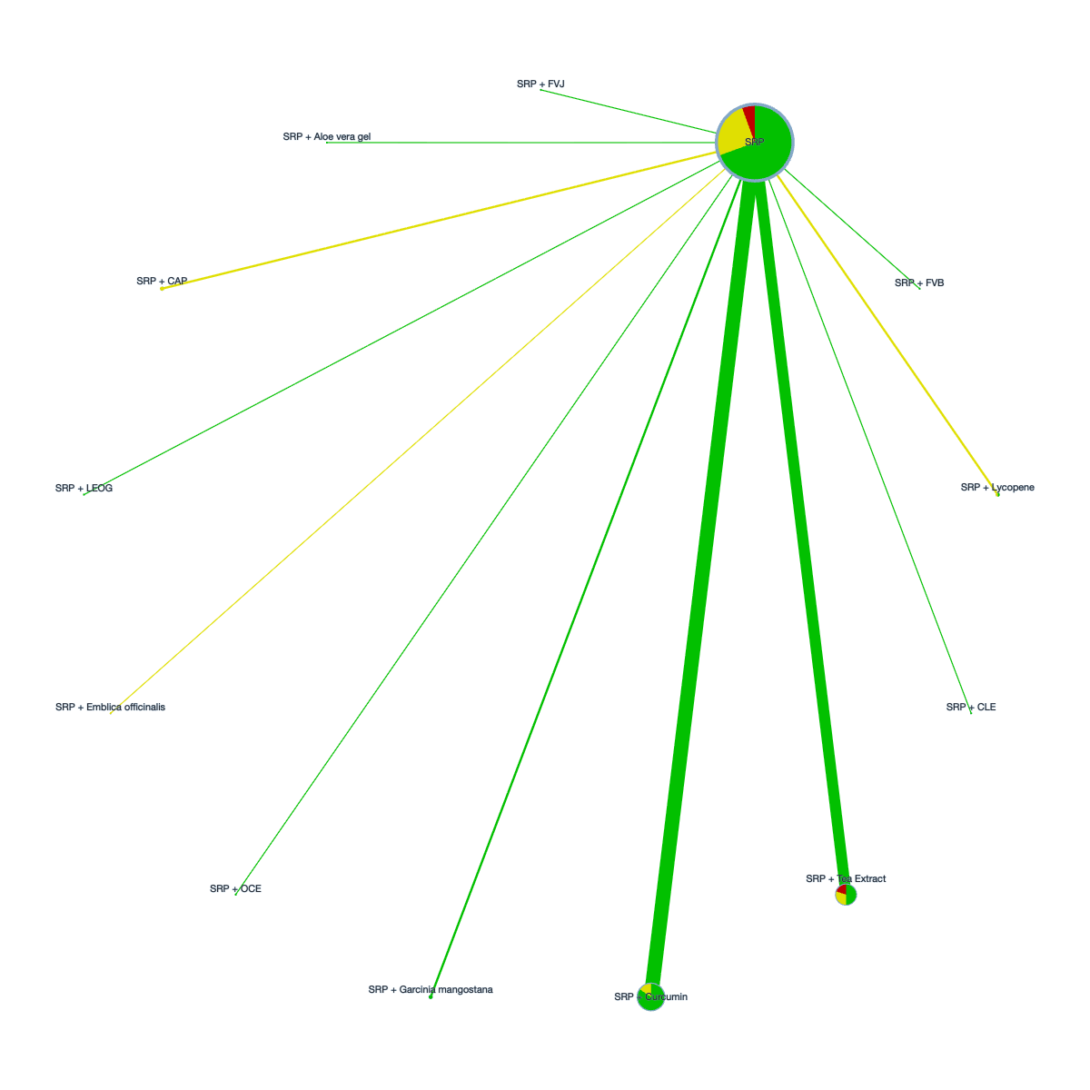

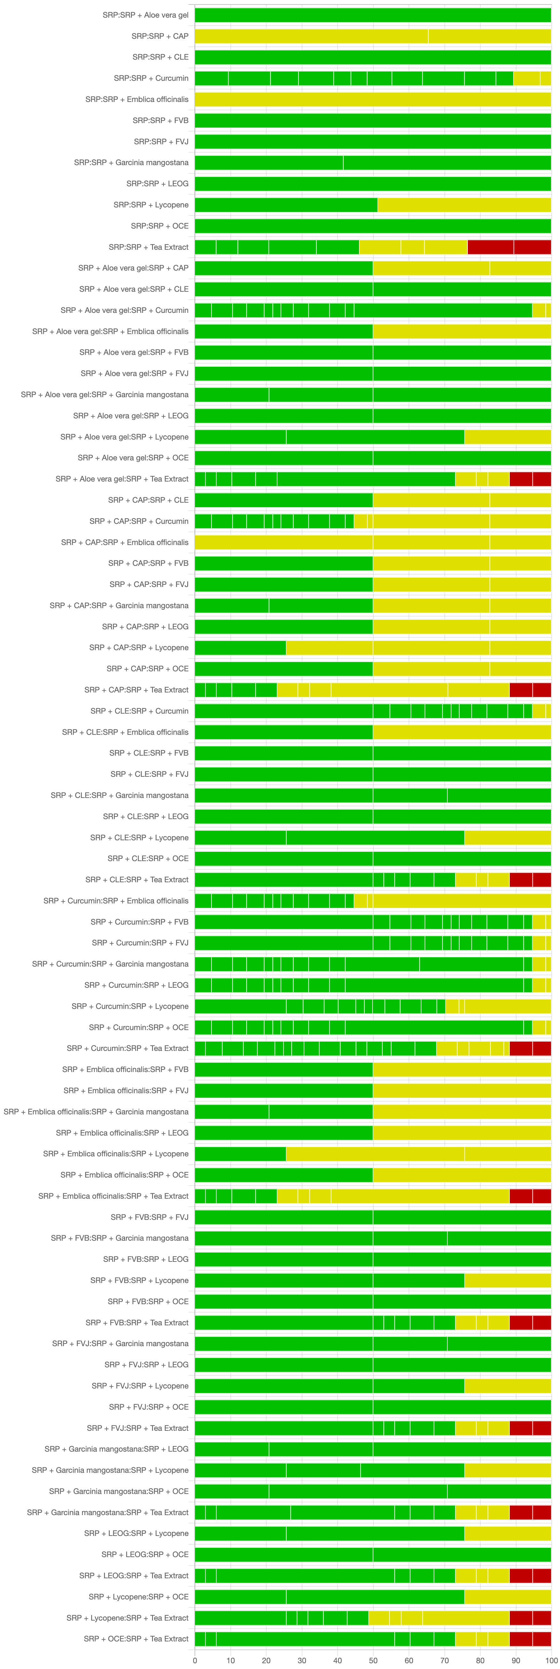

Figure S8.3: GI

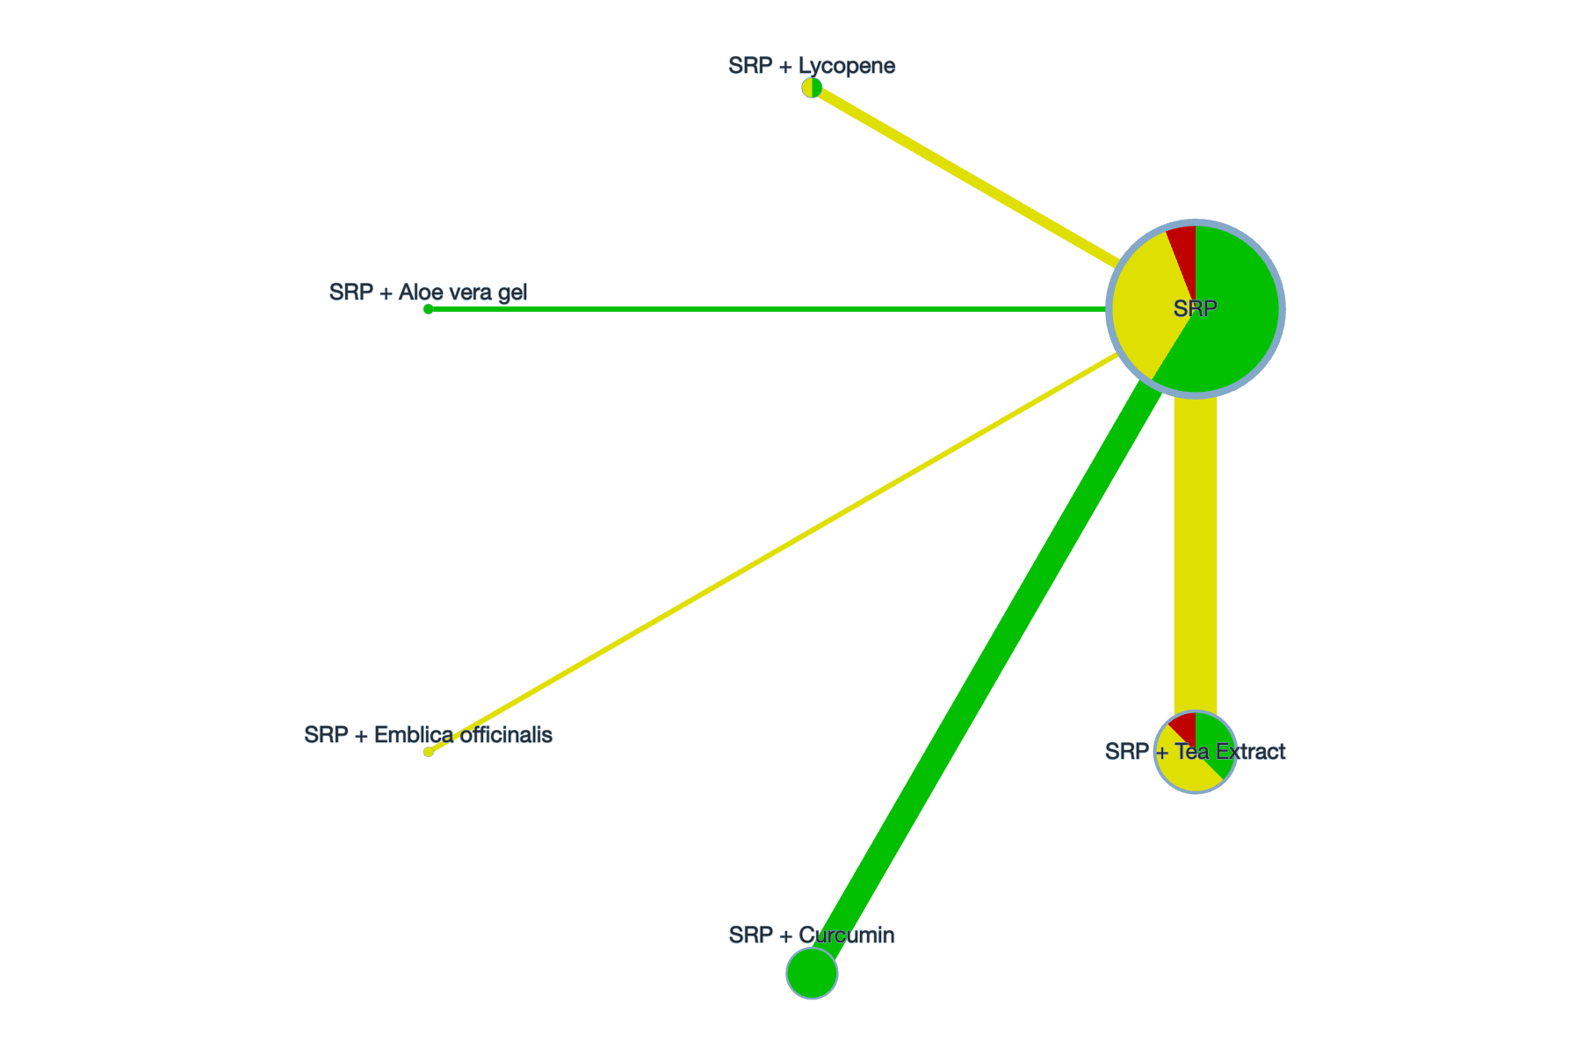

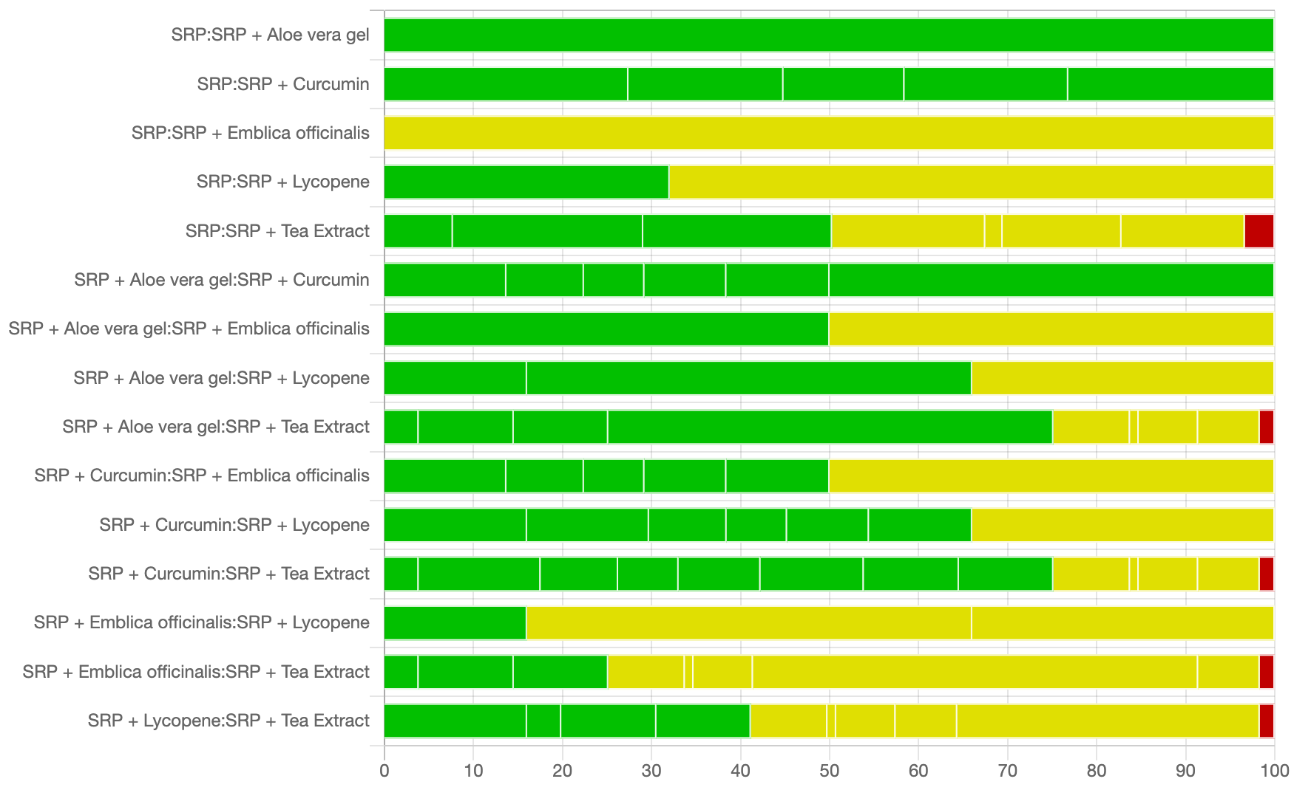

Figure S8.4: PI

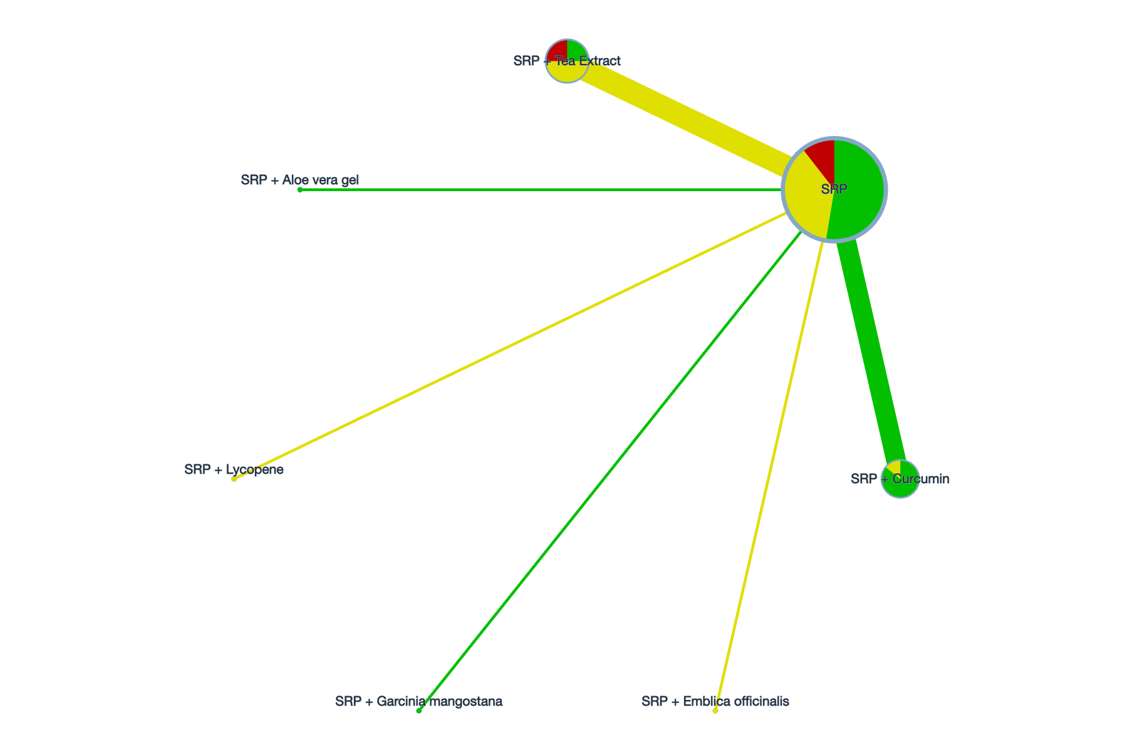

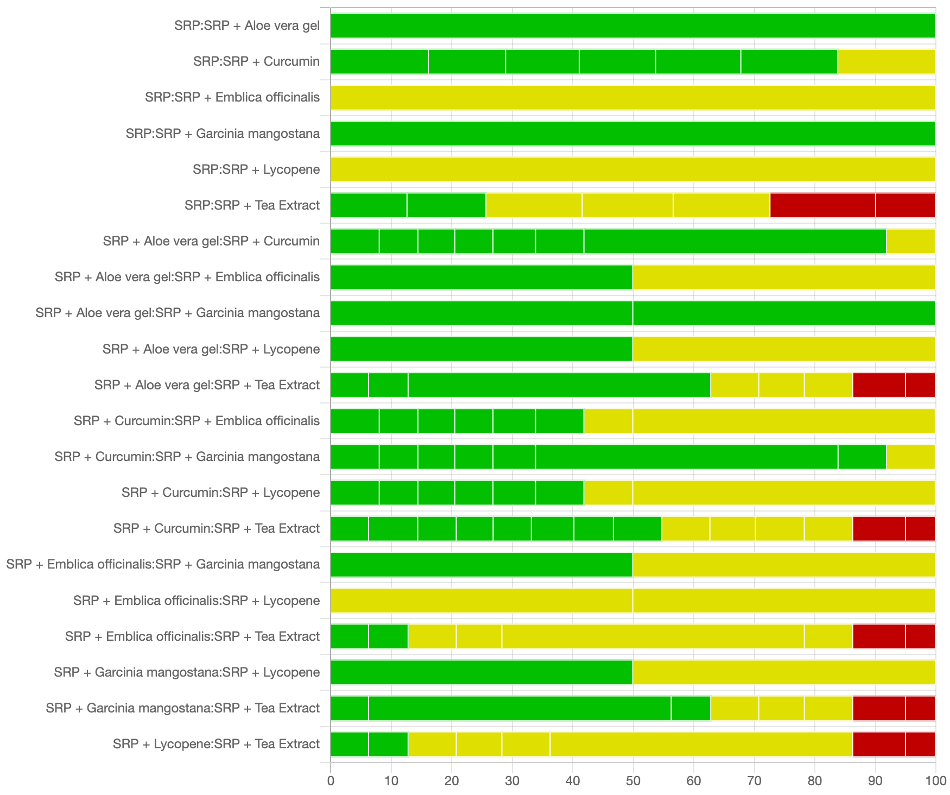

Appendix 9: Funnel plots
The figures show the assessment of small-study effects in the network meta-analysis of plant extracts as adjuncts for periodontitis across the PPD, CAL, GI, and PI outcomes.
Figure S9.1: Funnel plot of PPD

Figure S9.2: Funnel plot of CAL

Figure S9.3: Funnel plot of GI

Figure S9.4: Funnel plot of PI

Appendix 10: Sensitivity analyses
Sensitivity analyses were performed by excluding studies judged as high risk of bias and studies involving patients with diabetes.
Figure S10.1: PRISMA-style flow diagram of sensitivity analyses.

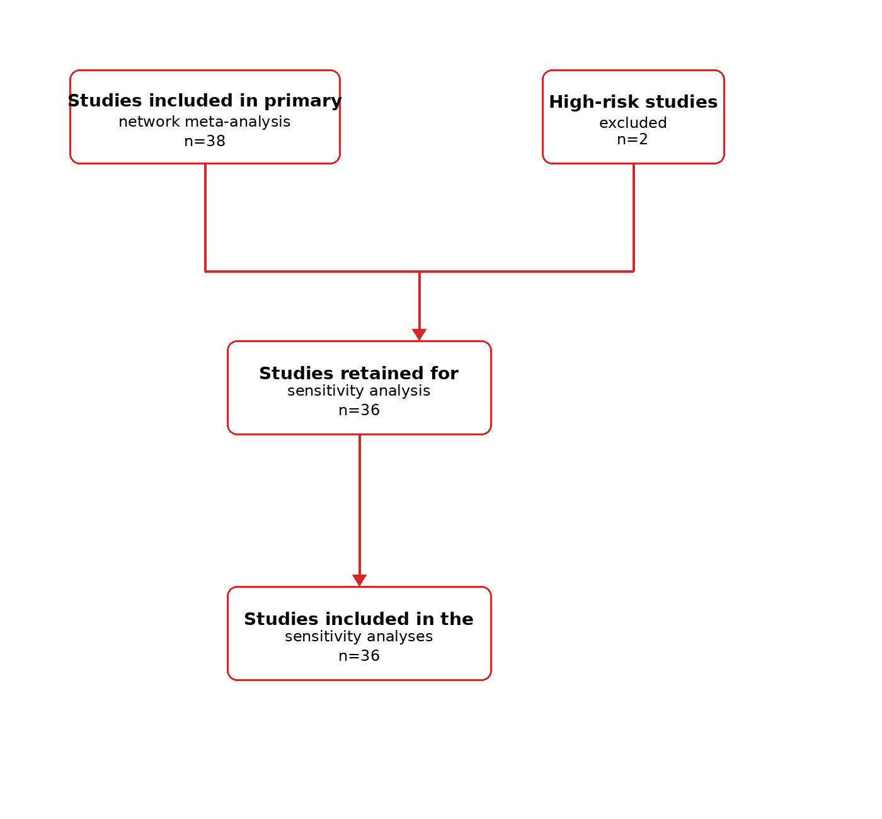

Table S10.1: Characteristics of the 36 studies retained after exclusion of studies at high overall risk of bias

Study | Country | Study design | Age (T/C) | Sample size (T/C) | Clinical characteristics | Intervention (T) | Comparator (C) | Follow-up | Outcomes reported
Chapple 2012 | United Kingdom | Three-arm parallel RCT | 30–60 / 30–60 | 20 / 20 | Non-smokers; non-diabetic | SRP + FVJ (oral) | SRP + placebo | 2, 5, and 8 months | CAL, PPD
Reddy 2015 | India | Parallel controlled trial | 35–50 / 35–50 | 20 / 20 | Non-smokers; type 2 diabetes | SRP + Lycopene (oral) | SRP + placebo | 2 and 6 months | CAL, PPD, GI
Babaei 2018 | Iran | Parallel controlled trial | 25–57 / 25–57 | 20 / 20 | Non-smokers; non-diabetic | SRP + chicory leaf methanol extract (oral) | SRP + placebo | 8 weeks | PPD
Kudva 2011 | India | Split-mouth self-controlled | 30–55 / 30–55 | 14 / 14 | Non-smokers; non-diabetic | SRP + Green tea (local) | SRP alone | 3 weeks | PPD, GI, PI
Hattarki 2013 | India | Split-mouth self-controlled | Adults / Adults | 20 / 20 | Non-smokers; non-diabetic | SRP + Green tea (local) | SRP alone | 5 weeks | PPD, GI, PI
Rattanasuwan 2016 | Thailand | Parallel controlled trial | 49.2 ± 8.3 / 51.4 ± 8.8 | 23 / 19 | Non-smokers; non-diabetic | SRP + Green tea (local) | SRP + placebo | 3 and 6 months | CAL, PPD, GI, PI
Hrishi 2016 | India | Parallel controlled trial | 18–60 / 18–60 | 15 / 15 | Non-smokers; non-diabetic | SRP + Green tea (local) | SRP + fluoride-triclosan toothpaste | 4 weeks | CAL, PPD, GI, PI
Gottumukkala 2013 | India | Parallel controlled trial | 30–55 / 30–55 | 23 / 23 | Non-smokers; non-diabetic | SRP + Curcumin (local) | SRP + placebo | 1, 3, and 6 months | PPD, PI
Bhatia 2014 | India | Split-mouth self-controlled | 21–45 / 21–45 | 50 / 50 | Non-smokers; non-diabetic | SRP + Curcumin (local) | SRP alone | 1, 3, and 6 months | CAL, PPD
Anuradha 2015 | India | Split-mouth self-controlled | 25–60 / 25–60 | 30 / 30 | Non-smokers; non-diabetic | SRP + Curcumin (local) | SRP alone | 30 and 45 days | CAL, PPD, GI, PI
Nagasri 2015 | India | Split-mouth self-controlled | 35–60 / 35–60 | 30 / 30 | Non-smokers; non-diabetic | SRP + Curcumin (local) | SRP alone | 4 weeks | CAL, PPD, GI, PI
Sreedhar 2015 | India | Split-mouth self-controlled | 35–55 / 35–55 | 15 / 15 | Non-smokers; non-diabetic | SRP + Curcumin (local) | SRP alone | 1 and 3 months | CAL, PPD, PI
Nasra 2017 | Egypt | Parallel controlled trial | 35–55 / 35–55 | 10 / 10 | Smoking: not reported; diabetes: not reported | SRP + Curcumin (local) | SRP alone | 1 month | PPD
Ivanaga 2019 | Brazil | Split-mouth self-controlled | 55.0 ± 10.2 / 55.0 ± 10.2 | 25 / 25 | Non-smokers; type 2 diabetes | SRP + Curcumin (local) | SRP + placebo | 3 and 6 months | CAL, PPD
Jaswal 2014 | India | Split-mouth self-controlled | 21–55 / 21–55 | 15 / 15 | Non-smokers; non-diabetic | SRP + Curcumin (local) | SRP alone | 7, 30, and 45 days | CAL, PPD, GI, PI
Behal 2011 | India | Split-mouth self-controlled | Adults / Adults | 30 / 30 | Smoking: not reported; diabetes: not reported | SRP + Curcumin (local) | SRP alone | 30 and 45 days | CAL, PPD, GI, PI
Jalaluddin 2019 | India | Parallel controlled trial | 25–45 / 25–45 | 20 / 20 | Non-smokers; non-diabetic | SRP + Curcumin (local) | SRP alone | 14 days and 4 weeks | PPD
Abdel-Fatah 2023 | Egypt | Parallel controlled trial | 40.83 ± 6.05 / 40.61 ± 6.51 / 39.17 ± 5.66 | 18 / 18 | Non-smokers; non-diabetic | SRP + Curcumin (local) | SRP alone | 6 weeks | PPD
Pérez-Pacheco 2020 | Brazil | Split-mouth self-controlled | 48.98 ± 6.46 / 48.98 ± 6.46 | 16 / 16 | Non-smokers; non-diabetic | SRP + Curcumin (local) | SRP + placebo | 1, 2, and 6 months | CAL, PPD
Hirasawa 2002 | Japan | Split-mouth self-controlled | 41–64 / 41–64 | 6 / 6 | Smoking: not reported; non-diabetic | SRP + Green tea (local) | SRP + placebo | 7–8 weeks | PPD
Rassameemasmaung 2008 | Thailand | Parallel controlled trial | 47.31 / 45.8 | 16 / 15 | Non-smokers; non-diabetic | SRP + Garcinia mangostana (local) | SRP alone | 3 months | CAL, PPD
Yaghini 2014 | Iran | Parallel controlled trial | 31–52 / 31–52 | 18 / 18 | Non-smokers; non-diabetic | SRP + OCE (local) | SRP + placebo | 1 and 3 months | CAL, PPD
Grover 2016 | India | Parallel controlled trial | 40.10 ± 7.71 / 44.70 ± 7.79 | 20 / 20 | Non-smokers; non-diabetic | SRP + Emblica officinalis (local) | SRP + placebo | 2 and 3 months | CAL, PPD, GI, PI
Mahendra 2017 | India | Parallel controlled trial | 30–65 / 30–65 | 25 / 25 | Non-smokers; non-diabetic | SRP + Garcinia mangostana gel (local) | SRP + placebo | 3 months | CAL, PPD, PI
Kurian 2018 | India | Parallel controlled trial | 33.26 ± 4.87 / 31.66 ± 5.33 / 32.7 ± 5.2 | 30 / 30 | Non-smokers; non-diabetic | SRP + Aloe vera gel (local) | SRP + placebo | 6 and 12 months | CAL, PPD, PI
Warad 2013 | India | Parallel controlled trial | 43.9 ± 5.4 / 43.9 ± 5.4 | 15 / 15 | Non-smokers; non-diabetic | SRP + LEOG (local) | SRP alone | 1 and 3 months | CAL, PPD
Deshpande 2012 | India | Parallel controlled trial | 21–43 / 21–43 | 10 / 10 | Non-smokers; non-diabetic | SRP + Green tea (oral) | SRP alone | 3 and 6 months | PI, PBI
Chopra 2016 | India | Parallel controlled trial | 20–50 / 20–50 | 60 / 60 | Non-smokers; non-diabetic | SRP + Green tea (oral) | SRP + placebo | 12 weeks | GI, PI
Arora 2013 | India | Parallel controlled trial | 25–52 / 25–52 | 21 / 21 | Non-smokers; non-diabetic | SRP + Lycopene (oral) | SRP + placebo | 8 weeks | CAL, PPD, GI, PI
Nafade 2022 | India | Parallel controlled trial | 20–60 / 20–60 | 30 / 30 | Non-smokers; non-diabetic | SRP + Oolong tea (oral) | SRP alone | 1 and 3 months | CAL, PPD
Raghava 2019 | India | Split-mouth self-controlled | 25–40 / 25–40 | 10 / 10 | Non-smokers; non-diabetic | SRP + Curcumin (local) | SRP alone | 4 weeks | CAL, PPD, GI, PI
Sharma 2016 | India | Split-mouth self-controlled | 25–30 / 25–30 | 20 / 20 | Non-smokers; non-diabetic | SRP + Curcumin (local) | SRP alone | 2 weeks | GI, PI
Sastravaha 2005 | Thailand | Split-mouth self-controlled | 32–68 / 32–68 | 15 / 15 | Smoking: NR; non-diabetic | SRP + Centella asiatica and pomegranate (SRP + CAP) (local) | SRP alone | 3 and 6 months | CAL, PPD
Sastravaha 2003 | Thailand | Split-mouth self-controlled | 35–65 / 35–65 | 20 / 20 | Non-smokers; non-diabetic | SRP + Centella asiatica and pomegranate (local) | SRP + placebo | 2, 4, 6, and 12 weeks | CAL, PPD, GI, PI
Funosas 2005 | Argentina | Split-mouth self-controlled | Adults / Adults | 50 / 50 | Smoking: NR; diabetes: NR | SRP + Green tea (local) | SRP + placebo | 3 months | CAL, PPD, GI
Singh 2016 | India | Split-mouth self-controlled | 30–50 / 30–50 | 20 / 20 | Non-smokers; non-diabetic | SRP + Aloe vera gel | SRP alone | 1, 2, and 3 months | PPD, GI, PI

Table S10.2: Main and sensitivity analyses for PPD, CAL, GI, and PI after exclusion of high-risk studies
Plant extract  intervention | PPD |  | CAL |  | GI |  | PI
Plant extract  intervention | Main estimate | Sensitivity analyses | Main estimate | Sensitivity analyses | Main estimate | Sensitivity analyses | Main estimate | Sensitivity analyses
SRP + Aloe vera gel | -0.20  (-0.91,0.51) | -0.20  (-0.89,0.49) | 0.97  (-0.20,2.14) | NA | -0.16  (-0.38,0.06) | -0.16  (-0.36,0.04) | -0.12  (-0.48,0.24) | -0.12  (-0.32,0.08)
SRP + CAP | 0.07  (-0.61,0.75) | 0.07  (-0.60,0.74) | 0.42  (-1.34,2.18) | 0.42  (-1.39,2.23) | NA | NA | NA | NA
SRP + CLE | 1.13  (0.44,1.82) | 1.13  (0.46,1.80) | NA | NA | NA | NA | NA | NA
SRP + Curcumin | 0.35  (0.12,0.57) | 0.34  (0.11,0.57) | 0.02  (-0.34,0.37) | -0.05  (-0.48,0.37) | 0.21  (0.10,0.32) | 0.20  (0.10,0.30) | 0.19  (0.05,0.33) | 0.19  (0.10,0.27)
SRP + Emblica officinalis | 0.46  (-0.30,1.21) | 0.46  (-0.28,1.19) | 1.04  (-0.25,2.32) | 1.04  (-0.32,2.40) | 0.34  (0.02,0.66) | 0.34  (0.04,0.64) | 0.29  (-0.13,0.71) | 0.29  (0.00,0.58)
SRP + FVB | -0.10  (-0.89,0.69) | -0.10  (-0.88,0.68) | 0.00  (-1.18,1.18) | 0.00  (-1.26,1.26) | NA | NA | NA | NA
SRP + FVJ | 0.00  (-0.78,0.78) | 0.00  (-0.76,0.76) | 0.10  (-1.07,1.27) | 0.10  (-1.15,1.35) | NA | NA | NA | NA
SRP + Garcinia mangostana | 1.00  (0.43,1.56) | 1.00  (0.44,1.55) | 0.59  (-0.32,1.49) | 0.58  (-0.38,1.54) | NA | NA | 0.04  (-0.34,0.42) | 0.04  (-0.19,0.27)
SRP + LEOG | 0.73  (-0.17,1.63) | 0.73  (-0.15,1.61) | 0.83  (-0.49,2.15) | 0.83  (-0.56,2.22) | NA | NA | NA | NA
SRP + Lycopene | 0.59  (0.07,1.11) | 0.59  (0.08,1.10) | 0.30  (-0.52,1.12) | 0.30  (-0.58,1.18) | 0.11  (-0.08,0.29) | 0.11  (-0.06,0.28) | 0.09  (-0.27,0.45) | 0.09  (-0.11,0.29)
SRP + OCE | 0.13  (-0.79,1.05) | 0.13  (-0.77,1.03) | 0.38  (-0.87,1.63) | 0.38  (-0.95,1.71) | NA | NA | NA | NA
SRP + Tea Extract | 0.39  (0.12,0.65) | 0.33  (0.05,0.62) | 0.49  (-0.06,1.05) | 0.49  (-0.10,1.08) | 0.18  (0.09,0.28) | 0.16  (0.07,0.25) | 0.16  (0.01,0.31) | 0.10  (0.00,0.20)

Effect estimates are mean differences (MDs) calculated as the SRP-based control minus the plant-extract adjunct. Positive values favour the plant-extract adjunct, whereas negative values favour the SRP-based control. NA, not estimable.
Figure S10.2: PRISMA-style flow diagram of the sensitivity analysis excluding diabetes studies
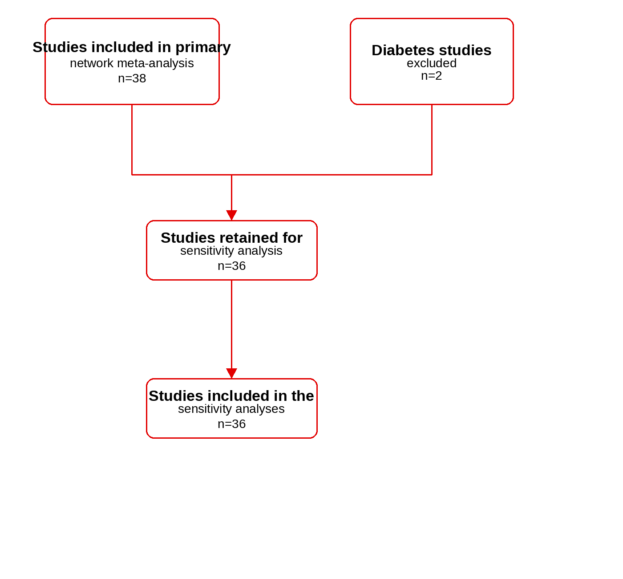

Table S10.3: Characteristics of the 36 studies retained after exclusion of studies specifically enrolling participants with diabetes and periodontitis
Study | Country | Study design | Age (T/C) | Sample size (T/C) | Clinical characteristics | Intervention (T) | Comparator (C) |  | Follow-up | Outcomes reported
Chapple 2012 | United Kingdom | Three-arm parallel RCT | 30–60 / 30–60 | 20 / 20 | Non-smokers; non-diabetic | SRP + FVJ (oral) | SRP + placebo |  | 2, 5, and 8 months | CAL, PPD
Babaei 2018 | Iran | Parallel controlled trial | 25–57 / 25–57 | 20 / 20 | Non-smokers; non-diabetic | SRP + chicory leaf methanol extract (oral) | SRP + placebo | 8 weeks |  | PPD
Kudva 2011 | India | Split-mouth self-controlled | 30–55 / 30–55 | 14 / 14 | Non-smokers; non-diabetic | SRP + Green tea (local) | SRP alone |  | 3 weeks | PPD, GI, PI
Hattarki 2013 | India | Split-mouth self-controlled | Adults / Adults | 20 / 20 | Non-smokers; non-diabetic | SRP + Green tea (local) | SRP alone |  | 5 weeks | PPD, GI, PI
Rattanasuwan 2016 | Thailand | Parallel controlled trial | 49.2 ± 8.3 / 51.4 ± 8.8 | 23 / 19 | Non-smokers; non-diabetic | SRP + Green tea (local) | SRP + placebo |  | 3 and 6 months | CAL, PPD, GI, PI
Hrishi 2016 | India | Parallel controlled trial | 18–60 / 18–60 | 15 / 15 | Non-smokers; non-diabetic | SRP + Green tea (local) | SRP + fluoride-triclosan toothpaste |  | 4 weeks | CAL, PPD, GI, PI
Gottumukkala 2013 | India | Parallel controlled trial | 30–55 / 30–55 | 23 / 23 | Non-smokers; non-diabetic | SRP + Curcumin (local) | SRP + placebo |  | 1, 3, and 6 months | PPD, PI
Bhatia 2014 | India | Split-mouth self-controlled | 21–45 / 21–45 | 50 / 50 | Non-smokers; non-diabetic | SRP + Curcumin (local) | SRP alone |  | 1, 3, and 6 months | CAL, PPD
Anuradha 2015 | India | Split-mouth self-controlled | 25–60 / 25–60 | 30 / 30 | Non-smokers; non-diabetic | SRP + Curcumin (local) | SRP alone |  | 30 and 45 days | CAL, PPD, GI, PI
Nagasri 2015 | India | Split-mouth self-controlled | 35–60 / 35–60 | 30 / 30 | Non-smokers; non-diabetic | SRP + Curcumin (local) | SRP alone |  | 4 weeks | CAL, PPD, GI, PI
Sreedhar 2015 | India | Split-mouth self-controlled | 35–55 / 35–55 | 15 / 15 | Non-smokers; non-diabetic | SRP + Curcumin (local) | SRP alone |  | 1 and 3 months | CAL, PPD, PI
Nasra 2017 | Egypt | Parallel controlled trial | 35–55 / 35–55 | 10 / 10 | Smoking: not reported; diabetes: not reported | SRP + Curcumin (local) | SRP alone |  | 1 month | PPD
Jaswal 2014 | India | Split-mouth self-controlled | 21–55 / 21–55 | 15 / 15 | Non-smokers; non-diabetic | SRP + Curcumin (local) | SRP alone |  | 7, 30, and 45 days | CAL, PPD, GI, PI
Behal 2011 | India | Split-mouth self-controlled | Adults / Adults | 30 / 30 | Smoking: not reported; diabetes: not reported | SRP + Curcumin (local) | SRP alone |  | 30 and 45 days | CAL, PPD, GI, PI
Jalaluddin 2019 | India | Parallel controlled trial | 25–45 / 25–45 | 20 / 20 | Non-smokers; non-diabetic | SRP + Curcumin (local) | SRP alone |  | 14 days and 4 weeks | PPD
Abdel-Fatah 2023 | Egypt | Parallel controlled trial | 40.83 ± 6.05 / 40.61 ± 6.51 / 39.17 ± 5.66 | 18 / 18 | Non-smokers; non-diabetic | SRP + Curcumin (local) | SRP alone |  | 6 weeks | PPD
Pérez-Pacheco 2020 | Brazil | Split-mouth self-controlled | 48.98 ± 6.46 / 48.98 ± 6.46 | 16 / 16 | Non-smokers; non-diabetic | SRP + Curcumin (local) | SRP + placebo |  | 1, 2, and 6 months | CAL, PPD
Hirasawa 2002 | Japan | Split-mouth self-controlled | 41–64 / 41–64 | 6 / 6 | Smoking: not reported; non-diabetic | SRP + Green tea (local) | SRP + placebo |  | 7–8 weeks | PPD
Rassameemasmaung 2008 | Thailand | Parallel controlled trial | 47.31 / 45.8 | 16 / 15 | Non-smokers; non-diabetic | SRP + Garcinia mangostana (local) | SRP alone |  | 3 months | CAL, PPD
Yaghini 2014 | Iran | Parallel controlled trial | 31–52 / 31–52 | 18 / 18 | Non-smokers; non-diabetic | SRP + OCE (local) | SRP + placebo |  | 1 and 3 months | CAL, PPD
Grover 2016 | India | Parallel controlled trial | 40.10 ± 7.71 / 44.70 ± 7.79 | 20 / 20 | Non-smokers; non-diabetic | SRP + Emblica officinalis (local) | SRP + placebo |  | 2 and 3 months | CAL, PPD, GI, PI
Mahendra 2017 | India | Parallel controlled trial | 30–65 / 30–65 | 25 / 25 | Non-smokers; non-diabetic | SRP + Garcinia mangostana gel (local) | SRP + placebo |  | 3 months | CAL, PPD, PI
Kurian 2018 | India | Parallel controlled trial | 33.26 ± 4.87 / 31.66 ± 5.33 / 32.7 ± 5.2 | 30 / 30 | Non-smokers; non-diabetic | SRP + Aloe vera gel (local) | SRP + placebo |  | 6 and 12 months | CAL, PPD, PI
Warad 2013 | India | Parallel controlled trial | 43.9 ± 5.4 / 43.9 ± 5.4 | 15 / 15 | Non-smokers; non-diabetic | SRP + LEOG (local) | SRP alone |  | 1 and 3 months | CAL, PPD
Deshpande 2012 | India | Parallel controlled trial | 21–43 / 21–43 | 10 / 10 | Non-smokers; non-diabetic | SRP + Green tea (oral) | SRP alone |  | 15 and 30 days | PI, PBI
Chopra 2016 | India | Parallel controlled trial | 20–50 / 20–50 | 60 / 60 | Non-smokers; non-diabetic | SRP + Green tea (oral) | SRP + placebo |  | 12 weeks | GI, PI
Arora 2013 | India | Parallel controlled trial | 25–52 / 25–52 | 21 / 21 | Non-smokers; non-diabetic | SRP + Lycopene (oral) | SRP + placebo |  | 8 weeks | CAL, PPD, GI, PI
Nafade 2022 | India | Parallel controlled trial | 20–60 / 20–60 | 30 / 30 | Non-smokers; non-diabetic | SRP + Oolong tea (oral) | SRP alone |  | 1 and 3 months | CAL, PPD
Taleghani 2018 | Iran | Parallel controlled trial | 45 / 45 | 15 / 15 | Non-smokers; non-diabetic | SRP + Green tea (oral) | SRP alone |  | 6 weeks | PPD, PI
Raghava 2019 | India | Split-mouth self-controlled | 25–40 / 25–40 | 10 / 10 | Non-smokers; non-diabetic | SRP + Curcumin (local) | SRP alone |  | 4 weeks | CAL, PPD, GI, PI
Sharma 2016 | India | Split-mouth self-controlled | 25–30 / 25–30 | 20 / 20 | Non-smokers; non-diabetic | SRP + Curcumin (local) | SRP alone |  | 2 weeks | GI, PI
Sastravaha 2005 | Thailand | Split-mouth self-controlled | 32–68 / 32–68 | 15 / 15 | Smoking: NR; non-diabetic | SRP + Centella asiatica and pomegranate (SRP + CAP) (local) | SRP alone |  | 3 and 6 months | CAL, PPD
Sastravaha 2003 | Thailand | Split-mouth self-controlled | 35–65 / 35–65 | 20 / 20 | Non-smokers; non-diabetic | SRP + Centella asiatica and pomegranate (local) | SRP + placebo |  | 2, 4, 6, and 12 weeks | CAL, PPD, GI, PI
Funosas 2005 | Argentina | Split-mouth self-controlled | Adults / Adults | 50 / 50 | Smoking: NR; diabetes: NR | SRP + Green tea (local) | SRP + placebo |  | 3 months | CAL, PPD, GI
Nagate 2020 | India | Split-mouth self-controlled | 20–40 / 20–40 | 20 / 20 | Non-smokers; non-diabetic | SRP + Green tea (local) | SRP alone |  | 14 days and 4 weeks | PPD, GI, PI
Singh 2016 | India | Split-mouth self-controlled | 30–50 / 30–50 | 20 / 20 | Non-smokers; non-diabetic | SRP + Aloe vera gel | SRP alone |  | 1, 2, and 3 months | PPD, GI, PI
Abbreviations: T, treatment group; C, control group; SRP, scaling and root planing; CAL, clinical attachment level; PPD, probing pocket depth; GI, gingival index; PI, plaque index; PBI, papillary bleeding index; NR, not reported.

Table S10.4: Main and sensitivity analyses after exclusion of studies specifically enrolling participants with diabetes and periodontitis
Plant extract  intervention | PPD |  | CAL |  | GI |  | PI
Plant extract  intervention | Main  estimate | Sensitivity  analyses | Main  estimate | Sensitivity  analyses | Main  estimate | Sensitivity  analyses | Main  estimate | Sensitivity  analyses
SRP + Aloe vera gel | -0.20  (-0.91,0.51) | -0.20  (-0.95,0.55) | 0.97  (-0.20,2.14) | NA | -0.16  (-0.38,0.06) | -0.16  (-0.40,0.08) | -0.12  (-0.48,0.24) | -0.12  (-0.48,0.24)
SRP + CAP | 0.07  (-0.61,0.75) | 0.07  (-0.63,0.77) | 0.42  (-1.34,2.18) | 0.42  (-1.46,2.30) | NA | NA | NA | NA
SRP + CLE | 1.13  (0.44,1.82) | 1.13  (0.40,1.86) | NA | NA | NA | NA | NA | NA
SRP + Curcumin | 0.35  (0.12,0.57) | 0.37  (0.13,0.61) | 0.02  (-0.34,0.37) | -0.03  (-0.50,0.43) | 0.21  (0.10,0.32) | 0.21  (0.09,0.32) | 0.19  (0.05,0.33) | 0.19  (0.05,0.33)
SRP + Emblica officinalis | 0.46  (-0.30,1.21) | 0.46  (-0.33,1.25) | 1.04  (-0.25,2.32) | 1.04  (-0.41,2.49) | 0.34  (0.02,0.66) | 0.34  (0.01,0.67) | 0.29  (-0.13,0.71) | 0.29  (-0.13,0.71)
SRP + FVB | -0.10  (-0.89,0.69) | -0.10  (-0.93,0.73) | 0.00  (-1.18,1.18) | 0.00  (-1.36,1.36) | NA | NA | NA | NA
SRP + FVJ | -0.00  (-0.78,0.78) | 0.00  (-0.81,0.81) | 0.10  (-1.07,1.27) | 0.10  (-1.25,1.45) | NA | NA | NA | NA
SRP + Garcinia mangostana | 1.00  (0.43,1.56) | 0.99  (0.40,1.59) | 0.59  (-0.32,1.49) | 0.57  (-0.45,1.60) | NA | NA | 0.04  (-0.34,0.42) | 0.04  (-0.34,0.42)
SRP + LEOG | 0.73  (-0.17,1.63) | 0.73  (-0.20,1.66) | 0.83  (-0.49,2.15) | 0.83  (-0.65,2.31) | NA | NA | NA | NA
SRP + Lycopene | 0.59  (0.07,1.11) | 0.67  (-0.11,1.45) | 0.30  (-0.52,1.12) | 0.29  (-1.04,1.62) | 0.11  (-0.08,0.29) | 0.13  (-0.12,0.38) | 0.09  (-0.27,0.45) | 0.09  (-0.27,0.45)
SRP + OCE | 0.13  (-0.79,1.05) | 0.13  (-0.82,1.08) | 0.38  (-0.87,1.63) | 0.38  (-1.03,1.79) | NA | NA | NA | NA
SRP + Tea Extract | 0.39  (0.12,0.65) | 0.39  (0.11,0.66) | 0.49  (-0.06,1.05) | 0.48  (-0.14,1.11) | 0.18  (0.09,0.28) | 0.19  (0.09,0.28) | 0.16  (0.01,0.31) | 0.16  (0.01,0.31)

Appendix 11: Subgroup analyses by route of administration
Subgroup analyses were stratified according to route of administration. Interventions were classified as local or oral administration. Within each subgroup, the comparator remained SRP alone or SRP plus placebo.
Figure S11.1: Network map of PPD in the local administration subgroup
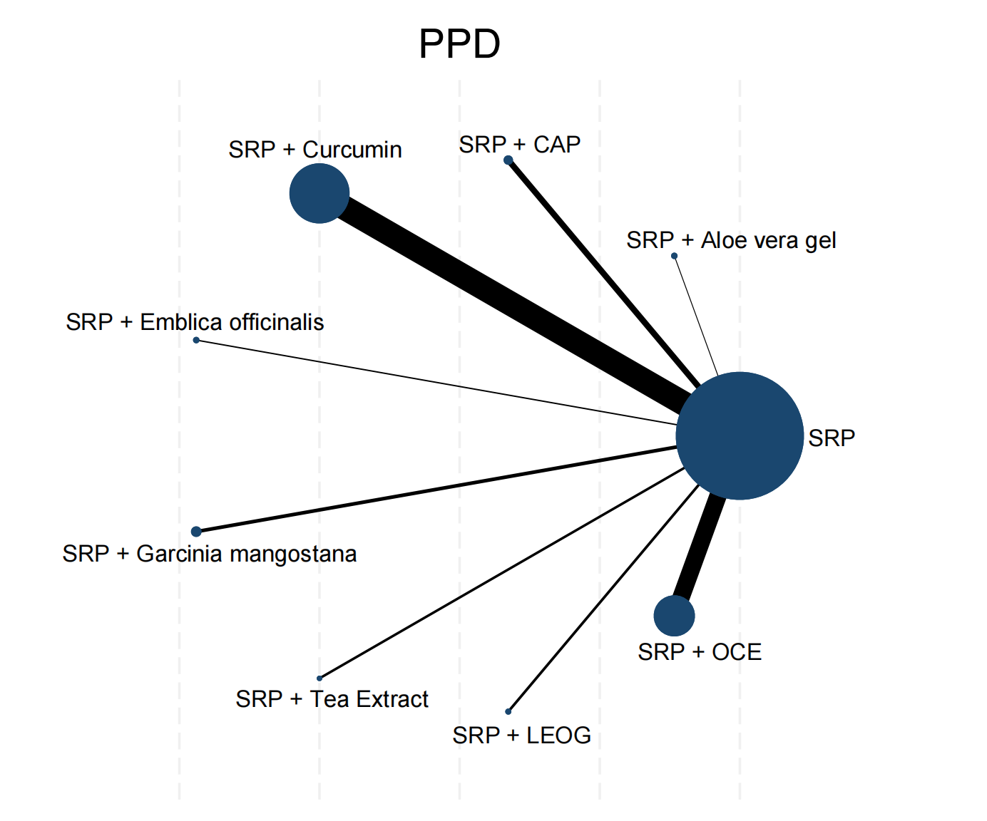

Figure S11.2: Forest plot of PPD in the local administration subgroup
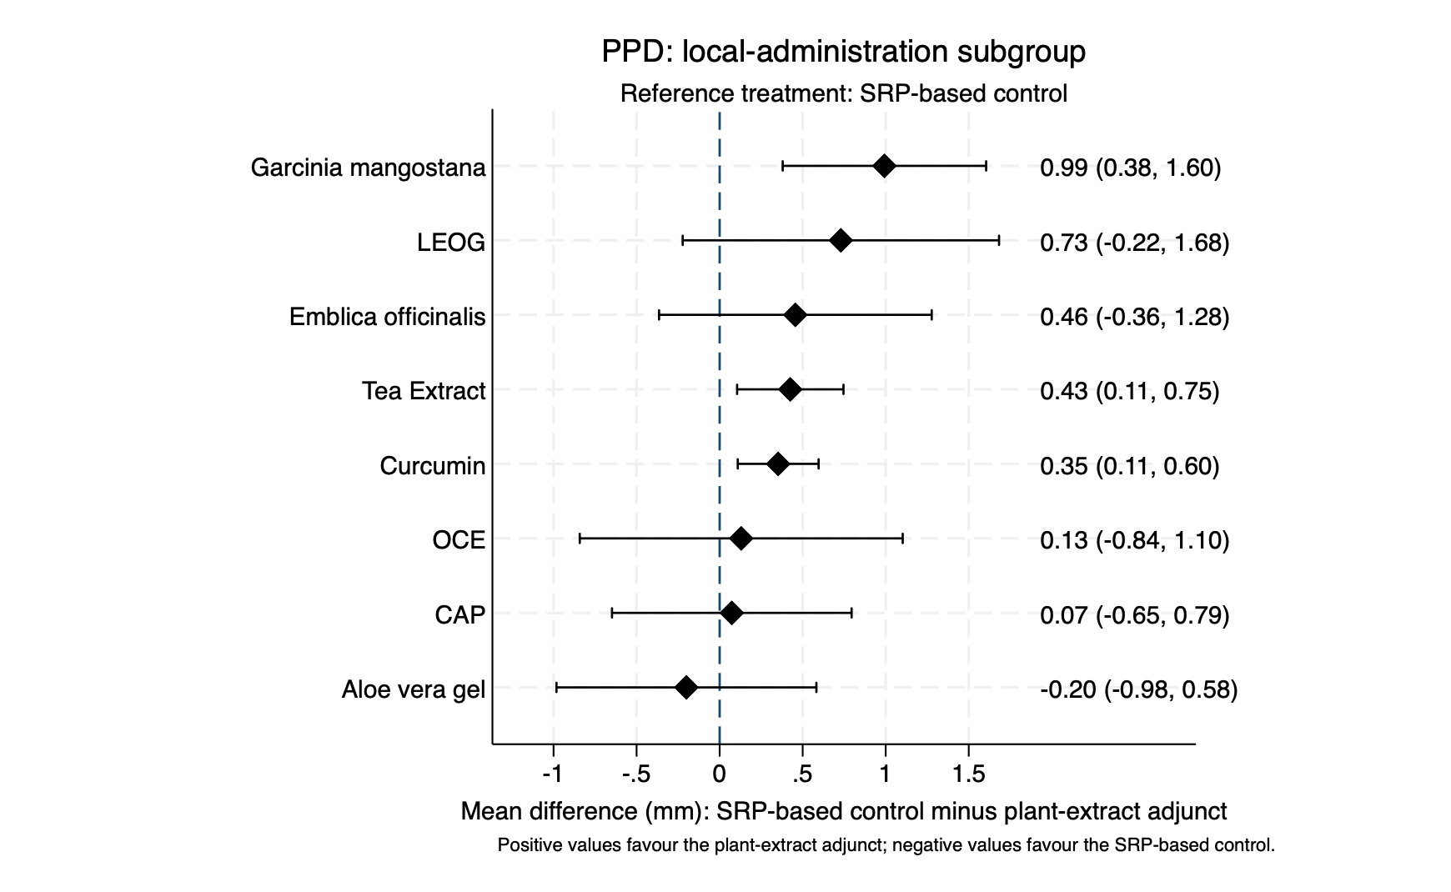

Figure S11.3: League table of PPD in the local administration subgroup
SRP | 0.20 (-0.58,0.98) | -0.07 (-0.79,0.65) | -0.35 (-0.60,-0.11) | -0.46 (-1.28,0.36) | -0.99 (-1.60,-0.38) | -0.73 (-1.68,0.22) | -0.13 (-1.10,0.84) | -0.43 (-0.75,-0.11)
-0.20 (-0.98,0.58) | SRP + Aloe vera gel | -0.27 (-1.34,0.79) | -0.55 (-1.37,0.27) | -0.66 (-1.79,0.48) | -1.19 (-2.19,-0.20) | -0.93 (-2.16,0.30) | -0.33 (-1.58,0.92) | -0.63 (-1.47,0.22)
0.07 (-0.65,0.79) | 0.27 (-0.79,1.34) | SRP + CAP | -0.28 (-1.04,0.48) | -0.38 (-1.48,0.71) | -0.92 (-1.87,0.03) | -0.66 (-1.85,0.54) | -0.06 (-1.27,1.15) | -0.35 (-1.14,0.44)
0.35 (0.11,0.60) | 0.55 (-0.27,1.37) | 0.28 (-0.48,1.04) | SRP + Curcumin | -0.10 (-0.96,0.75) | -0.64 (-1.30,0.02) | -0.38 (-1.36,0.61) | 0.22 (-0.78,1.23) | -0.07 (-0.48,0.33)
0.46 (-0.36,1.28) | 0.66 (-0.48,1.79) | 0.38 (-0.71,1.48) | 0.10 (-0.75,0.96) | SRP + Emblica officinalis | -0.54 (-1.56,0.49) | -0.27 (-1.53,0.98) | 0.33 (-0.95,1.60) | 0.03 (-0.85,0.91)
0.99 (0.38,1.60) | 1.19 (0.20,2.19) | 0.92 (-0.03,1.87) | 0.64 (-0.02,1.30) | 0.54 (-0.49,1.56) | SRP + Garcinia mangostana | 0.26 (-0.87,1.39) | 0.86 (-0.29,2.01) | 0.57 (-0.12,1.26)
0.73 (-0.22,1.68) | 0.93 (-0.30,2.16) | 0.66 (-0.54,1.85) | 0.38 (-0.61,1.36) | 0.27 (-0.98,1.53) | -0.26 (-1.39,0.87) | SRP + LEOG | 0.60 (-0.76,1.96) | 0.30 (-0.70,1.31)
0.13 (-0.84,1.10) | 0.33 (-0.92,1.58) | 0.06 (-1.15,1.27) | -0.22 (-1.23,0.78) | -0.33 (-1.60,0.95) | -0.86 (-2.01,0.29) | -0.60 (-1.96,0.76) | SRP + OCE | -0.30 (-1.32,0.73)
0.43 (0.11,0.75) | 0.63 (-0.22,1.47) | 0.35 (-0.44,1.14) | 0.07 (-0.33,0.48) | -0.03 (-0.91,0.85) | -0.57 (-1.26,0.12) | -0.30 (-1.31,0.70) | 0.30 (-0.73,1.32) | SRP + Tea Extract

Each cell reports the mean difference (95% CI) for the column treatment versus the row treatment. For outcomes in which lower values indicate improvement, negative values favour the column treatment and positive values favour the row treatment.

Figure S11.4: Network map of CAL in the local administration subgroup

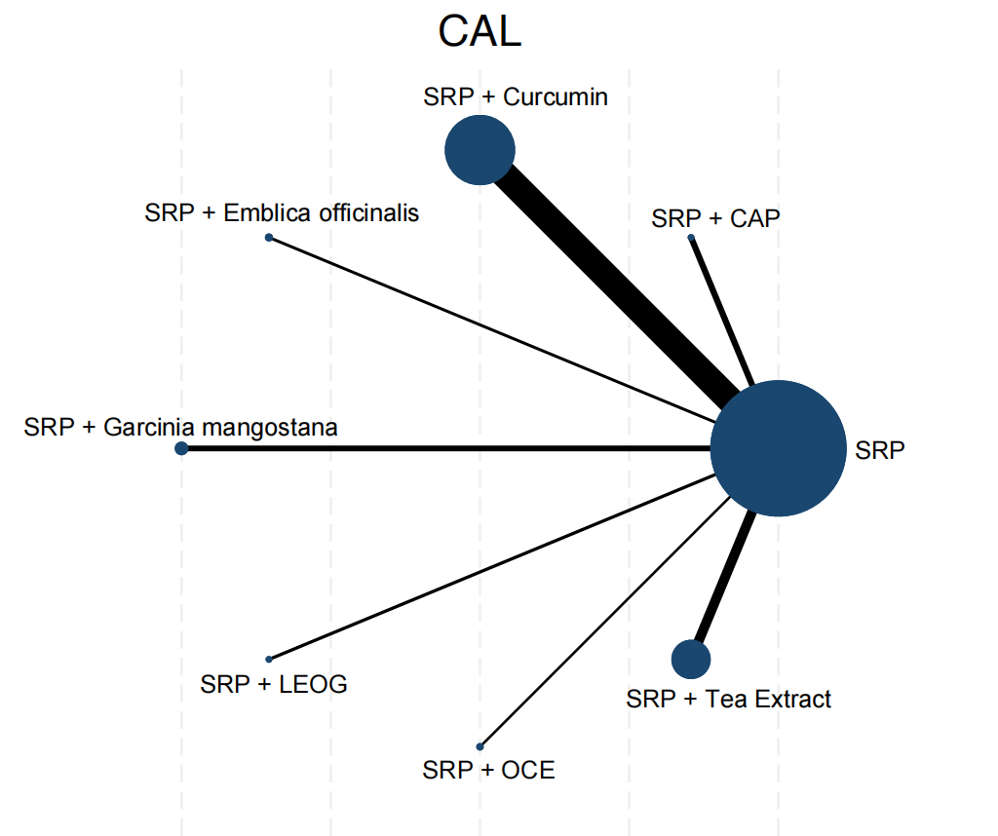
Figure S11.5: Forest plot of CAL in the local administration subgroup

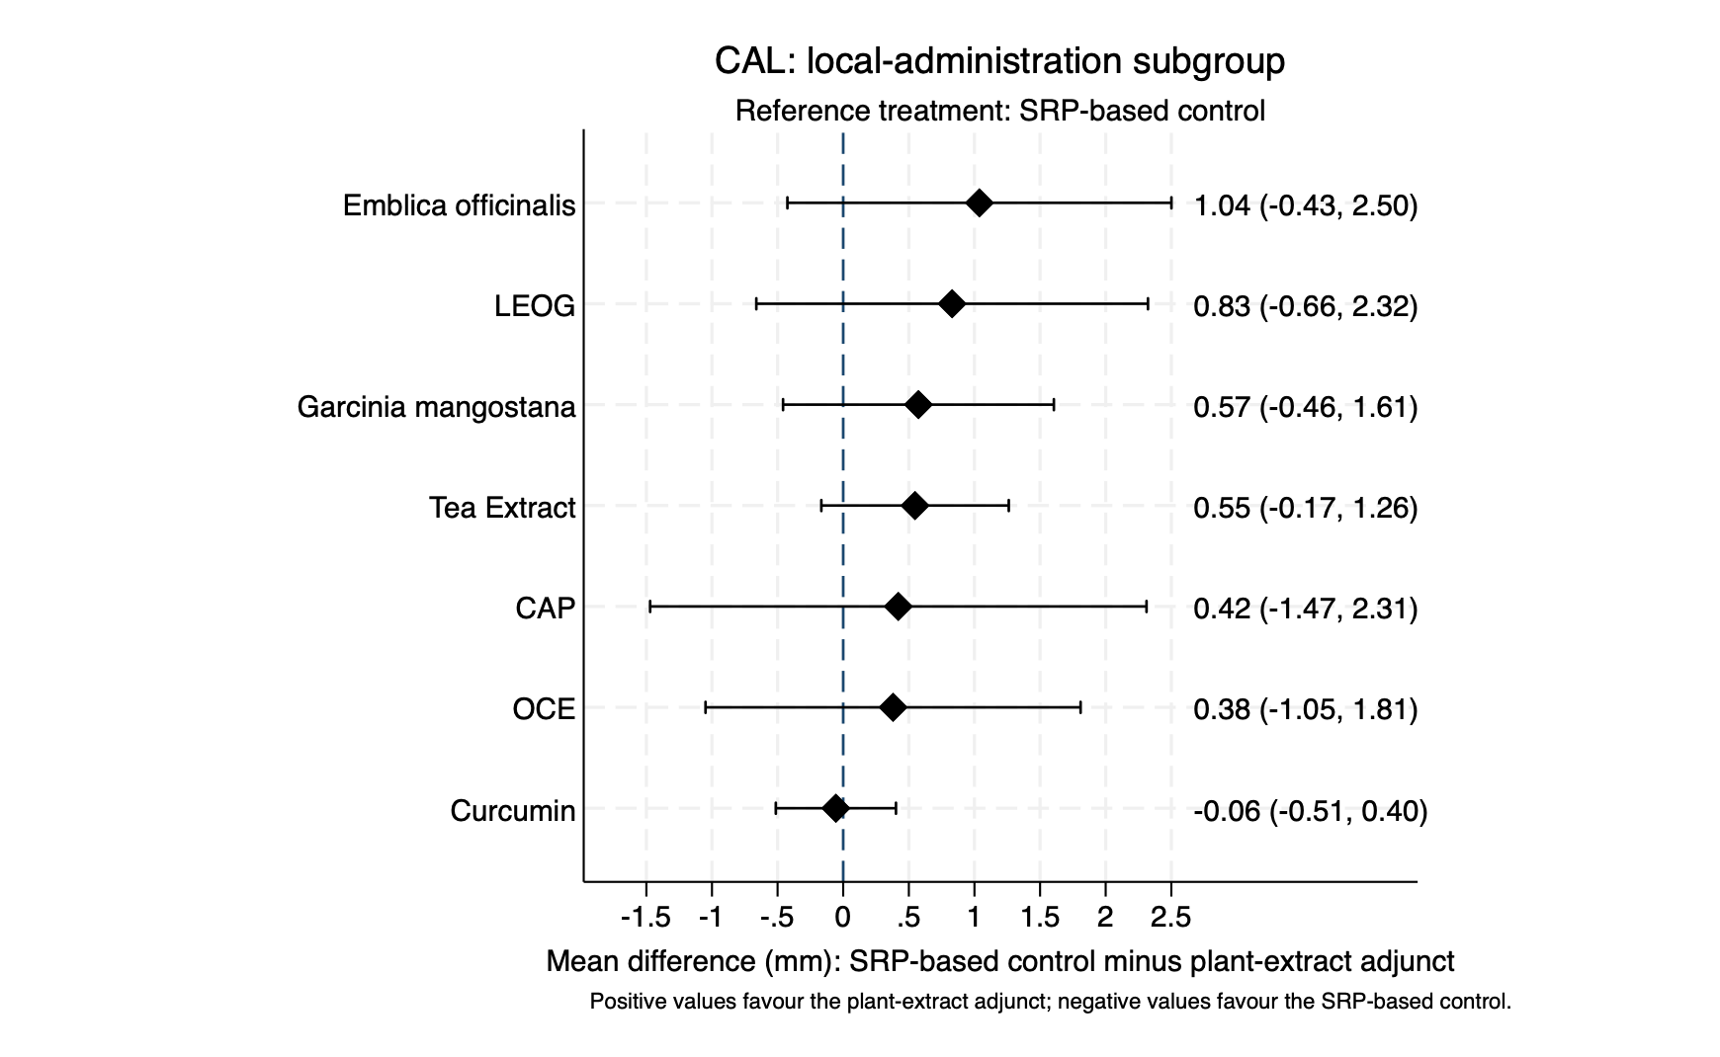

Figure S11.6: League table of CAL in the local administration subgroup

SRP | -0.42 (-2.31,1.47) | 0.06 (-0.40,0.51) | -1.04 (-2.50,0.43) | -0.57 (-1.61,0.46) | -0.83 (-2.32,0.66) | -0.38 (-1.81,1.05) | -0.55 (-1.26,0.17)
0.42 (-1.47,2.31) | SRP + CAP | 0.48 (-1.47,2.42) | -0.62 (-3.01,1.77) | -0.15 (-2.31,2.00) | -0.41 (-2.82,2.00) | 0.04 (-2.33,2.41) | -0.13 (-2.15,1.89)
-0.06 (-0.51,0.40) | -0.48 (-2.42,1.47) | SRP + Curcumin | -1.09 (-2.63,0.44) | -0.63 (-1.76,0.50) | -0.89 (-2.45,0.67) | -0.44 (-1.94,1.06) | -0.60 (-1.45,0.24)
1.04 (-0.43,2.50) | 0.62 (-1.77,3.01) | 1.09 (-0.44,2.63) | SRP + Emblica officinalis | 0.46 (-1.33,2.25) | 0.21 (-1.88,2.30) | 0.66 (-1.39,2.70) | 0.49 (-1.14,2.12)
0.57 (-0.46,1.61) | 0.15 (-2.00,2.31) | 0.63 (-0.50,1.76) | -0.46 (-2.25,1.33) | SRP + Garcinia mangostana | -0.26 (-2.07,1.56) | 0.19 (-1.57,1.96) | 0.03 (-1.23,1.28)
0.83 (-0.66,2.32) | 0.41 (-2.00,2.82) | 0.89 (-0.67,2.45) | -0.21 (-2.30,1.88) | 0.26 (-1.56,2.07) | SRP + LEOG | 0.45 (-1.62,2.52) | 0.28 (-1.37,1.94)
0.38 (-1.05,1.81) | -0.04 (-2.41,2.33) | 0.44 (-1.06,1.94) | -0.66 (-2.70,1.39) | -0.19 (-1.96,1.57) | -0.45 (-2.52,1.62) | SRP + OCE | -0.17 (-1.76,1.43)
0.55 (-0.17,1.26) | 0.13 (-1.89,2.15) | 0.60 (-0.24,1.45) | -0.49 (-2.12,1.14) | -0.03 (-1.28,1.23) | -0.28 (-1.94,1.37) | 0.17 (-1.43,1.76) | SRP + Tea Extract
Each cell reports the mean difference (95% CI) for the column treatment versus the row treatment. For outcomes in which lower values indicate improvement, negative values favour the column treatment and positive values favour the row treatment.

Figure S11.7: Network map of PPD in the oral administration subgroup

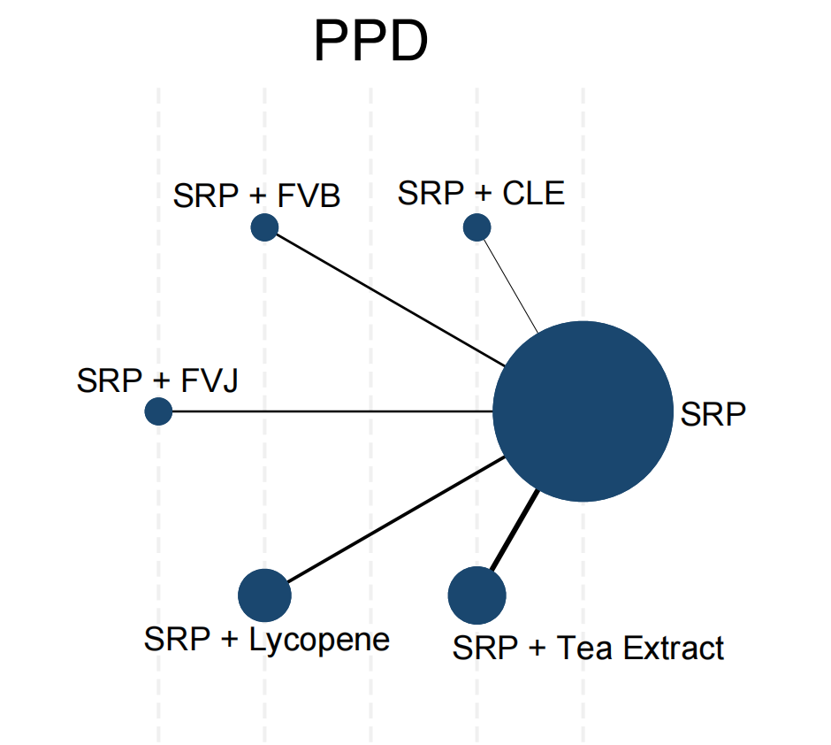

Figure S11.8: Forest plot of PPD in the oral administration subgroup

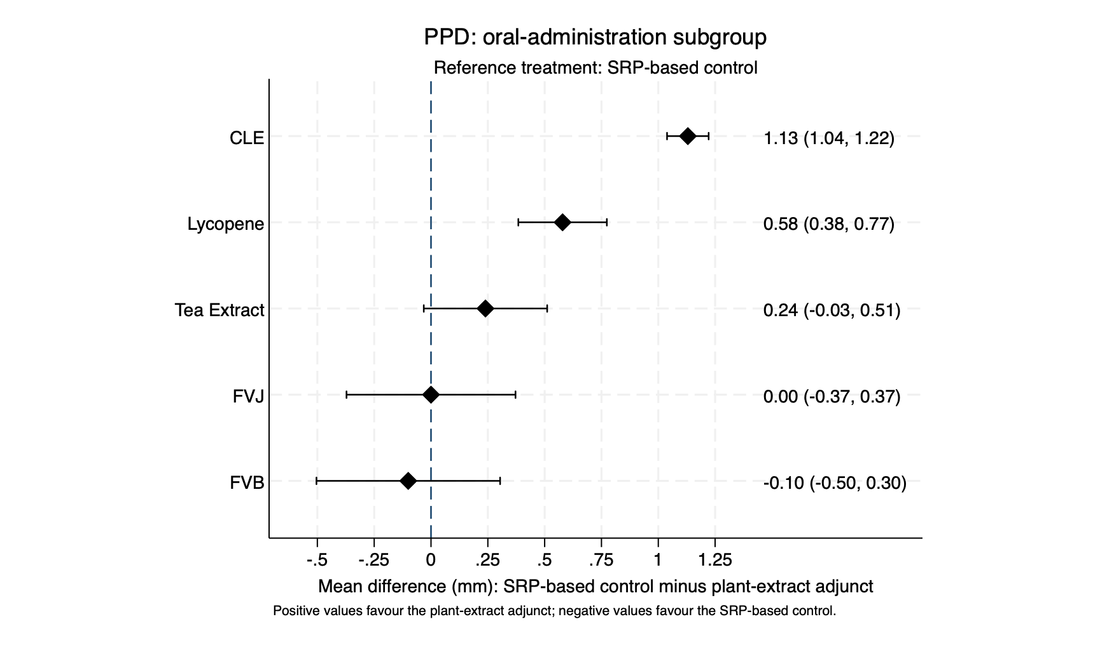

Figure S11.9: League table of PPD in the oral administration subgroup

SRP | -1.13 (-1.22,-1.04) | 0.10 (-0.30,0.50) | -0.00 (-0.37,0.37) | -0.58 (-0.77,-0.38) | -0.24 (-0.51,0.03)
1.13 (1.04,1.22) | CLE | 1.23 (0.82,1.64) | 1.13 (0.75,1.51) | 0.55 (0.34,0.77) | 0.89 (0.60,1.18)
-0.10 (-0.50,0.30) | -1.23 (-1.64,-0.82) | FVB | -0.10 (-0.65,0.45) | -0.68 (-1.13,-0.23) | -0.34 (-0.83,0.15)
0.00 (-0.37,0.37) | -1.13 (-1.51,-0.75) | 0.10 (-0.45,0.65) | FVJ | -0.58 (-1.00,-0.16) | -0.24 (-0.70,0.22)
0.58 (0.38,0.77) | -0.55 (-0.77,-0.34) | 0.68 (0.23,1.13) | 0.58 (0.16,1.00) | Lycopene | 0.34 (0.01,0.67)
0.24 (-0.03,0.51) | -0.89 (-1.18,-0.60) | 0.34 (-0.15,0.83) | 0.24 (-0.22,0.70) | -0.34 (-0.67,-0.01) | Tea Extract

Each cell reports the mean difference (95% CI) for the column treatment versus the row treatment. For outcomes in which lower values indicate improvement, negative values favour the column treatment and positive values favour the row treatment.

Figure S11.10: Network map of CAL in the oral administration subgroup

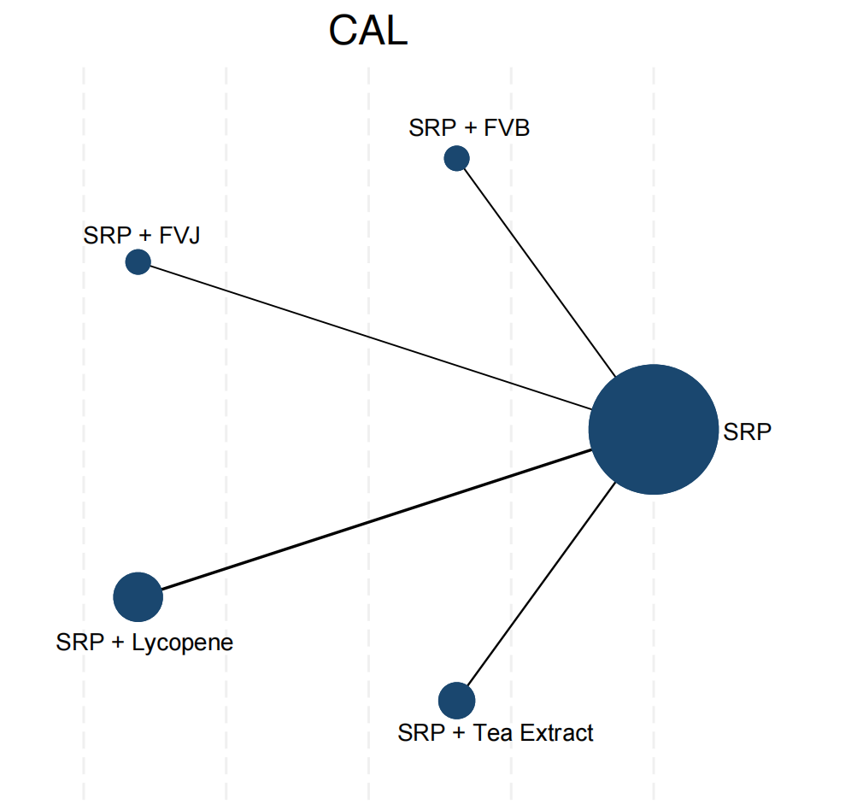

Figure S11.11: Forest plot of CAL in the oral administration subgroup

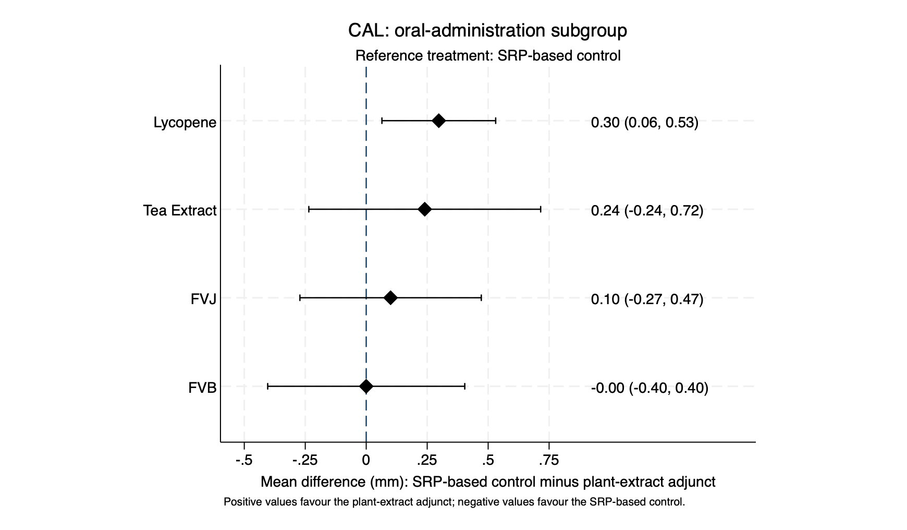

Figure S11.12: League table of CAL in the oral administration subgroup

SRP | 0.00 (-0.40,0.40) | -0.10 (-0.47,0.27) | -0.30 (-0.53,-0.06) | -0.24 (-0.72,0.24)
-0.00 (-0.40,0.40) | SRP + FVB | -0.10 (-0.65,0.45) | -0.30 (-0.76,0.17) | -0.24 (-0.86,0.38)
0.10 (-0.27,0.47) | 0.10 (-0.45,0.65) | SRP + FVJ | -0.20 (-0.64,0.24) | -0.14 (-0.74,0.46)
0.30 (0.06,0.53) | 0.30 (-0.17,0.76) | 0.20 (-0.24,0.64) | SRP + Lycopene | 0.06 (-0.47,0.59)
0.24 (-0.24,0.72) | 0.24 (-0.38,0.86) | 0.14 (-0.46,0.74) | -0.06 (-0.59,0.47) | SRP + Tea Extract

Each cell reports the mean difference (95% CI) for the column treatment versus the row treatment. For outcomes in which lower values indicate improvement, negative values favour the column treatment and positive values favour the row treatment.

Appendix 12: Subgroup analyses by study design

Subgroup analyses were stratified according to study design. Studies were classified as parallel-group or split-mouth trials. Within each subgroup, the comparator remained SRP alone or SRP plus placebo.

Figure S12.1: Network map of PPD in parallel-group studies

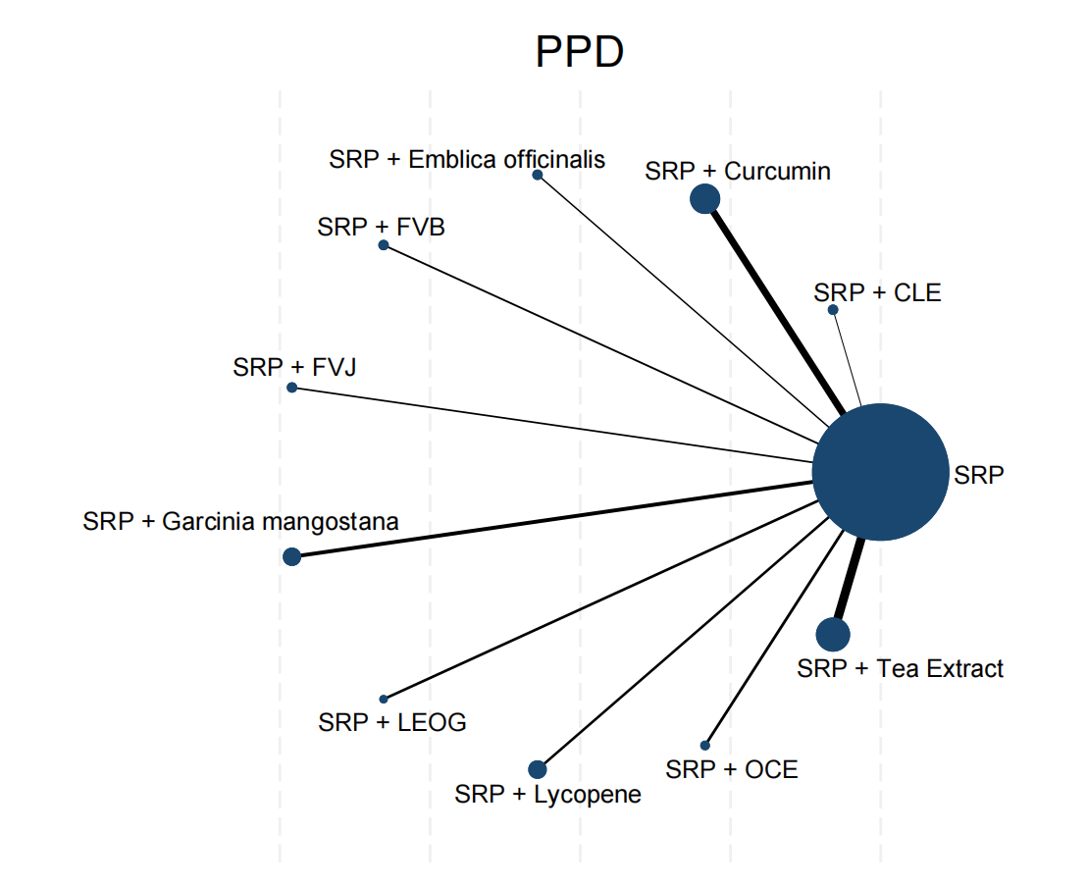

Figure S12.2: Forest plot of PPD in parallel-group studies

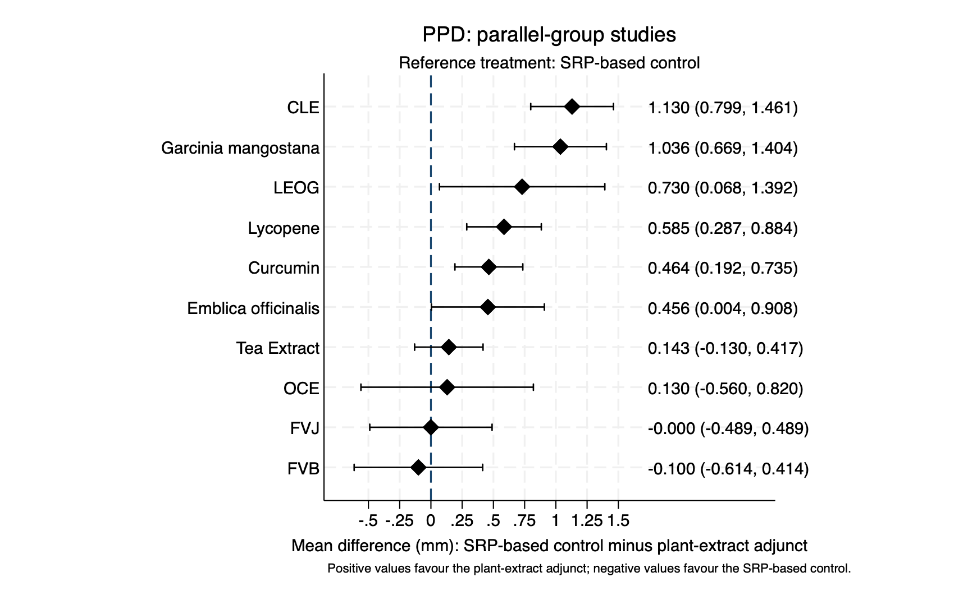

Figure S12.3: League table of PPD in parallel-group studies

SRP | -1.13 (-1.46,-0.80) | -0.46 (-0.74,-0.19) | -0.46 (-0.91,-0.00) | 0.10 (-0.41,0.61) | 0.00 (-0.49,0.49) | -1.04 (-1.40,-0.67) | -0.73 (-1.39,-0.07) | -0.59 (-0.88,-0.29) | -0.13 (-0.82,0.56) | -0.14 (-0.42,0.13)
1.13 (0.80,1.46) | SRP + CLE | 0.67 (0.24,1.09) | 0.67 (0.11,1.23) | 1.23 (0.62,1.84) | 1.13 (0.54,1.72) | 0.09 (-0.40,0.59) | 0.40 (-0.34,1.14) | 0.54 (0.10,0.99) | 1.00 (0.23,1.77) | 0.99 (0.56,1.42)
0.46 (0.19,0.74) | -0.67 (-1.09,-0.24) | SRP + Curcumin | 0.01 (-0.52,0.54) | 0.56 (-0.02,1.15) | 0.46 (-0.10,1.02) | -0.57 (-1.05,-0.10) | -0.27 (-0.98,0.45) | -0.12 (-0.52,0.28) | 0.33 (-0.41,1.08) | 0.32 (-0.08,0.72)
0.46 (0.00,0.91) | -0.67 (-1.23,-0.11) | -0.01 (-0.54,0.52) | SRP + Emblica officinalis | 0.56 (-0.13,1.24) | 0.46 (-0.21,1.12) | -0.58 (-1.16,0.00) | -0.27 (-1.08,0.53) | -0.13 (-0.67,0.41) | 0.33 (-0.50,1.15) | 0.31 (-0.22,0.84)
-0.10 (-0.61,0.41) | -1.23 (-1.84,-0.62) | -0.56 (-1.15,0.02) | -0.56 (-1.24,0.13) | SRP + FVB | -0.10 (-0.81,0.61) | -1.14 (-1.77,-0.50) | -0.83 (-1.67,0.01) | -0.69 (-1.28,-0.09) | -0.23 (-1.09,0.63) | -0.24 (-0.83,0.34)
-0.00 (-0.49,0.49) | -1.13 (-1.72,-0.54) | -0.46 (-1.02,0.10) | -0.46 (-1.12,0.21) | 0.10 (-0.61,0.81) | SRP + FVJ | -1.04 (-1.65,-0.42) | -0.73 (-1.55,0.09) | -0.59 (-1.16,-0.01) | -0.13 (-0.98,0.72) | -0.14 (-0.70,0.42)
1.04 (0.67,1.40) | -0.09 (-0.59,0.40) | 0.57 (0.10,1.05) | 0.58 (-0.00,1.16) | 1.14 (0.50,1.77) | 1.04 (0.42,1.65) | SRP + Garcinia mangostana | 0.31 (-0.45,1.06) | 0.45 (-0.02,0.93) | 0.91 (0.12,1.69) | 0.89 (0.44,1.35)
0.73 (0.07,1.39) | -0.40 (-1.14,0.34) | 0.27 (-0.45,0.98) | 0.27 (-0.53,1.08) | 0.83 (-0.01,1.67) | 0.73 (-0.09,1.55) | -0.31 (-1.06,0.45) | SRP + LEOG | 0.14 (-0.58,0.87) | 0.60 (-0.36,1.56) | 0.59 (-0.13,1.30)
0.59 (0.29,0.88) | -0.54 (-0.99,-0.10) | 0.12 (-0.28,0.52) | 0.13 (-0.41,0.67) | 0.69 (0.09,1.28) | 0.59 (0.01,1.16) | -0.45 (-0.93,0.02) | -0.14 (-0.87,0.58) | SRP + Lycopene | 0.46 (-0.30,1.21) | 0.44 (0.04,0.85)
0.13 (-0.56,0.82) | -1.00 (-1.77,-0.23) | -0.33 (-1.08,0.41) | -0.33 (-1.15,0.50) | 0.23 (-0.63,1.09) | 0.13 (-0.72,0.98) | -0.91 (-1.69,-0.12) | -0.60 (-1.56,0.36) | -0.46 (-1.21,0.30) | SRP + OCE | -0.01 (-0.76,0.73)
0.14 (-0.13,0.42) | -0.99 (-1.42,-0.56) | -0.32 (-0.72,0.08) | -0.31 (-0.84,0.22) | 0.24 (-0.34,0.83) | 0.14 (-0.42,0.70) | -0.89 (-1.35,-0.44) | -0.59 (-1.30,0.13) | -0.44 (-0.85,-0.04) | 0.01 (-0.73,0.76) | SRP + Tea Extract

Each cell reports the mean difference (95% CI) for the column treatment versus the row treatment. For outcomes in which lower values indicate improvement, negative values favour the column treatment and positive values favour the row treatment.

Figure S12.4: Network map of CAL in parallel-group studies

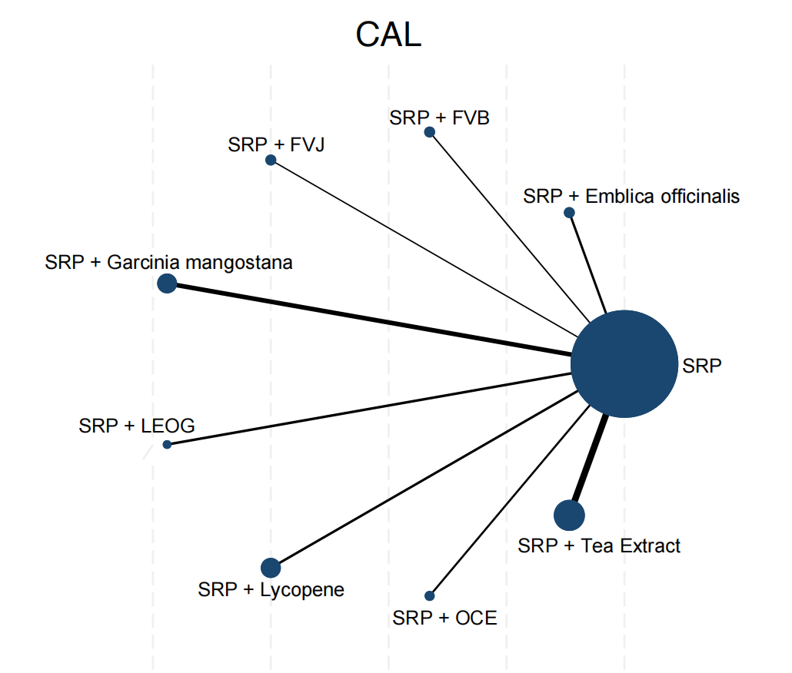

Figure S12.5: Forest plot of CAL in parallel-group studies

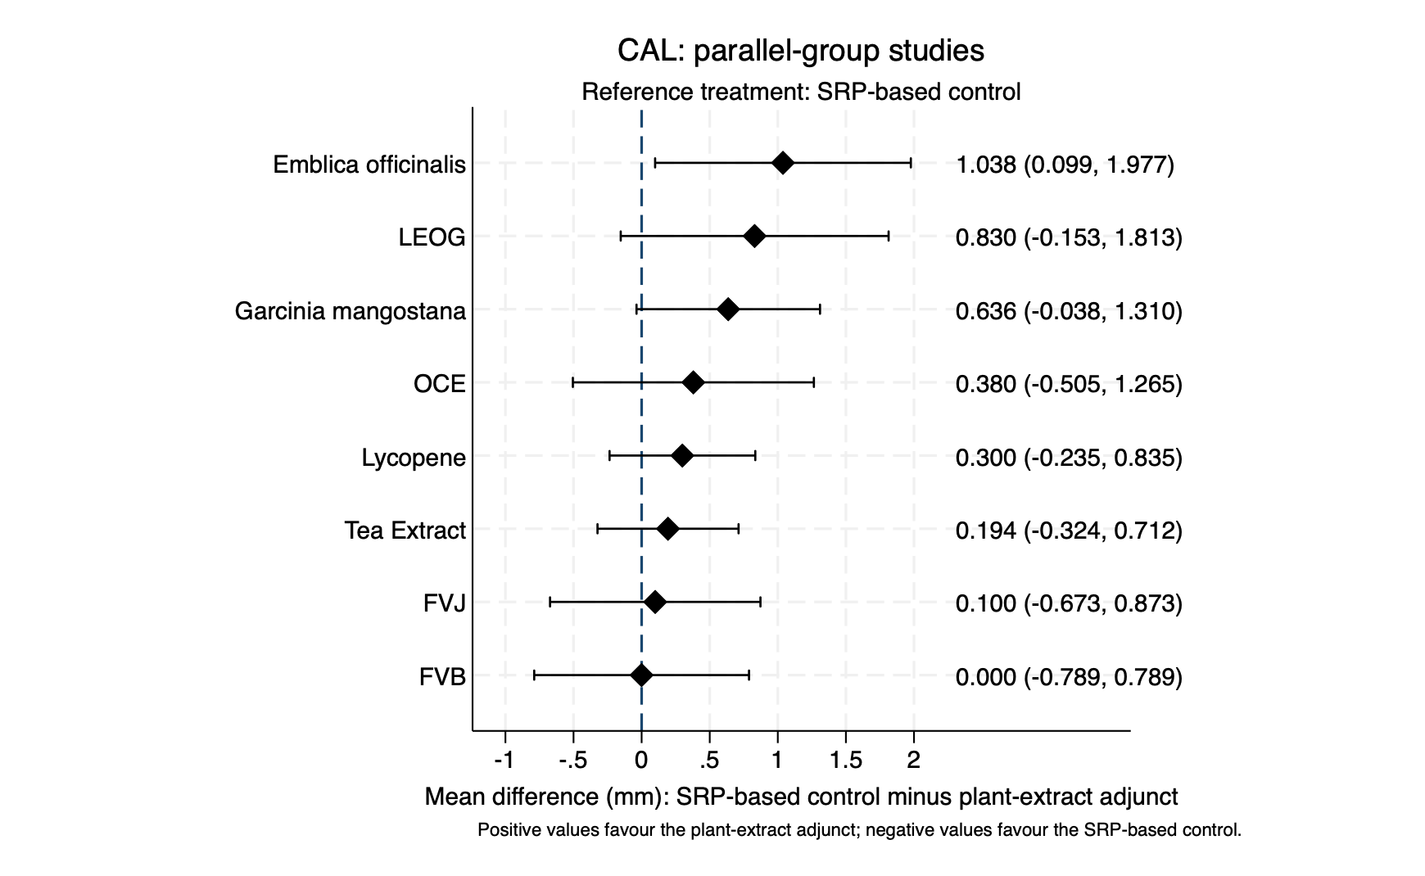

Figure S12.6: League table of CAL in parallel-group studies

SRP | -1.04 (-1.98,-0.10) | -0.00 (-0.79,0.79) | -0.10 (-0.87,0.67) | -0.64 (-1.31,0.04) | -0.83 (-1.81,0.15) | -0.30 (-0.83,0.24) | -0.38 (-1.26,0.50) | -0.19 (-0.71,0.32)
1.04 (0.10,1.98) | SRP + Emblica officinalis | 1.04 (-0.19,2.26) | 0.94 (-0.28,2.15) | 0.40 (-0.75,1.56) | 0.21 (-1.15,1.57) | 0.74 (-0.34,1.82) | 0.66 (-0.63,1.95) | 0.84 (-0.23,1.92)
0.00 (-0.79,0.79) | -1.04 (-2.26,0.19) | SRP + FVB | -0.10 (-1.20,1.00) | -0.64 (-1.67,0.40) | -0.83 (-2.09,0.43) | -0.30 (-1.25,0.65) | -0.38 (-1.57,0.81) | -0.19 (-1.14,0.75)
0.10 (-0.67,0.87) | -0.94 (-2.15,0.28) | 0.10 (-1.00,1.20) | SRP + FVJ | -0.54 (-1.56,0.49) | -0.73 (-1.98,0.52) | -0.20 (-1.14,0.74) | -0.28 (-1.45,0.89) | -0.09 (-1.02,0.84)
0.64 (-0.04,1.31) | -0.40 (-1.56,0.75) | 0.64 (-0.40,1.67) | 0.54 (-0.49,1.56) | SRP + Garcinia mangostana | -0.19 (-1.39,1.00) | 0.34 (-0.52,1.20) | 0.26 (-0.86,1.37) | 0.44 (-0.39,1.27)
0.83 (-0.15,1.81) | -0.21 (-1.57,1.15) | 0.83 (-0.43,2.09) | 0.73 (-0.52,1.98) | 0.19 (-1.00,1.39) | SRP + LEOG | 0.53 (-0.59,1.65) | 0.45 (-0.87,1.77) | 0.64 (-0.48,1.75)
0.30 (-0.24,0.83) | -0.74 (-1.82,0.34) | 0.30 (-0.65,1.25) | 0.20 (-0.74,1.14) | -0.34 (-1.20,0.52) | -0.53 (-1.65,0.59) | SRP + Lycopene | -0.08 (-1.11,0.95) | 0.11 (-0.64,0.85)
0.38 (-0.50,1.26) | -0.66 (-1.95,0.63) | 0.38 (-0.81,1.57) | 0.28 (-0.89,1.45) | -0.26 (-1.37,0.86) | -0.45 (-1.77,0.87) | 0.08 (-0.95,1.11) | SRP + OCE | 0.19 (-0.84,1.21)
0.19 (-0.32,0.71) | -0.84 (-1.92,0.23) | 0.19 (-0.75,1.14) | 0.09 (-0.84,1.02) | -0.44 (-1.27,0.39) | -0.64 (-1.75,0.48) | -0.11 (-0.85,0.64) | -0.19 (-1.21,0.84) | SRP + Tea Extract

Each cell reports the mean difference (95% CI) for the column treatment versus the row treatment. For outcomes in which lower values indicate improvement, negative values favour the column treatment and positive values favour the row treatment.

Figure S12.7: Network map of PPD in split-mouth studies

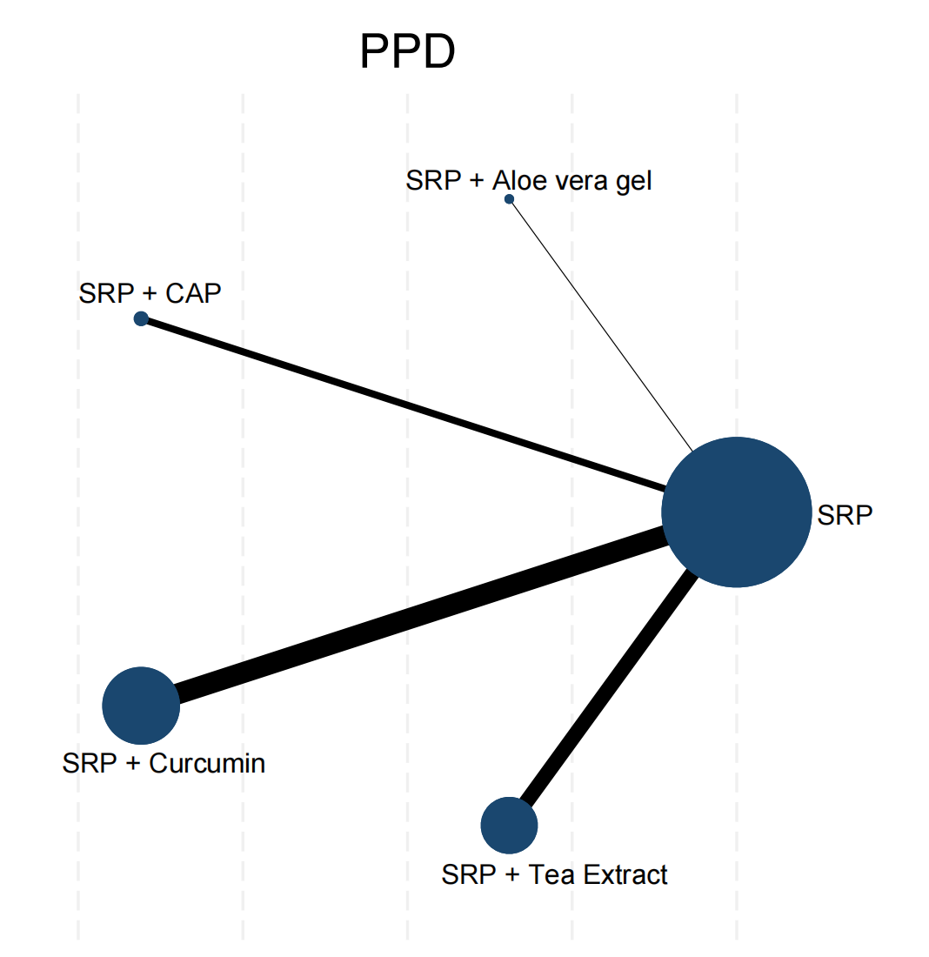

Figure S12.8: Forest plot of PPD in split-mouth studies

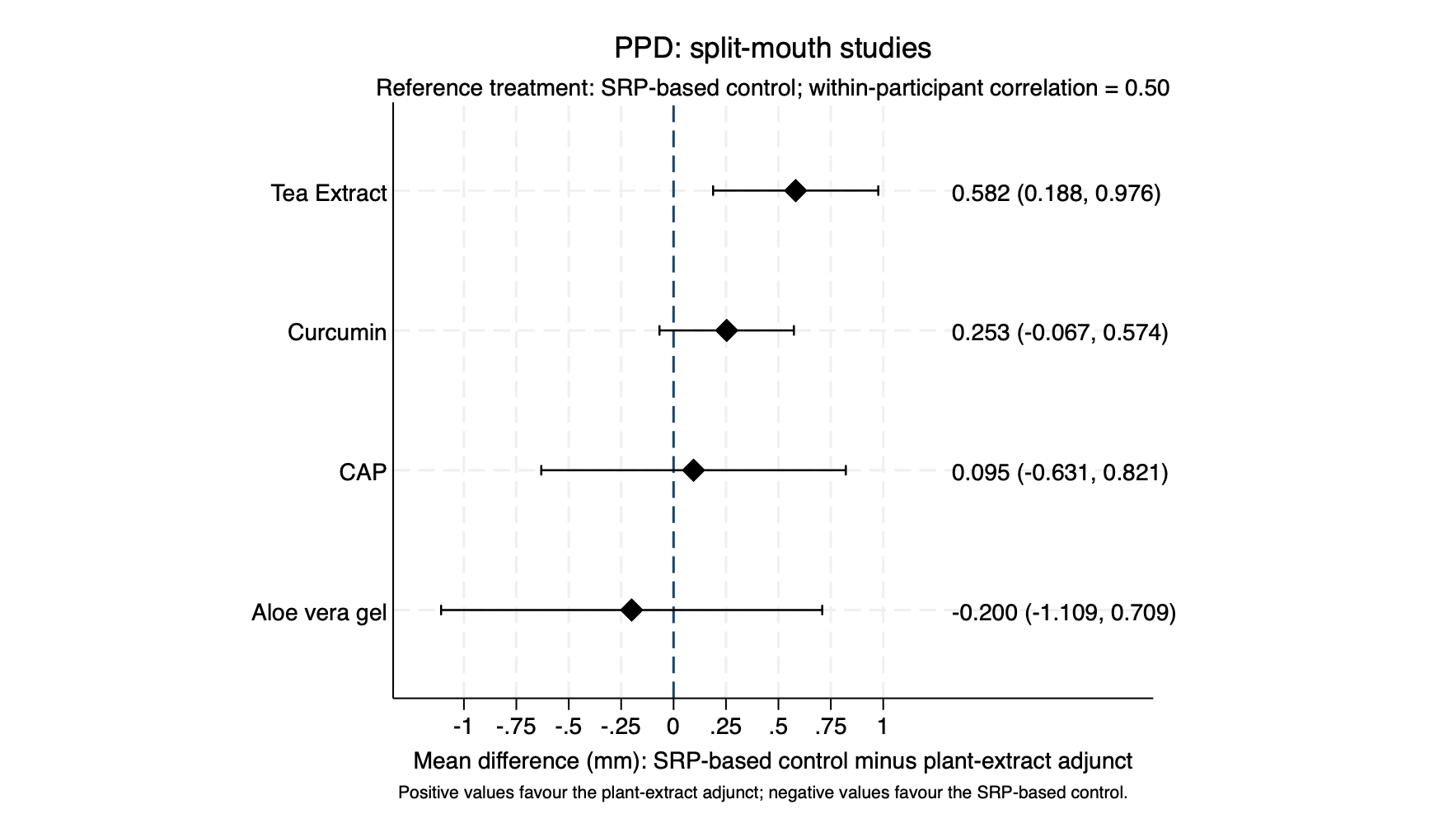

Figure S12.9: League table of PPD in split-mouth studies

SRP | 0.20  (-0.71, 1.11) | -0.10  (-0.82, 0.63) | -0.25  (-0.57, 0.07) | -0.58  (-0.98, -0.19)
-0.20  (-1.11, 0.71) | Aloe vera gel | -0.30  (-1.46, 0.87) | -0.45  (-1.42, 0.51) | -0.78  (-1.77, 0.21)
0.10  (-0.63, 0.82) | 0.30  (-0.87, 1.46) | CAP | -0.16  (-0.95, 0.64) | -0.49  (-1.31, 0.34)
0.25  (-0.07, 0.57) | 0.45  (-0.51, 1.42) | 0.16  (-0.64, 0.95) | Curcumin | -0.33  (-0.84, 0.18)
0.58  (0.19, 0.98) | 0.78  (-0.21, 1.77) | 0.49  (-0.34, 1.31) | 0.33 (-0.18, 0.84) | Tea Extract

Each cell reports the mean difference (95% CI) for the column treatment versus the row treatment. For outcomes in which lower values indicate improvement, negative values favour the column treatment and positive values favour the row treatment.

Figure S12.10: Network map of CAL in split-mouth studies

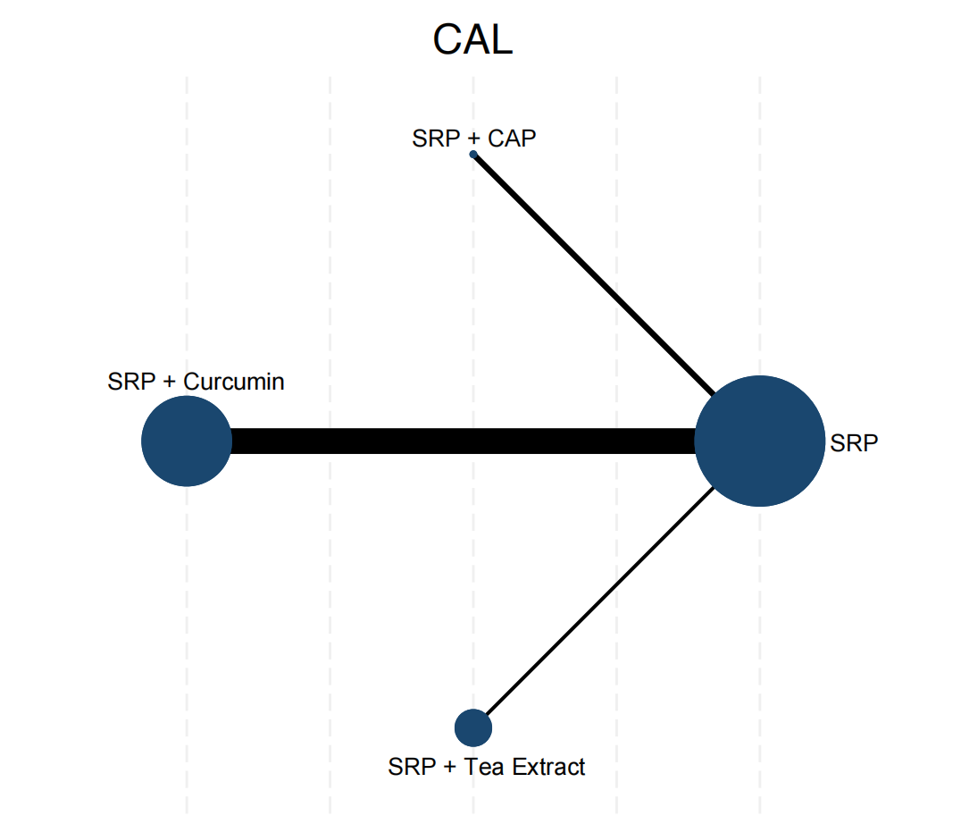

Figure S12.11: Forest plot of CAL in split-mouth studies

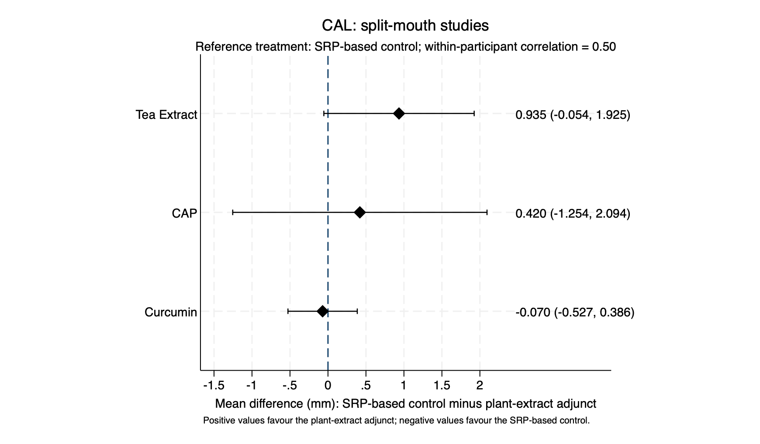

Figure S12.12: League table of CAL in split-mouth studies

SRP | -0.42  (-2.09, 1.25) | 0.07  (-0.39, 0.53) | -0.94  (-1.92, 0.05)
0.42  (-1.25, 2.09) | CAP | 0.49  (-1.24, 2.23) | -0.52  (-2.46, 1.43)
-0.07  (-0.53, 0.39) | -0.49  (-2.23, 1.24) | Curcumin | -1.01  (-2.10, 0.08)
0.94  (-0.05, 1.92) | 0.52  (-1.43, 2.46) | 1.01  (-0.08, 2.10) | Tea Extract

Each cell reports the mean difference (95% CI) for the column treatment versus the row treatment. For outcomes in which lower values indicate improvement, negative values favour the column treatment and positive values favour the row treatment.

