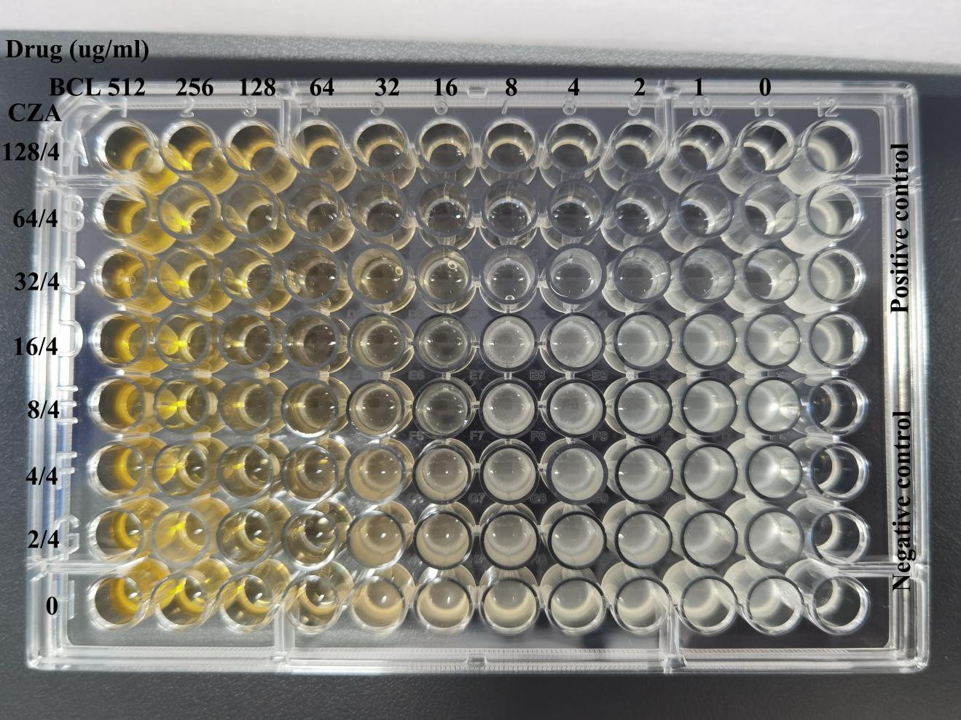
Supplementary Fig. 1 Original photograph of broth microdilution checkerboard synergy assay plate for CZA combined with BCL against CRAB. Vertical axis indicates gradient concentrations of CZA (μg/mL); horizontal axis shows serial two‑fold dilutions of BCL (μg/mL). Turbid wells represent visible bacterial growth; clear wells indicate complete growth inhibition. The four wells in the upper‑right corner serve as positive control (bacteria without drug); the four wells in the bottom‑right corner are negative control (sterile culture medium only).

Supplementary Fig. 2 Venn‑diagram showing overlap of differentially expressed genes (DEGs) from four pairwise transcriptome comparisons. Venn-diagram illustrating the shared and unique differentially expressed genes obtained from four pairwise comparisons: R0‑vs‑R2, R0‑vs‑R3, R1‑vs‑R2, R1‑vs‑R3. A total of 100 common differentially expressed genes were identified at the intersection of the four groups, which were considered candidate genes responsible for the synergistic antibacterial effect of ceftazidime‑avibactam (CZA) combined with baicalein (BCL).

Supplementary Fig. 3 KEGG pathway enrichment analysis of 100 common differentially expressed genes. Bubble plot of KEGG pathway enrichment for the 100 shared DEGs derived from four pairwise transcriptomic comparisons. The X-axis represents gene ratio (the proportion of DEGs annotated to each pathway among total background genes). The Y-axis lists enriched KEGG pathways. The size of each bubble corresponds to the number of enriched differentially expressed genes; bubble color corresponds to the significance of enrichment.

