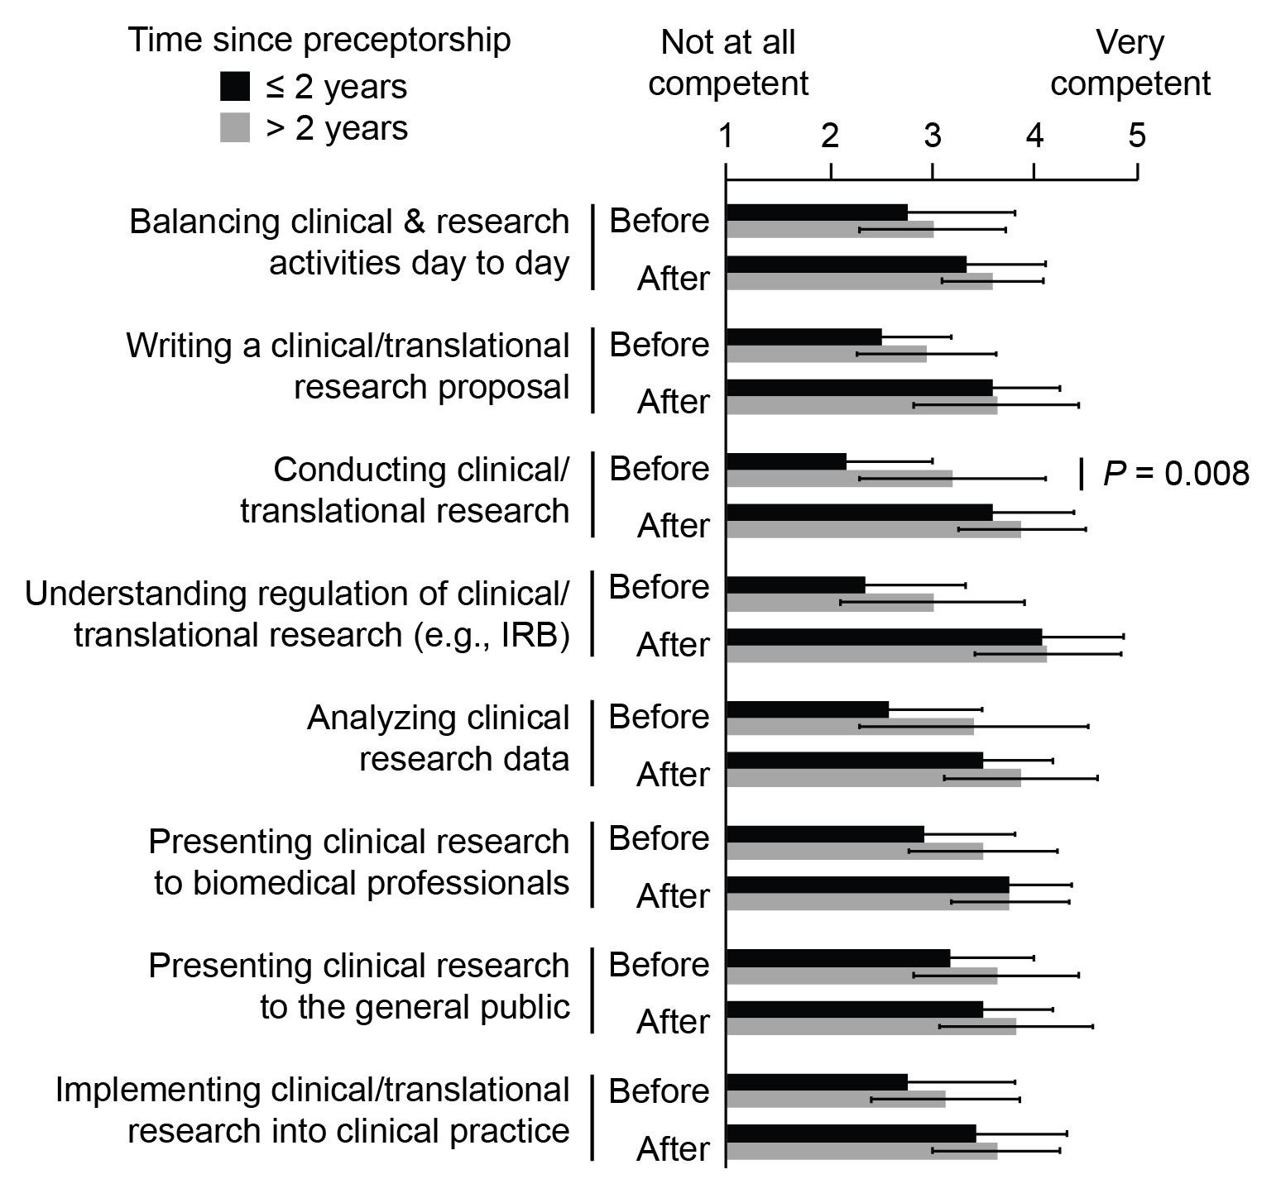
Supplemental Figure 4. Student self-assessment of competency levels before and after taking the preceptorship (mean ± SD) separated by time elapsed since taking the preceptorship. P values were determined with a Mann-Whitney test (two-sided) (n = 12 for group ≤ 2 years; n = 16 for group > 2 years since taking the preceptorship). P values not shown were > 0.05.

