Additional file 1
Figure S1. Learning organization and data collection. Each step was illustrated with pictures together with a concise description as follows.
- Students were divided into five groups comprised of 9-10 students within each group. | 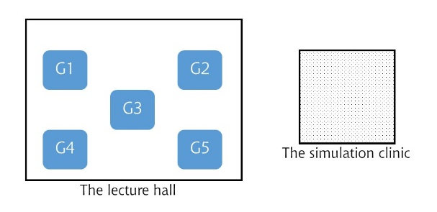
- One student was randomly selected as an interviewer for taking a history from a simulated patient with given chief compliant in the simulation clinic. | 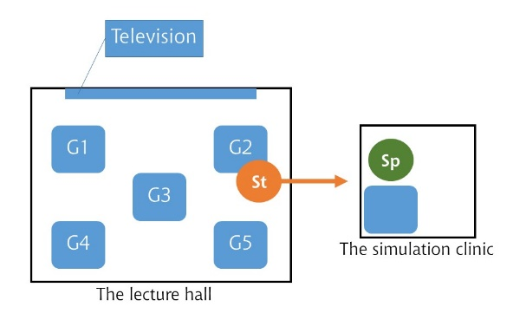
- While the interviewer was taking a history, the other students and instructors observed the session via a closed-circuit television in a lecture hall. | 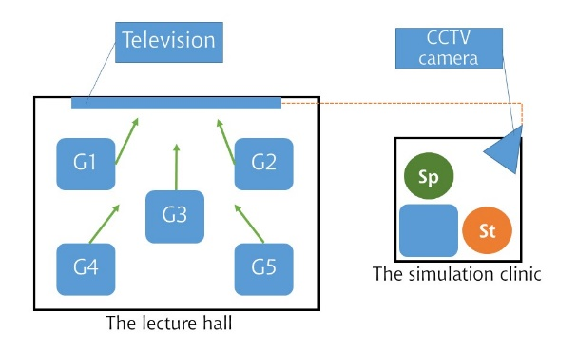
20-30 minutes
- The interviewer came back to reflect his or her own performance in front of the lecture hall—individual RP. | 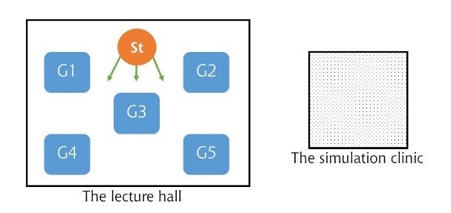
5 minutes
- After 5-minute group discussion without the interviewer while the interviewer was still in the room, the other five volunteers (one from each group) embarked on collaborative RP. | 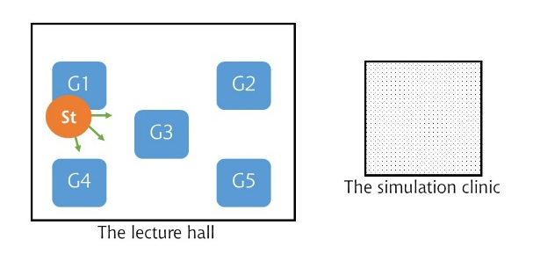
30 minutes
- The instructors provided the feedback (5-10 minutes). | 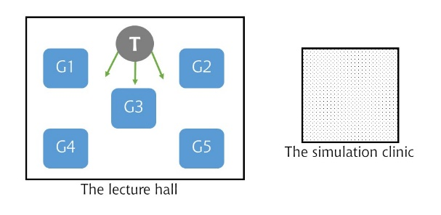

Note.—G = Group, Sp = Simulated patient, St = Student, T = Instructor, CCTV = Closed-circuit television. Both individual RP and collaborative RP were all video-recorded and distributed as learning materials for the students to review their own performances. All video files were, thereafter, gathered and analysed to assess the learning outcomes.

