Online supplement

Effectiveness of a serious game addressing guideline adherence:

Cohort study with 1.5-year follow-up

Tobias Raupach, MD. MME^{1,2}: raupach@med.uni-goettingen.de
Insa de Temple¹: Insa.Frisch@gmx.de
Angélina Middeke, MD¹: angelina.middeke@med.uni-goettingen.de
Sven Anders³: s.anders@uke.de
Caroline Morton⁴: caroline.morton@phc.ox.ac.uk
Nikolai Schuelper, MD⁵: n.schuelper@medius-kliniken.de

¹ Department of Cardiology and Pneumology, Göttingen University Medical Centre, Robert-Koch-Straße 40, Göttingen, D-37075, Germany
² Department of Medical Education, University Hospital Bonn, Venusberg-Campus 1, Gebäude 33, 53127 Bonn
³ Department of Legal Medicine, University Medical Centre Hamburg-Eppendorf, Butenfeld 34, Hamburg, D-22529, Germany
⁴ Nuffield Department of Primary Care Health Sciences, Medical Sciences Division, University of Oxford, Radcliffe Primary Care Building, Radcliffe Observatory Quarter, Woodstock Road, Oxford OX2 6GG, United Kingdom

⁵ Medius Klinik Ostfildern Ruit, Hedelfinger Straße 166, D-73760 Ostfildern-Ruit, Germany

Methods – eTables 1a-c: Scoring sheets for log file analyses and proportions of students performing respective actions while using the game 2

Results – eFigure 1: Change in total, history and management scores from week 2 to week 6 in both modules (data collection in summer term 2017).. 5

eTables 1a-c: Scoring sheets for log file analyses and proportions of students performing respective actions while using the game (comparison between pre-exposed and non-exposed students at week 80; analysis 3). Data are presented as percentage (n) or mean ± standard error of the mean, respectively. p values were derived from χ² tests (dichotomous items) and independent T tests (sum scores), as appropriate.

eTable 1a: Stable pulmonary embolism
Stable pulmonary embolism | Previous exposure (n = 58) | No previous exposure (n = 42) | p value
History
Cough | 32.8 (19) | 26.2 (11) | 0.479
Pain | 62.1 (36) | 52.4 (22) | 0.333
History of presenting complaint | 70.7 (41) | 78.6 (33) | 0.375
Smoking | 50.0 (29) | 54.8 (23) | 0.638
Past medical history | 84.5 (49) | 95.2 (40) | 0.090
Drug history | 79.3 (46) | 76.2 (32) | 0.710
History: max. 6 points | 3.8 ± 0.2 | 3.8 ± 0.2 | 0.878
Management
Arterial blood gases | 87.9 (51) | 85.7 (36) | 0.745
Troponin | 91.4 (53) | 71.4 (30) | 0.009
D dimers | 79.3 (46) | 57.1 (24) | 0.017
Electrocardiogram | 98.3 (57) | 83.3 (35) | 0.007
Cardiac ultrasound | 29.3 (17) | 19.0 (8) | 0.242
CT scan of the thorax | 69.0 (40) | 52.4 (22) | 0.092
Correct diagnosis | 79.3 (46) | 59.5 (25) | 0.031
Treatment: anticoagulation | 55.2 (32) | 35.7 (15) | 0.054
Management: max. 8 points | 5.9 ± 0.2 | 4.6 ± 0.3 | <0.001
Total score: max. 14 points | 9.7 ± 0.2 | 8.5 ± 0.3 | 0.003

eTable 1b: Hypertensive crisis

Hypertensive crisis | Previous exposure (n = 56) | No previous exposure (n = 41) | p value
History
Dizziness | 19.6 (11) | 17.1 (7) | 0.748
History of presenting complaint | 66.1 (37) | 65.9 (27) | 0.982
Past medical history | 71.4 (40) | 80.5 (33) | 0.307
Drug history | 89.3 (50) | 90.2 (37) | 0.878
History: max. 4 points | 2.4 ± 0.1 | 2.5 ± 0.1 | 0.641
Management
Full physical examination | 73.2 (41) | 73.2 (30) | 0.996
Full blood count | 66.1 (37) | 70.7 (29) | 0.627
Electrocardiogram | 57.1 (32) | 48.8 (20) | 0.415
Correct diagnosis | 94.6 (53) | 97.6 (40) | 0.475
Treatment: nitrates | 60.7 (34) | 56.1 (23) | 0.648
Treatment: antihypertensive drugs | 58.9 (33) | 70.7 (29) | 0.232
Management: max. 6 points | 4.0 ± 0.2 | 4.1 ± 0.2 | 0.678
Total score: max. 10 points | 6.3 ± 0.2 | 6.6 ± 0.3 | 0.578

eTable 1c: NSTEMI

NSTEMI | Previous exposure (n = 58) | No previous exposure (n = 42) | p value
History
Difficulty breathing | 43.1 (25) | 42.9 (18) | 0.980
Onset of presenting complaint | 55.2 (32) | 61.9 (26) | 0.501
History of presenting complaint | 32.8 (19) | 16.7 (7) | 0.070
Smoking | 36.2 (21) | 28.6 (12) | 0.423
Allergies | 36.2 (21) | 26.2 (11) | 0.289
Past medical history | 69.0 (40) | 71.4 (30) | 0.791
Family history | 29.3 (17) | 40.5 (17) | 0.245
Drug history | 79.3 (46) | 71.4 (30) | 0.362
History: max. 8 points | 3.8 ± 0.2 | 3.6 ± 0.2 | 0.479
Management
Physical examination: thorax | 94.8 (55) | 88.1 (37) | 0.221
Troponin | 100.0 (58) | 100.0 (42) | —
CK | 96.6 (56) | 92.9 (39) | 0.403
CKMB | 98.3 (57) | 92.9 (39) | 0.172
TSH | 27.6 (16) | 2.4 (1) | 0.001
Electrocardiogram | 98.3 (57) | 97.6 (41) | 0.817
Coronary angiogram | 89.7 (52) | 78.6 (33) | 0.126
Correct diagnosis | 87.9 (51) | 69.0 (29) | 0.020
Treatment: aspirin | 34.5 (20) | 26.2 (11) | 0.376
Treatment: heparin | 36.2 (21) | 21.4 (9) | 0.111
Treatment: nitrates | 50.0 (29) | 38.1 (16) | 0.238
Management: max. 11 points | 8.1 ± 0.2 | 7.0 ± 0.2 | 0.001
Total score: max. 19 points | 12.0 ± 0.3 | 10.7 ± 0.3 | 0.004

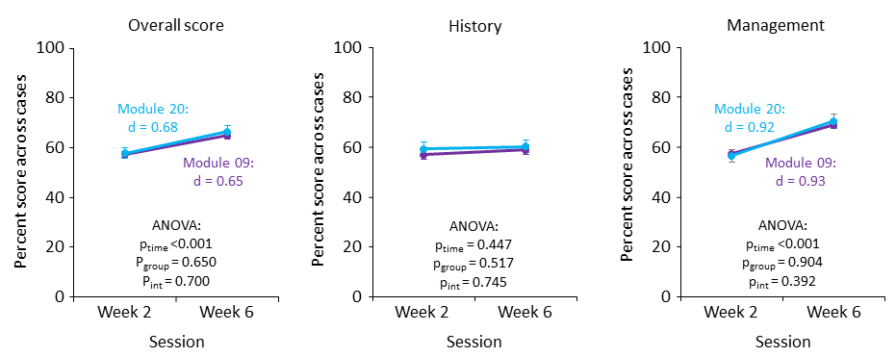
eFigure 1: Change in total, history and management scores from week 2 to week 6 in both modules (data collection in summer term 2017). Error bars indicate standard errors of the mean. p_{int}, p for interaction (ANOVA)

