Sustainability in quality improvement (SusQI): a case-study in undergraduate medical education

Philippa Clery^{1,2}, Stuart d’Arch Smith³, Oliver Marsden¹, Kathleen Leedham-Green⁴

¹ Bristol Medical School, University of Bristol, Bristol, UK
² University Hospitals Bristol and Weston NHS Foundation Trust, Bristol, UK
³ Centre for Sustainable Healthcare, Oxford, UK
⁴ Medical Education Research Unit, Imperial College London, London, UK

Workshop slides (visit susQI.org for updated generic template session)

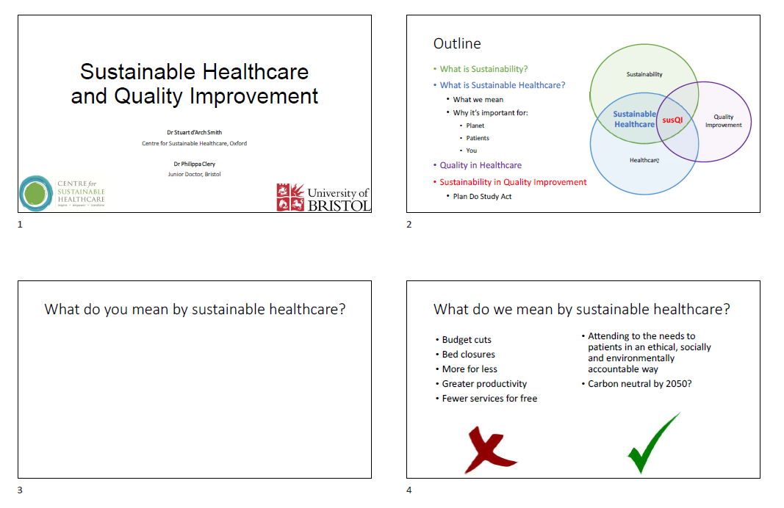

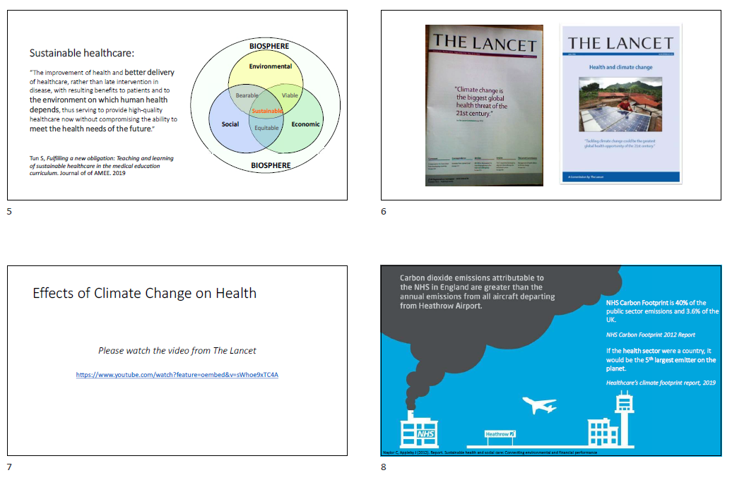
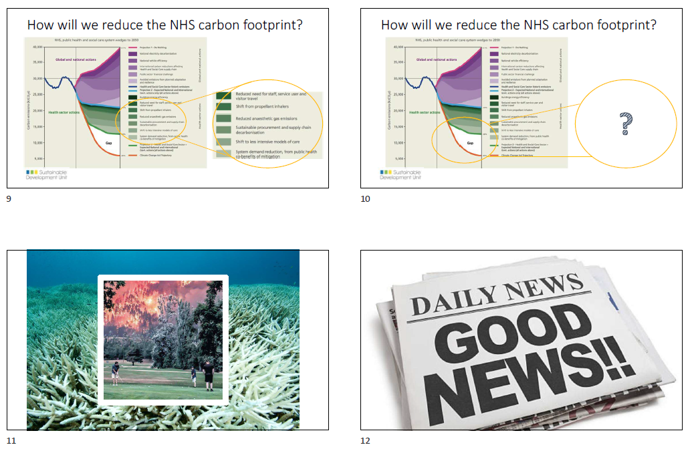
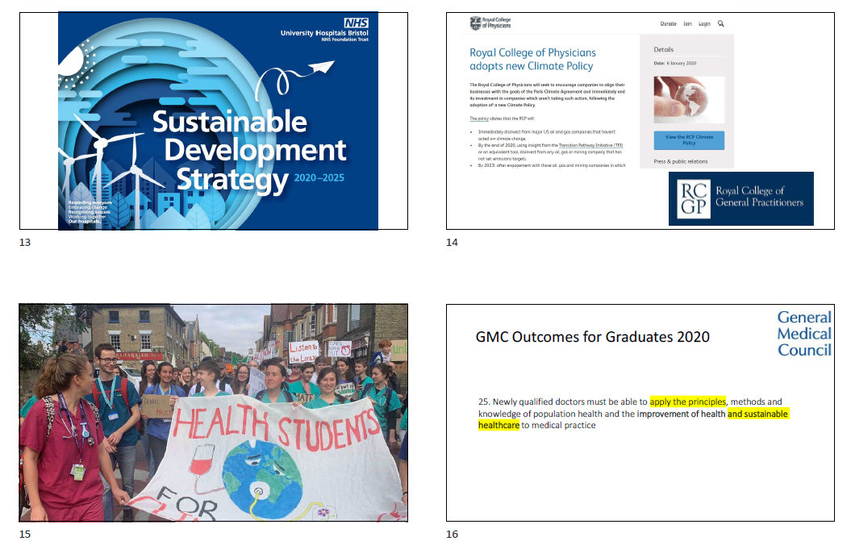
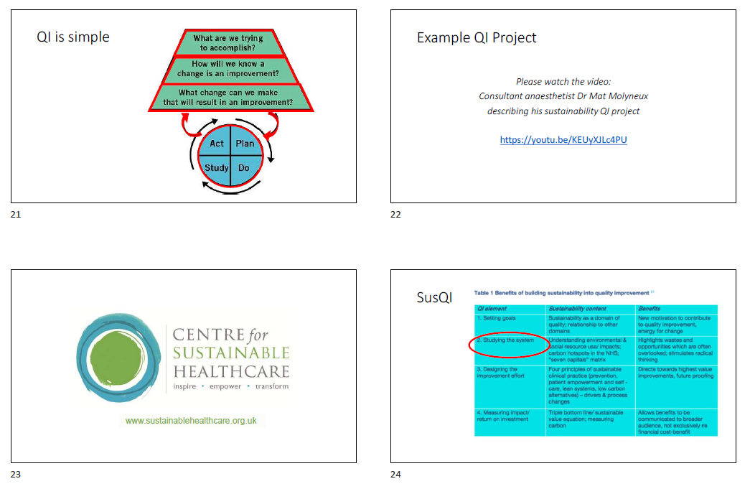
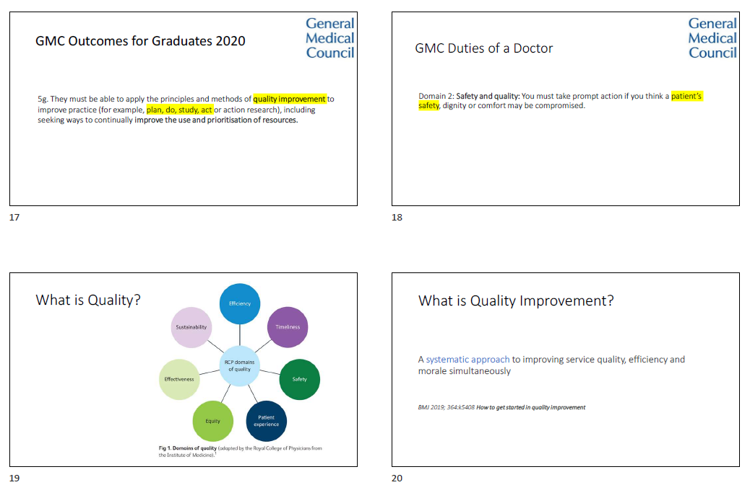
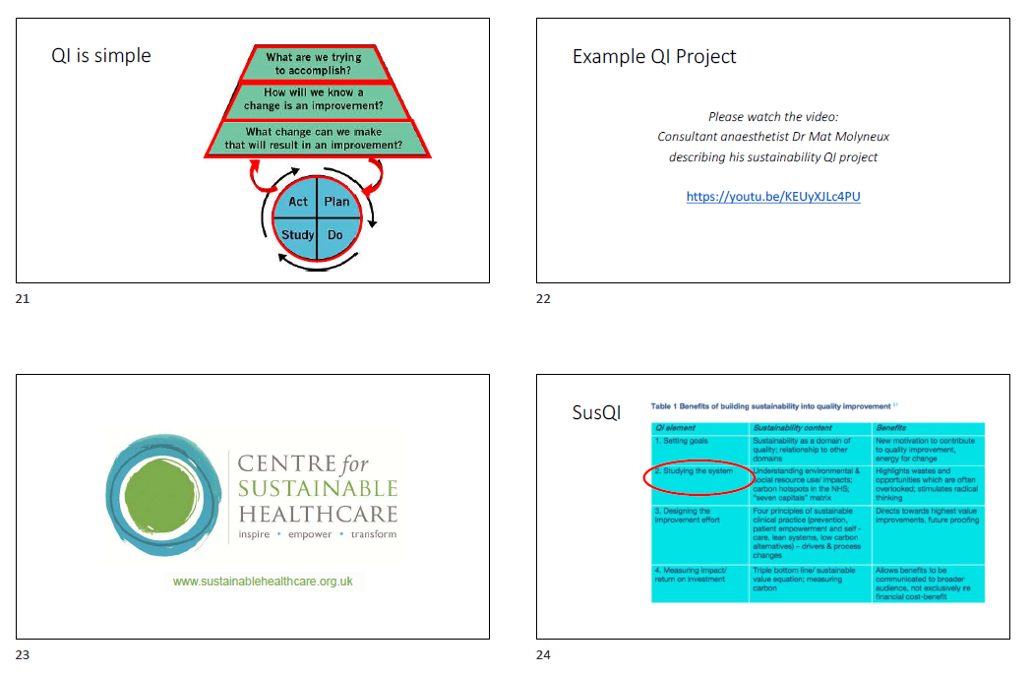
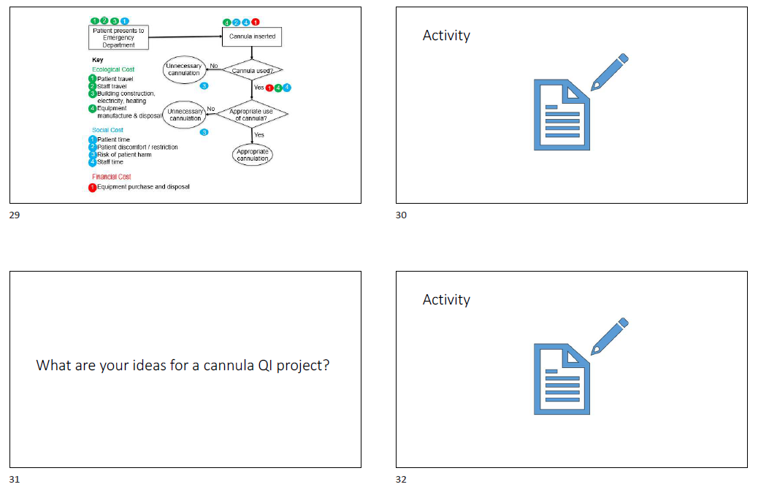
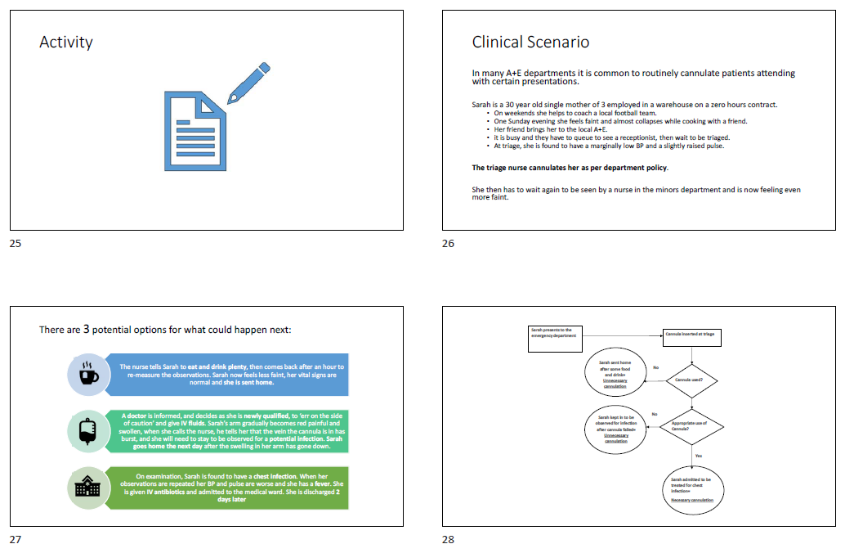

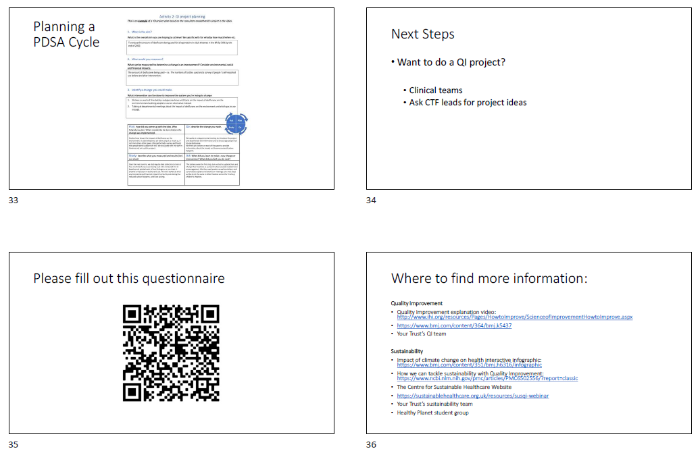

Workshop Activity 1: Consider the environmental, financial and social impacts of this cannulation pathway and then write them down next to the relevant stage of the pathway.

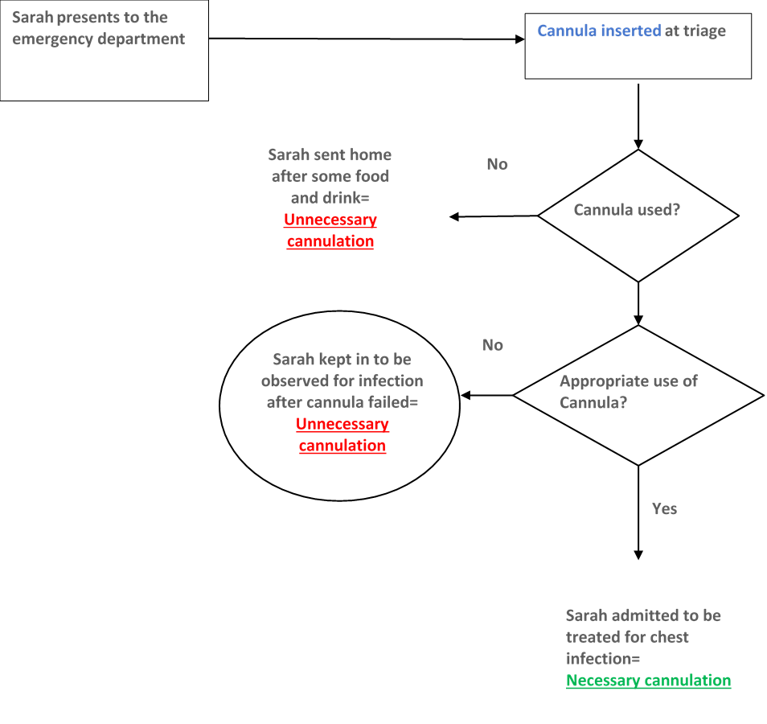
Workshop Activity 2: Using the SusQI project idea, use the following PDSA project plan template to outline your project plan
