Appendix A: Responses to Likert-type questions in the survey of trainee doctors

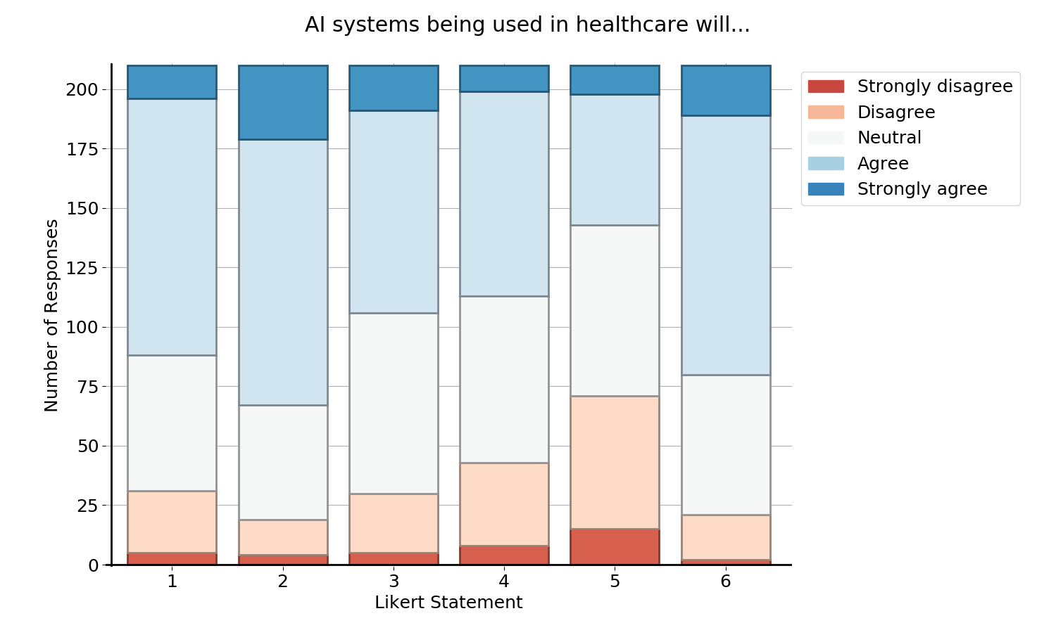
Figure 1: 'AI systems being used in healthcare will...'
Number | Likert Statement
1 | … improve my training and education.
2 | … make it easier for me to map my training curriculum.
3 | … improve my research, audit and quality improvement skills.
4 | …improve my clinical judgement/decision-making.
5 | … improve my practical skills.
6 | … will reduce my clinical workload.

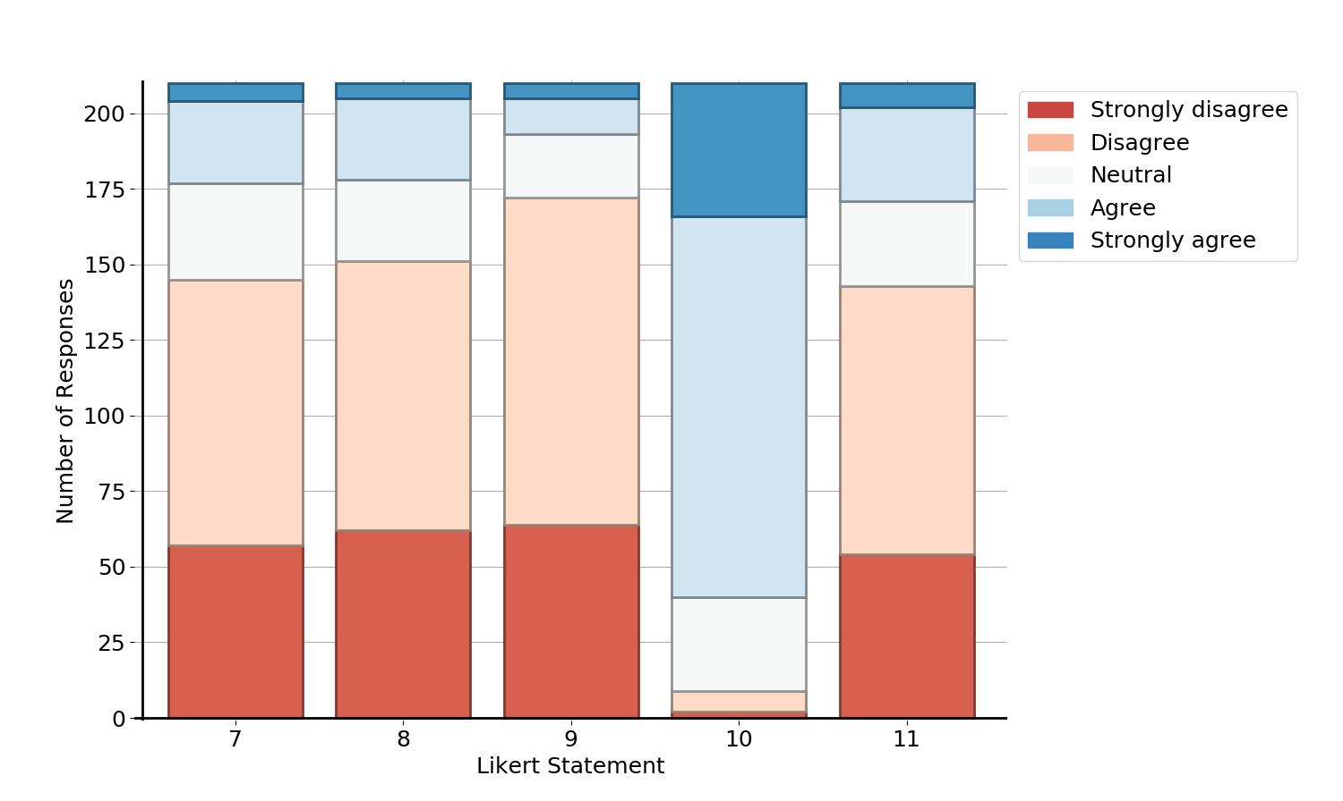
Figure 2:
Number | Likert Statement
7 | I regularly encounter AI systems in my clinical practice.
8 | I regularly encounter AI systems in my training and education.
9 | There is currently sufficient training in AI in my clinical training curriculum.
10 | More training in AI should be made available for junior doctors.
11 | I know where the responsibility lies when AI systems are used in clinical practice.

