When it’s Needed Most: A Blueprint for Resident Creative Writing Workshops during Inpatient Rotations

Lauren Michelle Edwards, MD¹; Yeuen Kim, MD¹; Matthew Stevenson, MD²; Tyler Johnson, MD³; Nora Sharp^{4,5}; Anna Reisman, MD6; Malathi Srinivasan, MD^{1,4}

- Division of Primary Care and Population Health, Stanford School of Medicine, Palo Alto, CA
- Division of Primary Care, Palo Alto Veterans Administration Hospital, Palo Alto, CA
- Division of Hematology and Oncology, Stanford School of Medicine, Palo Alto, CA
- Stanford Center for Asian Health Research and Education, Stanford School of Medicine, Palo Alto, CA
- Computational and Systems Biology Interdepartmental Program, University of California, Los Angeles, Westwood, CA
- Department of Internal Medicine (General Medicine), Yale School of Medicine, New Haven, CT

Corresponding Author Lauren Michelle Edwards, MD
Program Co-Director, Narrative Medicine
Assistant Clinical Professor
Division of Primary Care and Population Health
Stanford University School of Medicine
960 North San Antonio Road, Suite 101
Los Altos, CA 94022
Work: 650-498-9000
Mobile: 510-295-9891
laurened@stanford.edu

Author Affiliations and Contributions
Lauren Michelle Edwards, MD
Program Co-Director, Narrative Medicine
Assistant Clinical Professor
Division of Primary Care and Population Health
Stanford University School of Medicine
Contributions: program design and implementation, study design, manuscript preparation

Yeuen Kim, MD MAS
Program Co-Director, Narrative Medicine
Clinical Instructor
Division of Primary Care and Population Health
San Francisco Department of Public Health, Outbreak Management Group
Contributions: program design and implementation, study design, manuscript preparation

Matthew Stevenson, MD
Program Co-Director, Narrative Medicine
Clinical Assistant Professor
Division of Primary Care and Population Health
Palo Alto Veterans Administration Hospital
Contributions: program design and implementation, study design, manuscript preparation

Tyler Johnson, MD
Program Director, Oncology Residency Training Program
Associate Clinical Professor
Division of Hematology and Oncology
Stanford University School of Medicine
Contributions: program design and implementation, manuscript preparation

Nora Sharp
Program Administrator
Center for Asian Health Research and Education
Stanford University School of Medicine
Computational and Systems Biology Interdepartmental Program, University of California, Los Angeles
Contributions: study design, data analysis and interpretation, manuscript preparation

External Expert
Anna Reisman, MD
Professor of Medicine, Yale University School of Medicine
Director, Yale School of Medicine Program for Humanities in Medicine
Contributions: data analysis and interpretation, manuscript preparation

Malathi Srinivasan, MD
Clinical Professor of Medicine
Division of Primary Care and Population Health
Stanford University School of Medicine
Contributions: Study design, qualitative data analysis, manuscript preparation

Online Appendix A

1. Effect of Narrative Medicine workshops on Physician Wellbeing Inventory (PWBI) and PWBI items scores of residents during an inpatient oncology rotation, in control (2017-2018) and workshop implementation (2018-2019) years
 | 2017-2018 Academic Year  Without Narrative Medicine Curriculum |  |  | 2018-2019 Academic Year  With Narrative Medicine Curriculum
 | Mean Initial Weeks (SD)  N=16 | Mean Final Week (SD)  N=15 | Mean Change Between Initial and Final Weeks  (P-Value of Initial Weeks vs Final Week) | Mean Initial Weeks (SD)  N=13 ^{b} | Mean Final Week (SD)  N=24 | Mean Change Between Initial and Final Weeks  (P-Value of Initial Weeks vs Final Week) | P-Value of Mean Difference Between Control and Implementation Years
Total PWBI | 3.0 (1.1) | 3.40 (1.60) | 0.40 (0.42) | 3.08 (1.85) | 3.29 (1.57) | 0.21 (0.71) | 0.62
PWBI – Burnout | 0.81 (0.40) | 1 (0) | 0.19 (0.08) | 0.62 (0.51) | 0.83 (0.38) | 0.21 (0.15) | 0.74
PWBI – Emotional Detachment | 0.75 (0.45) | .60 (0.51) | -0.15 (0.39) | 0.62 (0.51) | 0.75 (0.44) | 0.13 (0.41) | 0.02
PWBI – Depression | 0.19 (0.40) | .33 (0.49) | 0.14 (0.37) | 0.54 (0.52) | 0.42 (0.50) | -0.12 (0.49) | 0.03
PWBI – Fatigue | 0.06 (0.25) | 0.07 (0.26) | 0.01 (0.96) | 0.15 (0.38) | 0.17 (0.38) | 0.02 (0.92) | 0.91
PWBI – Stress/Overload | 0.38 (0.50) | 0.40 (0.51) | 0.02 (0.89) | 0.38 (0.51) | 0.25 (0.44) | -0.13 (0.41) | 0.18
PWBI – Anxiety & Irritability | 0.69 (0.48) | 0.80 (0.41) | 0.11 (0.49) | 0.54 (0.52) | 0.58 (0.50) | 0.04 (0.80) | 0.57
PWBI – Physical Quality of Life  Decrease | 0.13 (0.34) | 0.20 (0.41) | 0.07 (0.59) | 0.25 ^{c} (0.45) | 0.29 (0.46) | 0.04 (0.80) | 0.75
- Residents took the PWBI survey at the beginning and end of the rotations. PWBI of 3-4 indicates a high risk for burnout, whereas PWBI of 4 or greater indicates burnout.
- One individual pre rotation, 2018-2019, did not answer for PWBI - Physical Quality of Life, and that mean is calculated out of 12 individuals
- The first survey for each person was coded as “Initial Weeks” survey if done. One individual in 2018-2019 completed their initial survey in Week 3 and second survey post-workshop in Week 3. Another individual responded in 2018-2019 completed their initial survey in Week 3 and second survey post-workshop in Week 4.
- Table includes information from all surveys from 2017-2018 and 2018-2019 with complete PWBI information for initial and final survey by medicine residents on Stanford inpatient oncology rotation.

- Effect of Narrative Medicine Curriculum on Physician Wellbeing Inventory (PWBI) scores of residents during an inpatient oncology rotation, in initial and final week paired samples for control (2017-2018) and workshop implementation (2018-2019) Years
 | 2017-2018 Academic Year  Without Narrative Medicine Curriculum |  |  | 2018-2019 Academic Year  With Narrative Medicine Curriculum
Measure | Mean Initial Week (SD)  N=5 | Mean Final Week (SD)  N=5 | Mean Change Between Initial and Final Weeks  (P-Value of Initial Weeks vs Final Week) | Mean Initial Week (SD)  N=5 | Mean Final Week (SD)  N=5 | Mean Change Between Initial and Final Weeks  (P-Value of Initial Weeks vs Final Week) | P-Value of Mean Difference Between Control and Implementation Years
Total PWBI | 2.4 (0.89) | 3.8 (0.84) | 1.4 (0.005) | 2.2 (2.17) | 2.8 (1.30) | 0.60 (0.21) | 0.22
PWBI – Burnout | 0.8 (0.45) | 1 (0) | 0.2 (0.37) | 0.60 (0.55) | 0.80 (0.45) | 0.20 (0.37) | 1
PWBI – Emotional Detachment | 1 (0) | 1 (0) | 0 (N/A) | 0.40 (0.55) | 0.40 (0.55) | 0 (N/A) | 1
PWBI – Depression | 0 (0) | 0.2 (0.45) | 0.2 (0.37) | 0.20 (0.45) | 0.40 (0.55) | 0.20 (0.37) | 1
PWBI – Fatigue | 0 (0) | 0 (0) | 0 (N/A) | 0.20 (0.45) | 0 (0) | -0.20 (0.37) | 0.06
PWBI – Stress/Overload | 0.2 (0.45) | 0.6 (0.55) | 0.4 (0.18) | 0.40 (0.55) | 0.40 (0.55) | 0 (1) | 0.11
PWBI-Anxiety and Irritability | 0.4 (0.55) | 1 (0) | 0.6 (0.07) | 0.40 (0.55) | 0.60 (0.55) | 0.20 (0.37) | 0.08
PWBI-Physical Quality of Life Decrease | 0 (0) | 0 (0) | 0 (N/A) | 0 (0) | 0.20 (0.45) | 0.20 (0.37) | 0.06
- Table includes information from surveys from 2017-2018 and 2018-2019 with complete PWBI information for paired initial and final surveys by medicine residents on Stanford inpatient oncology rotation.

3. Graphic: Effect of Narrative Medicine Curriculum on Physician Wellbeing Inventory (PWBI) scores of residents during an inpatient oncology rotation, in initial and final week paired samples for control (2017-2018) and workshop implementation (2018-2019) Years
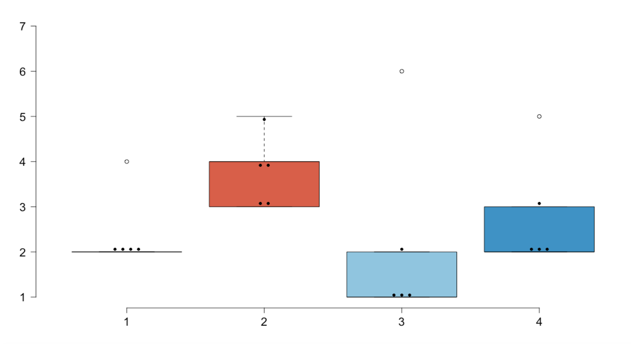
Narrative Medicine Year: 2018-2019
Control Year: 2017-2018
Final Weeks Post-Workshop n = 5 residents

Initial Weeks Pre-Workshop n = 5 residents

Initial Weeks Usual Activities n = 5 residents

Final Week Usual Activities n = 5 residents

PWBI SCORE
(3-4 = burnout risk; >4 = burnout)

