Additional files 4.

Supplementary Figure 2 Graphic display of monotonicity. One graph for each item plots the estimated item response function.
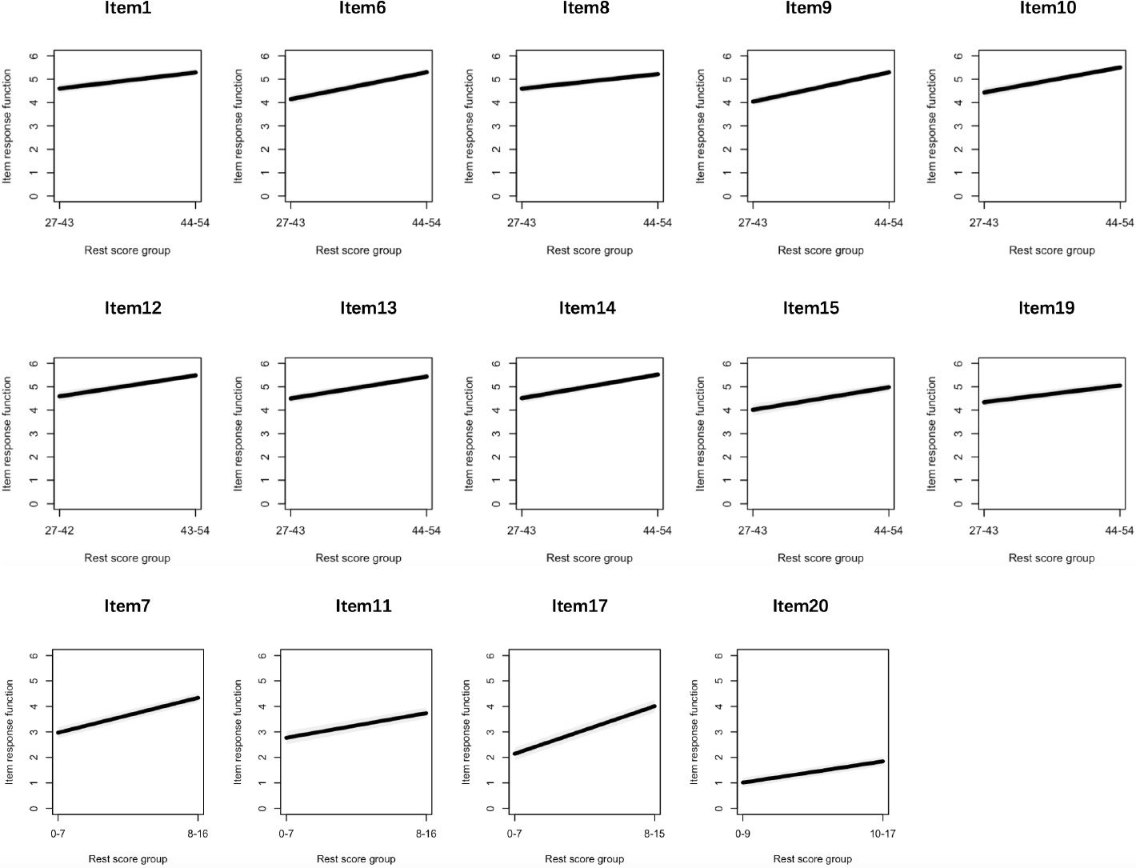

Item 1. I prefer to choose general and famous hospital（i.e. tertiary hospitals） Item 6. I prefer to work at a hospital near my hometown
Item 8. I prefer a subspecialty that will provide a high salary Item 9. I prefer a subspecialty with prestigious experts
Item 10. I prefer a subspecialty with good career prospects Item 12. I prefer an interesting subspecialty
Item 13. I prefer a subspecialty with greater job satisfaction

Item 14. I prefer a subspecialty that fits my character and work style

Item 15. I prefer a subspecialty that will have a limited effect on my leisure time Item 19. I am willing to choose a subspecialty where I can serve my relatives Item 7. I am willing to work at a hospital with greater occupational stress

Item 11. I prefer a more competitive subspecialty

Item 17. I am willing to choose a subspecialty where I will always be on-call

Item 20. I am willing to choose a subspecialty with a greater likelihood of patient-physician conflict

