Appendix

Appendix 1: The web-based questionnaire

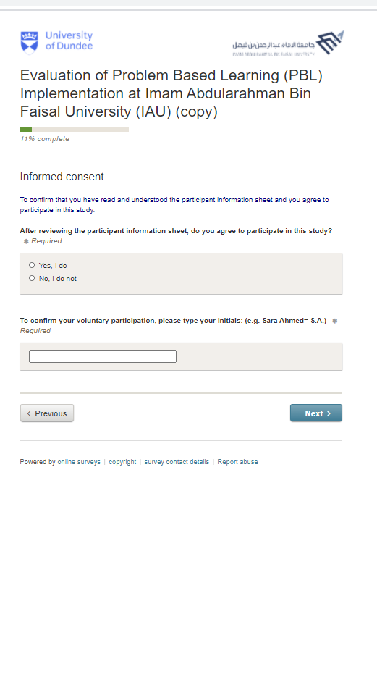
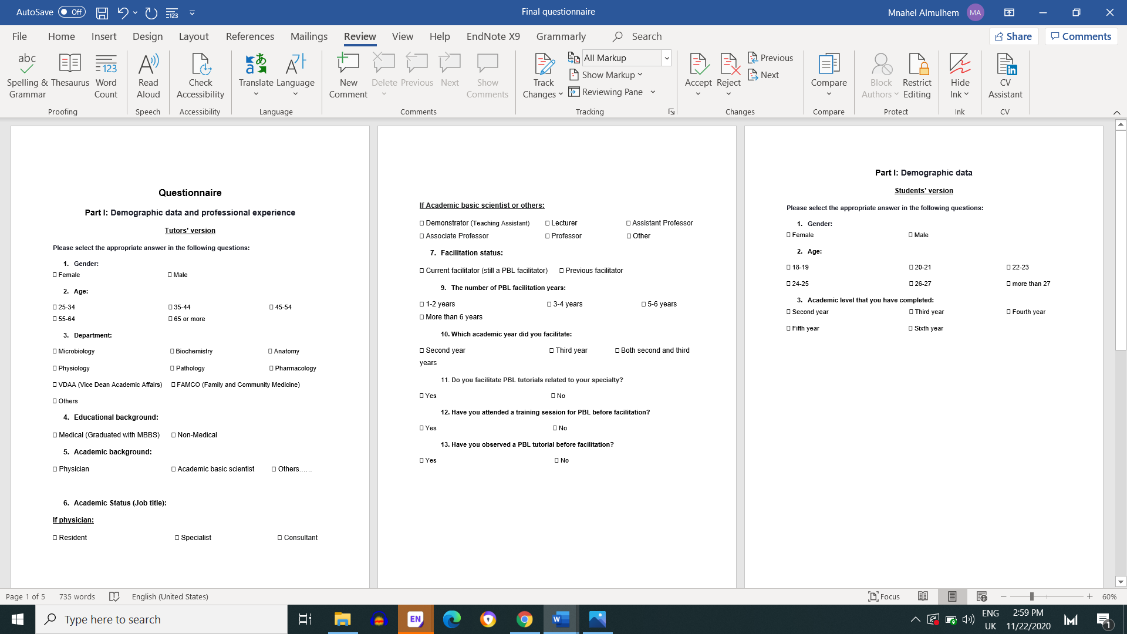

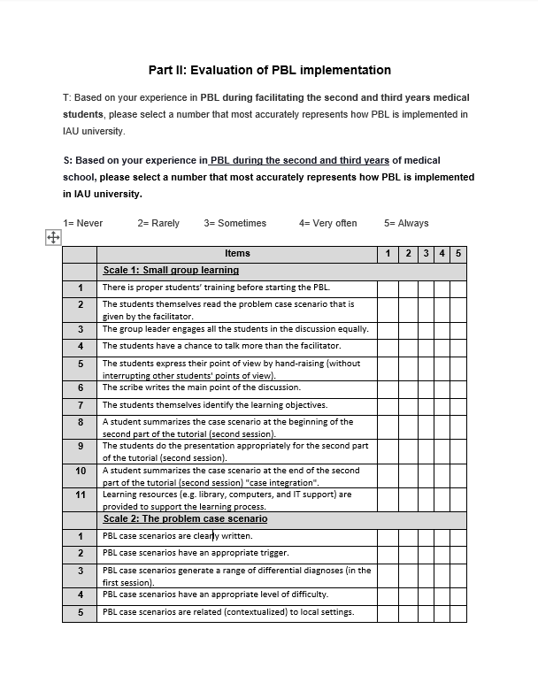

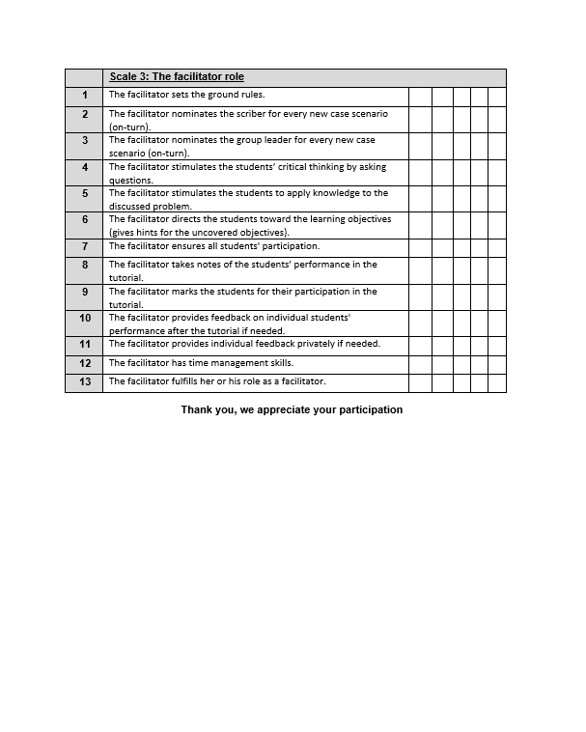

Appendix 2: The facilitators’ characteristics and the small group learning scale
T-test for the facilitators' evaluation of the small group learning scale
P | t | SD | Mean | N | Demographics
.632 | 0.482 | 4.889 | 48.42 | 24 | Female | Gender
 |  | 5.231 | 49.14 | 22 | Male | Gender
.834 | 0.211 | 5.032 | 48.73 | 44 | Medical  (Graduated with MBBS) | Educational background
 |  | 6.364 | 49.50 | 2 | Non-Medical | Educational background
.249 | 1.167 | 5.694 | 47.74 | 19 | Physician | Academic background
 |  | 4.441 | 49.48 | 27 | Academic basic scientist | Academic background
.017 | 2.485 | 3.641 | 49.79 | 34 | Current facilitator (still a PBL facilitator) | Facilitation status
 |  | 7.095 | 45.83 | 12 | Previous facilitator | Facilitation status
.237 | 1.198 | 5.039 | 49.34 | 32 | Yes | Facilitating tutorial related to the facilitators’ specialty
 |  | 4.863 | 47.43 | 14 | No | Facilitating tutorial related to the facilitators’ specialty
.029 | 2.252 | 4.500 | 49.44 | 39 | Yes | Attending training session before facilitation
 |  | 6.377 | 45.00 | 7 | No | Attending training session before facilitation
.188 | 1.338 | 4.199 | 49.21 | 38 | Yes | Observing BPL tutorial before facilitation
 |  | 7.873 | 46.63 | 8 | No | Observing BPL tutorial before facilitation

ANOVA for the facilitators' evaluation of the small group learning scale
P | F | MS | df | SS | Source | Demographics
.955 | 0.108 | 2.884 | 3 | 8.651 | Between Groups | Age
 |  | 26.708 | 42 | 1121.718 | Within Groups | Age
 |  |  | 45 | 1130.370 | Total | Age
.366 | 1.129 | 27.811 | 7 | 194.674 | Between Groups | Department
 |  | 24.624 | 38 | 935.695 | Within Groups | Department
 |  |  | 45 | 1130.370 | Total | Department
.326 | 1.197 | 29.560 | 4 | 118.241 | Between Groups | Academic status
 |  | 24.686 | 41 | 1012.129 | Within Groups | Academic status
 |  |  | 45 | 1130.370 | Total | Academic status
.475 | .848 | 21.523 | 3 | 64.570 | Between Groups | Number of facilitation years
 |  | 25.376 | 42 | 1065.800 | Within Groups | Number of facilitation years
 |  |  | 45 | 1130.370 | Total | Number of facilitation years
.357 | 1.055 | 26.430 | 2 | 52.859 | Between Groups | Academic year of facilitation
 |  | 25.058 | 43 | 1077.510 | Within Groups | Academic year of facilitation
 |  |  | 45 | 1130.370 | Total | Academic year of facilitation

Appendix 3: The facilitators’ characteristics and the problem case scenario scale
T-test for the facilitators' evaluation of the problem case scenario scale
P | t | SD | Mean | N | Demographics
.161 | 1.424 | 2.667 | 21.38 | 24 | Female | Gender
 |  | 2.686 | 22.50 | 22 | Male | Gender
.631 | .484 | 2.728 | 21.95 | 44 | Medical  (Graduated with MBBS) | Educational background
 |  | 2.828 | 21.00 | 2 | Non-Medical | Educational background
.090 | 1.736 | 3.178 | 21.11 | 19 | Physician | Academic background
 |  | 2.208 | 22.48 | 27 | Academic basic scientist | Academic background
.017 | 2.483 | 2.149 | 22.47 | 34 | Current facilitator (still a PBL facilitator) | Facilitation status
 |  | 3.525 | 20.33 | 12 | Previous facilitator | Facilitation status
.004 | 3.067 | 2.548 | 22.66 | 32 | Yes | Facilitating tutorial related to the facilitators’ specialty
 |  | 2.326 | 20.21 | 14 | No | Facilitating tutorial related to the facilitators’ specialty
.084 | 1.768 | 2.557 | 22.21 | 39 | Yes | Attending training session before facilitation
 |  | 3.147 | 20.29 | 7 | No | Attending training session before facilitation
.452 | .759 | 2.503 | 22.05 | 38 | Yes | Observing BPL tutorial before facilitation
 |  | 3.655 | 21.25 | 8 | No | Observing BPL tutorial before facilitation

ANOVA for the facilitators' evaluation of the problem case scenario scale
P | F | MS | Df | SS | Source | Demographics
.722 | 0.446 | 3.391 | 3 | 10.174 | Between Groups | Age
 |  | 7.607 | 42 | 319.478 | Within Groups | Age
 |  |  | 45 | 329.652 | Total | Age
.515 | 0.902 | 6.713 | 7 | 46.988 | Between Groups | Department
 |  | 7.439 | 38 | 282.664 | Within Groups | Department
 |  |  | 45 | 329.652 | Total | Department
.465 | 0.913 | 6.742 | 4 | 26.967 | Between Groups | Academic status
 |  | 7.383 | 41 | 302.685 | Within Groups | Academic status
 |  |  | 45 | 329.652 | Total | Academic status
.379 | 1.053 | 7.684 | 3 | 23.052 | Between Groups | Number of facilitation years
 |  | 7.300 | 42 | 306.600 | Within Groups | Number of facilitation years
 |  |  | 45 | 329.652 | Total | Number of facilitation years
.945 | .057 | .433 | 2 | .865 | Between Groups | Academic year of facilitation
 |  | 7.646 | 43 | 328.787 | Within Groups | Academic year of facilitation
 |  |  | 45 | 329.652 | Total | Academic year of facilitation

Appendix 4: The facilitators’ characteristics and the facilitator role scale
T-test for the facilitators' evaluation of the facilitator role scale
P | t | SD | Mean | N | Demographics
.909 | 0.116 | 5.790 | 59.29 | 24 | Female | Gender
 |  | 8.510 | 59.05 | 22 | Male | Gender
.716 | 0.366 | 7.239 | 59.09 | 44 | Medical  (Graduated with MBBS) | Educational background
 |  | 5.657 | 61.00 | 2 | Non-Medical | Educational background
.313 | 1.020 | 9.140 | 57.89 | 19 | Physician | Academic background
 |  | 5.320 | 60.07 | 27 | Academic basic scientist | Academic background
.224 | 1.234 | 5.438 | 59.94 | 34 | Current facilitator (still a PBL facilitator) | Facilitation status
 |  | 10.617 | 57.00 | 12 | Previous facilitator | Facilitation status
.440 | .779 | 7.726 | 59.72 | 32 | Yes | Facilitating tutorial related to the facilitators’ specialty
 |  | 5.622 | 57.93 | 14 | No | Facilitating tutorial related to the facilitators’ specialty
.875 | .158 | 7.297 | 59.10 | 39 | Yes | Attending training session before facilitation
 |  | 6.680 | 59.57 | 7 | No | Attending training session before facilitation
.152 | 1.456 | 5.194 | 59.87 | 38 | Yes | Observing BPL tutorial before facilitation
 |  | 13.032 | 55.88 | 8 | No | Observing BPL tutorial before facilitation

ANOVA for the facilitators' evaluation of the facilitator role scale
P | F | MS | df | SS | Source | Demographics
.748 | 0.409 | 21.673 | 3 | 65.019 | Between Groups | Age
 |  | 53.038 | 42 | 2227.590 | Within Groups | Age
 |  |  | 45 | 2292.609 | Total | Age
.169 | 1.586 | 74.044 | 7 | 518.311 | Between Groups | Department
 |  | 46.692 | 38 | 1774.298 | Within Groups | Department
 |  |  | 45 | 2292.609 | Total | Department
.352 | 1.138 | 57.288 | 4 | 229.152 | Between Groups | Academic status
 |  | 50.328 | 41 | 2063.456 | Within Groups | Academic status
 |  |  | 45 | 2292.609 | Total | Academic status
.388 | 1.033 | 52.492 | 3 | 157.475 | Between Groups | Number of facilitation years
 |  | 50.837 | 42 | 2135.133 | Within Groups | Number of facilitation years
 |  |  | 45 | 2292.609 | Total | Number of facilitation years
.032 | 3.727 | 169.373 | 2 | 338.745 | Between Groups | Academic year of facilitation
 |  | 45.439 | 43 | 1953.864 | Within Groups | Academic year of facilitation
 |  |  | 45 | 2292.609 | Total | Academic year of facilitation

Multiple comparisons result by type of academic year of facilitation (Tukey post-hoc test)
type of Academic year of facilitation | N | Mean | Second year | Third year | Both second and third years
Second year | 22 | 60.23 | -- | .080 | .758
Third year | 13 | 55.00 | .080 | -- | .039∗
Both second and third years | 11 | 62.00 | .758 | .039∗ | --

Appendix 5: The students’ characteristics and the small group learning scale
T-test for the student’s evaluation of the small group learning scale
P | t | SD | Mean | N | Demographics
.000 | 7.513 | 5.354 | 42.56 | 221 | Female | Gender
 |  | 7.796 | 36.97 | 103 | Male | Gender

ANOVA for the students’ evaluation of the small group learning scale
P | F | MS | df | SS | Source | Demographics
.000 | 10.183 | 416.028 | 4 | 1664.110 | Between Groups | Age
 |  | 40.857 | 319 | 13033.331 | Within Groups | Age
 |  |  | 323 | 14697.441 | Total | Age
.000 | 8.335 | 347.672 | 4 | 1390.688 | Between Groups | Academic year the student has completed
 |  | 41.714 | 319 | 13306.753 | Within Groups | Academic year the student has completed
 |  |  | 323 | 14697.441 | Total | Academic year the student has completed

Multiple comparisons table for the student’s age categories (Tukey post-hoc test)
Type of students age | N | Mean | 18-19 | 20-21 | 22-23 | 24-25 | more than 26
18-19 | 27 | 44.81 | -- | .243 | .015∗ | .000∗ | .190
20-21 | 119 | 42.02 | .243 | -- | .367 | .000∗ | .550
22-23 | 129 | 40.54 | .015∗ | .367 | -- | .001∗ | .792
24-25 | 46 | 36.17 | .000∗ | .000∗ | .001∗ | -- | 1.000
more than 26 | 3 | 36.33 | .190 | .550 | .792 | 1.000 | --

Multiple comparisons table for the student’s academic year they have completed (Tukey post-hoc test)
Type of Academic year the students have completed | N | Mean | Second-year | Third-year | Fourth-year | Fifth-year | Sixth- year
Second year | 62 | 43.44 | -- | .554 | .527 | .031∗ | .000∗
Third year | 52 | 41.60 | .554 | -- | 1.000 | .753 | .003∗
Fourth year | 72 | 41.69 | .527 | 1.000 | -- | .627 | .001∗
Fifth year | 75 | 40.20 | .031∗ | .753 | .627 | -- | .047∗
Sixth year | 63 | 37.14 | .000∗ | .003∗ | .001∗ | .047∗ | --

Appendix 6: The students’ characteristics and the problem case scenario scale
T-test for the student’s evaluation of the problem case scenario scale
P | t | SD | Mean | N | Demographics
.000 | 4.074 | 3.407 | 20.81 | 221 | Female | Gender
 |  | 4.542 | 18.96 | 103 | Male | Gender

ANOVA for the students’ evaluation of the problem case scenario scale
P | F | MS | Df | SS | Source | Demographics
.009 | 3.449 | 50.766 | 4 | 203.063 | Between Groups | Age
 |  | 14.718 | 319 | 4694.937 | Within Groups | Age
 |  |  | 323 | 4898.000 | Total | Age
.041 | 2.521 | 37.526 | 4 | 150.103 | Between Groups | Academic year the student completed
 |  | 14.884 | 319 | 4747.897 | Within Groups | Academic year the student completed
 |  |  | 323 | 4898.000 | Total | Academic year the student completed

Multiple comparisons table for the student’s age categories (Tukey post-hoc test)
Type of students age | N | Mean | 18-19 | 20-21 | 22-23 | 24-25 | more than 26
18-19 | 27 | 21.33 | -- | .893 | .721 | .023∗ | .517
20-21 | 119 | 20.59 | .893 | -- | .981 | .018∗ | .690
22-23 | 129 | 20.32 | .721 | .981 | -- | .052 | .761
24-25 | 46 | 18.52 | .023∗ | .018∗ | .052 | -- | .996
more than 26 | 3 | 17.67 | .517 | .690 | .761 | .996 | --

Multiple comparisons table for the student’s academic year they have completed (Tukey post-hoc test)
Type of Academic year the students have completed | N | Mean | Second-year | Third-year | Fourth-year | Fifth-year | Sixth- year
Second-year | 62 | 20.79 | -- | .956 | .985 | .136 | .015∗
Third year | 52 | 20.75 | .956 | -- | .968 | .173 | .023∗
Fourth year | 72 | 20.78 | .985 | .968 | -- | .126 | .012∗
Fifth year | 75 | 19.80 | .136 | .173 | .126 | -- | .286
Sixth year | 63 | 19.10 | .015∗ | .023∗ | .012∗ | .286 | --

Appendix 7: The students’ characteristics and the facilitator role scale
T-test for the student’s evaluation of the facilitator role scale
P | t | SD | Mean | N | Demographics
.000 | 5.096 | 7.526 | 53.42 | 221 | Female | Gender
 |  | 11.049 | 48.07 | 103 | Male | Gender

ANOVA for the students’ evaluation of the facilitator role scale
P | F | MS | Df | SS | Source | Demographics
.000 | 7.093 | 549.726 | 4 | 2198.905 | Between Groups | Age
 |  | 77.508 | 319 | 24724.971 | Within Groups | Age
 |  |  | 323 | 26923.877 | Total | Age
.001 | 4.652 | 371.013 | 4 | 1484.052 | Between Groups | Academic year the student completed
 |  | 79.749 | 319 | 25439.825 | Within Groups | Academic year the student completed
 |  |  | 323 | 26923.877 | Total | Academic year the student completed

Multiple comparisons table for the student’s age categories (Tukey post-hoc test)
Type of students age | N | Mean | 18-19 | 20-21 | 22-23 | 24-25 | more than 26
18-19 | 27 | 56.93 | -- | .132 | .046 | .000∗ | .996
20-21 | 119 | 52.51 | .132 | -- | .961 | .001∗ | .989
22-23 | 129 | 51.75 | .046 | .961 | -- | .003∗ | .970
24-25 | 46 | 46.28 | .000∗ | .001∗ | .003∗ | -- | .459
more than 26 | 3 | 55.00 | .996 | .989 | .970 | .459 | --

Multiple comparisons table for the student’s academic year they have completed (Tukey post-hoc test)
Type of Academic year the students have completed | N | Mean | Second-year | Third-year | Fourth-year | Fifth-year | Sixth- year
Second year | 62 | 54.77 | -- | .517 | .756 | .043 | .001∗
Third year | 52 | 52.13 | .517 | -- | .988 | .843 | .180
Fourth year | 72 | 52.93 | .756 | .988 | -- | .458 | .031∗
Fifth year | 75 | 50.48 | .043∗ | .843 | .458 | -- | .670
Sixth year | 63 | 48.44 | .001∗ | .180 | .031∗ | .670 | --

Appendix 8: Comparison between the facilitators’ and students’ evaluations
T-test to compare the facilitators' and students' evaluations of the evaluation scales
P | T | Std. Deviation | Mean | N | Participant | Scale
.000 | 7.723 | 5.012 | 48.76 | 46 | Facilitators | Small group learning
 |  | 6.746 | 40.78 | 324 | Students | Small group learning
.005 | 2.847 | 2.707 | 21.91 | 46 | Facilitators | Problem case scenario
 |  | 3.894 | 20.22 | 324 | Students | Problem case scenario
.000 | 5.312 | 7.138 | 59.17 | 46 | Facilitators | Facilitator role
 |  | 9.130 | 51.72 | 324 | Students | Facilitator role

