Supplementary Appendix

This appendix has been provided by the authors to give readers additional information about the work.
Supplement to: Wan-Ting Chen, Chung-Pei Fu, Yan-Di Chang, Yi-Chih Shiao, Po-Yi Chen, and Chih-Chia Wang. Developing an Innovative Medical Ethics and Law Curriculum—Constructing a Situation-Based, Interdisciplinary Court-Based Learning Course: A Mixed Methods Study
organization. BMC Med. Educ.

Supplementary materials
Developing an Innovative Medical Ethics and Law Curriculum—Constructing a Situation-Based, Interdisciplinary Court-Based Learning Course: A Mixed Methods Study

Wan-Ting Chenª, Chung-Pei Fu^{b}, Yan-Di Chang^{c}, Yi-Chih Shiao^{d}, Po-Yi Chen^{e}, and Chih-Chia Wang^{f}*
ªDepartment of Psychiatry, Tri-Service General Hospital and School of Medicine, National Defense Medical Center, No.325, Sec. 2, Chenggong Rd., Neihu Dist., Taipei City, 11490, Taiwan, friend1584@gmail.com; ^{b}Department of Occupational Therapy, College of Medicine, Fu Jen Catholic University, No.510, Zhongzheng Rd., Xinzhuang Dist., New Taipei City, Taiwan, cpfu0617@gmail.com; ^{c}Center of Medical Humanities Education, School of Medicine, National Defense Medical Center, No.161, Sec. 6, Minquan E. Rd., Neihu Dist., Taipei City, 11490, Taiwan, changyandi@gmail.com; ^{d}Department of Family and Community Medicine, Tri-Service General Hospital and School of Medicine, National Defense Medical Center, No.325, Sec. 2, Chenggong Rd., Neihu Dist., Taipei City, 11490, Taiwan, darthravenhugo@gmail.com; ^{e}School of Medicine, National Defense Medical Center, No.161, Sec. 6, Minquan E. Rd., Neihu Dist., Taipei City, 11490, Taiwan, 96504034@nccu.edu.tw; ^{f}Department of Family and Community Medicine, Tri-Service General Hospital and School of Medicine, National Defense Medical Center, No.325, Sec. 2, Chenggong Rd., Neihu Dist., Taipei City, 11490, Taiwan, tsghccwang@gmail.com

*Corresponding author: Chih-Chia Wang
Department of Family and Community Medicine, Tri-Service General Hospital and School of Medicine, National Defense Medical Center
No.325, Sec. 2, Chenggong Rd., Neihu Dist., Taipei City, 11490, Taiwan
Phone No: +886-2-8792-3311
Fax No: +886-2-8792-7207
Email Address: tsghccwang@gmail.com

Contents
Figure S1. Mediation process for medical disputes in the civil legal system in Taiwan ………1
Figure S2. Screening process of the students’ feedback ………………………………………2
Table S1. Evaluation form for court-based learning …………………………...………………3

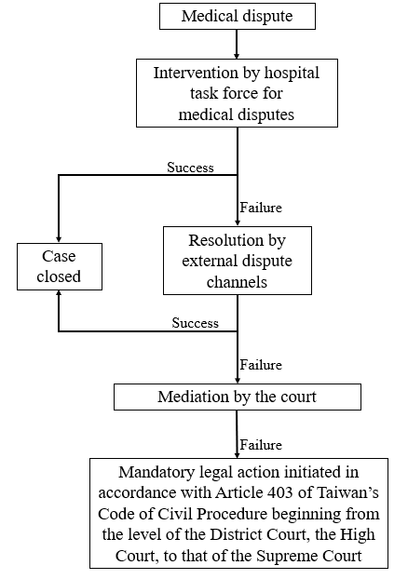
Figure S1. Mediation process for medical disputes in the civil legal system in Taiwan

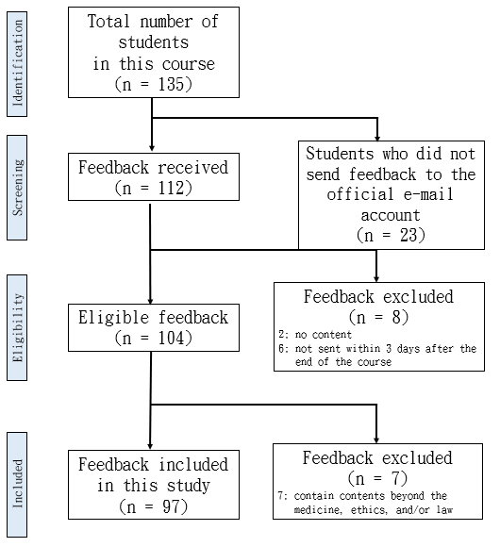
Figure S2. Screening process of the students’ feedback

Table S1. Evaluation form for court-based learning
Part 1a Self-Evaluation of Satisfaction of CBL
 | Satisfaction
 | Highly Dissatisfied | Dissatisfied | Neutral | Satisfied | Highly Satisfied
Introduction I
Introduction II (role-play)
Audit a court case
Panel discussion I (Q&A)
Panel discussion II (sharing of experience)
Part 1b Self-Evaluation of Practicality of CBL
 | Practicality
 | Not at All Useful | Not Useful | Neutral | Useful | Very Useful
Introduction I
Introduction II
(role-play)
Audit a court case
Panel discussion I (Q&A)
Panel discussion II (sharing of experience)
Part 1c Self-Evaluation of Knowledge, Attitudes, and Skills
 | Do Not Understand at All | Do Not Understand | Neutral | Understand | Completely Understand
Court operations
Medical lawsuit
Mediation

 | Strongly Disagree | Disagree | Neutral | Agree | Strongly Agree
Less worried about medical disputes
Accept the court’s ruling
Aware of potential medical disputes
Able to show empathy and apply mediation skills
More interested in medical law courses

Part 2 Please answer the following:
(1) What did you learn today?
(2) What impressed you most today?

