Supplementary Appendices

Step 1: Identifying the research question | Determination of a research question that provides breadth of coverage and serves as a roadmap for later stages.
Step 2: Identifying the relevant studies | Determination of the sources, time span, language and search terms for the literature search.
Step 3: Study Selection | Development of inclusion and exclusion criteria through an iterative process.
Step 4: Charting the Data | Development of a data charting form for extracting the relevant study information.
Step 5: Collating summarising and reporting results | Structuring and reporting the extracted data based on numerical and thematic analysis.
Step 6 (Optional): Consultation | Involvement of key stakeholders to arrive at insights beyond those in the literature e.g. students and educators

Supplementary Appendix 1: Arksey & O’Malley Framework for scoping review methodology ²⁶.

Kirkpatrick Level |  | Description
Level 1 | Participation | Covers learner’s views on the learning experience, its organization, presentation, content, teaching methods and aspects of instructional organization.
Level 2a | Attitudes/ Perceptions | Outcomes that relate to changes in the reciprocal attitudes or perceptions of participants towards the intervention.
Level 2b | Knowledge/Skills | Modification of the acquisition of concepts, procedures and principles or the acquisition of thinking/problem-solving psychomotor and social skills.
Level 3 | Behavior Change | Evidence of the transfer of learning to the workplace or willingness of learners to apply new knowledge or and skills.
Level 4a | Organizational Outcomes | Wider change in the organization or delivery of care attributable to the educational program.
Level 4b | Patient Outcomes | Any improvement in the health and well-being of patients/clients as a direct result of an educational program.

Supplementary Appendix 2: Kirkpatrick evaluation levels adopted from Yardley & Dornan (2011) ²⁸, originally based on the BEME specimen coding sheet.

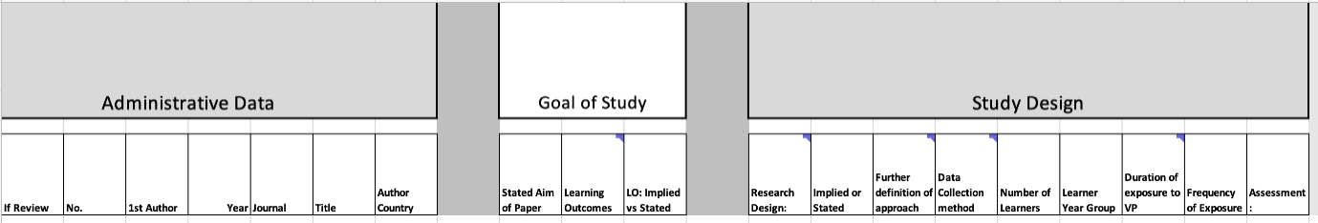

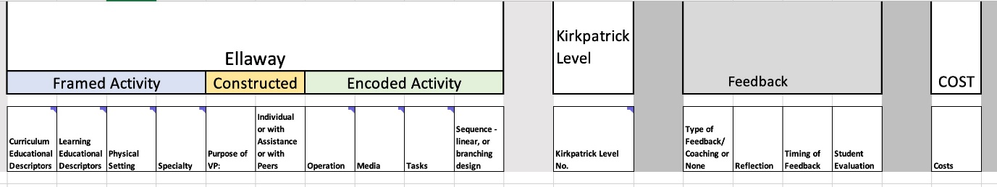

Supplementary Appendix 3: Data abstraction form.

Exclusion Criteria | No. of Records
Not English Language | n= 6
Interprofessional Education | n= 158
Patient Information/ Patient Education | n= 18
Not Healthcare related | n= 10
No Educational Intervention | n= 25
Other Healthcare Professionals (not medical) | n= 273
Social Media | n =9

Supplementary Appendix 4: Other Exclusion Criteria from PRISMA flow chart

