SUPPLEMENTARY 1: Pre- and Post-Knowledge Gain Test and Quality Impact Analysis for the iDPR Website
*Required

Student ID*:
Age*:
Gender*:
Mark only one oval.
- Male
- Female
Ethnicity*:
Mark only one oval.
- Malay
- Chinese
- Indian
- Others:
Current Year of Study*:
Mark only one oval.
- 4th Year Medical Student
- Final Year Medical Student
- Fresh Medical Graduates / BMedSc (Hons) Researchers
- Interns / House Officers (First Year)
- House Officers (Second Year)
- Other:

Pre-test Questionnaire

Interactive Digital Pathology Repository (iDPR) website is an interactive Pathology e-learning tool using 2-Dimensional and 3-Dimensional virtual images of pathological specimens annotated with interactive labels and integration of related gross pathology and histopathology information. The iDPR serves as a learning resource to reinforce pathology self-study at individual convenience (especially in the latter clinical years of medical school and also for interns / house officers). It should also offer a similar 3D learning experience as manipulating an actual specimen but without physically visiting a pathology museum. This questionnaire is designed to obtain feedback of the impact of iDPR on your pathology learning gains – if any – and to establish its usability as an e-learning tool. All information will be treated anonymously. Thank you for taking part in this survey.

Please select the most appropriate response.

Figure 1
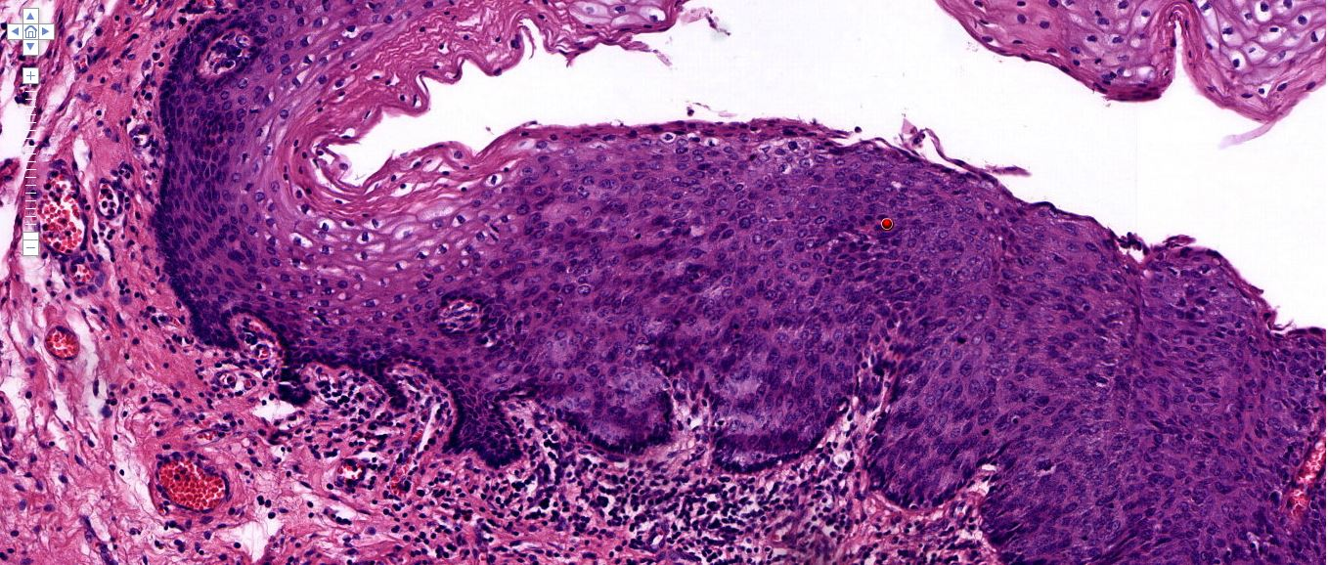

Question 1: Figure 1 shows a biopsy of the cervix. What is the grading and report based on the red label on the histopathology slide shown in Figure 1? *
Mark only one oval.
o Normal epithelium with HPV changes
o Mild squamous dysplasia (CIN 1) / Low grade squamous intraepithelial lesion
o HPV related changes (CIN 1) / Low grade squamous intraepithelial lesion
o Moderate squamous dysplasia (CIN 2) / High grade squamous intraepithelial lesion
o Severe squamous dysplasia (CIN 3) / High grade squamous intraepithelial lesion

Figure 2
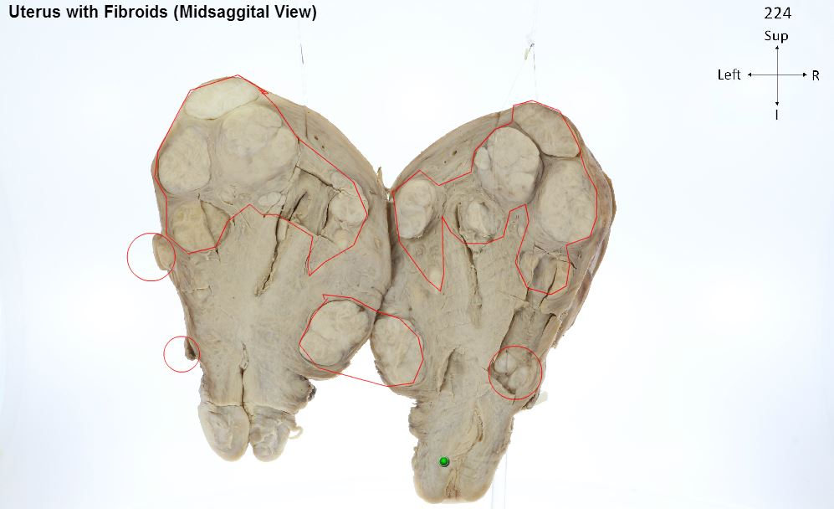

Question 2: Figure 2 shows uterus with fibroids. The fibroids are located _________. *
Mark only one oval.
o Intramural and submucosal
o Intramural and subserosal
o Intramural, submucosal and subserosal
o Submucosal, subserosal and extramural
o Intramural, submucosal, subserosal, extramural and intraluminal

Figure 3
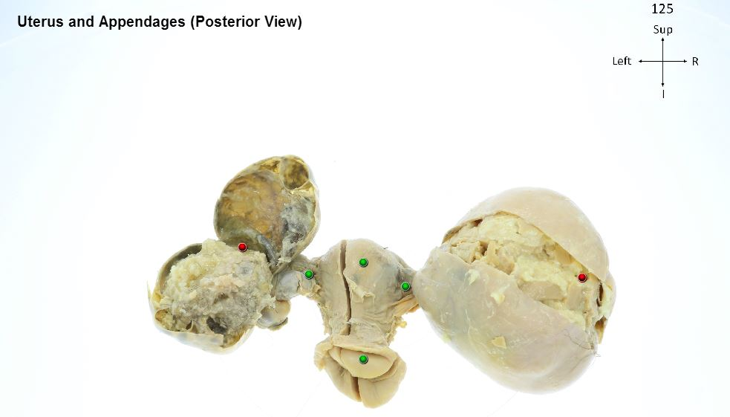
Question 3: Figure 3 shows uterus and both appendages. What is the pathological finding seen in Figure 3? *
Mark only one oval.
o Bilateral ovarian mature cystic teratoma (dermoid cyst)
o Endometriosis
o Bilateral mucinous ovarian carcinoma
o Bilateral clear cell carcinoma of the ovaries
o Polycystic ovary syndrome

Question 4: In a mature cystic teratoma, there is a predominance of ectodermal derivatives. Which of the following are derived from ectoderm? *
Mark only one oval.
o Smooth muscle, bone, teeth, cartilage, fat, gonads and dermis of skin
o Respiratory and gastrointestinal epithelium
o Thyroid and salivary gland tissue
o Keratinized epidermis, sebaceous and sweat glands, and hair follicles

Please explore the iDPR website and please return to complete the remaining part of this form
Kindly please use Google Chrome when exploring the iDPR website: www.i-dpr.com
Passwords for each module:
1. Cervix - Poorly differentiated squamous cell carcinoma:
2. Uterus - Leiomyomas (Fibroids):
3. Ovary - Mature Cystic Teratoma:
The password for the last module 4. Abnormalities of Placental Implantation: Placenta Accreta will be given at the end of the post-test questionnaire.
Thank you and hope you enjoy exploring the iDPR website.
Kindly please return to complete the remaining part of this once you have finished the aforementioned modules.

Post-test Questionnaire and Quality Impact Analysis for the iDPR Website

Please give your responses in relation to your recent experience with the iDPR website.

 | Please as appropriate
 | Strongly  Agree | Agree | Neutral | Disagree | Strongly  Disagree | Not  applicable
- The material used in this website is accurate and current to prepare you for rotation/posting in Obstetrics and Gynaecology.*
- The content is in concordance with the MBBS syllabus.*
- The content is written in a comprehensible way.*
- The content is written in an interesting way.*
- The 2D photographic images of gross pathology helped me comprehend pathology better than the traditional textbook learning.*
- The 3D photographic images of gross pathology helped me comprehend pathology better than the traditional textbook learning.*
- The scanned slide images of histopathology helped me comprehend pathology better than the traditional microscopy.*
- The links to other useful resources on the web are useful in learning pathology.*
- The 2D high resolution photographic images of gross pathology assist in my learning.*
- The 3D high resolution photographic images of gross pathology assist in my learning.*
- The high resolution scanned slide images of histopathology helped me comprehend pathology better than the traditional microscopy.*
- The layout of topics and subtopics in the iDPR websites are well structured.*
- The user interface of the iDPR website is intuitive.*
- The graphics and fonts (style, colour and saturation) for texts are legible and easy to read.*
- The participants can choose easily what parts they want to access, the order and studying pace.*
- The participants always know where they are in the iDPR website.*
- The iDPR website is more convenient than handling real specimens and slides on microscopes.*
- The iDPR website is easily accessible to a certain extent.*
- The pages and other components of the iDPR website download quickly.*
- The iDPR website is free from technical problems (hyperlink errors, programming errors, etc.).*
- The iDPR website uses high resolution images, high yield notes and evidence-based clinical decision support to gain the attention and maintain motivation of the participants.*
- The iDPR website provides access to a range of resources (web-links, evidence-based clinical decision support) appropriate to the learning context and for use in the real world.*
- The iDPR website engages participants in tasks that are closely aligned with the learning goals and objectives of the rotation/posting in Obstetrics and Gynaecology.*
- The iDPR website assists in highlighting and learning critical concepts.*
- The iDPR website incorporates novel characteristics.*
- The iDPR website stimulates further enquiry.*
- The iDPR website is enjoyable.*
- The iDPR website meets the learning needs of the participant.*
- The iDPR website provides participants opportunities to use the knowledge gained in the clinical setting.*
- Overall, taking all aspects into consideration, the iDPR website is effective in learning pathology for medical students and interns.*

Please comment on any suggestions or improvements for the iDPR or its future websites:

Post-test Questionnaire

Figure 1
Question 1: Figure 1 shows uterus and both appendages. What is the pathological finding seen in Figure 1? *
Mark only one oval.
  - Bilateral ovarian mature cystic teratoma (dermoid cyst)
  - Endometriosis
  - Bilateral mucinous ovarian carcinoma
  - Bilateral clear cell carcinoma of the ovaries
  - Polycystic ovary syndrome

Question 2: In a mature cystic teratoma, there is a predominance of ectodermal derivatives. Which of the following are derived from ectoderm? *
Mark only one oval.
  - Smooth muscle, bone, teeth, cartilage, fat, gonads and dermis of skin
  - Respiratory and gastrointestinal epithelium
  - Thyroid and salivary gland tissue
  - Keratinized epidermis, sebaceous and sweat glands, and hair follicles

Figure 3
Question 3: Figure 3 shows uterus with fibroids. The fibroids are located _________. *
Mark only one oval.
  - Intramural and submucosal
  - Intramural and subserosal
  - Intramural, submucosal and subserosal
  - Submucosal, subserosal and extramural
  - Intramural, submucosal, subserosal, extramural and intraluminal

Figure 4

Question 4: Figure 4 shows a biopsy of the cervix. What is the grading and report based on the red label on the histopathology slide shown in Figure 4? *
Mark only one oval.
  - Normal epithelium with HPV changes
  - Mild squamous dysplasia (CIN 1) / Low grade squamous intraepithelial lesion
  - HPV related changes (CIN 1) / Low grade squamous intraepithelial lesion
  - Moderate squamous dysplasia (CIN 2) / High grade squamous intraepithelial lesion
  - Severe squamous dysplasia (CIN 3) / High grade squamous intraepithelial lesion

Thank you for your kind participation and feedback.

As promised, the password to the last module: 4. Abnormalities of Placental Implantation: Placenta Accreta is . Many thanks for taking your kind participation and feedback. I sincerely hope you have benefited from my humble modules on the iDPR website. I wish you all the best in your future endeavours and keep in touch. Lastly, I would to remind you of A/P Dr Khoo JJ's quote: "Pathology is the basis of medicine." Thank you.

Sincerely,
Ken Wan

Due acknowledgement are given to the following sources (Adapted from):
- Zaharias P. A usability evaluation method for e-learning courses. Unpublished PhD Thesis, Athens University of Economics and Business, Greece. 2004.
- Balaban I, Bubas G, Pipan M. Key elements of an e-learning course evaluation survey: An empirical validation. InInteractive Collaborative Learning (ICL), 2011 14th International Conference on 2011 Sep 21 (pp. 336-343). IEEE.
- Questionnaire used by students to determine if they would find an educational package on posterior neck useful and, if so, what features should be included from the journal article: Pearce M, Evans D. Students developing resources for students. The Clinical Teacher, 2012, Vol.9(3), pp.178-182 [Peer Reviewed Journal].
- Hamilton PW, Wang Y, McCullough SJ. Virtual microscopy and digital pathology in training and education. Apmis. 2012 Apr 1;120(4):305-15.
- Appendix B (Questionnaire 2: Survey distributed to Medical Students), Payne KF, Wharrad H, Watts K. Smartphone and medical related App use among medical students and junior doctors in the United Kingdom (UK): a regional survey. BMC medical informatics and decision making. 2012 Oct 30;12(1):121.

Powered by


