
Department of Ophthalmology
Director: Prof. Dr. T. Kohnen

Study Center Retina, House 8b
Prof. Dr. F. Koch/ Dr. S. Deuchler

Tel. 069/6301-5689/-6459
Fax: 069/6301-5621

Title of the Study
Evaluation of the efficiency of microsurgical simulation training in the context of student training
Trainee Nr.: ……………………………………..
Before training with Eyesi Surgical:
 | Rating
On a scale from 0 (very bad) to 10 (very good): how would you rate your ophthalmological knowledge? | 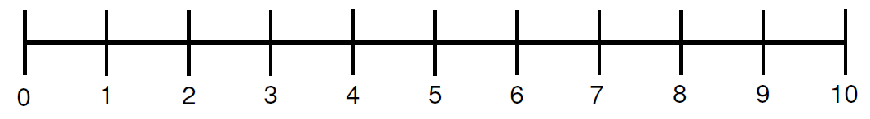

Rating
On a scale from 0 (not interested) to 10 (very interested): how would you rate your interest in ophthalmology?

Rating
How do you assess the relevance of ophthalmological disease for your later work (0 irrelevant, 10 very relevant)?

Rating
On a scale from 0 (very bad) to 10 (very good): how would you rate your microsurgical skills?

Which medical discipline would you like to specialize in?

Thank you for your participation!
Department of Ophthalmology
Director: Prof. Dr. T. Kohnen

Study Center Retina, House 8b
Prof. Dr. F. Koch/ Dr. S. Deuchler

Tel. 069/6301-5689/-6459
Fax: 069/6301-5621

Title of the Study
Evaluation of the efficiency of microsurgical simulation training in the context of student training
Trainee Nr.: ……………………………………..
After training with Eyesi Surgical:
Rating
On a scale from 0 (very bad) to 10 (very good): how would you rate your microsurgical skills?

 | Strongly Disagree  (1) | Disagree  (2) | Somewhat Disagree  (3) | Neither Agree nor Disagree  (4) | Somewhat Agree  (5) | Agree  (6) | Strongly Agree  (7)
Training with Eyesi Surgical has changed the self-assessment of my microsurgical skills.
The training with Eyesi Surgical has confirmed the self-assessment of my microsurgical skills.
Ophthalmology surgical training with the Eyesi Surgical is a useful part of the ophthalmology clerkship.

Thank you for your participation!

