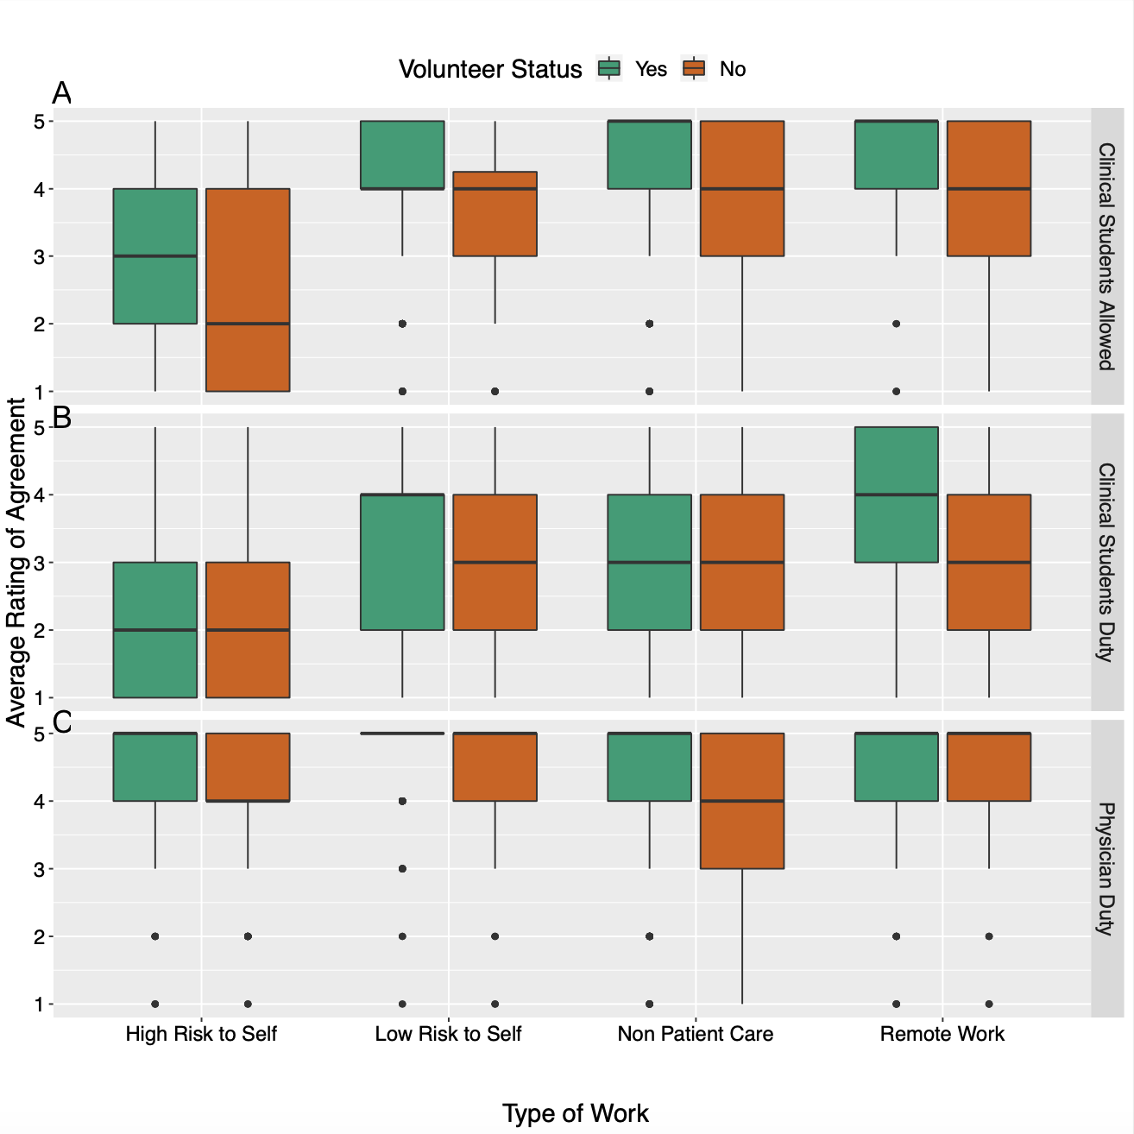

Supplemental Figure 3. Box and whisker plots of medical students’ median rating of agreement with working in various risk settings during a pandemic based on stage of medical training (A-C). Stratified by whether or not student volunteered during COVID-19 pandemic. Likert scale with 1 representing strongly disagreeing and 5 representing strongly agreeing with working in various risk settings. A. Should Clinical students be allowed to work in these settings? B. Do clinical students have a duty to work in these settings? C. Do physicians have a duty to work in these settings?

