Table S1: Domain knowledge's questionnaire
Q1.- Which is the presumptive lesion inside the green box in photograph #1?
Ulcer | Figure S1: Hematoma image
Papule
Vesicle
Macular lesion
Hematoma
Q2.-What is the presumptive diagnosis based on the lesion located inside the green box in photograph #2?
Lichen planus | Figure S2: Oral carcinoma image
Candidiasis
Oral carcinoma
Cheilitis
White sponge nevus
Q3.- What is the presumptive diagnosis based on the lesion located inside the green box in photograph #3?
Verrucous carcinoma | Figure S3: Verrucous carcinoma image
Behcet's síndrome
Lichen planus
Cheilitis
Wegener's granulomatosis
Q4.- What is the presumptive diagnosis based on the lesion located inside the green box in photograph #4?
Verrucous carcinoma  Behcet's syndrome  Fibrous hyperplasia  Cheilitis  Wegener's granulomatosis | Figure S4: Oral fibrous hyperplasia image
Q5.- What is the most common feature in patients with initial oral cancer?
Profuse salivation
Painless ulcer
Hard nodule
Intense pain
Cryptogenic fever
Q6.- What is the most frequent anatomical region of oral cancer presentation?
Tongue
Palate
Maxillary bones
Superior lip
Salivary glands
Q7.- What is the most common type of oral cancer?
Lymphoma
Squamous cell carcinoma
Kaposi's sarcoma
Salivary gland adenoma
Verrucous carcinoma
Q8.- What is the age group with the higher prevalence of oral cancer?
< 5 years
6-14 years
15-24 years
25-60 years
≥ 61 years
Q9.- What are the main characteristics of the cervical lymph nodes in a patient with oral cancer and metastasis?
Hard, painful and movable
Hard, painless, and movable or fixed
Soft, painful, and movable
Soft, painless, and movable or fixed
Soft, painful, fixed
Q10.- What is the gold standard study for oral cancer diagnosis?
Flow cytometry
Pipecolinic acid quantification
VELscope
Orascoptic DK
Histopathological study of oral biopsy
Q11.- All the following are risk factors for oral cancer, EXCEPT:
Previous diagnoses of another cancer
Low consumption of fruits and vegetables
Unprotected oral sex
Tooth infection
Smoking
Q12.- Which elements must the dentist palp during the physical examination of oral cancer?
Preauricular, retroauricular, and occipital ganglion chains
Sinuses
Endoperiodontal lesion
Periodontal probing
Maxillary sinuses
Q13.- Which of the following are preventive habits against oral cancer?
Electronic cigarette consumption
Daily flossing
Use of mouthwashes with benzydamide
Fruit and vegetable consumption
Tooth brushing 3 times a day

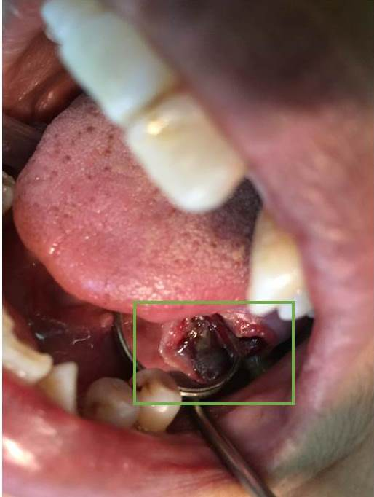
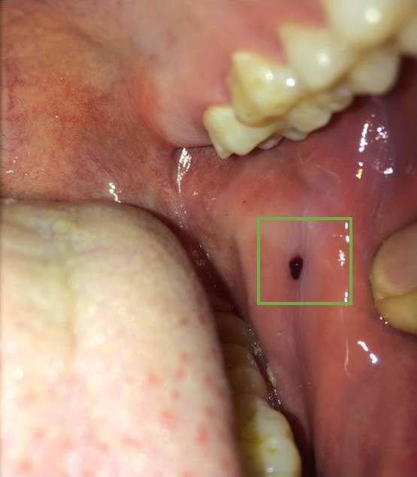

Figure S1: Hematoma image Figure S2: Oral carcinoma image

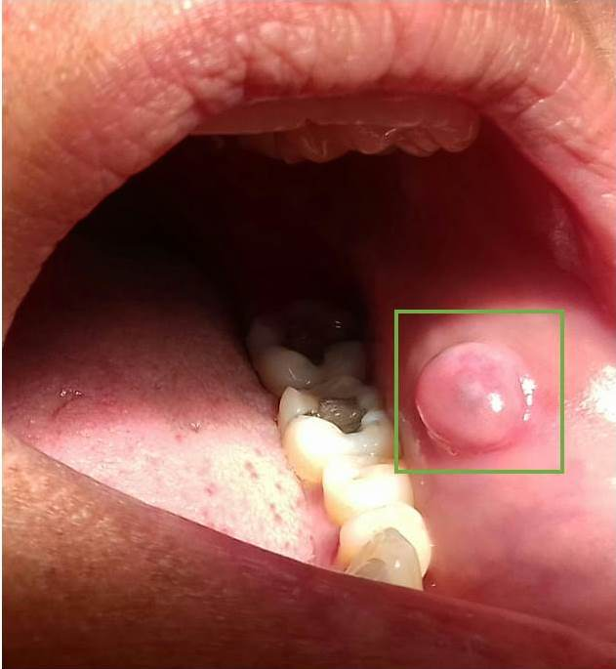
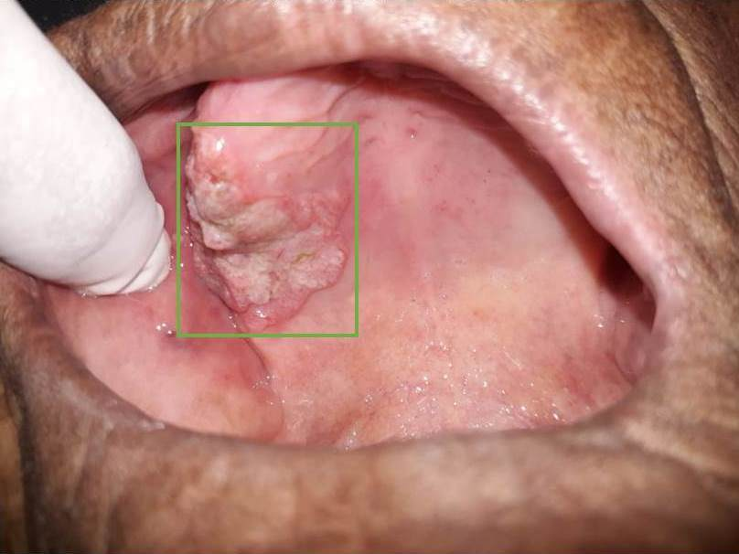

Figure S3: Verrucous carcinoma image Figure S4: Oral fibrous hyperplasia image

