Supplement 1. Course sequence, adapted from Greim et al. [37]
9.00–9.30 a.m. | Welcome and presentation of the program, including learning goals
9.30–10.00 a.m. | Technical, anatomic, and functional basics
10.00–10.30 a.m. | Standard sections and settings options
10.30–11.00 a.m. | Live ultrsound and knobology
11.00 a.m.–1 p.m. | Practice cycle 1
1.00–1.30 p.m. | Lunch break
1.30– | Right ventricular and left ventricular function (overview)
–2.15 p.m. | Pathologies + use of ultrasound in resuscitation
2.15–2.30 p.m. | Break
2.30–4.30 p.m. | Practice cycle 2
4.30–4.45 p.m. | Break
4.45–5.30 p.m. | Documentation with quiz
5.30 p.m. | End of course, farewell, certificates
Practical time: 240 min = 5.33 teaching units; theory: 210 min = 4,66 teaching units

Supplement 2. Rotation plan for the practice group. MAPSE, mitral annular plane systolic excursion; TAPSE, tricuspid annular plane systolic excursion; EPSS, mitral valve E-point to septal separation.

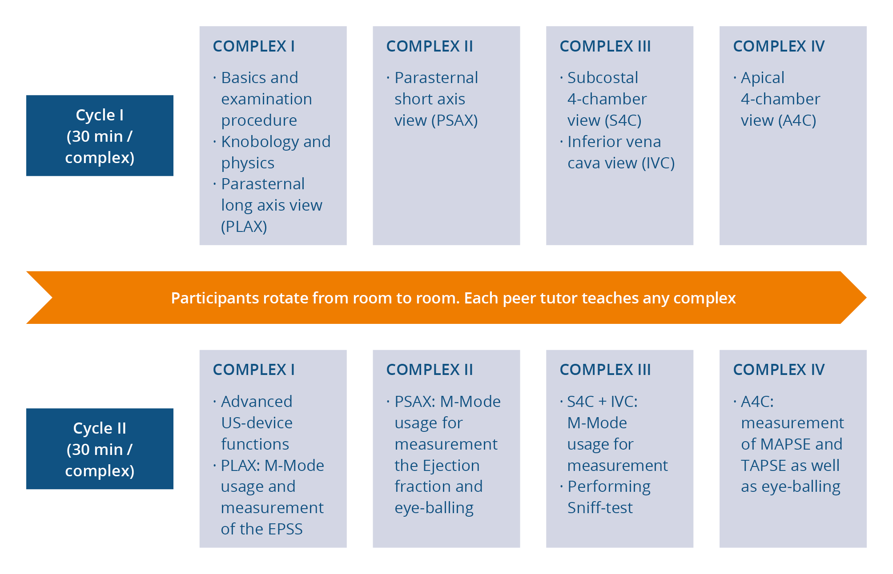

Supplement 3. Excerpt from the test sections on “figural intelligence” and “technical knowledge.”

