Regression results
The figure A1 below shows the Box plot for all variables used in the regression models. As shown in the figure below, there was a presence of mild outliers denoted with a circle. These were considered mild and were not removed from the data set. The assumption of normality was confirmed by virtually assessing residual statistics which indicated that a critical chi-square value for Mahalanobis distance was not exceeded in relation to the number of independent variables used. See the residual Table A1 below.
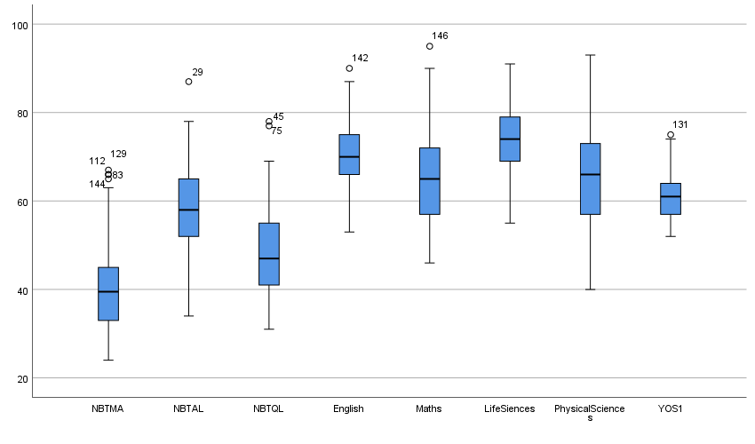
Figure A1: Boxplot for all variables

Table A1. Residuals Statistics

Residuals Statistics
 | Minimum | Maximum | Mean | Std. Deviation | N
Predicted Value | 54.69 | 68.58 | 61.08 | 2.859 | 146
Std. Predicted Value | -2.234 | 2.627 | .000 | 1.000 | 146
Standard Error of Predicted Value | .486 | 1.603 | .896 | .215 | 146
Adjusted Predicted Value | 54.52 | 69.10 | 61.07 | 2.900 | 146
Residual | -9.437 | 10.692 | .000 | 3.841 | 146
Std. Residual | -2.397 | 2.715 | .000 | .976 | 146
Stud. Residual | -2.575 | 2.793 | .000 | 1.005 | 146
Deleted Residual | -10.894 | 11.312 | .003 | 4.077 | 146
Stud. Deleted Residual | -2.630 | 2.865 | .001 | 1.012 | 146
Mahal. Distance | 1.215 | 23.046 | 6.952 | 3.819 | 146
Cook's Distance | .000 | .128 | .008 | .015 | 146
Centered Leverage Value | .008 | .159 | .048 | .026 | 146
a. Dependent Variable: YOS1

The assumption of normally distributed residuals was tested further with the Normal probability plot of regression standardised residual. As shown in Figure A2 below, the points are clustered along the diagonal line indicating that residuals are normally distributed.
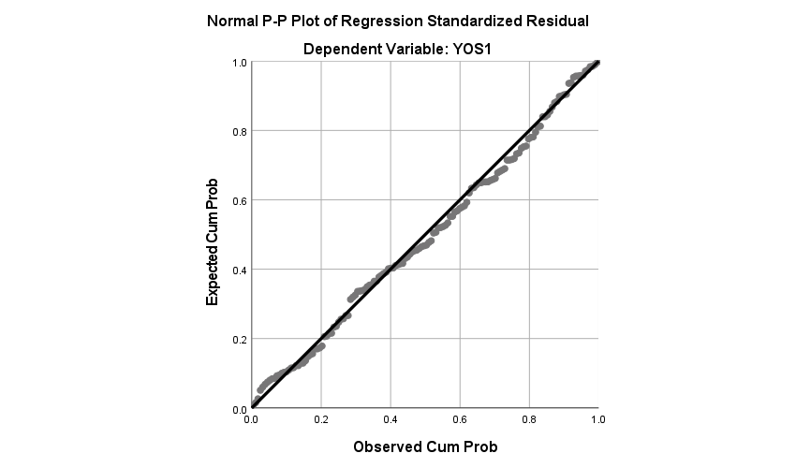
Figure A2: Normal probability plots

The assumption of normality, linearity, and homoscedasticity was not violated. As demonstrated in Figure A3, the scatterplot of standardised residuals against standardised predicted values below indicated an even spread of points which confirms that the assumption was not violated.

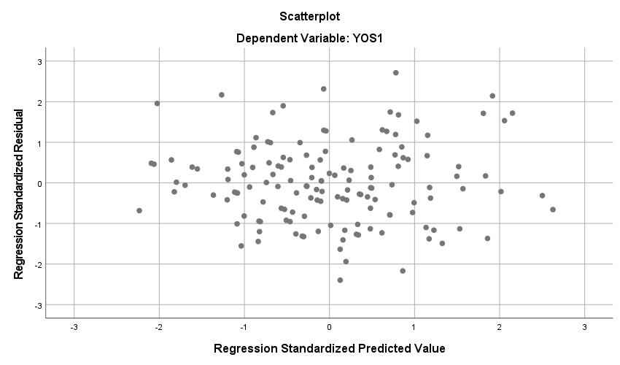
Figure A3: Scatterplot

The Table A2 below shows the r² coefficient for two blocks as reported on lines 242-252. In addition, the r² change is shown when the other set of variables were added in the model is shown.

Table A2: Model summary

Model Summary^{c}
Model | R | R Square | Adjusted R Square | Std. Error of the Estimate | Change Statistics
 |  |  |  |  | R Square Change | F Change | df1 | df2 | Sig. F Change
1 | .426ª | .181 | .164 | 4.377 | .181 | 10.493 | 3 | 142 | .000
2 | .597^{b} | .356 | .324 | 3.937 | .175 | 9.381 | 4 | 138 | .000
a. Predictors: (Constant), NBTQL, NBTMA, NBTAL
b. Predictors: (Constant), NBTQL, NBTMA, NBTAL, English, LifeSiences, PhysicalSciences, Maths
c. Dependent Variable: YOS1

The ANOVA test in Table A3 below shows the model's predictive utility and that the r² coefficient departs significantly from zero. From the r² change of this model, we can assume that the predicting variables explained a statistically significant variance in the outcome variable.

Table A3: ANOVA
ANOVAª
Model |  | Sum of Squares | df | Mean Square | F | Sig.
1 | Regression | 603.176 | 3 | 201.059 | 10.493 | .000^{b}
1 | Residual | 2720.996 | 142 | 19.162
1 | Total | 3324.171 | 145
2 | Regression | 1184.854 | 7 | 169.265 | 10.919 | .000^{c}
2 | Residual | 2139.317 | 138 | 15.502
2 | Total | 3324.171 | 145
a. Dependent Variable: YOS1
b. Predictors: (Constant), NBTQL, NBTMA, NBTAL
c. Predictors: (Constant), NBTQL, NBTMA, NBTAL, English, LifeSiences, PhysicalSciences, Maths

In Table A4 below, the unique contribution of each variable in the model is explained, Futhermore, Table A4 provides information about which variables were significant. The B weights represent the expected change in the criterion as a result of one unity change in the other predictor. The Beta values reflect the anticipated change in the standard deviation in the criterion associated with a 1 SD change in the relevant predictor while taking other predictors into account.

Table A4. Coefficients
Coefficients
Model |  | Unstandardised Coefficients |  | Standardised Coefficients | t | Sig. | 95,0% Confidence Interval for B |  | Correlations |  |  | Collinearity Statistics
 |  | B | Std. Error | Beta | t | Sig. | Lower Bound | Upper Bound | Zero-order | Partial | Part | Tolerance | VIF
1 | (Constant) | 46.416 | 3.153 |  | 14.724 | .000 | 40.184 | 52.648
1 | NBTMA | .176 | .042 | .333 | 4.238 | .000 | .094 | .258 | .252 | .335 | .322 | .934 | 1.071
1 | NBTAL | .182 | .040 | .362 | 4.513 | .000 | .102 | .262 | .272 | .354 | .343 | .894 | 1.118
1 | NBTQL | -.061 | .038 | -.128 | -1.599 | .112 | -.137 | .015 | .008 | -.133 | -.121 | .905 | 1.105
2 | (Constant) | 26.340 | 4.687 |  | 5.619 | .000 | 17.072 | 35.608
2 | NBTMA | .116 | .041 | .220 | 2.835 | .005 | .035 | .197 | .252 | .235 | .194 | .777 | 1.287
2 | NBTAL | .173 | .040 | .345 | 4.300 | .000 | .094 | .253 | .272 | .344 | .294 | .726 | 1.378
2 | NBTQL | -.055 | .036 | -.114 | -1.537 | .127 | -.125 | .016 | .008 | -.130 | -.105 | .851 | 1.175
2 | English | .092 | .053 | .133 | 1.724 | .087 | -.013 | .197 | .330 | .145 | .118 | .781 | 1.281
2 | Maths | .004 | .054 | .009 | .078 | .938 | -.103 | .112 | .219 | .007 | .005 | .392 | 2.552
2 | LifeSiences | .150 | .055 | .236 | 2.712 | .008 | .041 | .259 | .432 | .225 | .185 | .616 | 1.624
2 | PhysicalSciences | .076 | .045 | .178 | 1.669 | .097 | -.014 | .166 | .339 | .141 | .114 | .409 | 2.445
a. Dependent Variable: YOS1

