Supplementary figure
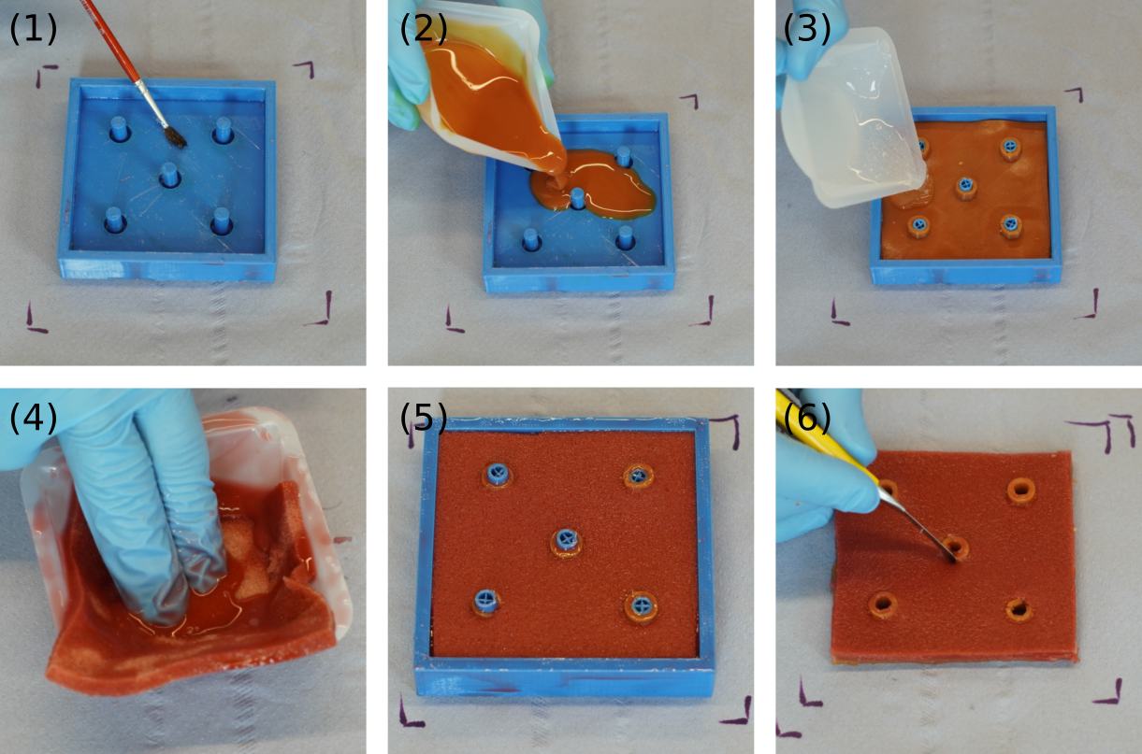
Supplementary figure 1: fabrication process: Step (1): Lubrication of the mold with oil. Step (2): Casting of layer I. Step (3): Flipping the first layer within the mold and casting of layer II (model A only). Step (4): Soaking the PU foam in silicone. Step (5): Introducing the soaked PU foam and casting layer III. Step (6): After curing, the model is removed from the mold. The protrusion were separated with a scalpel from the sidewalls of layer II and III.

