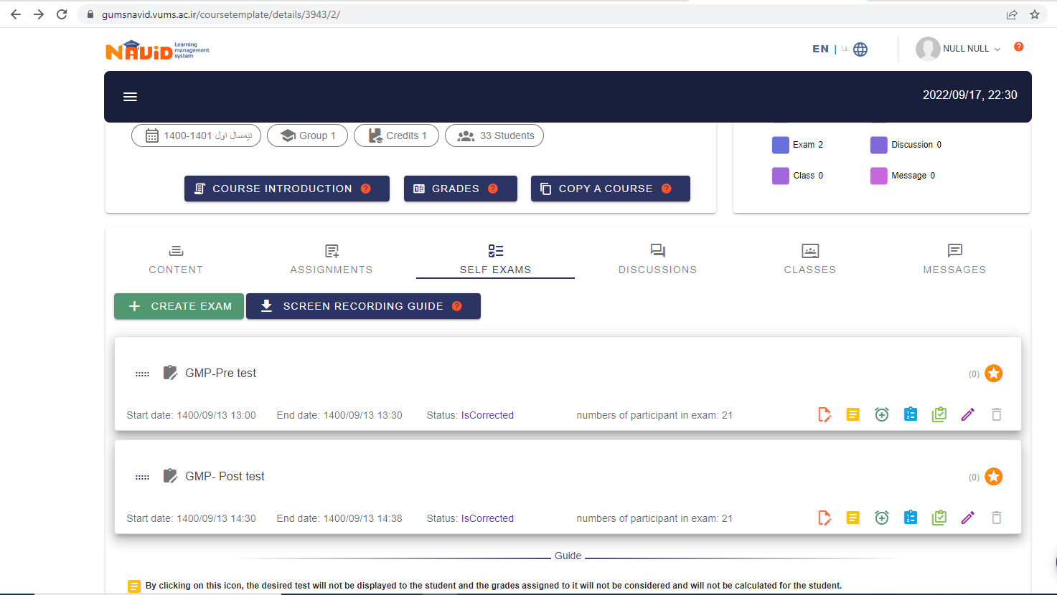
S₁: Screen shot of online pre/post tests of control group
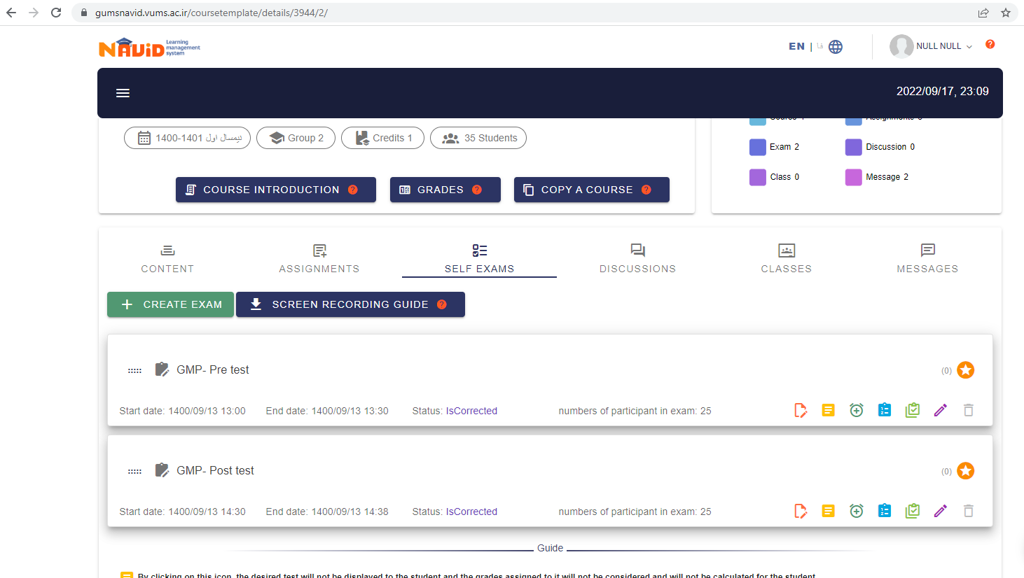
S₂: Screen shot of online pre/post tests of Spaced learning group

