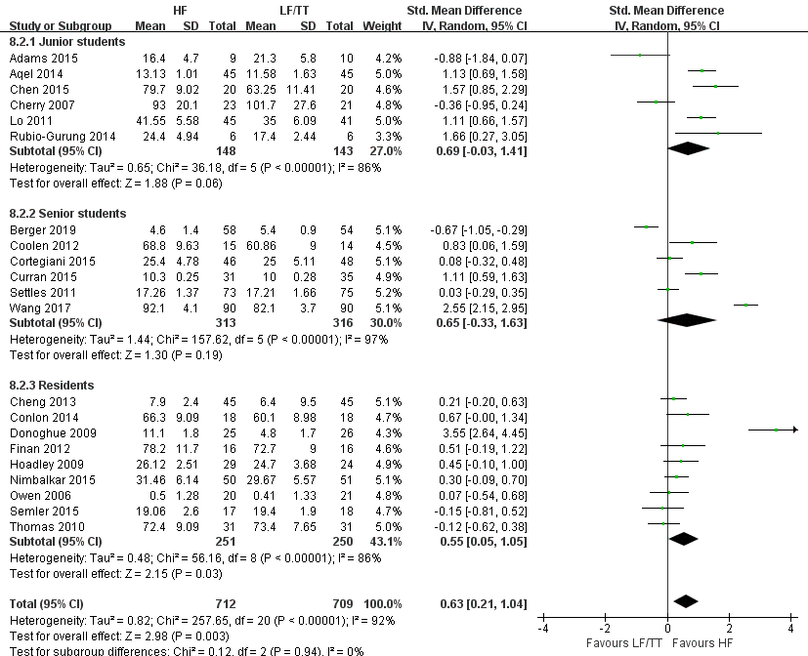
Supplement 5: Subgroup analysis: effects of improving skill performance with high-fidelity simulation at course conclusion.

