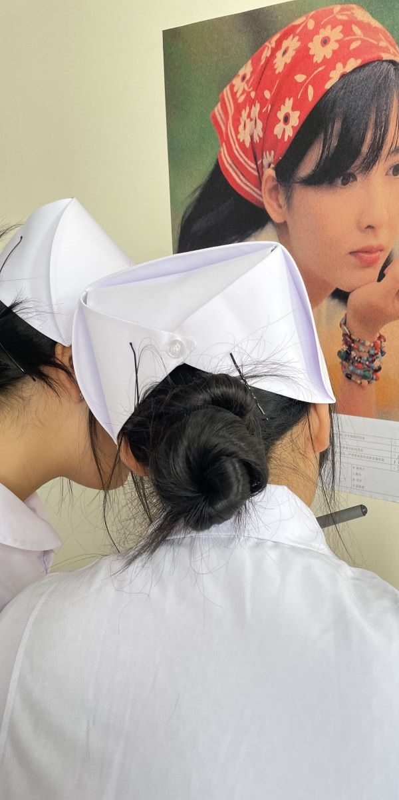
Fig. 1 The questions on the poster
Fig. 2 Multiple choice questions with key numbers and directions

Fig. 3 Only after wearing reading glasses can you see the Sudoku game combined with theoretical knowledge

