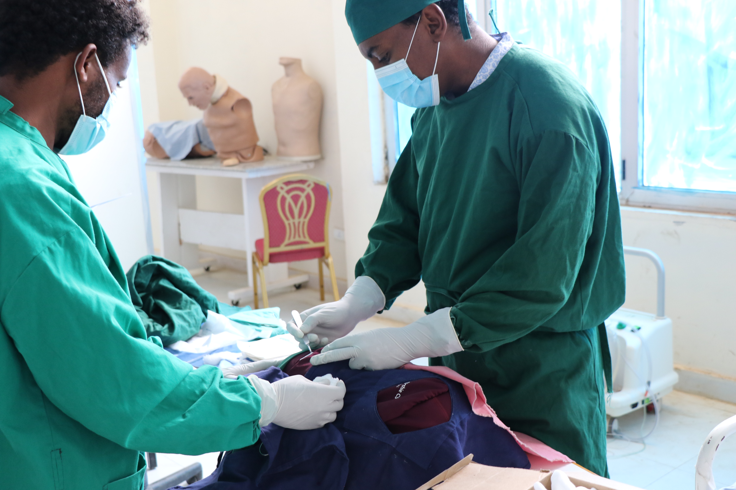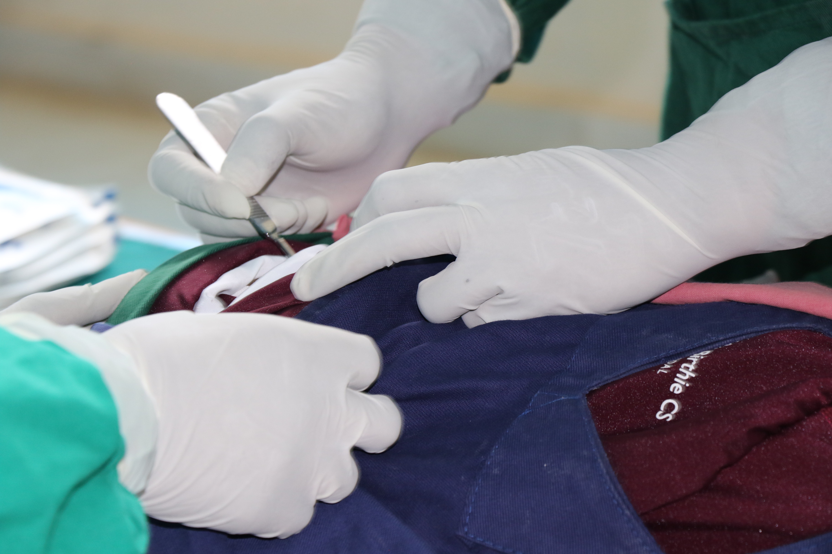
Supplementary Figure 1: Students practicing C-section on Mamabirthie simulator

