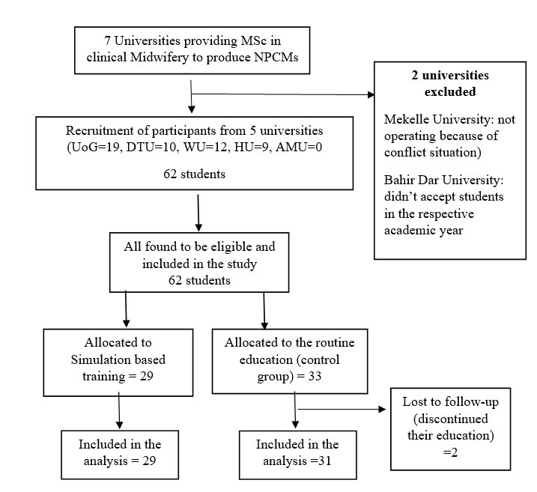

Supplementary Figure 2: Study participant selection process flow diagram

