Appendix Figure 1: Relationships between Comment Specificity, Comment Valence, and Quantitative Ratings from study of association of Gender and Resident Race and Ethnicity with Narrative Comments from Internal Medicine Resident Performance Assessments

Panel A: Mean Specificity of Narrative Comments and Standardized Composite Core Competency Score

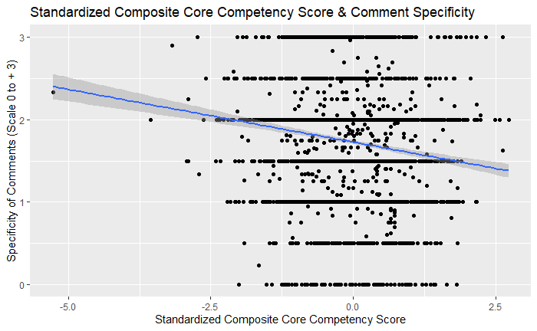

Panel B: Mean Valence of Narrative Comments and Standardized Composite Core Competency Score
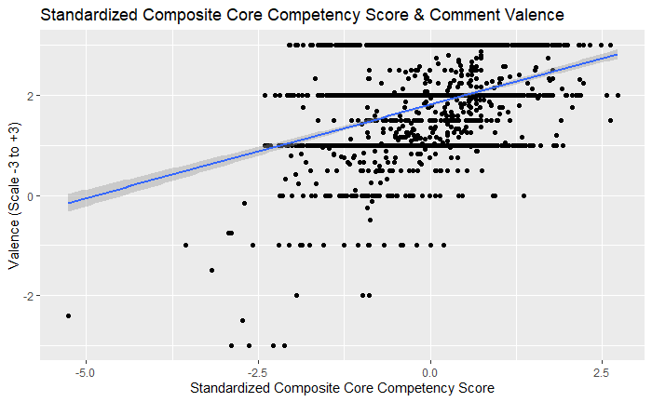
Panel C: Mean Specificity and Mean Valence of Narrative Comments
