ADDITIONAL METHODS.
Additional Table 1. Organization of matches: frequency of match per stage (group, play-off, quarter-finals, semi-finals, final) and per day; frequency of question type per match; and characteristics of question in terms of response time and collaborative nature.
 | 2021 |  |  |  | 2022
 | Group | 1/4 | 1/2 | Final | Group | Play-off | 1/4 | 1/2 | Final
Overall organisation
Number of days | 5 | 2 | 1 | 1 | 4.5 | 0.5 | 2 | 0.5 | 0.5
Total number of matches | 18 | 6 | 1 | 1 | 18 | 1 | 4 | 2 | 1
Number of teams involved | 9 | 2 | 3 | 2 | 12 | 6 | 8 | 4 | 2
Teams per match | 2 | 2 | 3 | 2 | 2 | 6 | 2 | 2 | 2
Match per team | 4 | 2 | 1 | 1 | 3 | 1 | 1 | 1 | 1 | Question details
Number of questions per match |  |  |  |  |  |  |  |  |  | Response time | Collective discussion
Online
MCQ-S | 15 |  | 10 |  | 10 | 20 |  |  |  | 30s
MCQ-M |  |  |  | 24 | 5 | 10 | 15 |  |  | 30s
T/F |  | 10 | 20 |  |  |  | 10 |  |  | 5s
A/B/both |  | 10 | 20 |  |  |  | 10 |  |  | 5s
Puzzle |  |  |  | 10 |  |  | 5 |  |  | 30s
Face to face
List of terms |  |  |  |  |  |  |  | 2 |  | 1min | +
Alphabet question |  |  |  |  |  |  |  | 26 |  | SB | +
Maximum of answers (set/team) |  |  |  |  |  |  |  |  | 1 | 2min | +
"I am…" |  |  |  |  |  |  |  |  | 6 | SB | ++
Menu (questions/team) |  |  |  |  |  |  |  |  | 6 | No limit | +++
1/2: semi-final; 1/4: quarter-final; MCQ-S: multiple choice question with single-select answer; MCQ-M: multiple choice question with multi-select answer; min: minute; s: second; SB: speed based (the first team to press the buzzer can give the answer); T/F: true or false question.

ADDITIONAL RESULTS
Additional Figure 1. Teachers' point of view on the fun, difficulty, enjoyment and formative aspect of creating different types of questions
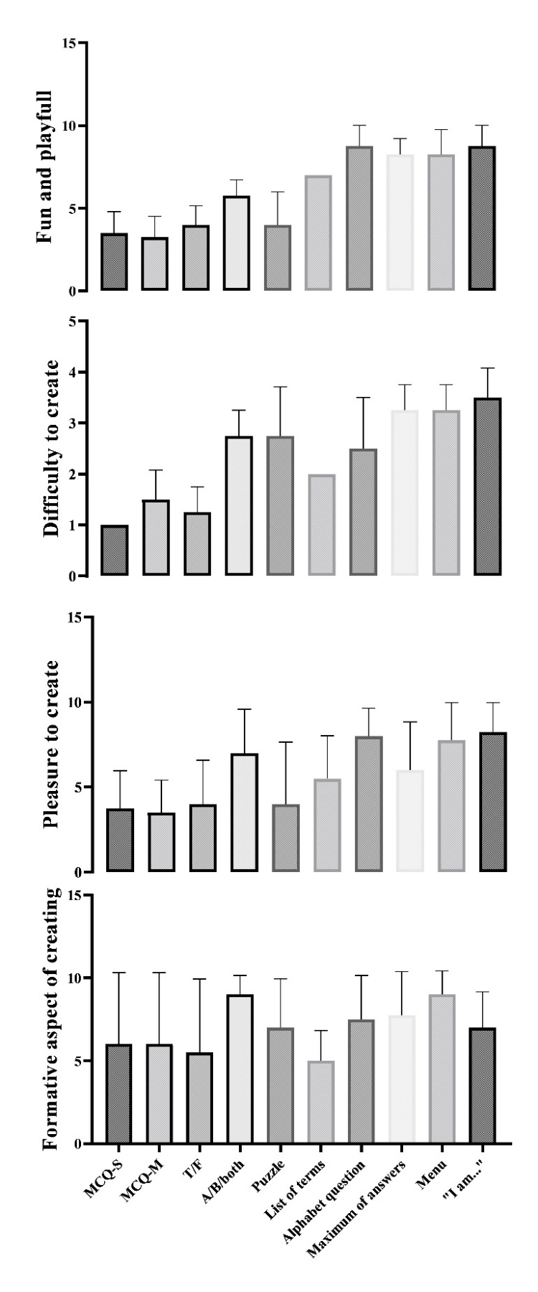
MCQ-S: multiple choice question with single-select answer; MCQ-M: multiple choice question with multi-select answer; T/F: true or false question.

