Figure S1：A forest plot showing the team assistance ability
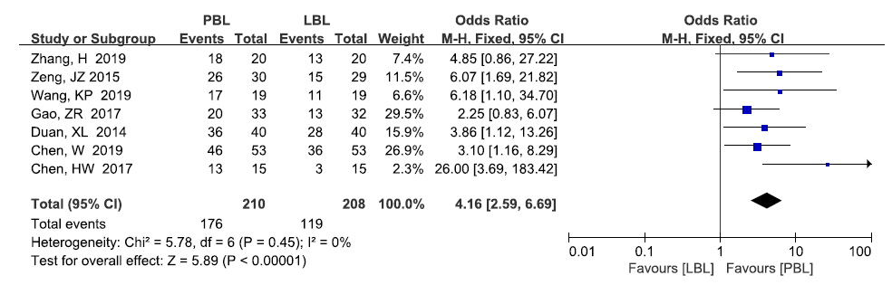

Figure S2：A forest plot showing the communication ability
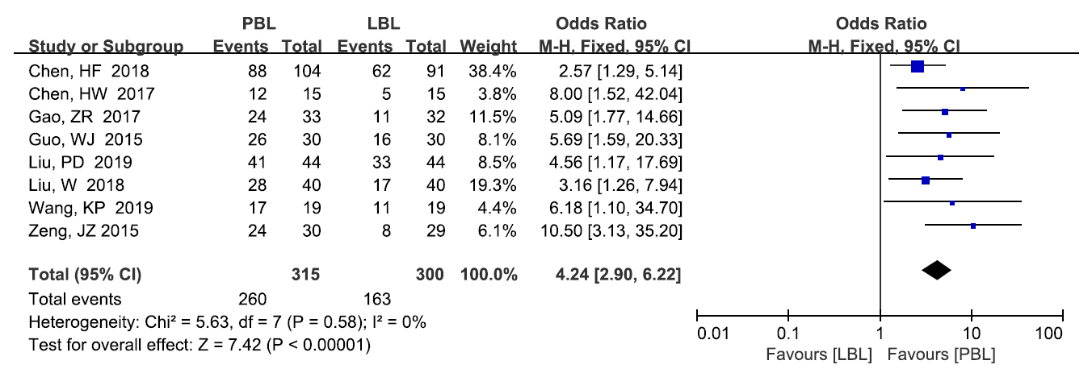

Figure S3：A forest plot showing the clinical reasoning ability
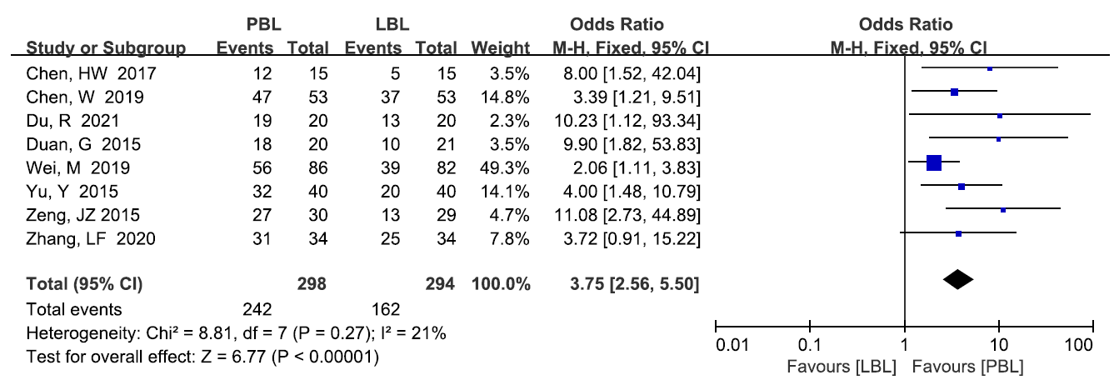

Figure S4：A funnel plot showing publication bias for procedural skill scores
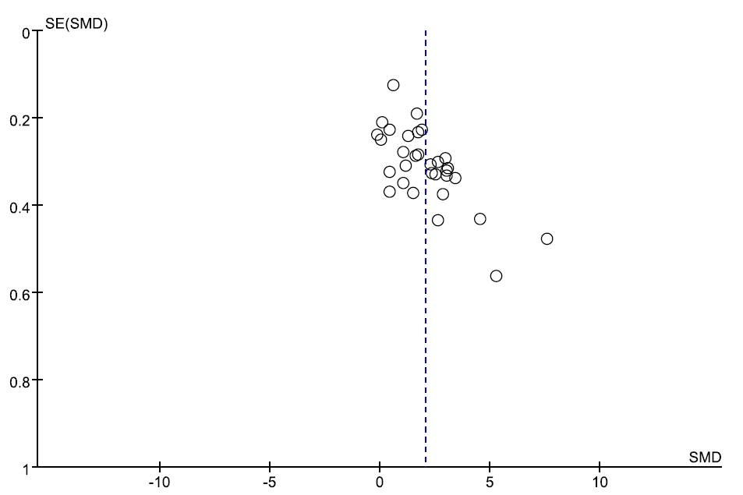

Figure S5：A funnel plot showing publication bias for clinical skill scores
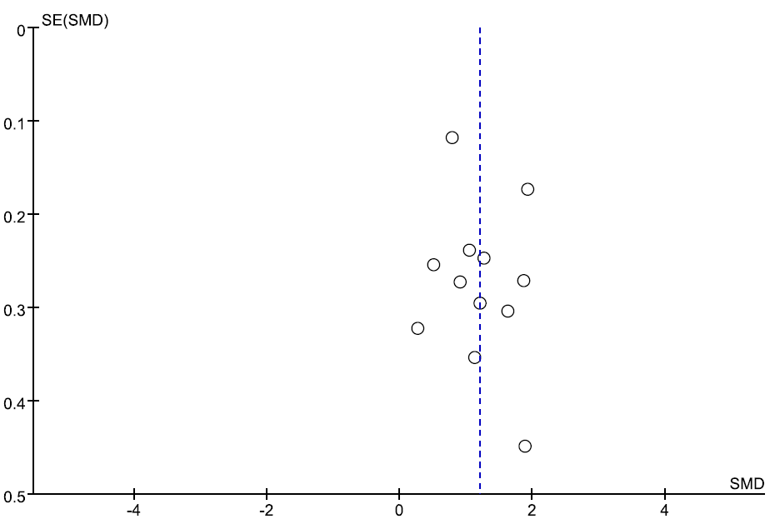

Figure S6：A funnel plot showing publication bias for total scores
