Figure B1. Educational material for the patient. Angiotensin converting enzyme inhibitor.
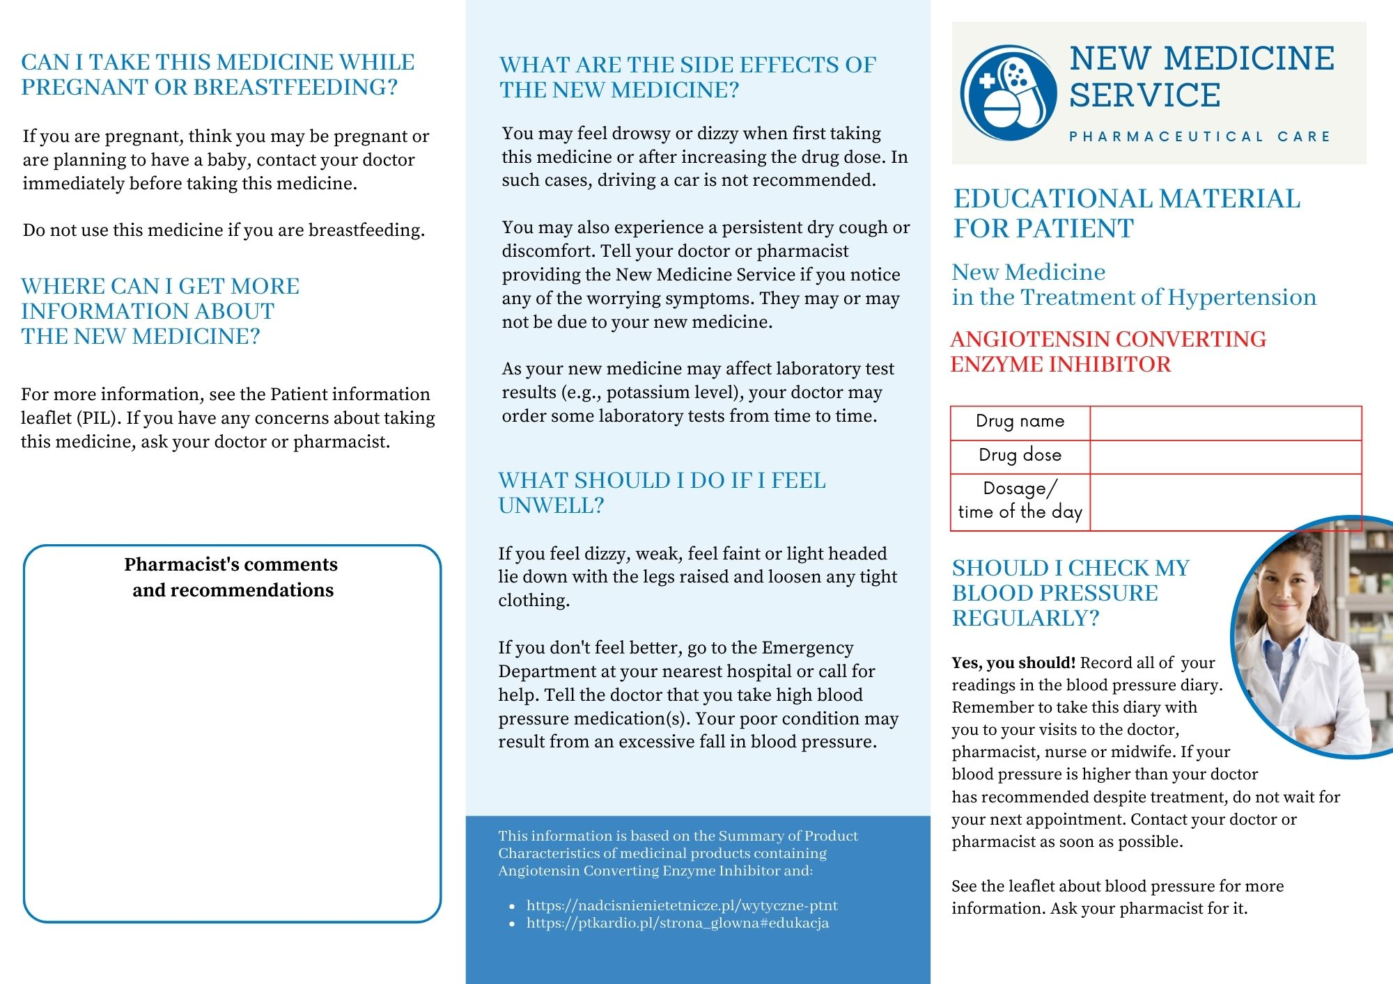

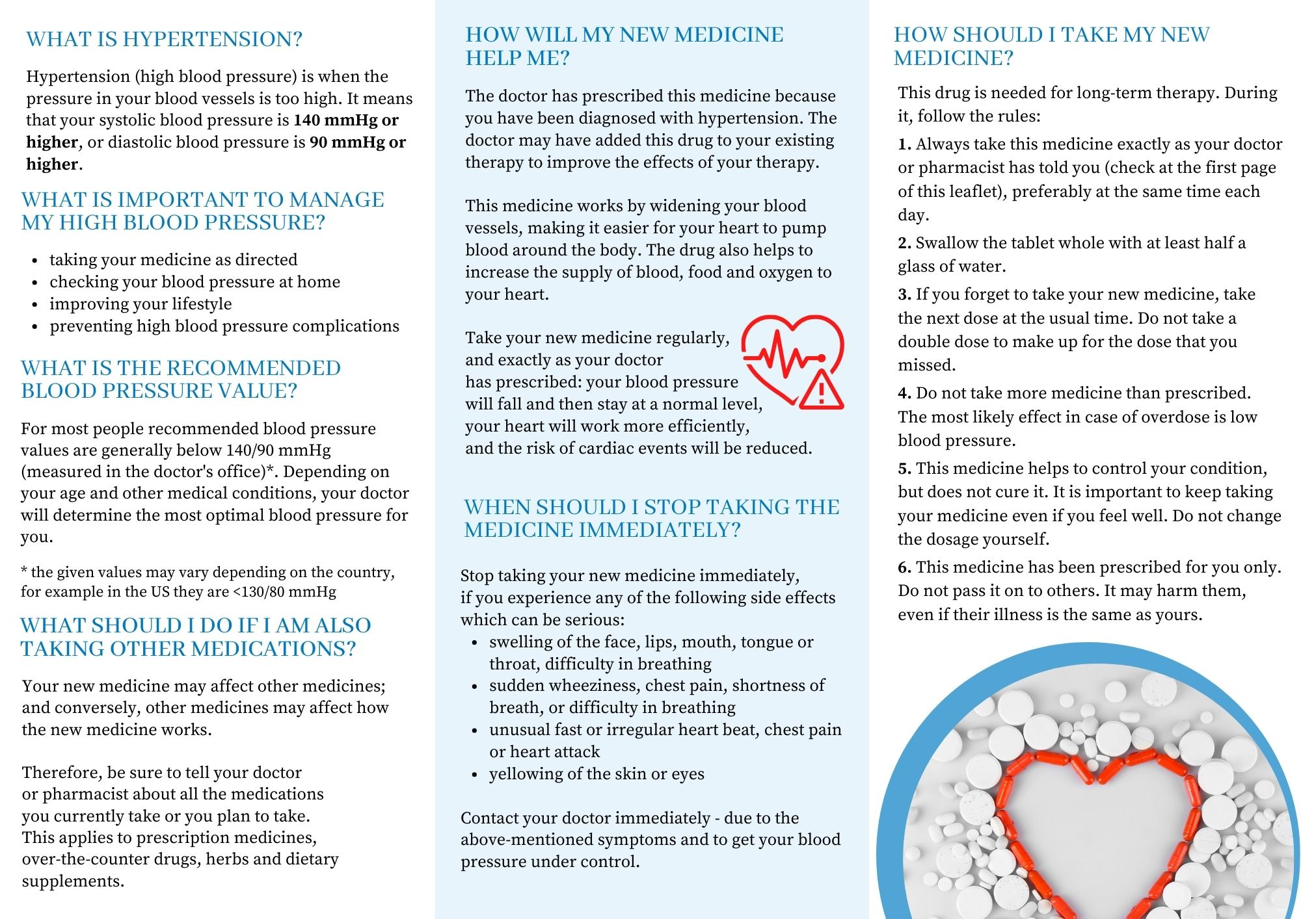

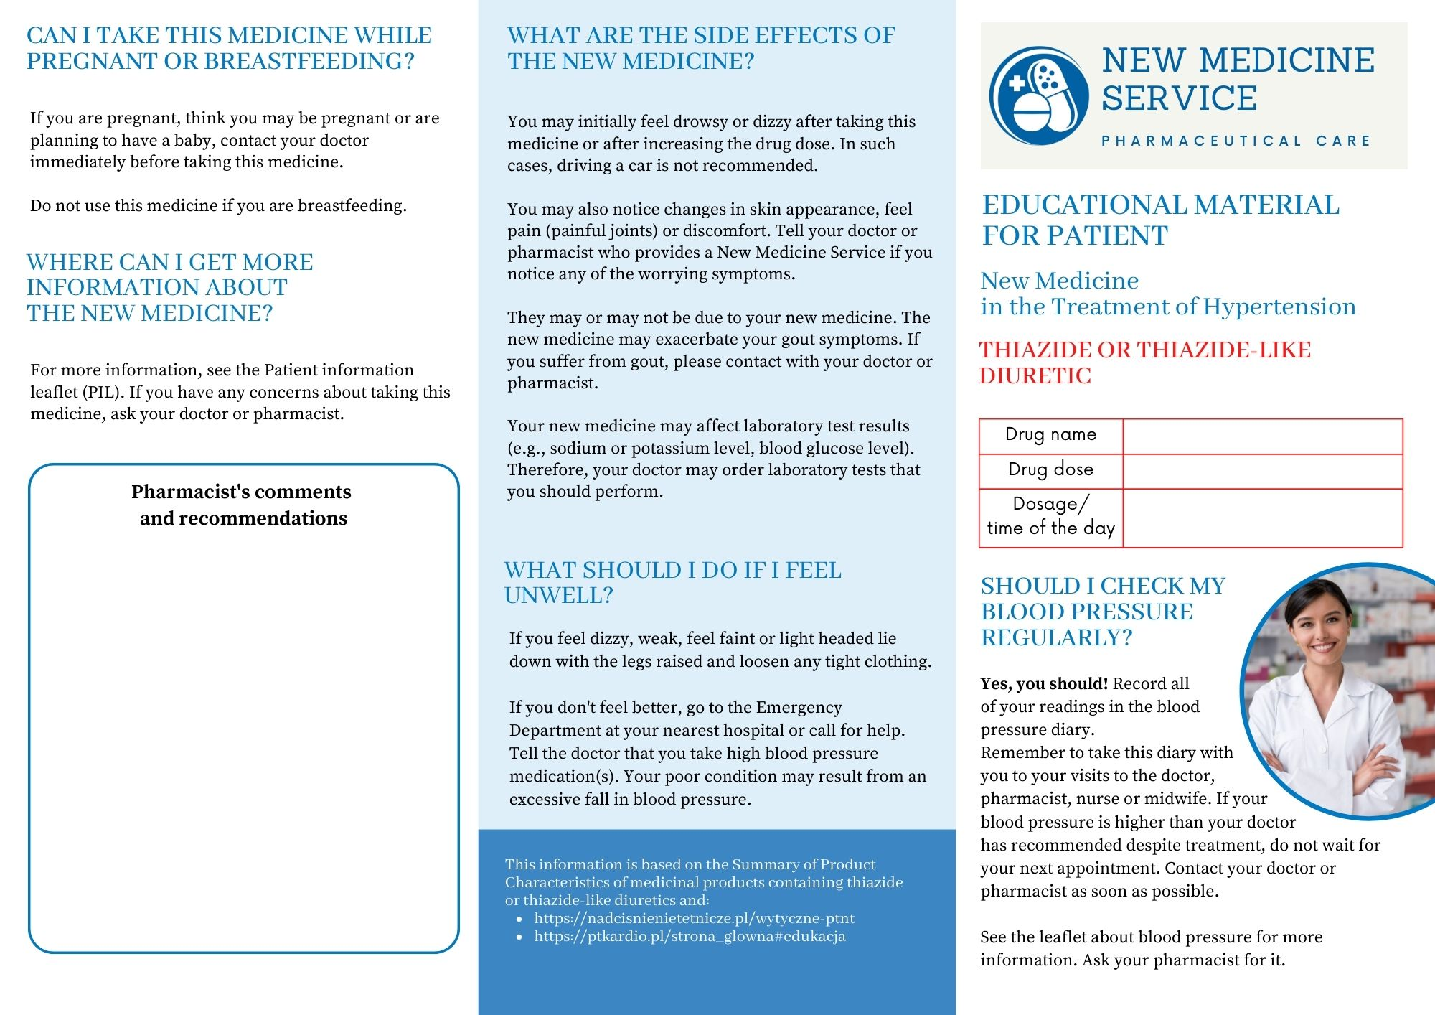
Figure B2. Educational material for the patient. Thiazide/thiazide-like diuretic.

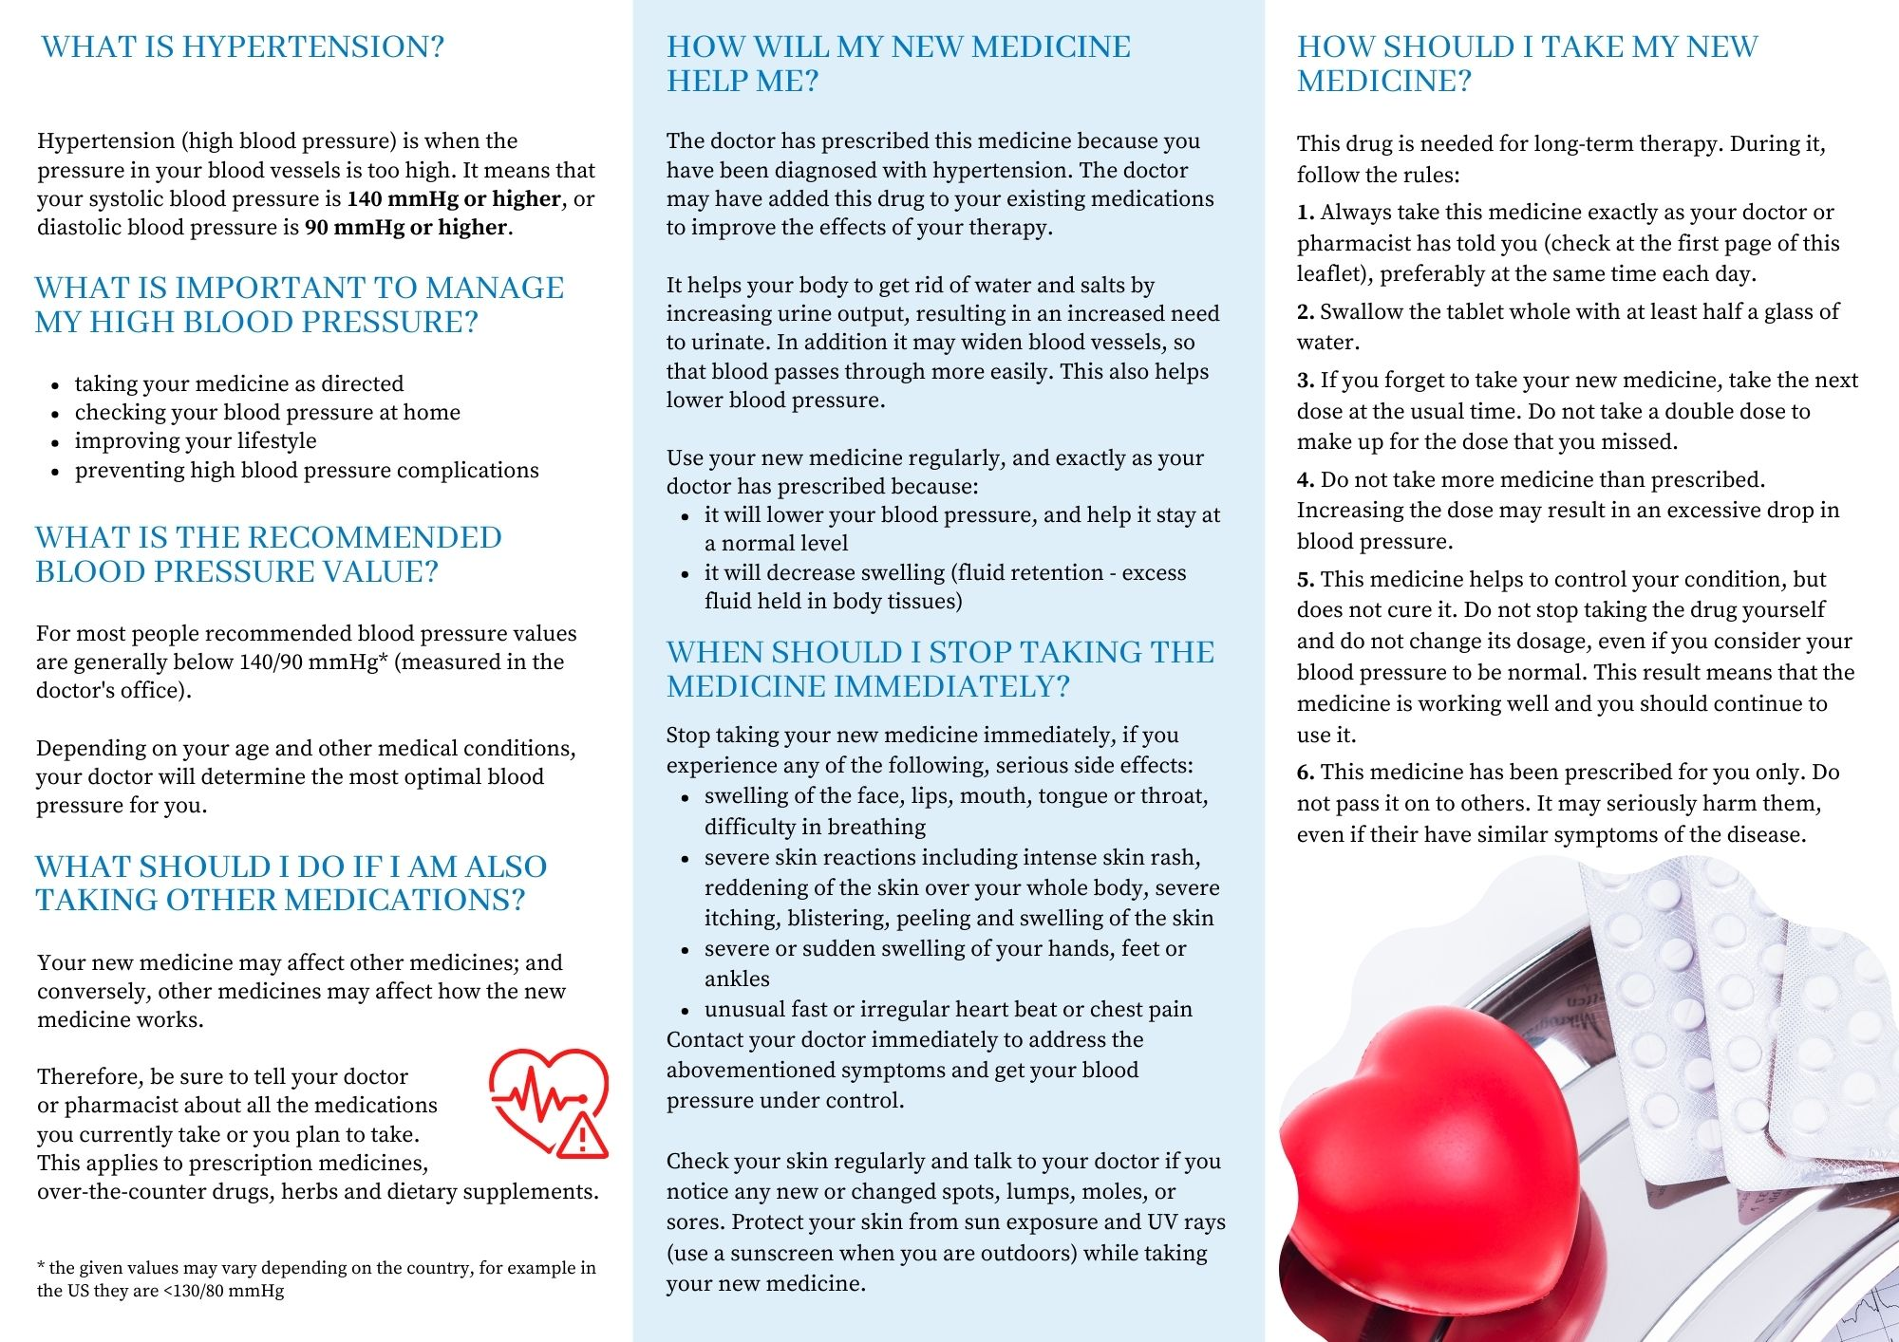

Figure B3. Educational material for the patient. Calcium channel blocker (calcium antagonist).
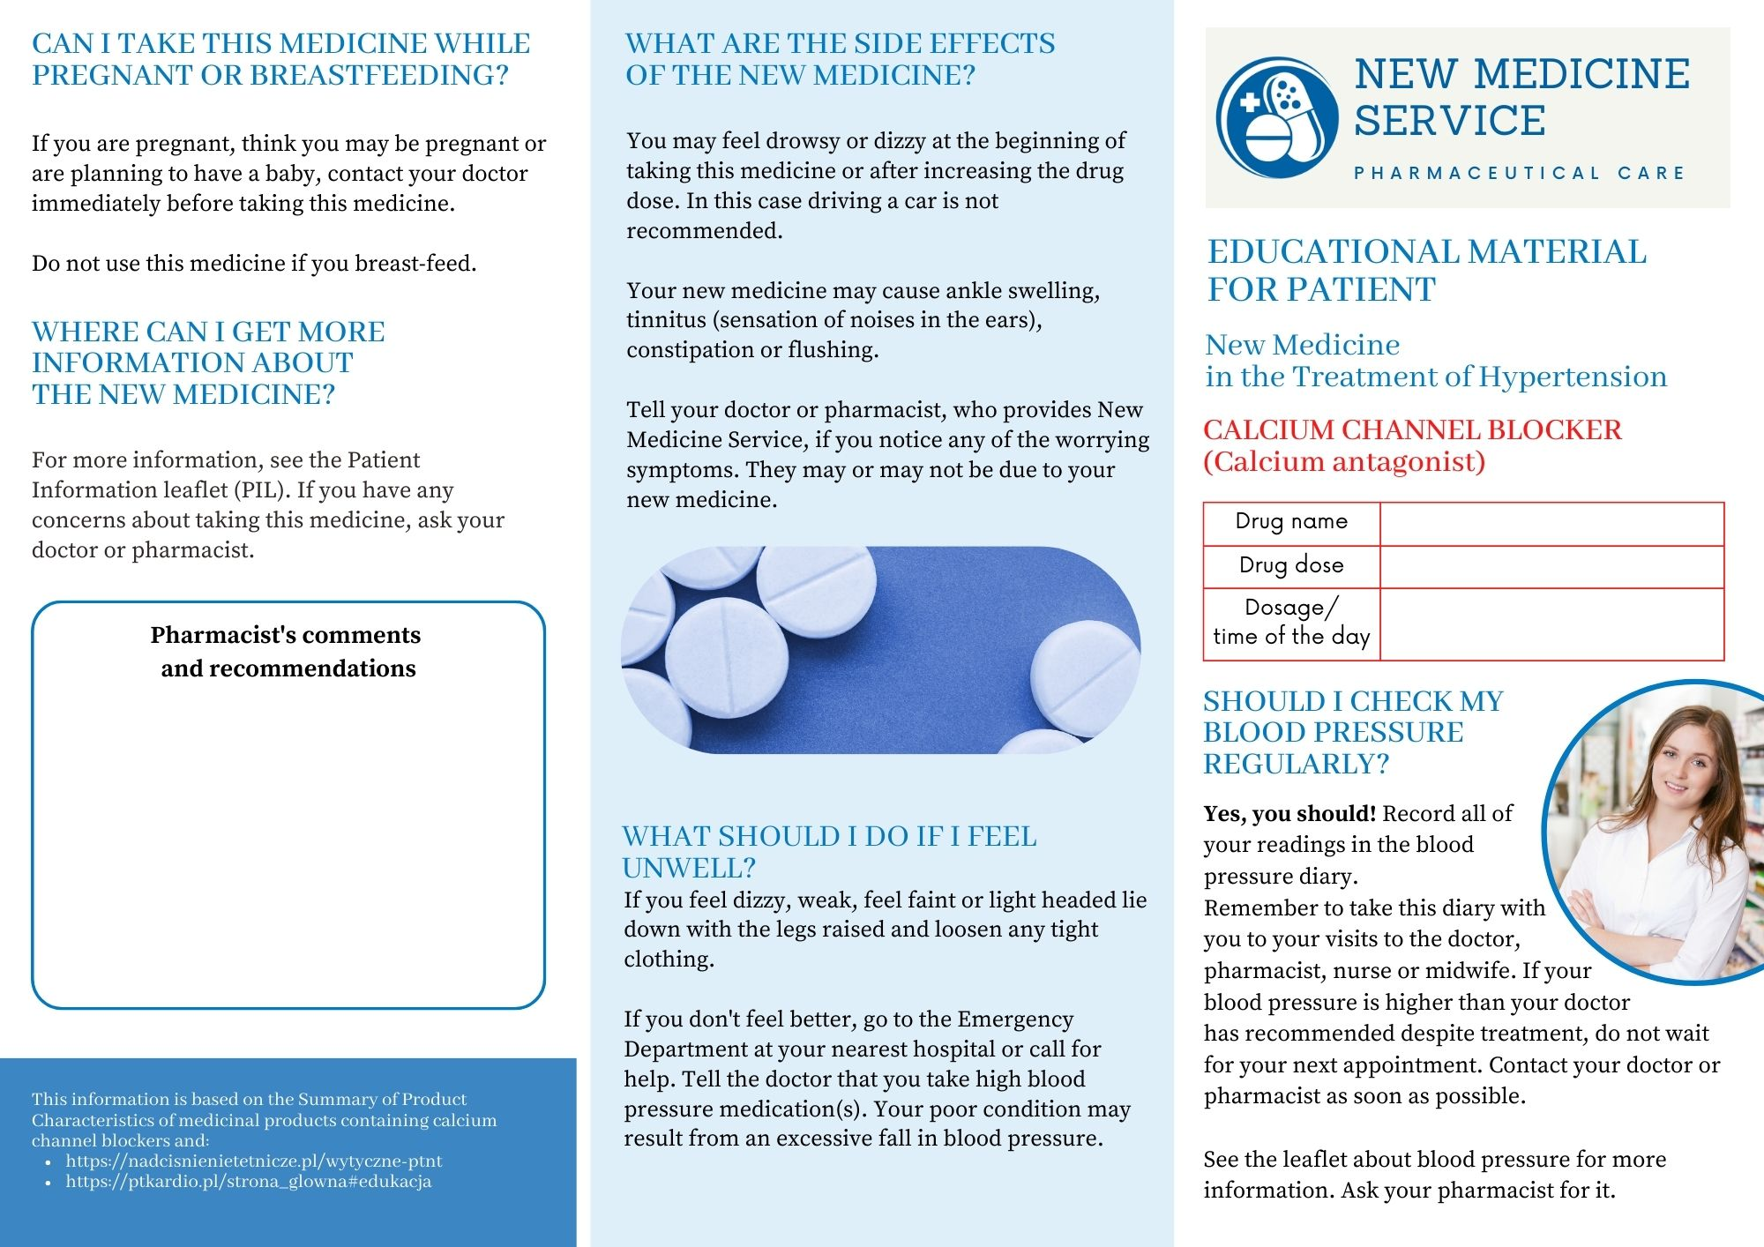

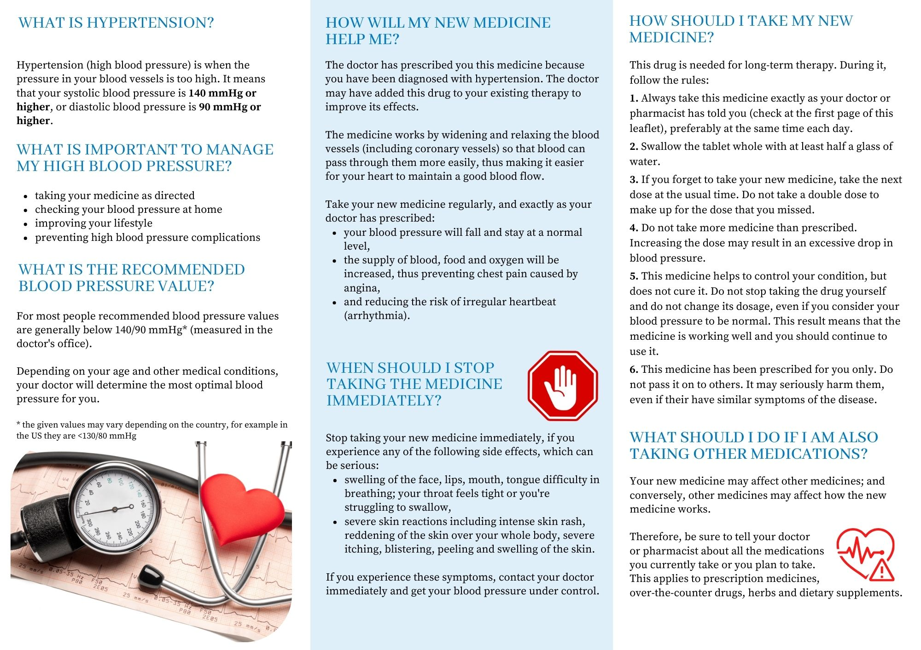

Figure B4
Figure B4. Educational material for the patient. Beta-adrenergic blocking agent (Beta-blocker).
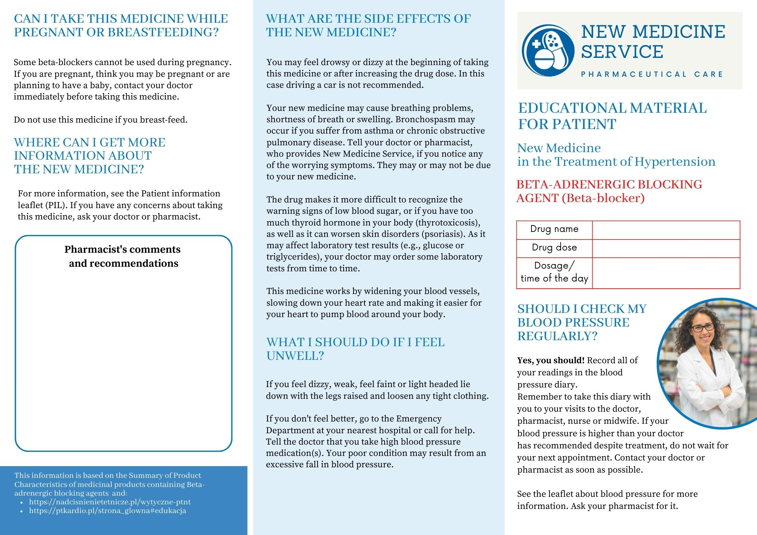

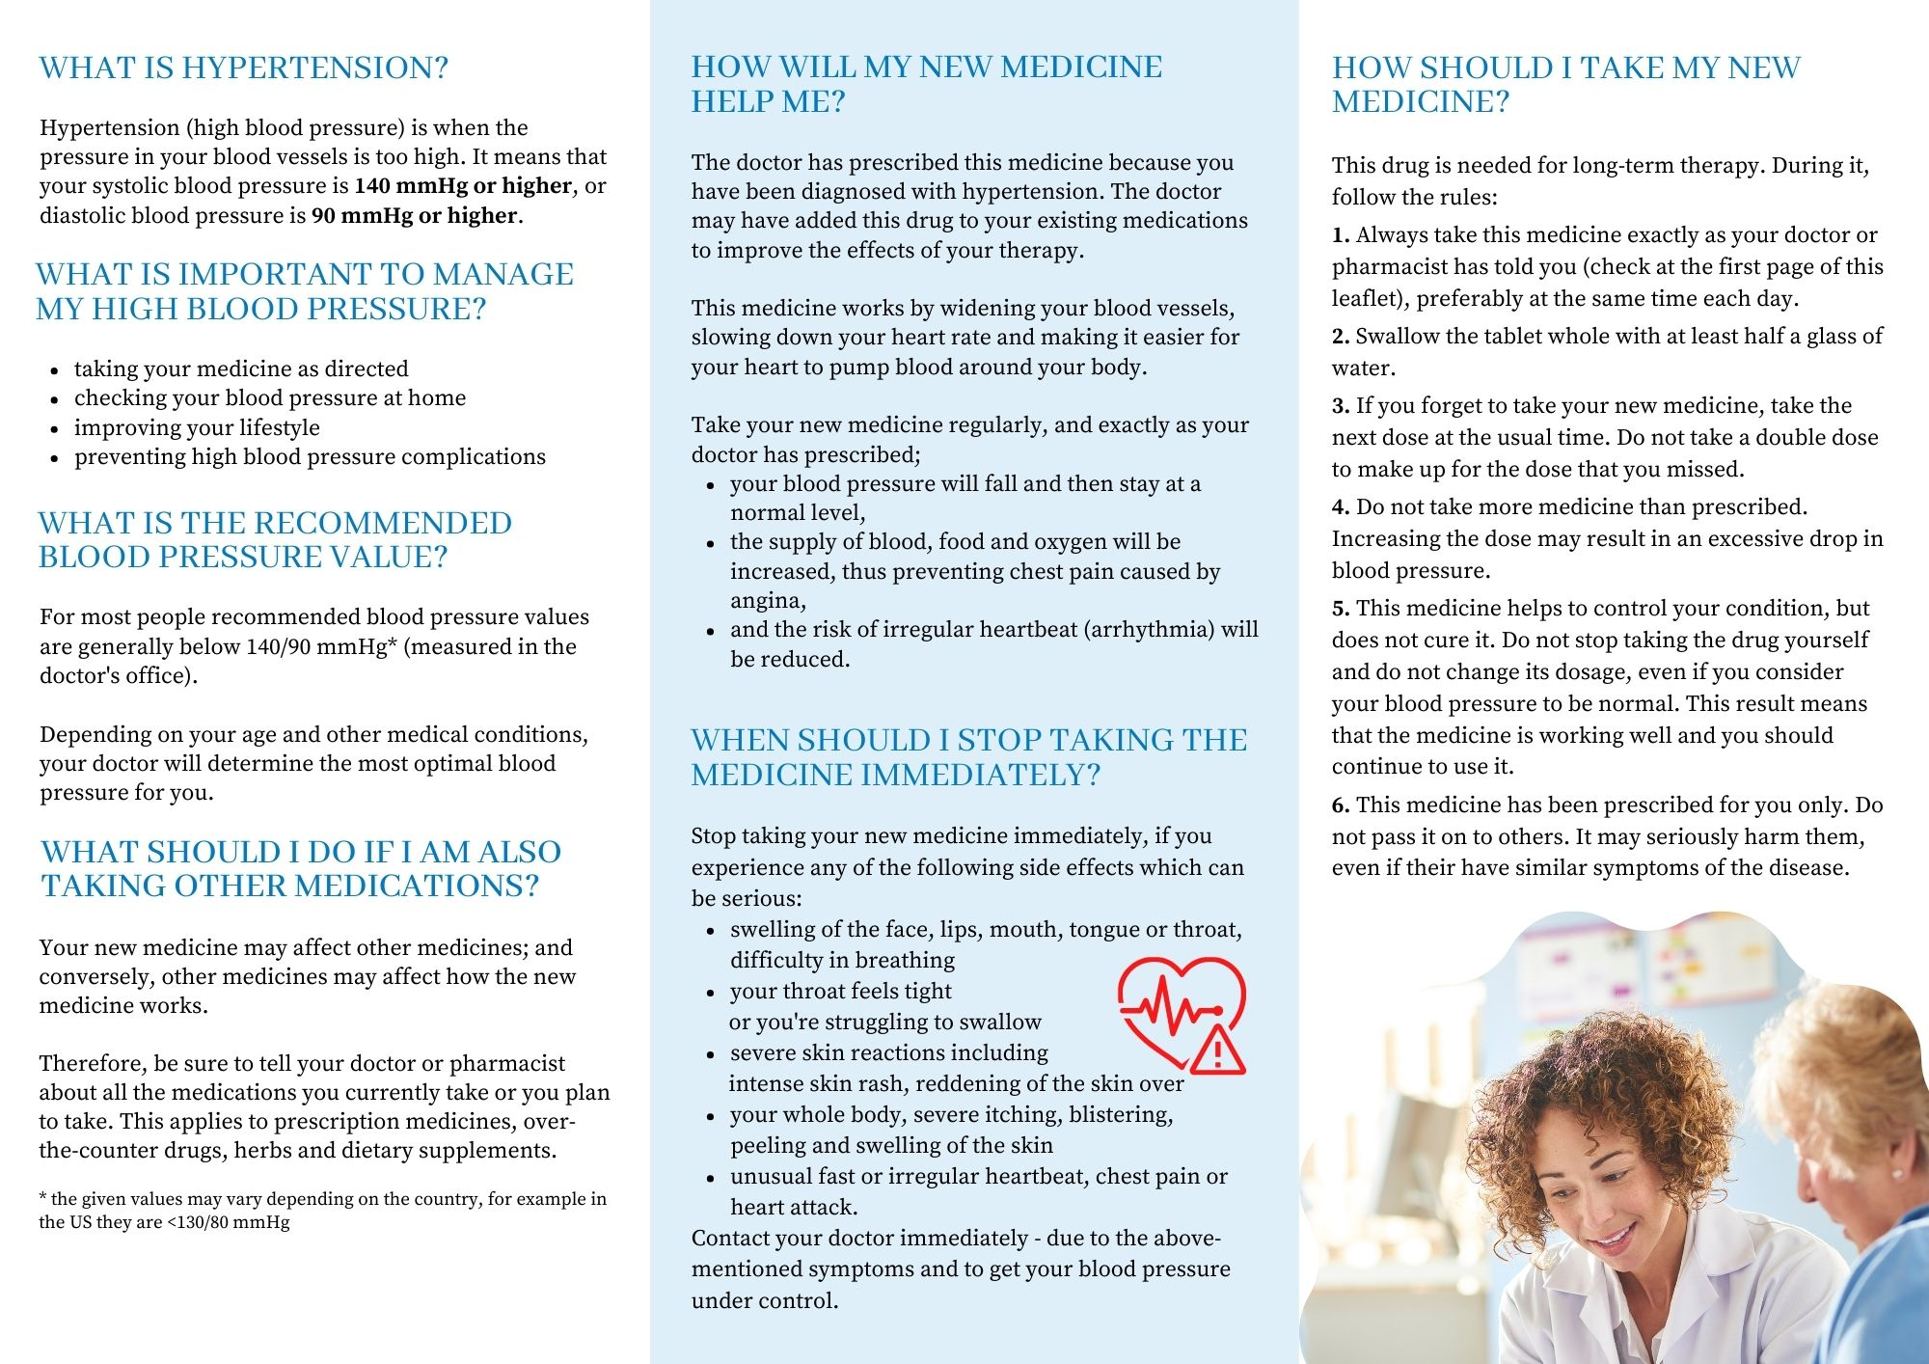

Figure B5
Figure B5. Educational material for the patient. Angiotensin II receptor antagonist.
