Supplement
eFigure 1 Risk of Bias assessment 7
eFigure 2 Association of female sex with success in qualifying exams 27
eFigure 3 Association of 10 years age decrement with success in certificate exams 28

eTable 1 Search strategy for all data bases 2
eTable 2 CHARMS-PF checklist of key items to be extracted from primary studies of prognostic factors, based on additions and modifications of the original CHARMS checklist for primary studies of predictive models (Moons et al., 2014). 4
eTable 3 Risk of bias of included studies 12
eTable 4: Predictors of success in matching residency 15
eTable 5: Predictors of IMG retention for practice and academic career pursuits in a new country 17
eTable 6: Predictors of Being disciplined or Complained to Medical Board 20
eTable 7: Clinical outcome of patients managed by IMGs 23
eTable 8: Univariate and bivariate (non-adjusted) predictors 26

eTable 1 Search strategy for all data bases
# ▲ | Searches | Results
1 | Foreign Medical Graduates/ | 3475
2 | ((international or foreign or overseas or immigrant?) adj2 (medical graduate? or medicine graduate? or clinical graduate?)).ti,ab,kw. | 1336
3 | 1 or 2 | 3936
4 | "Internship and Residency"/ | 49702
5 | (internship or residency or clerkship or trainee?).ti,ab,kw. | 57149
6 | exp Professional Competence/ or Practice Patterns, Physicians'/ | 173901
7 | (competenc* or skill? or performance).ti,ab,kw. | 1170225
8 | exp Credentialing/ | 54730
9 | (accredit* or credential* or licens* or certif*).ti,ab,kw. | 115149
10 | ("fitness to work" or "fit to work" or "fitness to practice" or "fit to practice" or "fitness to practise" or "fit to practise").ti,ab,kw. | 1191
11 | "compensation and redress"/ or liability, legal/ or exp malpractice/ | 44096
12 | Medical Errors/ | 16697
13 | (negligence or malpractice or liab* or disciplin*).ti,ab,kw. | 97156
14 | educational measurement/ or exp academic performance/ | 39498
15 | ((education* or academic*) adj3 (achiev* or attain*)).ti,ab,kw. | 17906
16 | (usmle or plab).ti,ab,kw. | 781
17 | (pass* or fail* or success* or unsuccessful).ti,ab,kw. | 2421670
18 | 4 or 5 or 6 or 7 or 8 or 9 or 10 or 11 or 12 or 13 or 14 or 15 or 16 or 17 | 3836978
19 | (predict* or barrier? or obstacle? or challeng* or inequit* or unequal* or inequal*).ti,ab. | 2687138
20 | (facilitat* or enabl* or opportunit* or influen* or motivat* or encourag* or empower* or equal* or equity).ti,ab. | 3255422
21 | (implement* or uptake or util?e? or utili?ation or adopt*).ti,ab. | 1252781
22 | (attitud* or perception* or perspective* or view* or opinion* or expectation? or fear?).ti,ab. | 1302197
23 | (knowledge or understand* or comprehen* or aware* or communicat*).ti,ab. | 2436506
24 | 19 or 20 or 21 or 22 or 23 | 8300987
25 | 3 and 18 and 24 | 804

eTable 2 CHARMS-PF checklist of key items to be extracted from primary studies of prognostic factors, based on additions and modifications of the original CHARMS checklist for primary studies of predictive models (Moons et al., 2014).
Domains and key items | General | Applicability | Risk of Bias
Source of data:
Source of data (e.g. cohort, Case control. Randomised trial, or registry data) | x | x | x
Participants:
Participants eligibility and recruitment method (e.g. consecutive participants, location, number of centres. Setting, inclusion and exclusion criteria) | x | x | x
Participant description | x | x
Details of treatments received (if relevant) |  | x | x
Study dates | x | x
Outcomes to be predicted:
Definition and method for measurement of outcomes |  | x | x
Was the same outcome definition (and method for measurement) used in all participants? |  |  | x
Types out outcomes (e.g. single or combined endpoints) | x | x
Were the outcomes assessed without knowledge of the candidate prognostic factors (that is, blinded)? |  |  | x
Were candidate prognostic factors part of the outcome (e. g. when using a panel or consensus outcome measurement)? |  |  | x
Time of outcome occurrence or summary of duration of follow up | x | x | x
Prognostic factors (index and comparator prognostic factors):
Number and type of prognostic factors (e.g. obtained from demographics, patient history, physical examination, additional testing, disease characteristics) | x |  | x
Definition and method for measurement of prognostic factors |  | x | x
Timing of prognostic factor measurement (e.g. at patient presentation, diagnosis, treatment initiation, at the end of surgery) |  | x | x
Were prognostic factors assessed blinded for outcome, and for each other (if relevant) |  |  | x
Handling of prognostic factors in the analysis (e.g. continuous, non-linear transformations or categorised) |  |  | x
Sample size:
Was a sample size calculation conducted and if so, how? | x
Number of participants and number of outcomes or events | x
Number of outcomes or events in relation to the number of candidates prognostic factors (events per variable)
Missing data:
Number of participants with any missing value (in the prognostic factors and outcomes) | x |  | x
Number of participants with missing data for each prognostic factor of interest |  |  | x
Details of attrition (loss to follow up) and for time-to-event outcomes, number of censored observations (ideally in each category for those categorical prognostic factors of interest) |  |  | x
Handling of missing data (e.g. Complete case analysis, imputation or other methods) |  |  | x
Analysis:
Modelling method (e.g. linear, logistic, Cox, parametric survival, competing risks) regression | x |  | x
How modelling assumptions were checked, in particular, for time-to-event outcomes and the analysis of hazard ratios, the method for assessing non-proportional hazards (non-constant hazard ratios over time) |  |  | x
Method for selection of prognostic factors for inclusion in multivariate modelling (e.g. all candidate prognostic factors considered, preselection of established prognostic factors, retain only those significant from univariate analysis) |  |  | x
Method for selection of exclusion of prognostic factors (including those of interest and those used as adjustment factors during multivariate modeling (e.g. backward or forward selection, or full model approach including all factors regardless), and criteria used for any selection or exclusion (e.g. P value, Akaike information criterion) |  |  | x
Method of handling each continuous prognostic factor (e.g. dichotomisation, categorisation, linear, non-linear) including values of any cut-points used and their justification, for non-linear trends, the method of identifying non-linear relationships (e.g. splines, fractional polynomials) |  |  | x
Results:
Unadjusted and adjusted prognostic effect estimates (e.g. risk ratios, odds ratios, hazard ratios, mean differences) for each prognostic factor of interest, and the corresponding 95% confidence interval (or variance or standard error). Details of any non-linear relationships and whether modelling assumptions hold; in particular, for time-to-event outcomes, any evidence of non-proportional hazards (non-constant hazard ratios) for each prognostic factor of interest | x | x | x
For each extracted adjusted prognostic effect estimate of interest, the set of adjustment factors used. | x | x | x
Interpretation and discussion
Interpretation of presented results | x | x
Comparison with other studies, discussion of generalisability, strengths and limitations | x | x

eFigure 1 Risk of Bias assessment
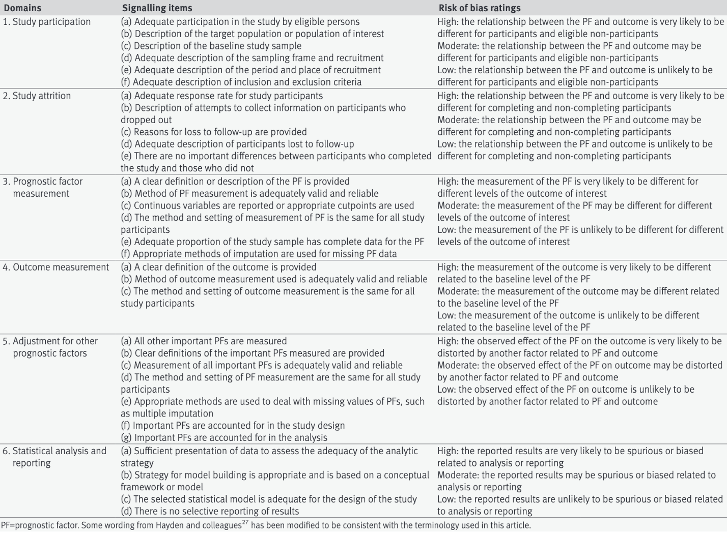

eTable 3 Risk of bias of included studies
 | Study | Study participation | Study attrition | Predictors measurement | Outcome measurement | Statistical analysis and reporting | Adjustment for other prognostic factors | Overall Risk of Bias
1 | Driver, 2014 | MODERATE | MODERATE | MODERATE | MODERATE | MODERATE | MODERATE | HIGH
2 | Mathews, 2017 | LOW | MODERATE | LOW | MODERATE | LOW | MODERATE | HIGH
3 | Mathews, 2017 | LOW | MODERATE | LOW | LOW | MODERATE | LOW | HIGH
4 | Grierson, 2017 | LOW | LOW | LOW | LOW | LOW | MODERATE | MODERATE
5 | Tiffin, 2017 | LOW | LOW | LOW | LOW | LOW | LOW | LOW
6 | Tiffin, 2014 | LOW | LOW | LOW | LOW | LOW | LOW | LOW
7 | Patterson, 2018 | LOW | LOW | LOW | LOW | LOW | LOW | LOW
8 | Nayer, 2013 | LOW | LOW | MODERATE | LOW | MODERATE | HIGH | HIGH
9 | Elkin, 2012 | LOW | MODERATE | MODERATE | LOW | MODERATE | MODERATE | HIGH
10 | Alam, 2017 | LOW | LOW | LOW | LOW | MODERATE | MODERATE | HIGH
11 | Haukilahti, 2012 | LOW | LOW | LOW | LOW | LOW | LOW | LOW
12 | Schabort, 2014 | LOW | LOW | LOW | LOW | LOW | LOW | LOW
13 | Mehdizadeh, 2017 | LOW | LOW | HIGH | LOW | MODERATE | MODERATE | HIGH
14 | Sturesson, 2020 | MODERATE | LOW | LOW | LOW | MODERATE | MODERATE | HIGH
15 | Peterson, 2020 | LOW | LOW | LOW | LOW | LOW | LOW | LOW
16 | Van Zanten, 2003 | LOW | LOW | LOW | LOW | LOW | LOW | LOW
17 | Norcini, 2014 | LOW | LOW | LOW | LOW | LOW | LOW | LOW
18 | Shaw, 2014 | LOW | MODERATE | MODERATE | LOW | MODERATE | HIGH | HIGH
19 | Menzies, 2015 | LOW | LOW | LOW | LOW | LOW | LOW | LOW
20 | Bessant, 2006 | MODERATE | LOW | LOW | LOW | LOW | LOW | MODERATE
21 | Norcini, 2010 | LOW | LOW | LOW | LOW | LOW | LOW | LOW
22 | Tamblyn 2022 | LOW | LOW | LOW | HIGH | LOW | LOW | HIGH
23 | Khalafallah 2021 | HIGH | LOW | LOW | MODERATE | LOW | MODERATE | HIGH
24 | Kanna, 2009 | HIGH | HIGH | HIGH | HIGH | HIGH | HIGH | HIGH
25 | Norcini, 2023 | LOW | LOW | LOW | LOW | LOW | LOW | LOW

eTable 4: Predictors of success in matching residency
Author/ Year/ Sample size/Country/RoB | Predictor | OR (95% CI) | pValue | Outcome | Baseline risk for outcome | Predictor/Absolute success or failure change
Driver, 2014  N= 340  USA | Having 3 letters of recommendation from US ophthalmologists | 6.2 (2.54, 15.16) | 0.001 | Matching in ophthalmology residency in USA | 50% | IMG with 3 references were more likely to match.  36% (95%CI: 22%, 44%) more successful
Driver, 2014  N= 340  USA | having 2 letters of recommendation from US ophthalmologist | 3.98 (1.75, 9.04) | 0.001 | Matching in ophthalmology residency in USA | 50% | IMG with 2 references were more likely to match.  30% (95%CI: 14%, 40%) more successful
Driver, 2014  N= 340  USA | US Medical Licensing Examination (USMLE) Step 1 score ≥236 | 3.22 (1.38, 7.49) | 0.008 | Matching in ophthalmology residency in USA | 50% | IMG with higher USMLE step 1 score were more likely to match  30% more successful (95%CI: 14%, 40%)
Driver, 2014  N= 340  USA | Academic awards (per one increase) | 1.12 (1.03, 1.22) | 0.01 | Matching in ophthalmology residency in USA | 50% | IMG with academic awards were more likely to match  3% more successful (95%CI: 1%, 5%) per one award
Driver, 2014  N= 340  USA | high-impact journal publications | 2.99 (1.51, 5.72) | 0.0005 | Matching in ophthalmology residency in USA | 50% | IMGs who have publication in high impact journal were more likely to match  25% more successful (95%CI: 10%, 35%)
Driver, 2014  N= 340  USA | US research experience | 2.95 (1.31, 6.67) | 0.009 | Matching in ophthalmology residency in USA | 50% | IMG with US research experience were more likely to match  25% more successful (95%CI: 7%, 37%)
Driver, 2014  N= 340  USA | Postgraduate clinical training, including years spent as surgical interns in the US ≥3 years | 0.26 (0.12, 0.58) | 0.003 | Matching in ophthalmology residency in USA | 50% | IMG with 3 years and longer clinical training were less likely to match  29% less (95%CI: 13%, 39% less likely)
NS=Not-significant, NR=Not reported, Bold font =Significant; Red=High RoB

eTable 5: Predictors of IMG retention for practice and academic career pursuits in a new country
Author/ Year/ Sample size/Country/RoB | Predictor | OR (95% CI) | pValue | Outcome | Baseline risk for outcome | Predictor/Absolute success or failure change
 | Outcome: Working in destination country (Retention after residency training)
Mathews, 2017  N=876  Canada | Years between MD and PGME  ≤5 years vs ≥6 years | 1.36 (1.03, 1.79) | 0.031 | Working in Canada with in 2 years after PGME | 37.6% | Recent graduated IMGs were more likely to work in Canada with in 2 years after PGME (Family medicine residency)  7.4% (95%CI: 0.7%, 14%)
Mathews, 2017  N=876  Canada | Eligible for full license (Yes vs. No) | 3.72 (2.30, 5.99) | 0.001 | Working in Canada in 2015 | 91.2% of PGME residents registered between 2005-2010 in CAPER, worked in Canada in 2015 | IMGs who were eligible for a full licence were more  likely to work in Canada in 2015  6.4% (95%CI: 4.88%, 7.38%)
Mathews, 2017  N=1,214  Canada | Eligible for full license (Yes vs. No) | 4.28 (2.92, 6.27) | 0 | Working in Canada in 2015 | 88% | IMG who entered PGME (family medicine & speciality program) and were eligible for full license were more likely to work in Canada 8.9% (95%CI: 7.5%, 9.9%)
Mathews, 2017  N=1,214  Canada | Resident vs fellowship candidates | 2.63 (1.59, 4.35) | 0 | Working in Canada in 2015 | 88% | Residency candidates are more likely to work in Canada 7.1% (95%CI: 4.1%, 9%)
Mathews, 2017  N=1,068  Canada | Family medicine vs specialists | 2.32 (1.33, 4.17) | 0.003 | Working in rural communities in Canada | 9% | Family medicine candidates were more likely to work in rural communities than speciality PGME candidates.  9.7% (95%CI: 2.63%, 20.2%)
Mathews, 2017  N=1,068  Canada | Male vs Female | 1.77 (1.16, 2.70) | 0.009 | Working in rural communities in Canada | 9% | Male candidates were more likely to work in rural communities then females.  5.9% (95%CI: 1.3%, 12.1%)
Pursuing academic career
Khalafallah, 2021  N=243  USA | Completion of a clinical fellowship | 1.73 (1.01, 2.96) | 0.046 | Academic neurosurgical Career Trajectory | 59.6% | IMGs who completed a post residency clinical fellowship were more likely to pursue an academic career.  12.2% (0.24%, 21.8%)
Khalafallah, 2021  N=243  USA | Greater h-index during residency | 1.03 (0.98, 1.09) | 0.25 | Academic neurosurgical Career Trajectory | 59.6% | 0.71% (-0.49%, 2.06%)
Khalafallah, 2021  N=243  USA | Greater protected research time during residency | 1.03 (1.00, 1.06) | 0.082 | Academic neurosurgical Career Trajectory | 59.6% | 0.71% (0%, 1.4%)
Bold font =Significant; Green=Low Risk of Bias (RoB), Red=High RoB

eTable 6: Predictors of being disciplined or Complained to Medical Board
Author/ Year/ Sample size/Country/RoB | Predictor | OR (95% CI) | pValue | Outcome | Baseline risk for outcome | Predictor/Absolute success or failure change
 | Outcome: Being disciplined, Complains to Medical Board
Tiffin 2017  N=1,182  UK | Male vs Female | HR: 2.73 (1.90, 3.93) | 0.001 | Censure vs no censure or referral | 18.2% | Male IMGs were more likely to be censured at any timepoint
Tiffin 2017  N=1,182  UK | Age | HR: 1.01 (0.98, 1.04) | 0.54 | Censure vs no censure or referral | 18.2%
Tiffin 2017  N=1,182  UK | IELTS speaking score | HR: 1.39 (1.13, 1.72) | 0.001 | Censure vs no censure or referral | 18.2% | IMGs with higher IELTS speaking score were more likely to be censured at any timepoint
Tiffin 2017  N=1,182  UK | PLAB part 1 score at first attempt | HR: 0.99 (0.99, 1.00) | 0.12 | Censure vs no censure or referral | 18.2%
Tiffin 2017  N=1,182  UK | PLAB part 2 score at first attempt | HR: 0.94 (0.91, 0.97) | 0.001 | Censure vs no censure or referral | 18.2% | IMGs with higher PLAB part 2 score were less likely to be censured at any timepoint
Tiffin 2017  N=1,182  UK | Passing PLAB part 1 at 2nd vs. 1st attempt | HR: 1.24 (0.86, 1.79) | 0.25 | Censure vs no censure or referral | 18.2%
Tiffin 2017  N=1,182  UK | Passing PLAB part 1 at 3rd vs. 1st attempt | HR: 1.58 (0.94, 2.64) | 0.08 | Censure vs no censure or referral | 18.2%
Tiffin 2017  N=1,182  UK | Passing PLAB part 1 at ≥4th vs. 1st attempt | HR: 2.3 (1.26, 3.59) | 0.001 | Censure vs no censure or referral | 18.2% | ≥4th vs 1st PLAB part1 attempters were more likely to be censured at any timepoint
Tiffin 2017  N=1,182  UK | Passing PLAB part 1 at 3rd vs. 2nd attempt | HR: 1.27 (0.72, 2.26) | 0.41 | Censure vs no censure or referral | 18.2%
Tiffin 2017  N=1,182  UK | Passing PLAB part 1 at ≥4th vs. 2nd attempt | HR: 1.72 (0.96, 3.06) | 0.07 | Censure vs no censure or referral | 18.2%
Tiffin 2017  N=1,182  UK | Passing PLAB part 1 at ≥4th vs. 3rd attempt | HR: 1.35 (0.69, 2.64) | 0.38 | Censure vs no censure or referral | 18.2%
Tiffin 2017  N=1,182  UK | Passing PLAB part 2 at 2nd vs. 1st attempt | HR: 1.29 (0.90, 1.83) | 0.16 | Censure vs no censure or referral | 18.2%
Tiffin 2017  N=1,182  UK | Passing PLAB part 2 at ≥3rd vs. 1st attempt | HR: 2.45 (1.44, 4.18) | 0.001 | Censure vs no censure or referral | 18.2% | ≥3rd vs 1st PLAB part2 attempters were more likely to be censured at any timepoint
Tiffin 2017  N=1,182  UK | Passing PLAB part 2 at ≥3rd vs. 2nd attempt | HR: 1.90 (1.06, 3.41) | 0.03 | Censure vs no censure or referral | 18.2% | ≥3rd vs 2nd PLAB part2 attempters were more likely to be censured at any timepoint
Elkin, 2012  N of doctors=39,155  and 196,646 doctor-year  Australia | IMG vs Australian trained doctors | 1.24 (1.13, 1.36) | 0.001 | Complaints to medical board | Baseline risk of complaint=27 complaints per 1000 doctor -years | IMG doctors was more likely to attract complaints  6 IMG doctors in 1000 (95% 3 to 9 in 1000)
 | IMG vs Australian trained doctors | 1.41 (1.07, 1.85) | 0.01 | Adverse disciplinary findings | Baseline risk=1% | IMG doctors were more likely to receive adverse disciplinary findings 4 IMG doctors in 1000 (95% 1 to 8 in 1000)
Bold font =Significant; Green=Low Risk of Bias (RoB), Red=High RoB

eTable 7: Clinical outcome of patients managed by IMGs
Author/ Year/ Sample size/Country/RoB | Predictor | OR (95% CI) | pValue | Outcome | Baseline risk for outcome | Predictor/Absolute success or failure change
 | Outcome: Mortality of Patients
Norcini, 2010  N of patients cared for= 244,153  USA | Non-USIMG vs USMG | 0.91 (0.86, 0.96) | NR | In hospital mortality of patients | 5.2% | the patients of non-USIMG had significantly lower mortality than U.S. graduates  -5 (-2, -7) in 1,000
Norcini, 2010  N of patients cared for= 244,153  USA | USIMG vs USMG | 1.07 (0.99-1.1) | NS | In hospital mortality of patients | 5.2% | 34 (-5, 49) in 10,000
Norcini, 2010  N of patients cared for= 244,153  USA | All IMG vs USMG | 0.99 (0.94, 1.04) | NS | In hospital mortality of patients | 5.2% | -5 (-30, 20) in 10,000
Norcini, 2014  N of physicians: 2,525  N of patients: 60,958  USA | USMLE Step 2 clinical knowledge examination | 0.998 (0.996, 0.999) | NR | In hospital mortality | 4.4% | For all physicians (Non-USIMG and USIMG)ª each additional point on USMLE examination was associated with 8 (4, 17) in 100,000 mortality reduction
 | Non-USIMG vs USIMG | 0.82 (0.62, 0.99) | NR | In hospital mortality | 4.4% | Patients of non-USIMGs had 76 (4, 163) in 10,000 lower mortalities than patients of USIMGs
 | Outcome: clinical competence (Opioid prescription)
Tamblyn, 2022  N of patients =65,012  N of IMG physician=7,373  USA | Male vs Female | 1.11 (1.03, 1.19) | 0.006 | Opioid prescription | 15.2 % | Male IMGs were more likely to prescribe opioid 1.4% (0.4%, 2.38%)
 | Citizenship (Ref: Asia)  Europe  India& Pakistan  Middle East  Other  USA & Canada | 0.94 (0.82, 1.07)  0.98 (0.88, 1.10)  0.97 (0.85, 1.12)  0.92 (0.81, 1.04)  1.03 (0.92, 1.16) | 0.354  0.54  0.718  0.178  0.569 | Opioid prescription | 15.2 % | -0.77% (-2.36, 0.88%)  -0.26% (-1.56, 1.26%)  -0.38% (-1.96, 1.50%)  -1.03% (-2.49, 0.51%)  0.38% (-1.03, 1.99%)
 | Physician speciality (Ref: Primary care)  Int Med  Medical Speciality  Surgery Speciality  Hospital based Speciality  Emergency med | 0.85 (0.79, 0.92)  0.34 (0.29, 0.40)  0.65 (0.52, 0.82)  0.90 (0.81, 1.01)  0.85 (0.75, 0.96) | <0.001  <0.001  <0.001  0.076  0.012 | Opioid prescription | 15.2 % | Specialist were less likely prescribe opioid than primary care physicians  Int Med: -1.99% (-1, -2.80%)  Med Spec: -9.46% (-8.51, -10.26%)  Surgery: -4.77% (-2.39, -6.67%)  Hospital: -1.31% (-2.52, 0.13%)  Emerg med: -1.98% (-0.52, -3.35%)
 | Region of practice  Ref: South  North  Midwest  West | 0.63 (0.58, 0.69)  1.04 (0.96, 1.13)  0.88 (0.80, 0.96) | <0.001  0.364  0.006 | Opioid prescription | 15.2 % | North: -5.05 (-4.19, -5.78)  Midwest: 0.51 (-0.52, 1.64)  West: -1.58 (-0.52, -2.66)
 | Physician age (per 10 years) | 1.00 (0.99, 1.00) | 0.207 | Opioid prescription | 15.2 %
Mehdizadeh 2017  N of total performance assessment cases=1,111  UK | Being trained outside of UK | Incident Rate Ratio (IRR)  IRR for each country reported in Fig 7 on page 8 (of 12) | IRR from all regions were statistically different from UK except South Africa | Have a performance assessment | 4/1000 | All doctors who trained outside the UK were more likely to have a performance assessment, except doctors trained in South Africa
Norcini, 2023  N of physicians: 1,765  N of patients: 196,881  USA | Being IMG vs US medical graduate | 0.95 (0.86, 1.06) | 0.366 | In hospital mortality | 2.1% | Mortality in patients treated by IMGs was 10% less (29 % less to 12% more)
NS=Not-significant, NR=Not reported, Bold font =Significant; Green=Low Risk of Bias (RoB), Yellow=Moderate RoB, Red=High RoB

eTable 8: Univariate and bivariate (non-adjusted) predictors
Author/ Year/ Sample size/Country/RoB | Predictor | OR (95% CI) | pValue | Outcome | Baseline risk for outcome | Predictor/Absolute success or failure change
 | Outcome: Being disciplined, Complaints to Medical Board
Alam 2017  IMG=264, North American Medical Graduates (NAMG)=530  Canada | Being graduate outside of North America  UK | Relative Risk  Not adjusted analysis |  | Being disciplined in Canada | Baseline risk: Discipline rate in NAMG was 8.16 (95%CI 7.53, 8.82) per 10,000 | IMG had a higher risk of being disciplined than NAMG;
 | UK | 1.37 (0.93, 1.94) | 0.09 | Being disciplined in Canada |  | IMG had a higher risk of being disciplined than NAMG;
 | South Africa | 1.73 (1.14, 2.51) | <0.01 | Being disciplined in Canada |  | IMG had a higher risk of being disciplined than NAMG;
 | India | 1.66 (1.01, 2.55) | 0.03 | Being disciplined in Canada |  | IMG had a higher risk of being disciplined than NAMG;
 | Egypt | 3.59 (2.18, 5.52) | <0.01 | Being disciplined in Canada |  | IMG had a higher risk of being disciplined than NAMG;
 | All IMG | 1.58 (1.38, 1.82) | <0.01 | Being disciplined in Canada |  | IMG had a higher risk of being disciplined than NAMG;
Nayer, 2013  N=1,382  Canada | Descriptive report of demographic characteristics of IMGs participated in Comprehensive Clinical Examination 1 (CE1), in Canada
Kanna, 2009  N=51  USA | 25% of IMG residents scored was consistently above US national median in-training scores in all 3 years of training and 16% pursued a fellowship

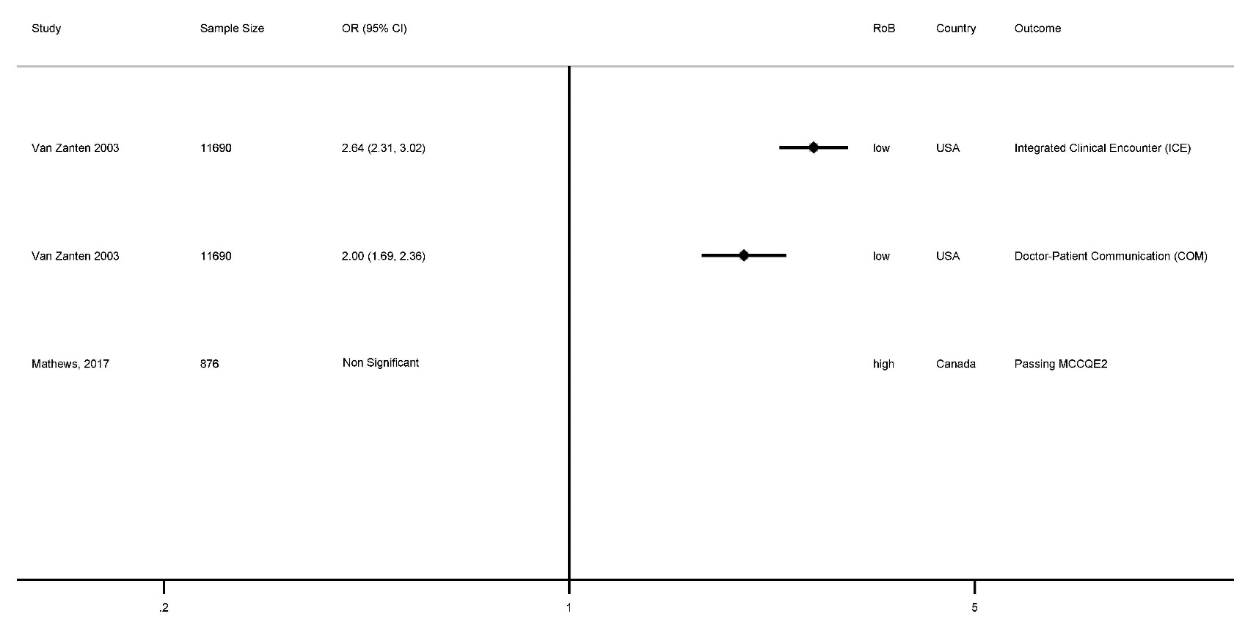
eFigure 2 Association of female sex with success in qualifying exams

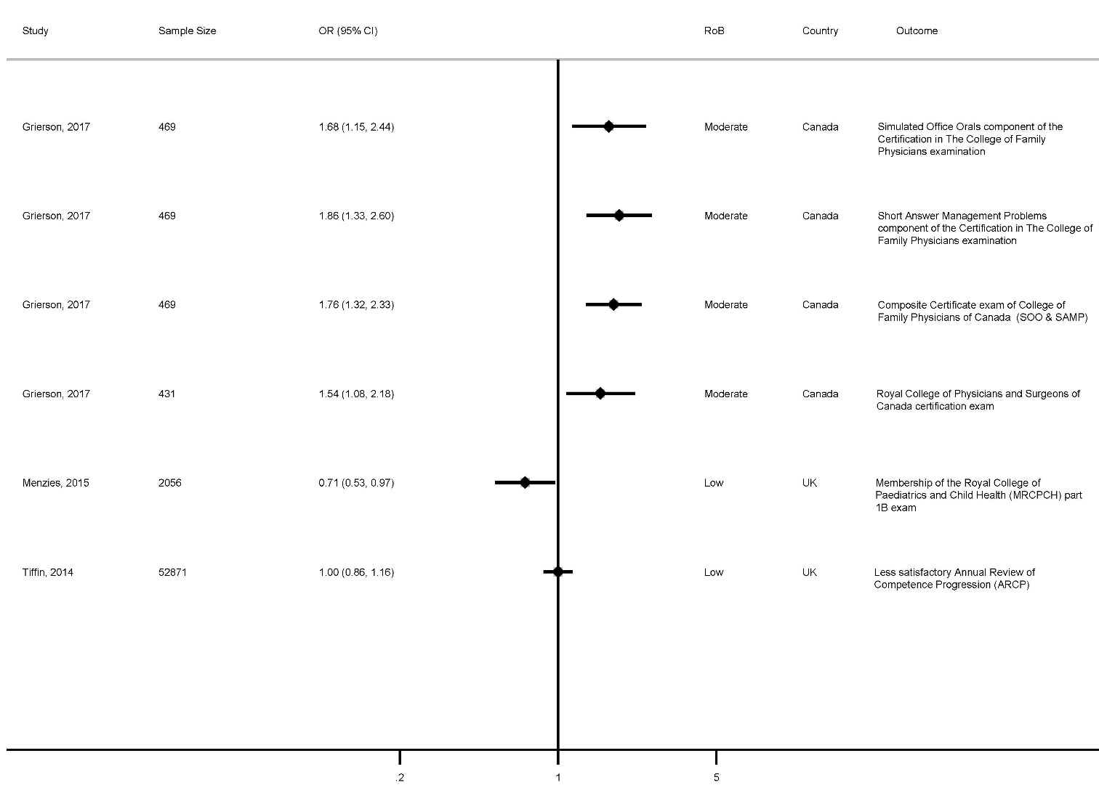
eFigure 3 Association of 10 years age decrement with success in certificate exams

