Additional file 3: Completeness rate by transmission time without extreme values (P12 and P17).
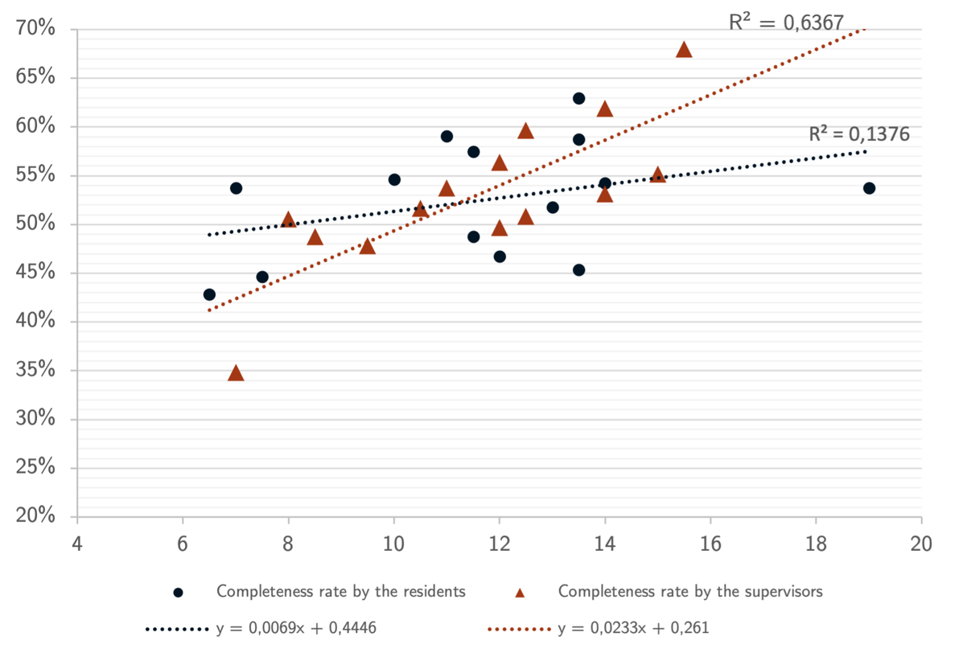
Figure 10: Completeness rate (%) by transmission time (minutes) for the residents’ group (red triangles) and for the supervisors’ group (black circles) without extreme values.

