Supplementary file 3
The tree diagram based on the PPR for the NMLE in 637 medical senior students of GUSM.
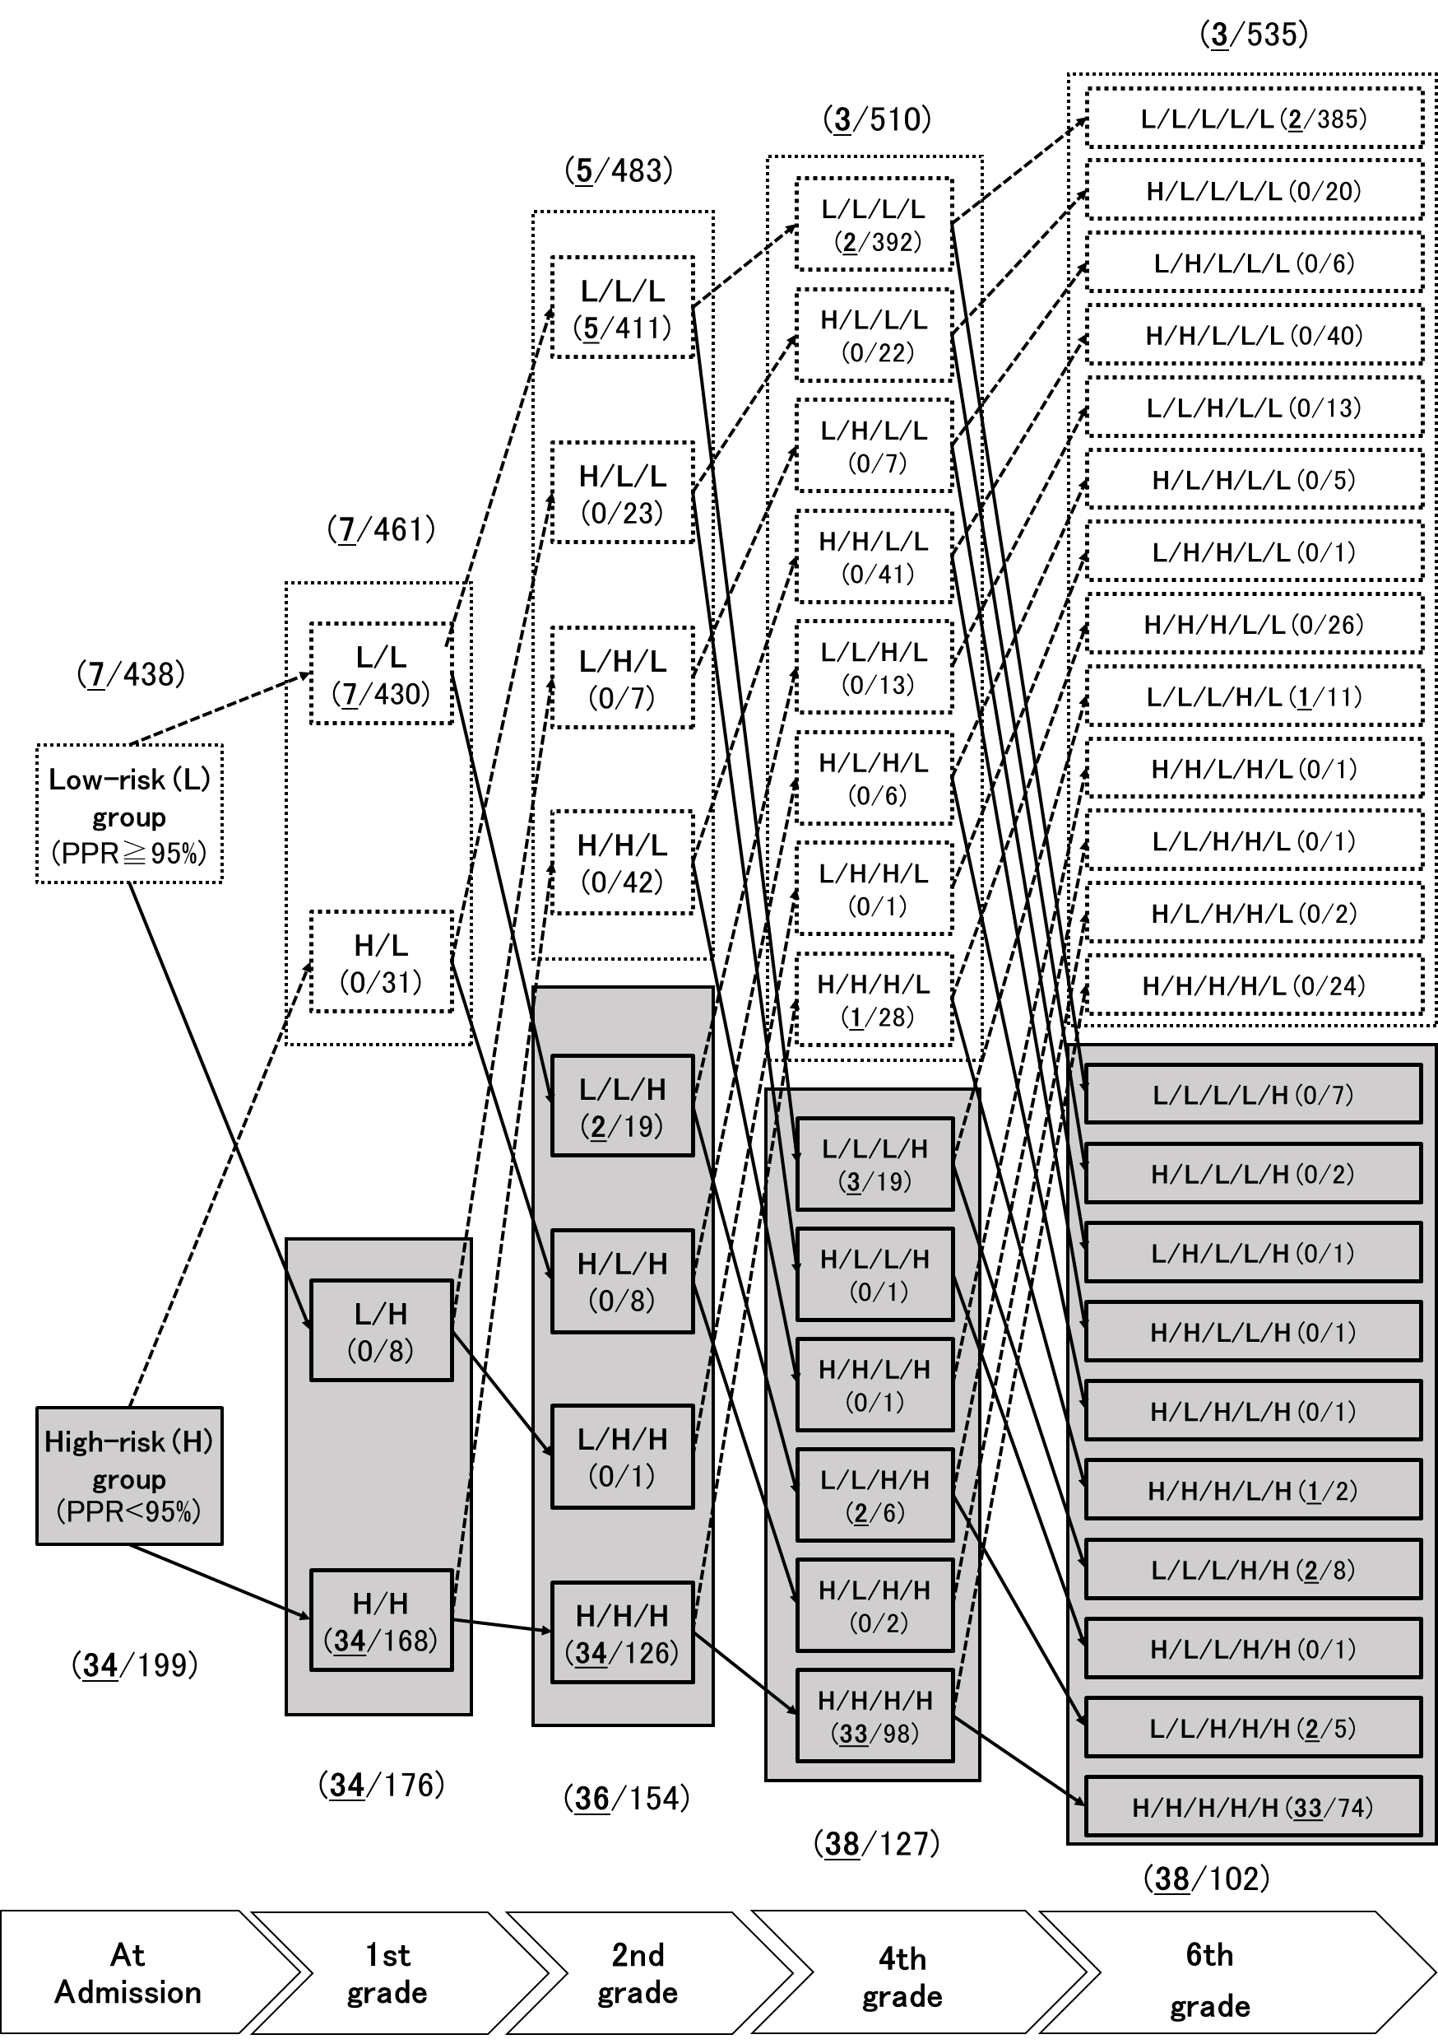
Note: H and L mean high- and low-risk groups, respectively. The numbers of failures for NMLE and total students shown in the parentheses in both groups at five time points, respectively, and the bold and underlined digits indicate the numbers of failures. The solid and dotted arrowed lines mean transferring student(s) from one group to another during 6 years in school, the former line shows transfers to high-risk group, the latter shows transfers to low-risk group. For instance, “H/H/L” means a subgroup which includes the students who belonged in the high-risk groups at admission and the end of 1st grade and in the low-risk group at the end of 2nd grade.

