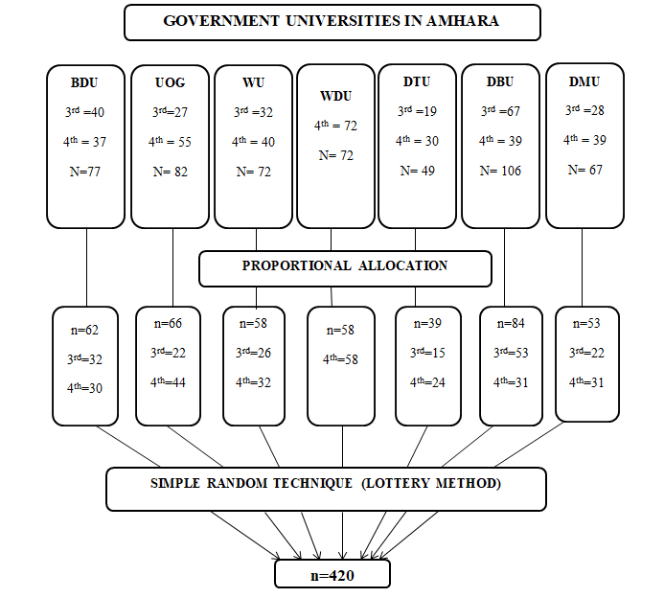
- S Figure 1 - ''Schematic diagram of sampling procedure for Students' satisfaction of SBE among undergraduate Midwifery Students in Amhara region Universities, Ethiopia 2022''

