A call for improving of musculoskeletal education on physical medicine and rehabilitation studies: a systematic review with meta-analysis
Contents
Supplemental Table 1. Search strategies ……………………………………………2
Supplemental Fig 1. Risk of bias summary …………………………………………3
Supplemental Fig 2. Risk of bias graph………………………………………………4
Supplemental Fig 3. The funnel plots for knowledge acquisition (compared with a control group)…………………………………………………5
Supplemental Fig 4. Sensitivity analysis for knowledge acquisition (compared with a control group) ……………………………………………… 6
Supplemental Fig 5. The funnel plots for knowledge acquisition (before and after comparison) ……………………………………………… 7
Supplemental Fig 6. Sensitivity analysis for knowledge acquisition (before and after comparison) …………………………………………… 8
Supplemental Fig 7. The funnel plots for confidence (before and after comparison)…………………………………………………9
Supplemental Fig 8. Sensitivity analysis for confidence (before and after comparison)……………………………………………… 10
Supplemental Fig 9. The funnel plots for satisfaction (compared with a control group)………………………………………………… 11
Supplemental Fig 10. Sensitivity analysis for satisfaction (compared with a control group)…………………………………………………12
Supplemental Table 2. Egger’s regression test ……………………………………13
Supplemental Table 3. Funding sources……………………………………………14

Supplemental Table 1. Search strategies.
Pubmed search strategy
("undergraduate*"[Title/Abstract] OR "undergraduate*"[MeSH Terms]) AND ("students, medical"[Title/Abstract] OR "medical students"[Title/Abstract] OR "housestaff"[Title/Abstract] OR "post graduate*"[Title/Abstract] OR "students, medical"[MeSH Terms] OR "medical students"[MeSH Terms] OR "housestaff"[MeSH Terms] OR "post graduate*"[MeSH Terms]) AND "educability"[Title/Abstract] OR "educable"[Title/Abstract] OR "educates"[Title/Abstract] OR "education"[Title/Abstract] OR "educational status"[Title/Abstract] OR "educable"[Title/Abstract] OR "educates"[Title/Abstract]) AND ("Musculoskeletal"[Title/Abstract] OR "Musculoskeletal"[MeSH Terms]) AND (2012:2024[pdat])

CENTRAL (Cochrane Central Register of Controlled Trials) search strategy
#1 (undergraduate or undergraduates or undergraduated):ti,ab.kw
#2 MeSH descriptor: [undergraduate] explode all trees
#3 #1 OR #2
#4 (students, medical or medical students or housestaff or post graduate):ti,ab.kw
#5 MeSH descriptor: [medical students] explode all trees
#6 MeSH descriptor: [housestaff ] explode all trees
#7 MeSH descriptor: [post graduate] explode all trees
#8 #4 OR #5 OR #6 OR #7
#9 (education or educability or educable or educates):ti,ab.kw
#10 MeSH descriptor: [education ] explode all trees
#11 #9 OR #10
#12 (Musculoskeletal):ti,ab.kw
#13 MeSH descriptor: [Musculoskeletal] explode all trees
#14 #12 OR #13
#15 #3 AND #8 AND #11 AND #14

EMBASE search strategy
1. (undergraduate or undergraduates or undergraduated).ab,kw,ti.
2. undergraduate/
3. 1 or 2
4. (students, medical or medical students or housestaff or "post graduate).ab,kw,ti.
5. medical students/
6. housestaff /
7. post graduate/
8. 4 or 5 or 6 or 7
9 (education or educability or educable or educates):ab,kw,ti
10 education/
11 9 or 10
12 (Musculoskeletal):ab,kw,ti
13 Musculoskeletal/
14 12 or 13
15 3 and 8 and 11 and 14
Supplemental Fig 1. Risk of bias summary. Green represents a low risk of bias, yellow some concerns, and red a high risk of bias

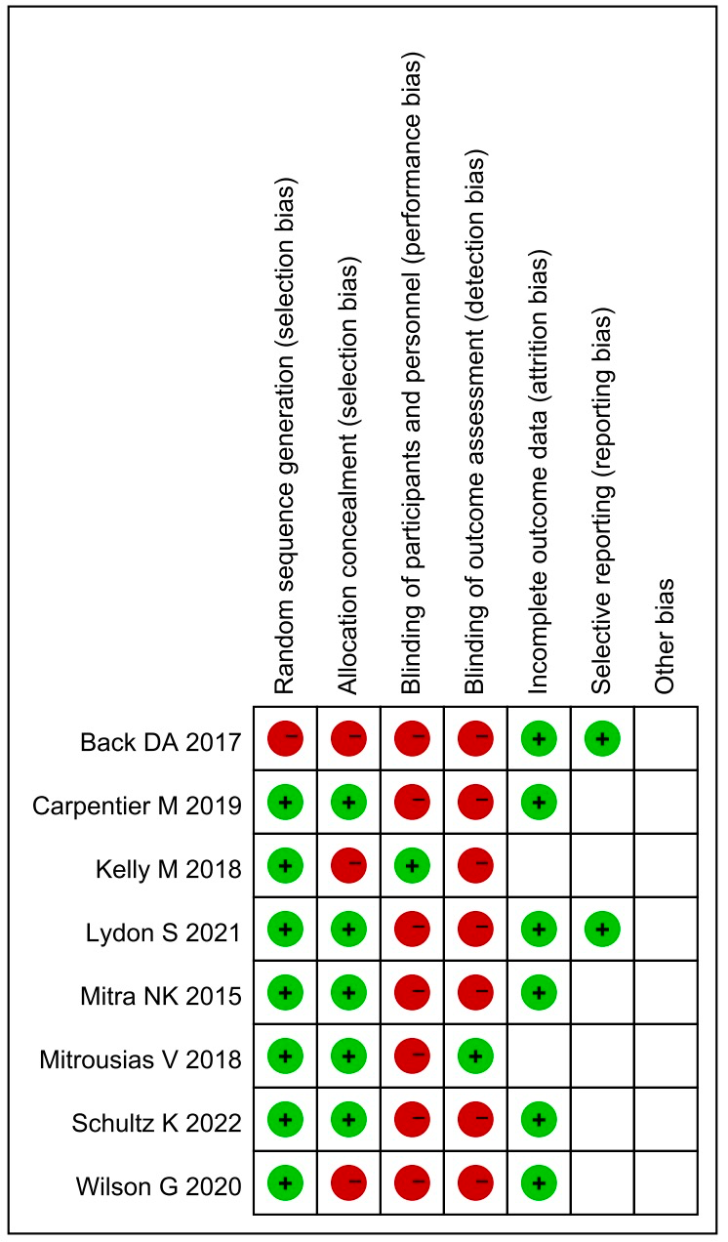

Supplemental Fig 2. Risk of bias graph
Green represents a low risk of bias, yellow some concerns, and red a high risk of bias
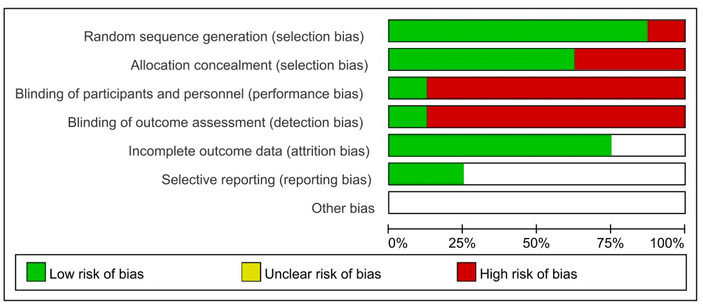

This included the results of funnel plots and sensitivity analysis of the degree of mastery of knowledge, self-confidence, and satisfaction.
Supplemental Fig 3. The funnel plots for knowledge acquisition (compared with a control group)
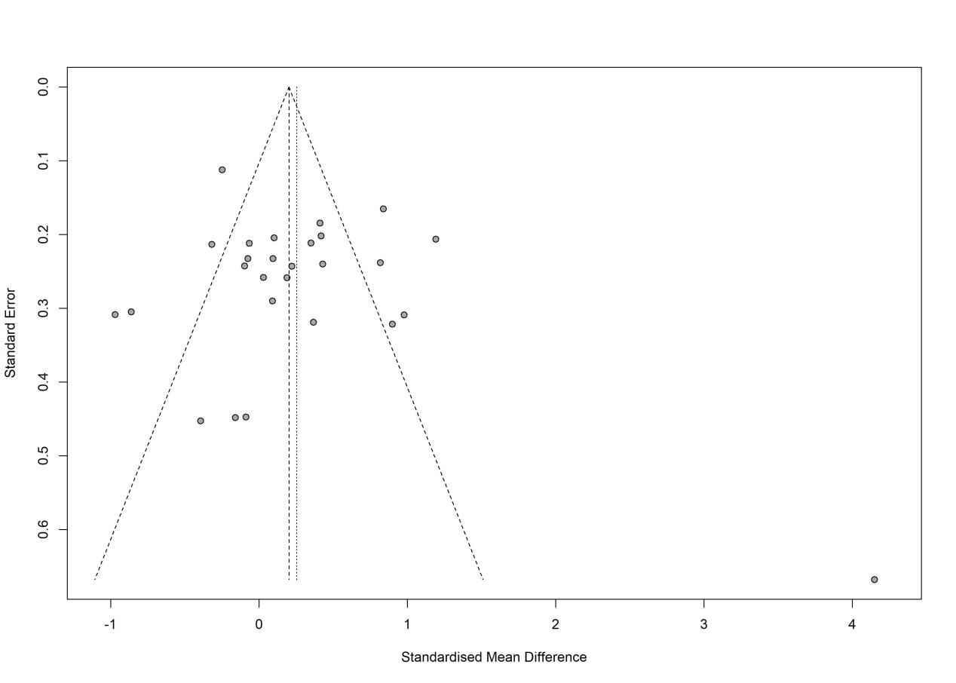

Supplemental Fig 4. Sensitivity analysis for knowledge acquisition (compared with a control group)
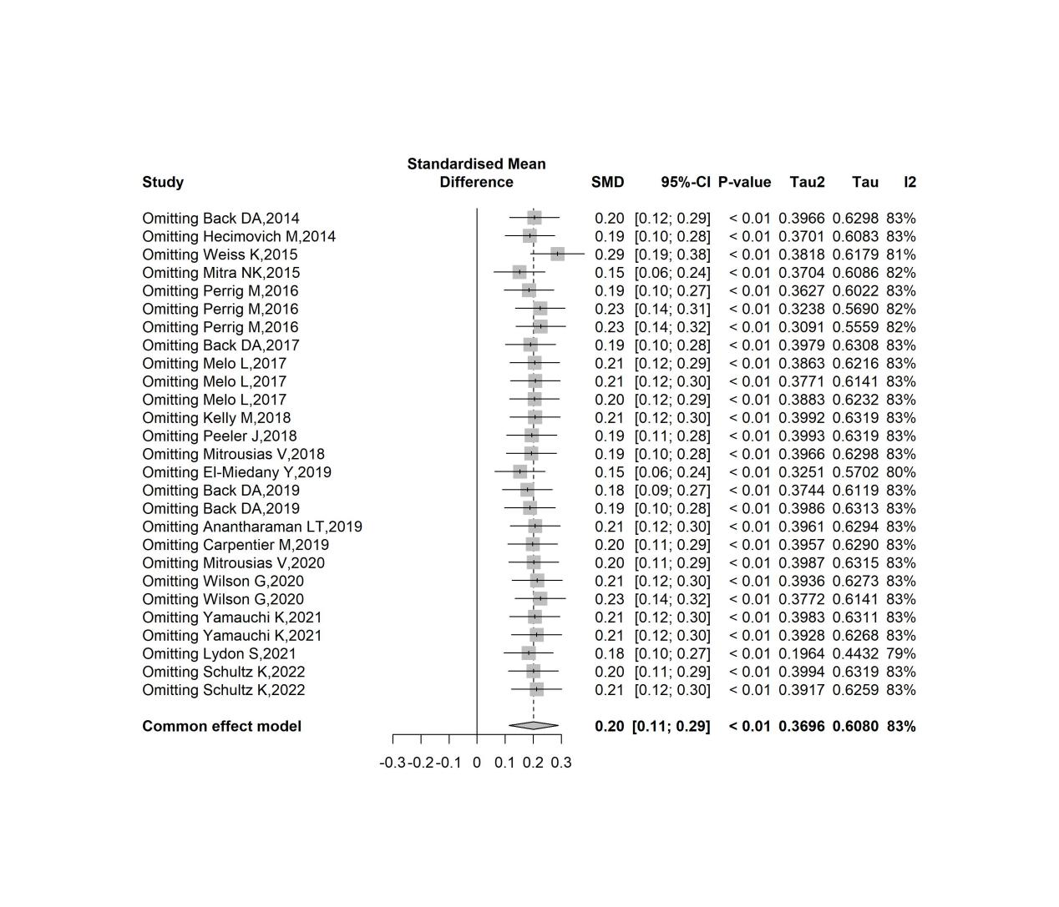

Supplemental Fig 5. The funnel plots for knowledge acquisition (before and after comparison)

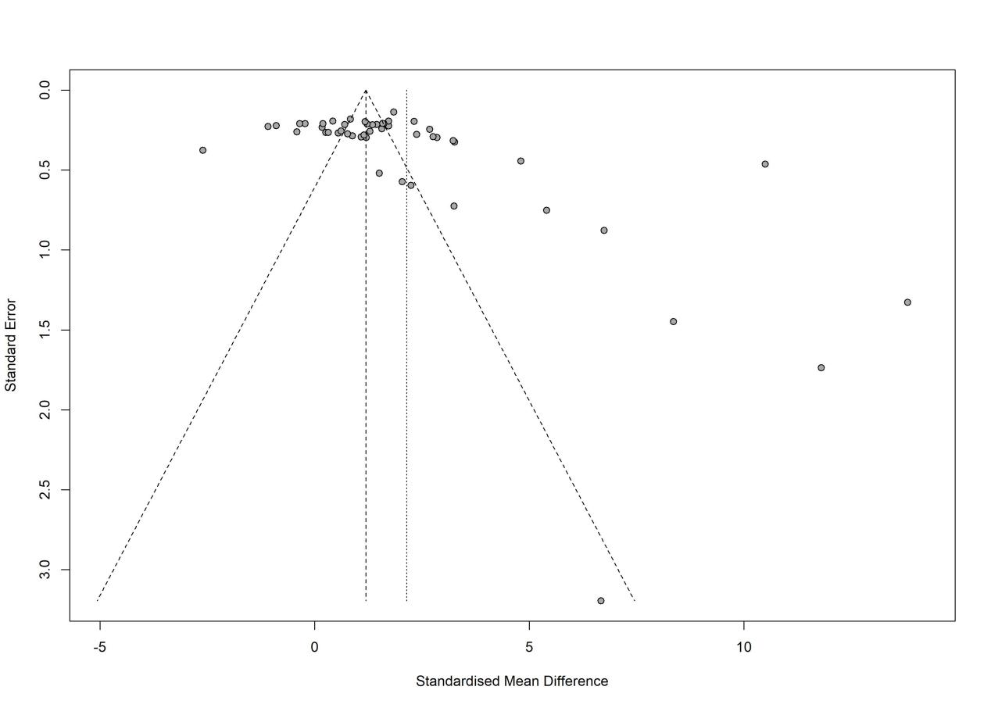

Supplemental Fig 6. Sensitivity analysis for knowledge acquisition (before and after comparison)

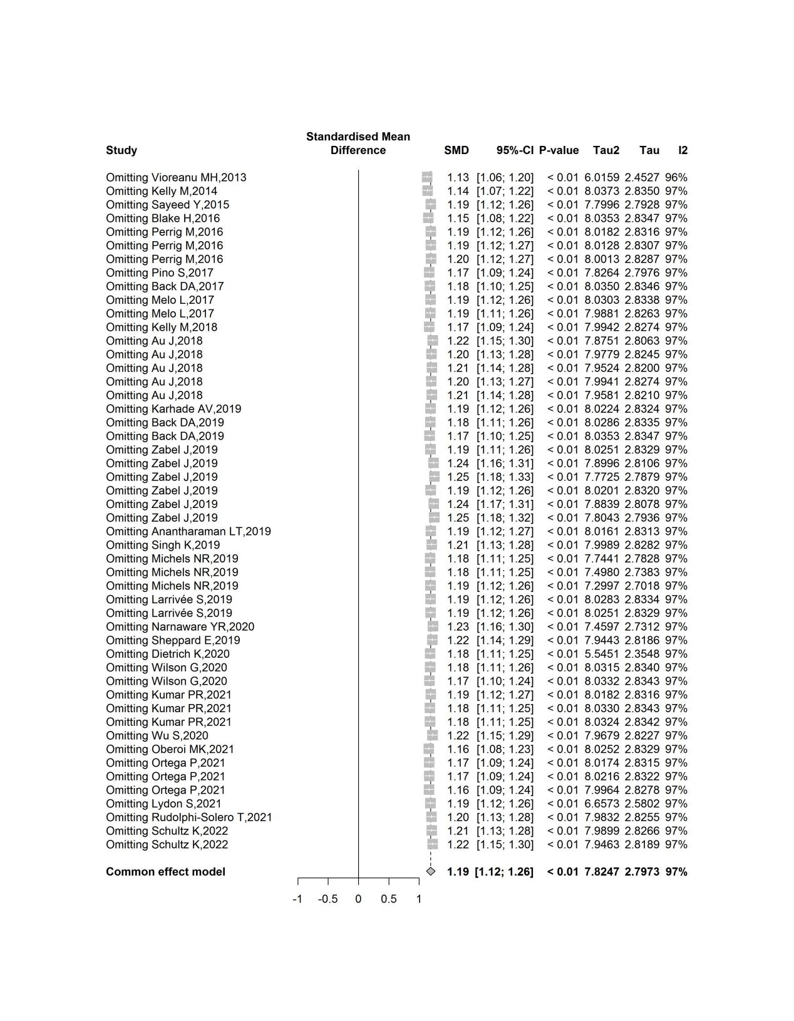

Supplemental Fig 7. The funnel plots for confidence (before and after comparison)
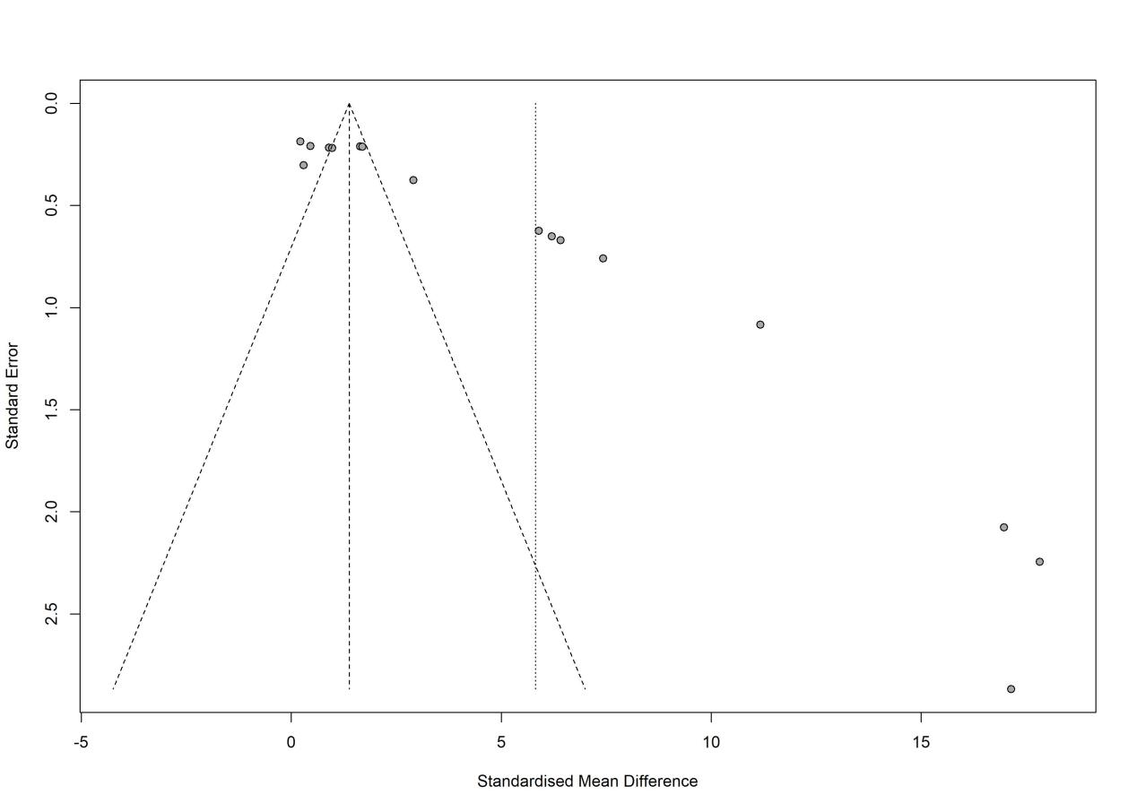

Supplemental Fig 8. Sensitivity analysis for confidence (before and after comparison)
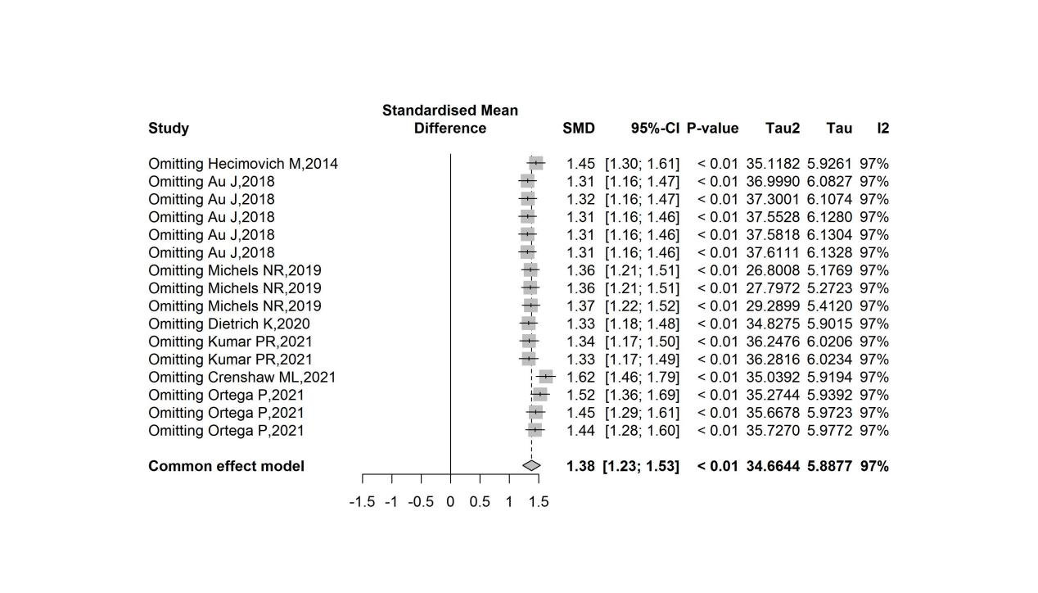

Supplemental Fig 9. The funnel plots for satisfaction (compared with a control group)
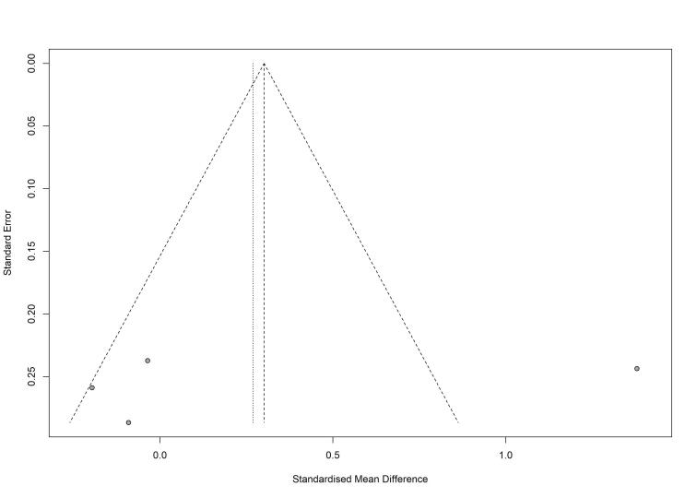

Supplemental Fig 10. Sensitivity analysis for satisfaction (compared with a control group)
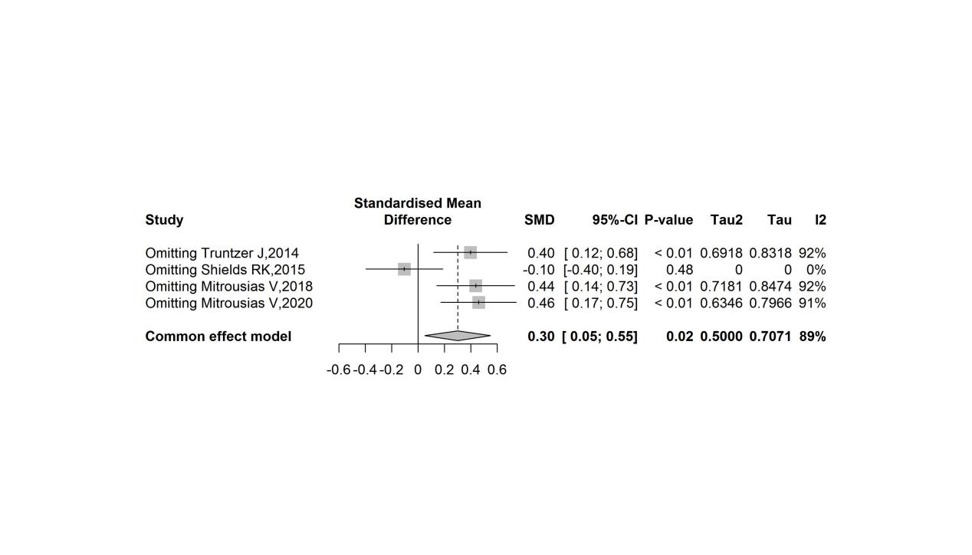

Supplemental Table 2. Egger’s regression test

Confidence (before and after comparison)
Std_Eff | Coef. | Std. Err. | t | P | 95% CI
slope | -1.136 | 0.349 | -3.25 | 0.006 | -1.886~-0.387
bias | 9.853 | 1.130 | 8.72 | <0.001 | 7.430~12.276

knowledge acquisition (before and after comparison)
Std_eff | Coef. | Std. Err. | t | P | 95% CI
slope | -0.304 | 0.490 | -0.62 | 0.538 | -1.290~0.681
bias | 6.284 | 1.887 | 3.33 | 0.002 | 2.491~10.077

knowledge acquisition (compared with a control group)【total】
Std_eff | Coef. | Std. Err. | t | P | 95% CI
slope | -0.107 | 0.335 | -0.32 | 0.751 | -0.798~0.583
bias | 1.416 | 1.442 | 0.98 | 0.335 | -1.553~4.386

knowledge acquisition (compared with a control group)【RCT】
Std_eff | Coef. | Std. Err. | t | P | 95% CI
slope | -0.561 | 0.604 | -0.93 | 0.375 | -1.907~0.784
bias | 4.216 | 2.698 | 1.56 | 0.149 | -1.795~10.228

knowledge acquisition (compared with a control group)【non-RCT】
Std_eff | Coef. | Std. Err. | t | P | 95% CI
slope | -0.057 | 0.402 | -0.14 | 0.890 | -0.926~0.812
bias | 0.553 | 1.675 | 0.33 | 0.747 | -3.066~4.172

satisfaction (compared with a control group)【total】
Std_eff | Coef. | Std. Err. | t | P | 95% CI
slope | 3.876 | 6.154 | 0.63 | 0.593 | -22.603~30.355
bias | -14.069 | 24.176 | -0.58 | 0.619 | -118.089~89.952

satisfaction (compared with a control group)【RCT N=1, couldn’t calculate】
Std_eff | Coef. | Std. Err. | t | P | 95% CI
slope
bias

satisfaction (compared with a control group)【non-RCT】
Std_eff | Coef. | Std. Err. | t | P | 95% CI
slope | 8.820 | 7.551 | 1.17 | 0.451 | -87.125~104.761
bias | -32.144 | 28.903 | -1.11 | 0.466 | -399.393~355.106

Supplemental Table 3. Funding sources
Author | Mentioned | Funding sources | Available
Vioreanu MH et al.^{[18]} | No | / | No
Back DA et al.^{[19]} | No | / | No
Hecimovich M et al.^{[20]} | Yes | This study was fully funded by the Clinical Simulation Support Unit, Health Department of Western Australia. | Yes
Kelly M et al.^{[21]} | Yes | There was no source of external funding for this study | No
Truntzer J et al.^{[22]} | No | / | No
Mitra NK et al.^{[23]} | No | / | No
Sayeed Y et al.^{[24]} | Yes | This study was funded by West Virginia University Institutional Funds. | Yes
Shields RK et al.^{[25]} | Yes | There is no funding support associated with this work | No
Weiss K et al.^{[26]} | No | / | No
Blake H et al.^{[27]} | Yes | Higher Education Funding Council for England. | Yes
Perrig M et al.^{[28]} | No | / | No
Back DA et al.^{[29]} | No | / | No
Melo L et al.^{[30]} | No | / | No
Pino S et al.^{[31]} | Yes | This work was supported by ILAR project funding 2015. | Yes
Au J et al.^{[32]} | Yes | No Funding was received. | No
Au J et al.^{[32]} | No | / | No
Au J et al.^{[32]} | No | / | No
Kelly M et al.^{[33]} | Yes | This research was provided by the Teaching and Learning Enhancement Fund at the University of Manitoba | Yes
Mitrousias V et al.^{[34]} | No | / | No
Peeler J et al.^{[35]} | Yes | There was no funding of the study. | No
Anantharaman LT et al.^{[36]} | No | / | No
Back DA et al.^{[37]} | No | / | No
Carpentier M et al.^{[38]} | Yes | The HAAOT (setting for this study) was funded in part by a grant from the Foundation of Orthopaedic Trauma. Conference travel for RAQ and CJM funded in part by a grant from the Boston Children’s Hospital Global Health Program. | Yes
El-Miedany Y et al.^{[39]} | Yes | Funding was provided by the Pan Am Clinic Foundation to facilitate providing meals to participants during the education session and follow-up testing session | Yes
Karhade AV et al.^{[40]} | Yes | No funding to report | No
Larrivée S et al.^{[41]} | No | / | No
Michels NR et al.^{[42]} | Yes | No funding was obtained for this study. | No
Michels NR et al.^{[42]} | Yes | This work was supported by the German Federal Ministry of Education and Research (grant 01PL12038A) as part of the joint research project. | Yes
Sheppard E et al.^{[43]} | No | / | No
Singh K et al.^{[15]} | No | / | No
Zabel J et al.^{[44]} | No | / | No
Zabel J et al.^{[44]} | No | / | No
Zabel J et al.^{[44]} | Yes | None. | No
Dietrich K et al.^{[45]} | Yes | The author(s) received no financial support for the research,authorship, and/or publication of this article. | No
Mitrousias V et al.^{[46]} | Yes | The authors have not declared a specific grant for this research from any funding agency in the public, commercial or not-for-profit sectors | Yes
Narnaware YR et al.^{[47]} | Yes | There is no funding to declare for this study | No
Wilson G et al.^{[48]} | No | / | No
Wu S et al.^{[49]} | Yes | The Medical Organization for Latino Advancement supported medical student Itzel López-Hinojosa with a summer research stipend to facilitate her participation in this research. | Yes
Crenshaw ML et al.^{[50]} | Yes | The Innovative Education Projects, #PIE17-113 and #PIE19-217, and the Department of Radiology and Physical Medicine of the University of Malaga partially supported this study. The maintenance cost of the Medical Master Island during this project was supported by the Andalusian Society of Radiol-ogy (Asociación de Radiólogos del Sur), a subsidiary of the Spanish Society of Radiology (SERAM). | Yes
Kumar PR et al.^{[51]} | Yes | This work was supported by JSPS KAKENHI Grant Number JP18K09986 and Initiative for Realising Diversity in the Research Environment of Tokyo Women’s Medical University. | Yes
Lydon S et al.^{[3]} | Yes | This project was supported by the Association of Pediatric Program Directors (APPD) | Yes
Oberoi MK et al.^{[52]} | No | This study was funded by West Virginia University Institutional Funds. | No
Ortega P et al.^{[53]} | No | There is no funding support associated with this work | No
Rudolphi-Solero T et al.^{[54]} | Yes | / | Yes
Yamauchi K et al.^{[55]} | Yes | Higher Education Funding Council for England. | No
Schultz K et al.^{[56]} | No | / | No

