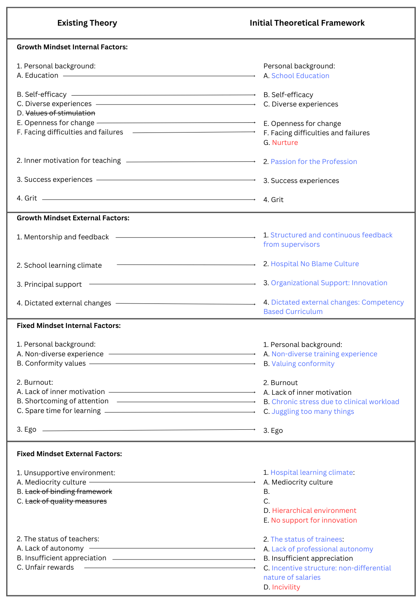

Supplementary File 1: Appendix 1: Table highlighting changes made to existing theory that formed the basis of the initial theoretical framework. Existing theory explored the same topic but in a different context: teachers’ perceptions of factors that shape their mindset. [1] Minor changes are in blue and major changes are in red.

Justifications for changes made to the theoretical framework prior to data collection
- We changed Education to School Education to specify primary and secondary education rather than higher education, which is what the existing theory was referring to.
- Values of stimulation referred to the taxonomy of Schwartz’s ten values, and is defined as motivation for an exciting, daring and varied life. [2] We removed this theme as we felt it was adequately reflected in Openness for change.
- We added Nurture as parental relationships were identified in previous research as internal factors that impacted mindset. [3]
- We changed Inner motivation for teaching to Passion for profession due to the different careers of our research participants.
- We amended Mentorship and feedback to Structured and continuous feedback from supervisors as all trainees are allocated clinical and educational supervisors during their training pathway who have responsibility to provide feedback, and we wanted to refer to supervision structures that were in place for all trainees.
- We adapted School learning climate to Hospital no blame culture due to the different learning environments of the research participants.
- We changed Principal support to Organizational support because of the different learning environments of our research participants, and we specified the word innovations as Principal support in the existing theory focused on principals supporting new initiatives (i.e. innovations).
- To provide clarity for the research participants about the primary dictated external change in their learning context, we added Competency based curriculum to Dictated external changes
- We added the word training to Non-diverse experience to specify lack of diverse experience in professional rather than personal life.
- We modified Conformity values to Valuing conformity as we felt this phraseology would be more familiar to trainees.
- Shortcoming of attention referred to burnout from excess work commitments and Spare time for learning referred to available time outside of work to focus on learning. We changed the wording to Chronic stress due to clinical workload and Juggling too many things, respectively, because we felt this was more familiar terminology for trainees when referring to the same themes.
- We adapted Unsupportive environment to Hospital learning climate to provide more specificity about location for the research participants when referring to Mediocrity culture, Hierarchical environment etc.
- We felt that Lack of binding framework and Lack of quality measures were unfamiliar references for our research participants, so we replaced with two types of learning climates in the hospital that we felt could impact mindset: Hierarchical environment and No support (financial or staffing) for innovation.
- We adapted The status of teachers to The status of trainees due to the difference in professions of our research participants.
- We modified Lack of autonomy to Lack of professional autonomy to provide further specificity for our research participants.
- Unfair rewards referred to financial compensation in the existing theory. To provide clarity that rewards were referring to payment, and to stimulate reflection that performance is not linked to payment, we changed Unfair Rewards to Incentive structure: non differential nature of salaries.
- We added Incivility to the initial theoretical framework because existing literature supported that rudeness in the workplace can have an impact on mindset, and we wanted to explore this

Supplementary References
1. Zilka A, Grinshtain Y, Bogler R. Fixed or growth: teacher perceptions of factors that shape mindset. Prof Dev Educ. 2022;48(1):149-65.
2. Schwartz SH. Universals in the content and structure of values: Theoretical advances and empirical tests in 20 countries. In Advances in experimental social psychology 1992 Jan 1 (Vol. 25, pp. 1-65). Academic Press.
3. Waithaka AG, Furniss TM, Gitimu PN. College Student Mind-Set: Does Student-Parental Relationship Influence the Student's Mind-Set?. Research in Higher Education Journal. 2017 Jun;32.
4. Babchenko O, Scott K, Jung S, Frank S, Elmaraghi S, Thiagarajasubramanian S, Rendell V, Poore SO, Bentz ML, Garland CB. Resident perspectives on effective surgical training: incivility, confidence, and mindset. Journal of Surgical Education. 2020 Sep 1;77(5):1088-96.

