APPENDICES

Appendix A. Studies included in systematic review and meta-analysis

A1. Tan, A.J.Q., Lee, C.C.S., Lin, P.Y., Cooper, S., Lau, L.S.T., Chua, W.L., Liaw, S.Y., 2017. Designing and evaluating the effectiveness of a serious game for safe administration of blood transfusion: a randomized controlled trial. Nurse Educ. Today. 55, 38-44. https://doi.org/10.1016/j.nedt.2017.04.027
A2. Bayram, S.B., Caliskan, N., 2019. Effect of a game-based virtual reality phone application on tracheostomy care education for nursing students: a randomized controlled trial. Nurse Educ. Today. 79, 25-31. https://doi.org/10.1016/j.nedt.2019.05.010
A3. Ignacio, J., Chen, H.C., 2020. The use of web-based classroom gaming to facilitate cognitive integration in undergraduate nursing students: a mixed methods study. Nurse Educ. Pract. 46, 102820. https://doi.org/10.1016/j.nepr.2020.102820
A4. Gutierrez-Puertas, L., Garcia-Viola, A., Márquez-Hernández, V.V., Garrido-Molina, J.M., Granados-Gamez, G., Aguilera-Manrique, G., 2021. Guess it (SVUAL): an app designed to help nursing students acquire and retain knowledge about basic and advanced life support techniques. Nurse Educ. Pract. 50, 102961. https://doi.org/10.1016/j.nepr.2020.102961
A5. Calik, A., Kapucu, S., 2022. The effect of serious games for nursing students in clinical decision-making process: a pilot randomized controlled trial. Games Health J. 11 (1), 30-37. https://doi.org/10.1089/g4h.2021.0180
A6. Gu, R., Wang, J., Zhang, Y., Li, Q., Wang, S., Sun, T., Wei, L., 2022. Effectiveness of a game-based mobile application in educating nursing students on flushing and locking venous catheters with pre-filled saline syringes: a randomized controlled trial. Nurse Educ. Pract. 58, 103260. https://doi.org/10.1016/j.nepr.2021.103260
A7. Elzeky, M.E., Elhabashy, H.M., Ali, W.G., Allam, S.M., 2022. Effect of gamified flipped classroom on improving nursing students’ skills competency and learning motivation: a randomized controlled trial. BMC Nurs. 21 (1), 316. https://doi.org/10.1186/s12912-022-01096-6
A8. Sarvan, S., Efe, E., 2022. The effect of neonatal resuscitation training based on a serious game simulation method on nursing students' knowledge, skills, satisfaction and self-confidence levels: a randomized controlled trial. Nurse Educ. Today. 111, 105298. https://doi.org/10.1016/j.nedt.2022.105298
A9. Rosa-Castillo, A., García-Pañella, O., Roselló-Novella, A., Maestre-Gonzalez, E., Pulpón-Segura, A., Icart-Isern, T., Solà-Pola, M., 2023. The effectiveness of an Instagram-based educational game in a Bachelor of Nursing course: An experimental study. Nurse Educ. Pract. 70, 103656. https://doi.org/10.1016/j.nepr.2023.103656
A10. Tang, Y., Gu, R., Zhao, Y., Wang, J., Zhang, Y., Li, Q., Wang, Z., Wang, S., Wei, Q., Wei, L., 2023. Effectiveness of a game-based mobile application in educating nursing students on venous blood specimen collection: a randomized controlled trial. Games Health J. 12 (1), 63-72. https://doi.org/10.1089/g4h.2022.0085
A11. Kulakaç, N., Çilingir, D., 2024. The effect of a serious game-based web application on stoma care education for nursing students: a randomized controlled trial. Teach. Learn Nurs. 19 (1), e126-e132. https://doi.org/10.1016/j.teln.2023.10.001

Appendix B. Forest plots for the sensitivity analysis

B.1. Sensitivity analysis for knowledge
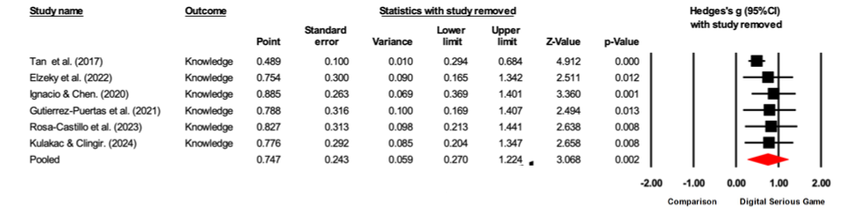
B.2. Sensitivity analysis for confidence
B.3. Sensitivity analysis for performance

